# Week 6 React Exercise Solutions

## ReactJS HOL – 1:

*Code: (App.js)*

import logo from './logo.svg';

import './App.css';

function **App**() {

return (

<h1>Welcome to first session of React</h1>

);

}

export default App;

*Output:*

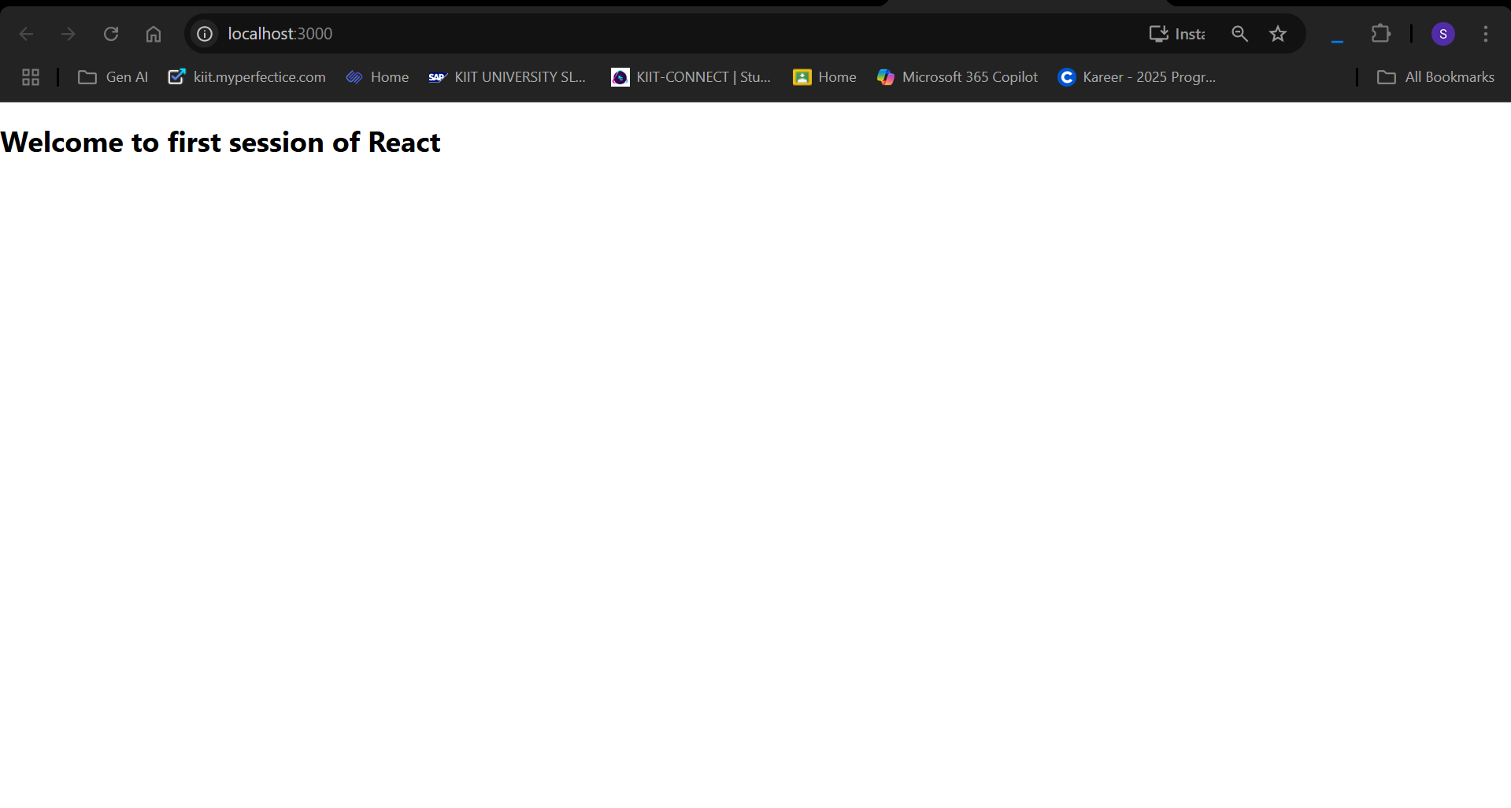

## ReactJS HOl – 2:

Code:(Components/Home.js)

import React, { Component } from 'react';

export default class Home extends Component {

**render**() {

return (

<div>

<h3>Welcome to Home Page of Student Management Portal</h3>

</div>

);

}

}

About.js

import React, { Component } from 'react';

export default class About extends Component {

**render**() {

return (

<div>

<h3>Welcome to About Page of Student Management Portal</h3>

</div>

);

}

}

Contact.js

import React, { Component } from 'react';

export default class Contact extends Component {

**render**() {

return (

<div>

<h3>Welcome to Contact Page of Student Management Portal</h3>

</div>

);

}

}

App.js

import logo from './logo.svg';

import './App.css';

import Home from './Components/Home';

import About from './Components/About';

import Contact from './Components/Contact';

function **App**() {

return (

<div *className*='container'>

<Home/>

<About/>

<Contact/>

</div>

);

}

export default App;

Output:

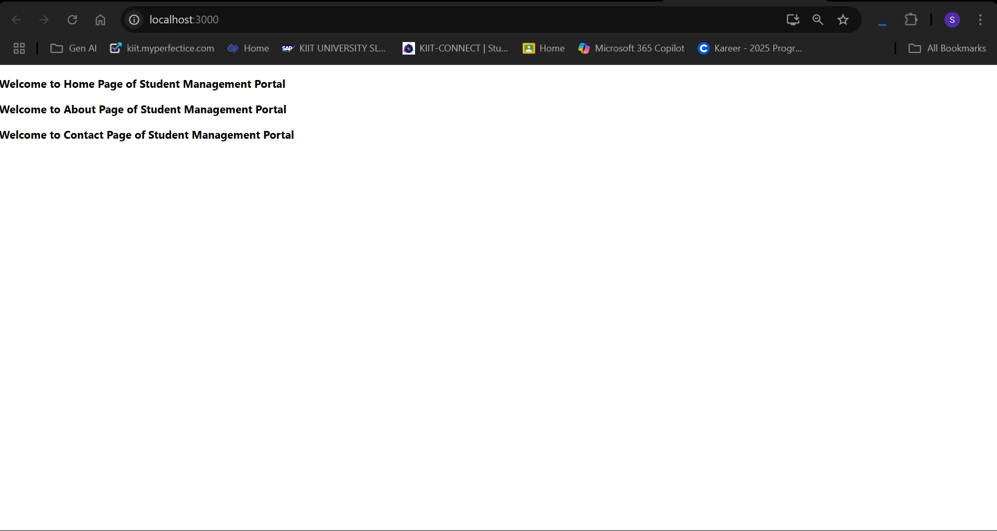

## ReactJs HOL – 3:

Code(CalculatorScore.js)

import '../Stylesheets/mystyle.css'

const **percentToDecimal** = (*decimal*)=>{

return (*decimal*.toFixed(2) + '%')

}

const **calScore** = (*total*, *goal*) => {

return percentToDecimal(*total*/*goal*)

}

export const **CalculateScore** = ({*Name*, *School*, *total*, *goal*}) => (

<div *clasName*="formatstyle">

<h1><font *color*="Brown">Student Details: </font></h1>

<div *clasName*="Name">

<b><span>Name: </span></b>

<span>{*Name*}</span>

</div>

<div *clasName*="School">

<b><span>School: </span></b>

<span>{*School*}</span>

</div>

<div *clasName*="Total">

<b><span>Total: </span></b>

<span>{*total*}</span>

<span>Marks</span>

</div>

<div *clasName*="Score">

<b><span>Score: </span></b>

<span>

{calScore(

*total*,

*goal*

)}

</span>

</div>

</div>

)

Mystyle.css

.Name{

font-weight: 300;

color: blue

}

.School{

color: crimson;

}

.Total{

color: darkmagenta;

}

.formatStyle{

text-align: center;

font-size: large;

}

.Score{

color: forestgreen;

}

App.js

import logo from './logo.svg';

import './App.css';

import { CalculateScore } from './Components/CalculatorScore';

function **App**() {

return (

<div *className*="App">

<CalculateScore *Name*={"Steeve"}

*School*={"DNV Public School"}

*total*={284}

*goal*={3}

/>

</div>

);

}

export default App;

Output:

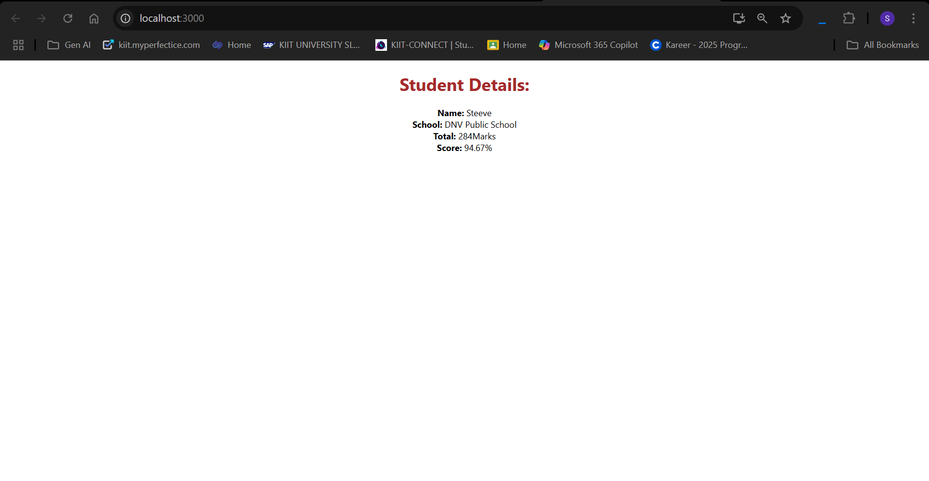

## ReactJS HOL – 4:

Code(Post.js)

class Post{

constructor(*id*, *title*, *body*){

this.id = *id*;

this.title = *title*;

this.body = *body*;

}

}

export default Post;

Posts.js

import React, {Component} from 'react';

import Post from './Post';

class Posts extends Component{

constructor(*props*){

*super*(*props*);

this.state = {

posts: [],

hasError: false,

};

}

**loadPosts** = async () => {

try{

const res = await fetch("https://jsonplaceholder.typicode.com/posts");

const data = await res.json();

const postList = data.map(*post* => new Post(

*post*.id,

*post*.title,

*post*.body

));

this.setState({posts: postList});

}catch(error){

console.error(error);

this.setState({hasError:true});

}

}

**componentDidMount**(){

this.loadPosts();

}

**componentDidCatch**(*error*, *info*){

alert(*error*);

this.setState({hasError:true});

}

**render**(){

if(this.state.hasError){

return <h2>Something went wrong!</h2>

}

return(

<div>

<h1>Blog Post</h1>

{this.state.posts.map(*post* => (

<div *key*={*post*.id}>

<h3>{*post*.title}</h3>

<p>{*post*.body}</p>

<hr/>

</div>

))}

</div>

)

}

}

export default Posts;

App.js

import logo from './logo.svg';

import './App.css';

import Posts from './Posts';

function **App**() {

return (

<div *className*='App'>

<Posts/>

</div>

);

}

export default App;

Output:

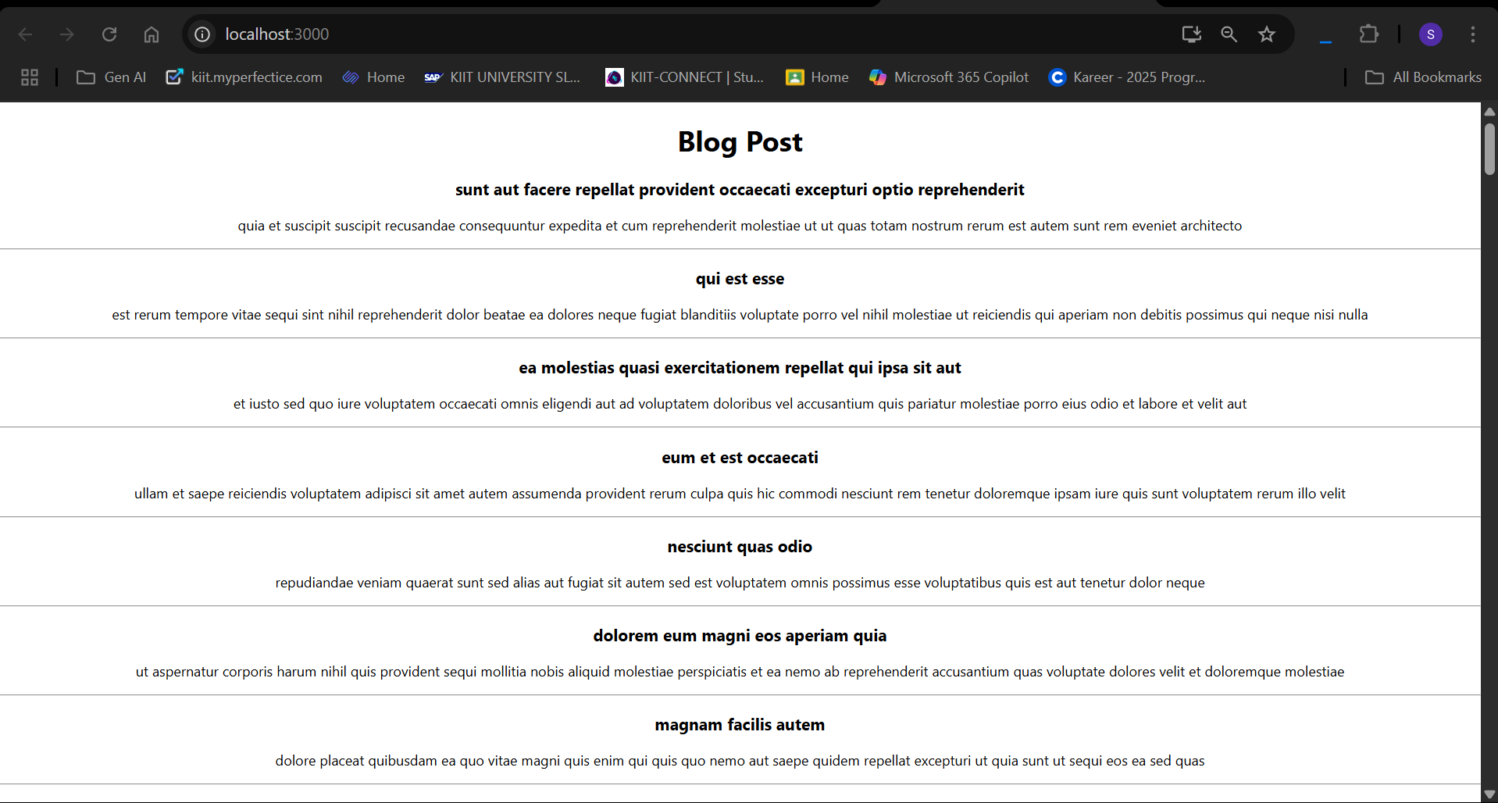

## ReactJS – HOL 5:

Code:(CohortDetails.module.css)

.box{

width: 300px;

display: inline-block;

margin: 10px;

padding-top: 10px;

padding-bottom: 10px;

padding-left: 20px;

padding-right: 20px;

border: 1px solid black;

border-radius: 10px;

}

dt{

font-weight: 500;

}

.ongoing{

color: green;

}

.other{

color: blue;

}

CohortDetails.js

import styles from './CohortDetails.module.css';

function **CohortDetails**(*props*) {

const cohort = *props*.cohort;

const headingClass = cohort.currentStatus.toLowerCase().trim() === 'ongoing' ? styles.ongoing : styles.other;

return (

<div *className*={styles.box}>

<h3 *className*={headingClass}>

{*props*.cohort.cohortCode} -

<span>{*props*.cohort.technology}</span>

</h3>

<dl>

<dt>Started On</dt>

<dd>{*props*.cohort.startDate}</dd>

<dt>Current Status</dt>

<dd>{*props*.cohort.currentStatus}</dd>

<dt>Coach</dt>

<dd>{*props*.cohort.coachName}</dd>

<dt>Trainer</dt>

<dd>{*props*.cohort.trainerName}</dd>

</dl>

</div>

);

}

export default CohortDetails;

Cohort.js

class Cohort {

constructor(*cohortCode*,

*startDate*,

*technology*,

*trainerName*,

*coachName*,

*currentStatus*) {

this.cohortCode = *cohortCode*;

this.coachName = *coachName*;

this.trainerName = *trainerName*;

this.technology = *technology*;

this.startDate = *startDate*;

this.currentStatus = *currentStatus*;

}

}

const CohortsData =[

new Cohort('INTADMDF10','22-Feb-2022', '.NET FSD', 'Jojo Jose','Aathma', 'Scheduled'),

new Cohort('ADM21JF014','10-Sep-2021', 'Java FSD', 'Elisa Smith','Apoorv', 'Ongoing'),

new Cohort('CDBJF21025','24-Dec-2021', 'Java FSD', 'John Doe','Aathma', 'Ongoing'),

new Cohort('INTADMJF12','22-Feb-2022', 'Java FSD', 'To Be Assigned','Ibrahim', 'Scheduled'),

new Cohort('CDE22JF011','24-Dec-2021', 'Java FSD', 'Emma Swan','Apoorv', 'Ongoing'),

new Cohort('INTADMDF09','22-Feb-2022', 'Dataware Housing', 'Babjee Rao','Aathma', 'Scheduled'),

new Cohort('ADM22DF001','10-Sep-2021', '.NET FSD', 'Marie Curie','Ibrahim', 'Ongoing'),

];

export {Cohort, CohortsData};

App.js

import logo from './logo.svg';

import './App.css';

import { CohortsData} from './Cohort'

import CohortDetails from './CohortDetails';

function **App**() {

return (

<div>

<h1>Cohorts Details</h1>

{CohortsData.map(*cohort* => <CohortDetails *cohort*={*cohort*}/>)}

</div>

);

}

export default App;

Output:

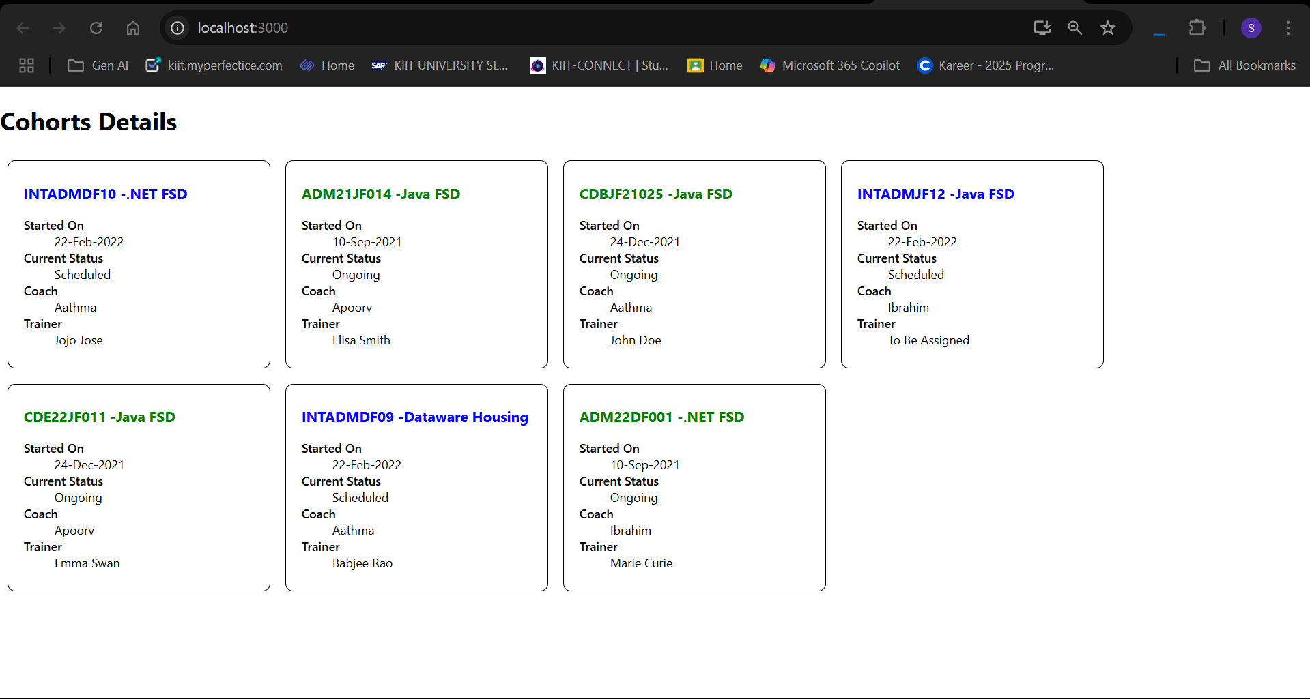

## ReactJS – HOL 6:

Code: (Trainer.js)

class Trainer{

constructor(*trainerId*, *Name*, *Email*, *Phone*, *Technology*, *Skills*){

this.trainerId = *trainerId*;

this.Name = *Name*;

this.Email = *Email*;

this.Phone = *Phone*;

this.Technology = *Technology*;

this.Skills = *Skills*;

}

}

export default Trainer;

TrainerList.js

import { Link } from "react-router-dom";

import trainersMock from "./TrainersMock";

export const **TrainersList** = () => {

return (

<>

<h1>Trainers List</h1>

{

trainersMock.map(*item* => {

return (

<div *key*={*item*.trainerId}>

<ul>

<li>

<Link *to*={`/trainer/${*item*.trainerId}`}>{*item*.Name}</Link>

</li>

</ul>

</div>

)

})

}

</>

)

}

TrainerDetails.js

import { useParams } from "react-router-dom";

import trainersMock from "./TrainersMock";

function **TrainerDetail**() {

const { id } = useParams();

const trainer = trainersMock.find((*t*) => *t*.trainerId === id);

if (!trainer) {

return <h1>Trainer not found!</h1>

}

return (

<div *style*={{ padding: '1rem', border: '1px solid #ccc', borderRadius: '10px', width: '300px' }}>

<h2>Trainer Details</h2>

<p><strong>Name:</strong> {trainer.Name}</p>

<p><strong>Email:</strong> {trainer.Email}</p>

<p><strong>Phone:</strong> {trainer.Phone}</p>

<p><strong>Technology:</strong> {trainer.Technology}</p>

<p><strong>Skills:</strong></p>

<ul>

{trainer.Skills.map((*skill*, *index*) => (

<li *key*={*index*}>{*skill*}</li>

))}

</ul>

</div>

);

}

export default TrainerDetail;

TrainersMock.js

import Trainer from "./Trainer";

const trainersMock = [

new Trainer(

'abc',

'ABC CBA',

'[abc@cognizant.com](mailto:abc@cognizant.com)',

'0987654321',

'.NET',

['C#','SQL','React','.NET Core']

),

new Trainer(

'xyz',

'XYZ ZYX',

'[xyz@cognizant.com](mailto:xyz@cognizant.com)',

'1234567890',

'JAVA',

['Java','SQL','React','Spring Boot']

),

new Trainer(

'pqr',

'PQR RQP',

'[pqr@cognizant.com](mailto:pqr@cognizant.com)',

'0908070601',

'Python',

['Python','SQL','React','Django']

),

]

export default trainersMock;

Home.js

export default function **Home**() {

return(

<>

<h1>Welcome to My Academy trainer page</h1>

</>

)

}

App.js

import logo from './logo.svg';

import './App.css';

import { TrainersList } from './Components/Trainerlist';

import { BrowserRouter, Routes, Route, Link } from 'react-router-dom';

import Home from './Components/Home';

import TrainerDetail from './Components/TrainerDetails';

function **App**() {

return (

<BrowserRouter>

<h1>My Academy Trainers App</h1>

<nav>

<ul>

<li>

<Link *to*='/home'>Home</Link>

</li>

<li>

<Link *to*='/trainers'>TrainersList</Link>

</li>

</ul>

</nav>

<Routes>

<Route *path*="/home" *element*={<Home/>}/>

<Route *path*="/trainers" *element*={<TrainersList/>}/>

<Route *path*='/trainer/:id' *element*={<TrainerDetail/>}/>

</Routes>

</BrowserRouter>

);

}

export default App;

Output:

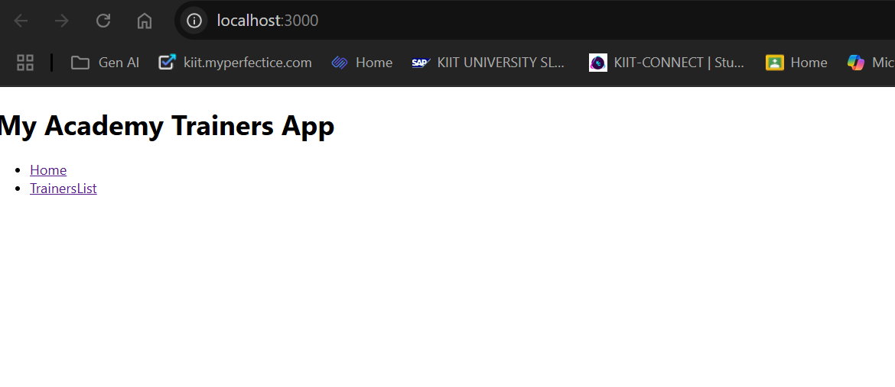

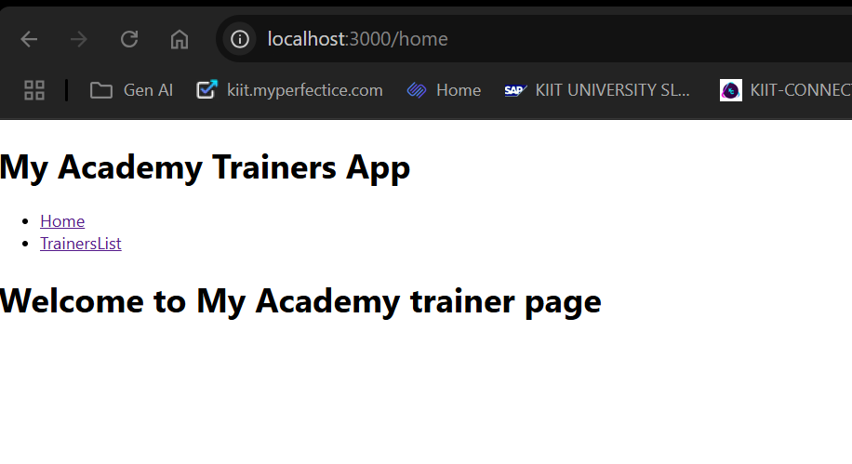

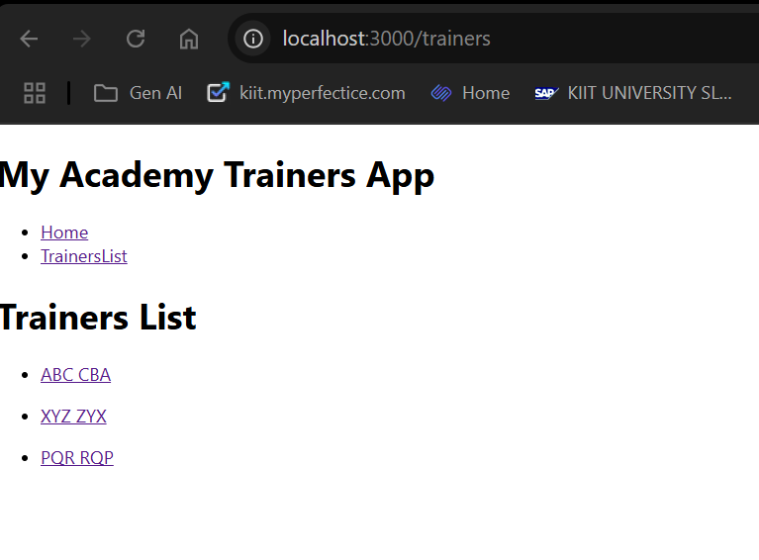

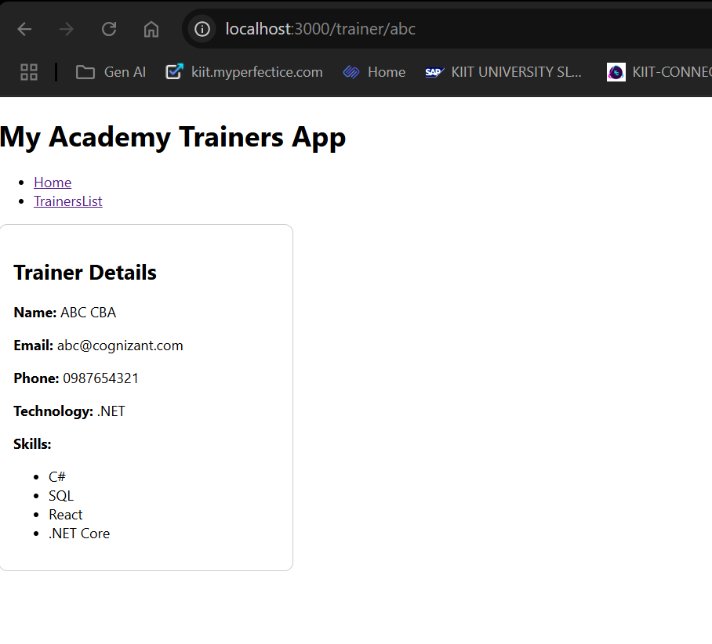

## ReactJS – HOL 7:

Code: (Cart.js)

import React, { Component } from 'react';

class Cart extends Component{

**render**(){

return(

<div *style*={{border:"1px solid gray", margin:"10px", padding:"10px"}}>

<h3>Item:{this.props.itemname}</h3>

<p>Price: ₹{this.props.price}</p>

</div>

)

}

}

export default Cart;

OnlineShopping.js

import { Component } from "react";

import Cart from "./Cart";

class OnlineShopping extends Component{

**render**(){

const items = [

{itemname: 'Shoes', price: 1500},

{itemname: 'T-Shirt', price: 700},

{itemname: 'Jeans', price: 1200},

{itemname: 'Watch', price: 2500},

{itemname: 'Bag', price: 1800},

];

return(

<div>

<h2>Welcome to Online Shopping</h2>

{items.map((*items*, *index*) => (

<Cart *key*={*index*} *itemname*={*items*.itemname} *price*={*items*.price}/>

))}

</div>

)

};

}

export default OnlineShopping;

App.js

import logo from './logo.svg';

import './App.css';

import OnlineShopping from './Components/OnlineShopping';

function **App**() {

return (

<>

<OnlineShopping/>

</>

);

}

export default App;

Output:

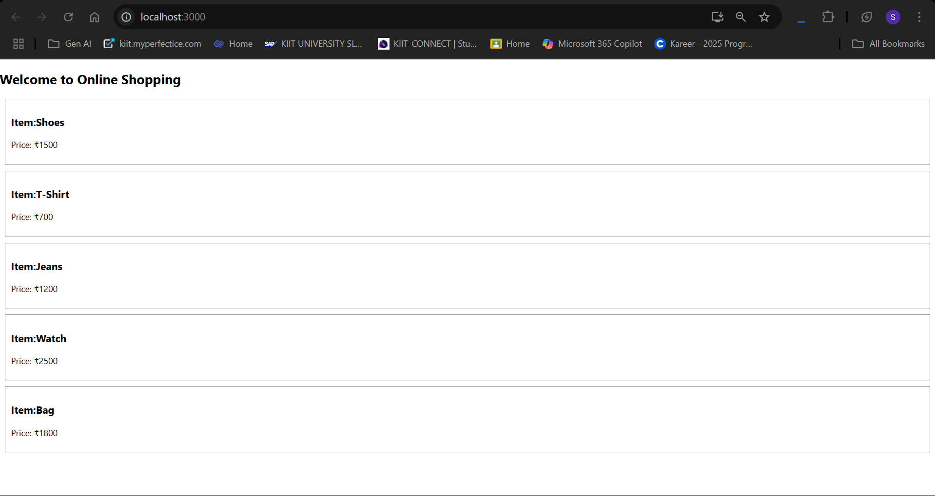

## ReactJS – HOL 8:

Code: (CounterPeople.js)

import React,{Component} from 'react';

class CounterPeople extends Component{

constructor(*props*){

*super*(*props*);

this.state = {

entryCount: 0,

exitCount: 0

};

}

**updateEntry** = () => {

this.setState((*prevState*) => ({

entryCount: *prevState*.entryCount + 1

}));

};

**updateExit** = () => {

this.setState((*prevState*) => ({

exitCount: *prevState*.exitCount + 1

}));

};

**render**() {

return (

<div *style*={{ border: '2px solid black', padding: '20px', width: '300px', margin: '20px auto' }}>

<h2>Count People in Mall</h2>

<p>People Entered: {this.state.entryCount}</p>

<p>People Exited: {this.state.exitCount}</p>

<button *onClick*={this.updateEntry} *style*={{ marginRight: '10px' }}>Login</button>

<button *onClick*={this.updateExit}>Exit</button>

</div>

);

}

}

export default CounterPeople;

App.js

import logo from './logo.svg';

import './App.css';

import CounterPeople from './CounterPeople';

function **App**() {

return (

<div *className*="App">

<CounterPeople/>

</div>

);

}

export default App;

Output:

