# Week 7 ReactJS Exercise Solutions

## ReactJS-HOL 9:

Code: IndianPlayers.js

import React from 'react';

function **IndianPlayers**() {

const T20players = ['Rohit', 'Kohli', 'Hardik', 'Bumrah'];

const RanjiTrophy = ['Shubman', 'Siraj', 'Sarfaraz', 'Ishan'];

const mergedPlayers = [...T20players, ...RanjiTrophy];

const oddTeam = mergedPlayers.filter((*_*, *index*) => *index* % 2 === 0);

const evenTeam = mergedPlayers.filter((*_*, *index*) => *index* % 2 !== 0);

return (

<div>

<h2>Odd Team Players</h2>

<ul>{oddTeam.map((*p*, *index*) => <li *key*={*index*}>{*p*}</li>)}</ul>

<h2>Even Team Players</h2>

<ul>{evenTeam.map((*p*, *index*) => <li *key*={*index*}>{*p*}</li>)}</ul>

</div>

);

}

export default IndianPlayers;

ListOfPlayers.js

import React from 'react';

const players = [

{ name: 'Rohit', score: 85 },

{ name: 'Kohli', score: 95 },

{ name: 'Gill', score: 60 },

{ name: 'Rahul', score: 45 },

{ name: 'Hardik', score: 70 },

{ name: 'Jadeja', score: 80 },

{ name: 'Samson', score: 66 },

{ name: 'Surya', score: 75 },

{ name: 'Shami', score: 50 },

{ name: 'Bumrah', score: 90 },

{ name: 'Ashwin', score: 40 }

];

const highScorers = players.map(*p* => `${*p*.name} - ${*p*.score}`);

const lowScorers = players.filter(*p* => *p*.score < 70);

function **ListofPlayers**() {

return (

<div>

<h2>All Players:</h2>

<ul>

{highScorers.map((*p*, *index*) => <li *key*={*index*}>{*p*}</li>)}

</ul>

<h2>Players with score below 70:</h2>

<ul>

{lowScorers.map((*p*, *index*) => <li *key*={*index*}>{*p*.name} - {*p*.score}</li>)}

</ul>

</div>

);

}

export default ListofPlayers;

App.js

import React, { useState } from 'react';

import ListofPlayers from './ListofPlayers';

import IndianPlayers from './IndianPlayers';

function **App**() {

const [flag, **setFlag**] = useState(true);

return (

<div *className*="App">

<h1>Cricket App</h1>

{flag ? <ListofPlayers /> : <IndianPlayers />}

<button *onClick*={() => setFlag(!flag)}>

Switch to {flag ? "Indian Players" : "List of Players"}

</button>

</div>

);

}

export default App;

Output:

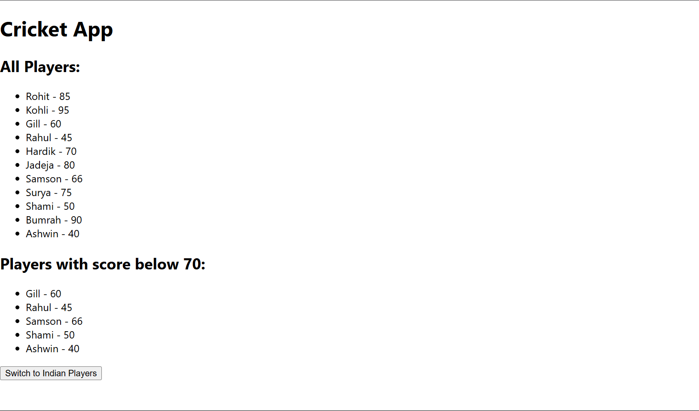

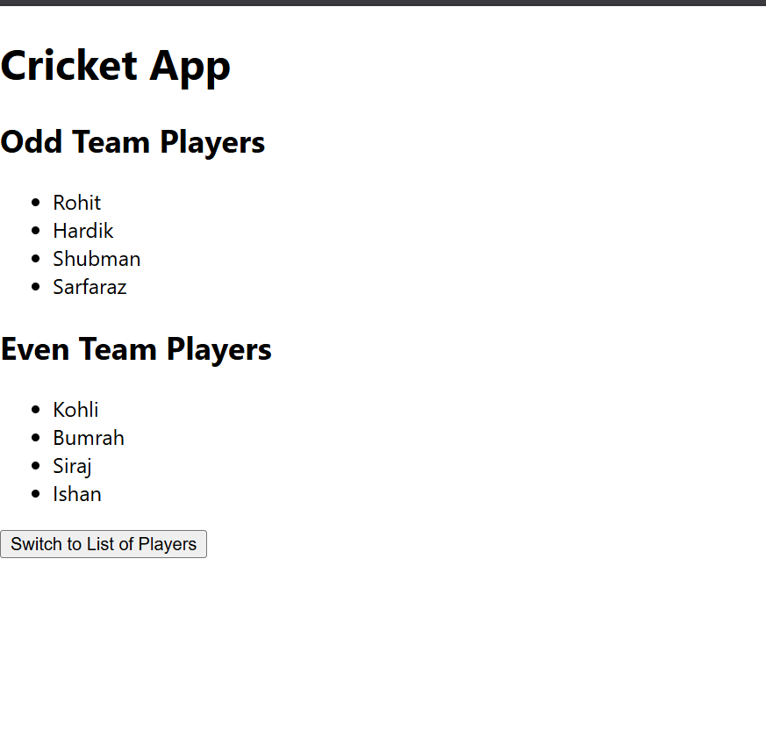

## ReactJS-HOL 10:

Code: OfficeSpace.js

import './officeSpace.css';

const officeList = [

{

name: 'DBS',

rent: 50000,

address: 'Chennai',

image: '/office1.jpg'

},

{

name: 'WeWork',

rent: 65000,

address: 'Bangalore',

image: '/office2.jpg'

},

{

name: 'Regus',

rent: 55000,

address: 'Mumbai',

image: '/office3.jpg'

}

];

function OfficeSpace() {

return (

<div *className*="container">

<h1>Office Space, at Affordable Range</h1>

{officeList.map((*office*, *index*) => (

<div *key*={index} *className*="office-card">

<img *src*={office.image} *alt*={`${office.name} office`} />

<h2>Name: {office.name}</h2>

<p

*style*={{

color: office.rent < 60000 ? 'red' : 'green',

fontWeight: 'bold'

}}

>

Rent: Rs. {office.rent}

</p>

<p>Address: {office.address}</p>

</div>

))}

</div>

);

}

export default OfficeSpace;

OfficeSpace.css

.container {

display: flex;

flex-direction: column;

align-items: center;

padding: 20px;

}

.office-card {

border: 1px solid #ccc;

padding: 16px;

margin-bottom: 20px;

width: 300px;

text-align: center;

box-shadow: 0 2px 6px rgba(0, 0, 0, 0.1);

}

.office-card img {

width: 100%;

height: auto;

margin-bottom: 10px;

}

App.js

import logo from './logo.svg';

import './App.css';

import OfficeSpace from './officeSpace';

function **App**() {

return (

<div *className*="App">

<OfficeSpace/>

</div>

);

}

export default App;

Output:

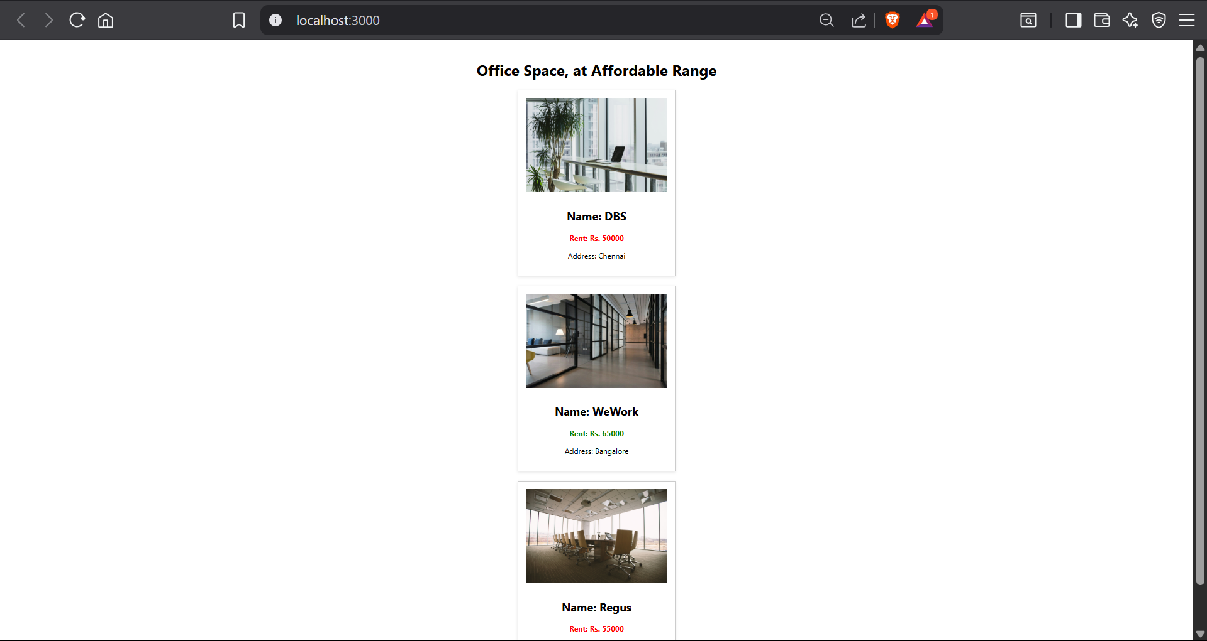

## ReactJS-HOL 11:

Code: Event.js

import React, { useState } from 'react';

function EventCalls() {

const [value, setValue] = useState(0);

const sayHello = () => {

alert("Hello! Member1");

};

const sayStaticMessage = () =>{

alert("Welcome to the Counter App");

};

const Increment = () => {

setValue(value+1);

}

const Decrement = () => {

setValue(value-1);

}

const handleIncrement = () => {

sayHello();

sayStaticMessage();

Increment();

}

const sayWelcome = (*msg*) => {

alert(`Welcome ${msg}`);

};

const handleOnPress = () => {

alert("I was clicked");

};

return(

<>

<button *onClick*={handleIncrement}>

Increment

</button>

<button *onClick*={Decrement}>

Decrement

</button>

<button *onClick*={() => sayWelcome("user")}>

Say Welcome

</button>

<button *onClick*={handleOnPress}>

Click on Me!

</button>

<p>Current Count: {value}</p>

</>

)

}

export default EventCalls;

CurrencyConvertor.js

import { useState } from "react";

function **CurrConvo**() {

const [inr, **setInr**] = useState('');

const [eur, **setEur**] = useState(null);

const **convert** = () => {

const result = parseFloat(inr) * 0.011;

setEur(result.toFixed(2));

};

return (

<>

<h1 *style*={{ color: "green" }}>Currency Converter!</h1>

<input

*type*="number"

*placeholder*="Amount in INR(₹)"

*className*="inrInput"

*value*={inr}

*onChange*={(*e*) => setInr(*e*.target.value)}

/>

<button *onClick*={convert}>Convert</button>

{eur && <p>EUR: €{eur}</p>}

</>

);

}

export default CurrConvo;

App.js

import logo from './logo.svg';

import './App.css';

import EventCalls from './Event';

import CurrConvo from './CurrencyConvertor';

function **App**() {

return (

<div *className*="App">

<EventCalls/>

<CurrConvo/>

</div>

);

}

export default App;

Output:

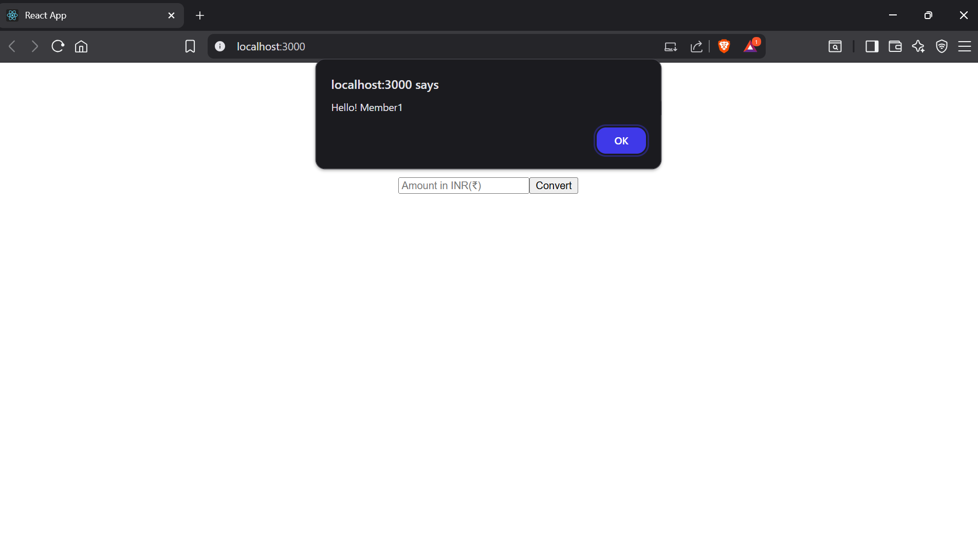

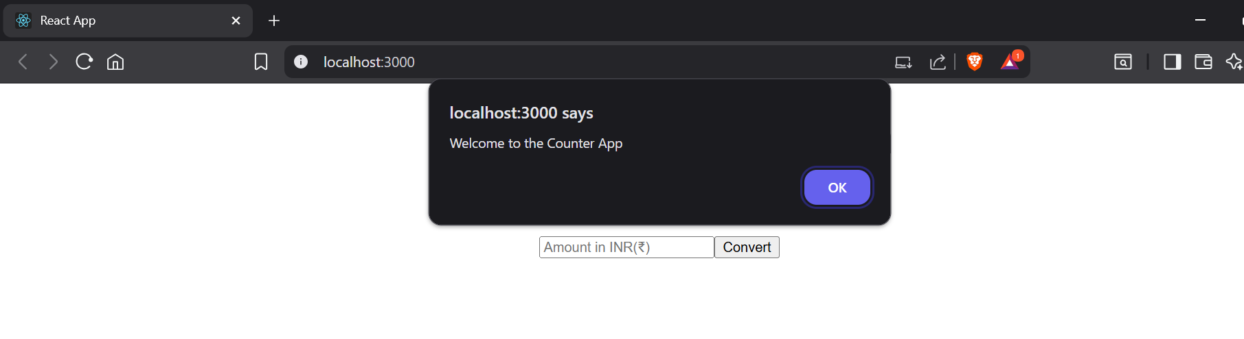

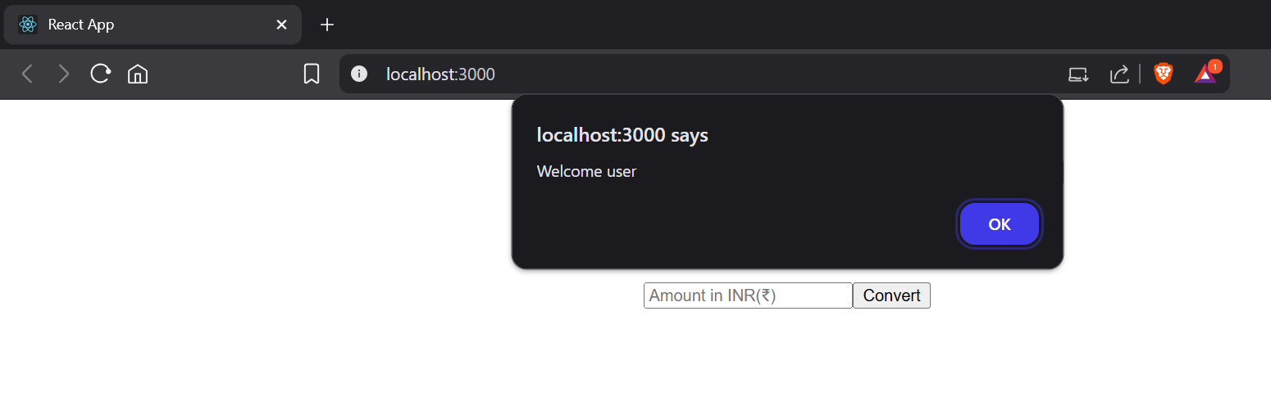

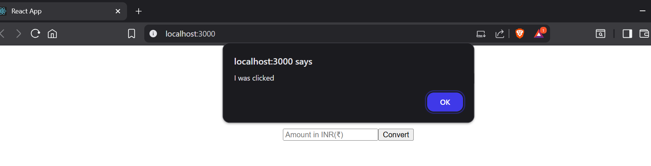

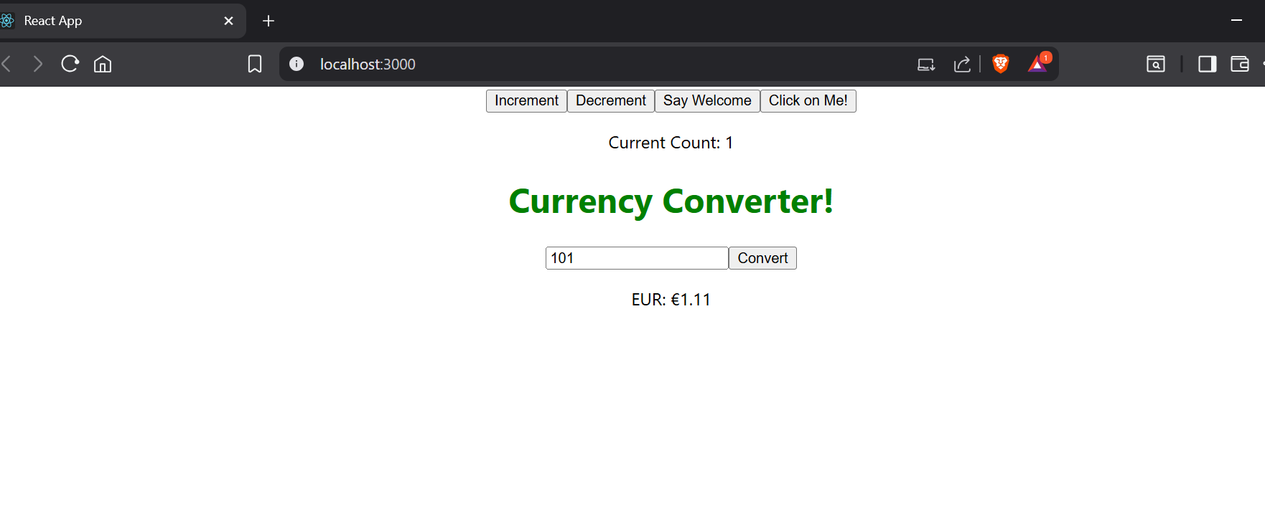

## ReactJS-HOL 12:

Code: UserPage.js

export function **UserPage**({*onLogout*}) {

return(

<>

<h1>Please Sign Up</h1>

<button

*onClick*={*onLogout*}

>Login</button>

</>

)

}

GuestPage.js

export function **GuestPage**({*onLogin*}) {

return(

<>

<h1>Welcome Back</h1>

<button

*onClick*={*onLogin*}

>Logout</button>

</>

)

}

App.js

import {useState} from 'react';

import './App.css';

import { UserPage } from './UserPage';

import { GuestPage } from './GuestPage';

function **App**() {

const [isLoggedIn, **setIsLoggedIn**] = useState(false);

const **handleLogin** = () => setIsLoggedIn(true);

const **handleLogout** = () => setIsLoggedIn(false);

return (

<div *className*="App">

{isLoggedIn ? (

<UserPage *onLogout*={handleLogout}/>

):(

<GuestPage *onLogin*={handleLogin}/>

)}

</div>

);

}

export default App;

Output:





## ReactJS-HOL 13:

Code: BlogDetails.js

export function **BlogDetails**() {

return(

<div *style*={{color:"#28a745"}}>

Blog Details

</div>

)

}

BookDetails.js

export function **BookDetails**() {

return(

<div *style*={{color:"#007bff"}}>

Book Details

</div>

)

}

CourseDetails.js

export function **CourseDetails**() {

return(

<div *style*={{color:"#ffc107"}}>

Course Details

</div>

)

}

App.js

import { useState } from "react";

import { BookDetails } from "./components/BookDetails";

import { BlogDetails } from "./components/BlogDetails";

import { CourseDetails } from "./components/CourseDetails";

function **App**() {

const [view, **setView**] = useState("book");

let elementView;

if (view === "book") {

elementView = <BookDetails />;

} else if (view === "blog") {

elementView = <BlogDetails />;

} else {

elementView = <CourseDetails />;

}

return (

<div *style*={styles.container}>

<h1 *style*={styles.heading}>Blogger App</h1>

<div *style*={styles.buttonGroup}>

<button *style*={styles.button} *onClick*={() => setView("book")}>Book Details</button>

<button *style*={styles.button} *onClick*={() => setView("blog")}>Blog Details</button>

<button *style*={styles.button} *onClick*={() => setView("course")}>Course Details</button>

</div>

<hr *style*={styles.hr} />

<div *style*={styles.section}>

<h3>Using Element Variable:</h3>

{elementView}

</div>

<div *style*={styles.section}>

<h3>Using Ternary Operator:</h3>

{

view === "book" ? <BookDetails /> :

view === "blog" ? <BlogDetails /> :

<CourseDetails />

}

</div>

<div *style*={styles.section}>

<h3>Using Logical && Operator:</h3>

{view === "book" && <BookDetails />}

{view === "blog" && <BlogDetails />}

{view === "course" && <CourseDetails />}

</div>

</div>

);

}

const styles = {

container: {

fontFamily: "Arial, sans-serif",

padding: "20px",

textAlign: "center"

},

heading: {

fontSize: "2em",

color: "#333"

},

buttonGroup: {

marginBottom: "20px"

},

button: {

margin: "0 10px",

padding: "10px 20px",

fontSize: "1em",

cursor: "pointer"

},

hr: {

margin: "30px 0"

},

section: {

margin: "20px 0"

}

};

export default App;