Energy Efficiency Strategies in Industrial Sectors for   
Carbon Footprint Reduction

A. One1, B. Two2, C. Three2, D. Four1  
1Name of Institute or Organization, Address, City, Zip code, Country

2Name of Institute or Organization, Address, City, Zip code, Country

Authors preparing abstracts for ECM 2025 are required to adhere to the prescribed formatting guidelines. While a Microsoft Word template is available for reference, those opting not to use it must ensure that their submissions strictly follow the specified format. Abstracts must be written in English and should contain a maximum of 1500 words, excluding the title and author information. The complete abstract, inclusive of any figures, tables, or equations, should not exceed two A4 pages. Submissions are expected to clearly articulate the motivation for the work, the problem being addressed, the methodology adopted, the principal results obtained, and a succinct conclusion. The inclusion of figures, equations, or tables is encouraged where they contribute meaningfully to the clarity and strength of the abstract.

The abstract should begin with the title and author names, both presented in bold. The title must be in 14-point Times New Roman font, and the list of authors should include full names, institutional affiliations, mailing addresses, and countries. The email address of the corresponding author must be provided as a footnote. The main body of the abstract should follow a single-column layout, using 12-point Times New Roman font, with full justification and single line spacing. Subheadings are not mandatory; however, clarity of expression and logical organization of content are essential.

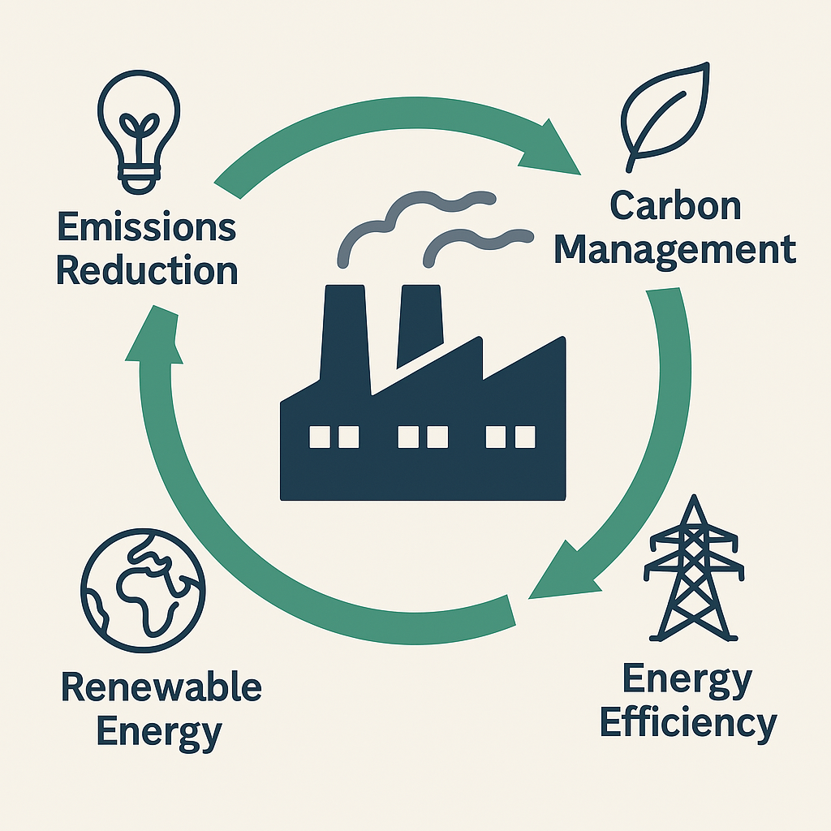

Figure 1. Carbon footprint reduction achieved through industrial energy efficiency measures.

Figures and tables should be incorporated thoughtfully and placed in the desired location within the text. All visual elements must be numbered consecutively. Captions for figures must be positioned below the respective figures, while captions for tables should appear above. All captions are to be left-aligned. These visual elements should be used selectively to reinforce key findings and facilitate comprehension.

Table 1. Comparative analysis of energy consumption before and after audit.

|  | Pre-Audit (kWh) | Post-Audit (kWh) | Reduction (%) |
| --- | --- | --- | --- |
| Boiler | 1500 | 1200 | 20% |
| HVAC | 2000 | 1600 | 20% |

References should be cited in the text using numbers enclosed in square brackets, in the order of their appearance (e.g., [1], [2], [1–3]). The full list of references must be provided at the end of the abstract or paper, numbered accordingly. All citations should be complete and formatted consistently. For journal articles, the reference must include the names of all authors, the full title of the article, the journal name in italics, year of publication, volume number, issue (if applicable), page range, and DOI. Conference papers should include the names of authors, title of the paper, name of the conference in italics, year and location of the event, publisher (if applicable), and page numbers. Book references should include the author(s), full title in italics, edition (if not the first), place of publication, publisher, and year of publication.

References:

1. Wang J, Li Z, Chen Y. Optimization of energy systems under uncertainty. *Applied Energy,* 2023;342:120456. <https://doi.org/10.1016/j.apenergy.2023.120456>
2. Rao M, Singh A. Energy modeling of hybrid systems. In: *Proceedings of the 10th International Conference on Sustainable Energy Technologies*; 2022; Kuala Lumpur, Malaysia. Elsevier; p. 215–20.
3. Bejan A. *Advanced Engineering Thermodynamics*. 4th ed. Hoboken: Wiley; 2016.