Synopsis

Air Quality Prediction System using Machine Learning Techniques

Problem Id: 15

Student Name-Gunmay Parganiha University Roll number-2028720 Section-L

Student Name-Shaurya Anant University Roll number-2510370571 Section-L

Student Name-Divyansh Verma University Roll number-2510370434 Section-L

- Problem Description:
Air pollution is a major environmental problem that impacts human health and climate around the world. Poor air quality can lead to respiratory diseases, heart issues, and other serious health concerns. Predicting air quality levels in advance can help both authorities and individuals take preventive actions.
This project aims to create a machine learning-based air quality prediction system using pollutant concentration data. This includes PM2.5, PM10, NO2, CO, and factors related to the weather. The system will preprocess data through missing value treatment, removing outliers, normalization, and extracting features from date values. It will use machine learning classification algorithms such as Logistic Regression, K-Nearest Neighbors (KNN), and Support Vector Machine (SVM) to classify air quality into categories like Good, Satisfactory, Moderate, Poor, Very Poor, and Severe.
The system will also assess model performance using accuracy, precision, recall, and F1 score. This project shows how machine learning can assist with environmental monitoring and smart city planning.

Steps of Implementation:

This section should explain the each phase of ML pipeline used.
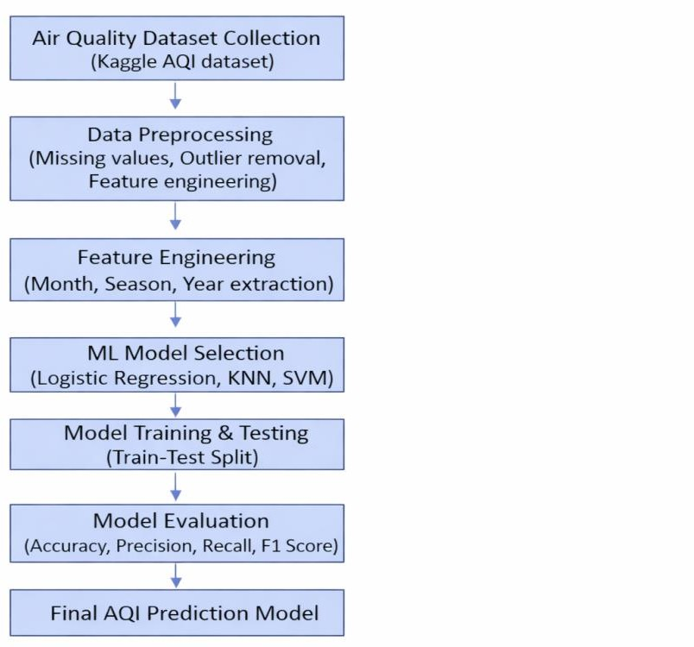

Steps of Preprocessing:

1. Data Preprocessing:
a) Removing Irrelevant Columns
Unnecessary columns such as City and AQI are removed from the dataset as they do not contribute to the classification task. This helps in reducing noise and improving model efficiency.
b) Handling Missing Target Values
Rows with missing values in the AQI Bucket column are dropped because this column is the target variable required for supervised learning.
c) Missing Value Treatment (Pollutant Features)
Missing values in pollutant columns such as PM2.5, PM10, NO₂, CO, SO₂, etc., are filled using the median of each column. Median is used as it is robust to extreme values and suitable for environmental datasets.
d) Outlier Detection and Removal
Outliers in pollutant values are detected using the Interquartile Range (IQR) method. Values lying outside the range (Q1 − 1.5 × IQR) and (Q3 + 1.5 × IQR) are removed to improve data quality and model performance.
2. Feature Engineering:
a) Date Conversion
The Date column is converted into datetime format to enable extraction of meaningful time-based features.
b) Month Extraction
A new feature Month is created from the Date column to capture monthly variations in air quality.
c) Year Extraction
The Year feature is extracted to analyse long-term trends in pollution levels.
d) Day of Week Extraction
A new feature Day Of Week is created to capture weekly patterns in air quality.
e) Season Classification
A new feature Season is generated based on the month:
- Winter → December, January, February
- Summer → March, April, May
- Monsoon → June, July, August
- Post-Monsoon → September, October, November
This helps in capturing seasonal variations in pollution levels.
f) Dropping Original Date Column
After extracting all relevant features, the original Date column is removed to avoid redundancy.
g) Label Encoding of Target Variable
The categorical target variable AQI_Bucket is converted into numerical form using Label Encoding, making it suitable for machine learning models.
- Steps of Feature Selection:
a) Mutual Information (MI) Scoring Mutual Information scores are computed for every feature against the target label (AQI_Label) using mutual_info_classif from scikit-learn. Features with a score below 0.01 are considered useless and dropped. A correlation matrix is also computed, and if two features have an absolute correlation above 0.90, the one with the lower MI score is removed. This eliminates multicollinearity and retains only the most informative features.
b) Sequential Feature Selection (SFS) After MI-based pruning, Sequential Feature Selector (forward direction) is applied using Logistic Regression as the estimator. SFS iteratively adds one feature at a time and evaluates 3-fold cross-validation accuracy for subset sizes 1 through 8. The subset size yielding the highest mean cross-validation score is selected as the final optimal feature set.
After applying all three steps, the final features selected were: PM2.5, PM10, NO, CO, and O3. Day Of Week and Year were dropped at the MI stage as they showed near-zero scores, indicating no meaningful relationship with AQI category.
- Steps of Train-Validation-Test Split and Scaling:
a) Train-Test Split (80-20) The dataset is split into 80% training-validation data and 20% test data using train_test_split with stratify=y to preserve class distribution across all splits.
b) Train-Validation Split (80-20) The 80% portion is further split 80-20 to create a dedicated validation set, giving a final approximate split of 60% training, 20% validation, and 20% test.
c) StandardScaler Normalization StandardScaler is fitted only on training data and applied to validation and test sets. This prevents data leakage and ensures distance-sensitive models like KNN and SVM receive properly scaled inputs with zero mean and unit variance.
d) Class Imbalance Handling A significant class imbalance was observed in the training data — Satisfactory had 4,037 samples while Severe had only 7. This reflects the rare real-world occurrence of Severe pollution events and is a data limitation, not a code issue. To handle this, class_weight='balanced' was applied to all models.

- Steps of Model Training:
a) Logistic Regression (LR) Logistic Regression is a linear classifier configured with class_weight='balanced' to handle class imbalance and max_iter=1000 to ensure convergence. It also serves as the baseline estimator used inside SFS during feature selection.
b) K-Nearest Neighbors (KNN) KNN classifies a sample based on the majority label among its 7 nearest neighbors using distance-weighted voting (weights='distance'), so closer neighbors contribute more to the final prediction.
c) Support Vector Machine (SVM) SVM with an RBF kernel finds an optimal hyperplane separating AQI classes in high-dimensional space. It is configured with class_weight='balanced' and probability=True to enable soft voting in ensemble combinations.
d) Ensemble Voting Classifiers Four soft-voting ensemble combinations are built using VotingClassifier. Soft voting averages the predicted class probabilities from each model and selects the class with the highest combined score:
- LR + KNN
- LR + SVM
- KNN + SVM
- LR + KNN + SVM (all three combined)
e) Validation Results
Validation accuracy results across all seven models:
- Logistic Regression: 0.6049
- SVM: 0.7119
- LR + SVM: 0.7631
- LR + KNN: 0.7674
- LR + KNN + SVM: 0.7835
- KNN: 0.7752
- KNN + SVM: 0.7867 (highest)
Although KNN + SVM achieved the highest validation accuracy, standalone KNN was selected as the final model. The accuracy difference was only 1.46% — a negligible gain for double the complexity and deployment cost. This follows the parsimony principle: prefer the simpler model when the performance difference is minimal.

- Steps of Final Test Evaluation
a) Test Set Performance
The KNN model was evaluated on the completely unseen test set for the first time, achieving a final test accuracy of 78.24%. All four metrics improved slightly from validation to test:
- Accuracy: 0.7752 → 0.7824
- Precision: 0.7713 → 0.7780
- Recall: 0.7752 → 0.7824
- F1-Score: 0.7721 → 0.7787
An improvement from validation to test confirms the model generalizes well to unseen data and is not overfitting.
b) Confusion Matrix Analysis
The confusion matrix showed most misclassifications occurred between neighbouring AQI categories such as Good-Satisfactory and Moderate-Poor. This is expected as adjacent AQI categories have overlapping pollutant concentration ranges by design of the AQI standard. Severe achieved zero correct predictions due to only 2 test samples, which is a data limitation and not a model failure.
c) ROC Curve Analysis
ROC curve analysis confirmed strong class separation across all categories:
- Good: AUC 0.95
- Moderate, Satisfactory, Very Poor: AUC 0.90 each
- Poor: AUC 0.89
- Severe: AUC 0.50 (due to insufficient samples)
AUC above 0.89 for five out of six categories confirms reliable and generalizable prediction performance.

Expected Modules/ Libraries to be used :

  - Pandas
Pandas helps with data manipulation and analysis. It allows reading the dataset, managing missing values, filtering data, and executing preprocessing operations on dataframes.

NumPy
NumPy is used for numerical calculations and array operations. It enables efficient mathematical operations during preprocessing.

Matplotlib
Matplotlib allows creating basic visualizations like histograms, bar graphs, and line plots to understand data distribution and trends.

Seaborn
Seaborn provides advanced data visualization. It helps in creating statistical plots like heatmaps and distribution plots for better analysis.

Scikit-learn
Scikit-learn implements machine learning algorithms like Logistic Regression, KNN, and SVM. It also offers tools for data splitting and evaluation metrics.

Label Encoder (sklearn.preprocessing)
Label Encoder converts categorical AQI categories into numerical labels so that machine learning models can process them.
  - Train test split (sklearn.model_selection)
This module splits data into training and testing sets for model validation.

Metrics (sklearn.metrics)
Metrics calculate accuracy, precision, recall, F1-score, and confusion matrix to evaluate model performance.

Datetime (Pandas datetime functions)
This is used to extract Month, Year, and Day features from the Date column for feature engineering.

Custom Functions
User-defined functions are applied for outlier removal using the IQR method and for season classification.
- Expected Evaluation metrics and Plots to be used:

Evaluation metrics:

Accuracy
. Accuracy measures the overall correctness of the model by calculating the ratio of correctly predicted observations to total observations. It gives a general idea of model performance.

Precision
Precision measures how many of the predicted AQI categories are correct. It is helpful when we need to reduce false positive predictions.

Recall
Recall measures how many actual AQI categories were correctly identified by the model out of all the true categories. It helps in evaluating how well the model is able to detect each pollution category.

F1-Score
F1-Score is the harmonic mean of Precision and Recall, combining both metrics into a single value. It is useful when the class distribution is imbalanced and a balanced evaluation is needed.

Confusion Matrix
F1-Score is the harmonic mean of Precision and Recall which combines both into a single performance measure. It is useful when the class distribution is uneven and a balanced evaluation of the model is required.

Visualization Plot:

Bar Chart
Used to visualize the distribution of AQI categories to understand how many data samples belong to each pollution category.

Histogram
Used to visualize the distribution of pollutant values like PM2.5 after preprocessing to understand the spread of data.

Line Plot
Used to show AQI trends across different months to identify seasonal pollution patterns.

Missing Value Plot
Used to visualize the percentage of missing values present in pollutant columns before preprocessing.

Correlation Heatmap
Used to understand the relationship between different pollutants and identify important features for the model.

Required topics from the subject:

Python Programming
Python is used as the main programming language for implementing the machine

learning pipeline such as data preprocessing, feature engineering, model training and model evaluation.

Data Structures
Data structures like arrays and dataframes are used to store and handle pollutant data efficiently. Pandas DataFrame is mainly used for managing the dataset.

File Handling
File handling is used to read the dataset from CSV files and store the processed dataset after preprocessing using functions like read_csv() and to_csv().

Functions
User-defined functions are created for tasks like outlier removal and season classification which help in making the code modular and reusable.

Conditional Statements
Conditional statements are used for decision making such as assigning seasons based on months and applying preprocessing conditions.

Loops
Loops are used to process multiple pollutant columns for handling missing values and performing preprocessing operations.

Machine Learning Concepts
Concepts like classification, training, testing and model evaluation are used to develop the AQI prediction model.

Data Visualization
Visualization techniques are used to understand data distribution and model performance using different graphs and plots.

Platform Required:
Visual studio
- Books and Link Sources:
  - https://www.kaggle.com
Used for downloading the air quality dataset.
  - https://scikit-learn.org
Official documentation for machine learning algorithms.
  - https://pandas.pydata.org
Reference for data preprocessing using Pandas.
  - https://matplotlib.org
Used for understanding data visualization techniques.

