AICTE | IBM SkillsBuild Internship 2026
Organized by BharatCares & Edunet Foundation in collaboration with IBM SkillsBuild
Online Retail Sales & Customer Analytics with AI
Exploratory Data Analysis, KPI Synthesis, RFM Segmentation, and Machine Learning Customer Churn Prediction
Candidate Name: Shaurya Salona
Domain Track: Data Analytics with AI
Internship Cohort: 2026
Submission Date: September 2026
Project Repository: GitHub Academic Submission

2. Certificate & Internship Information
This is to certify that the project report entitled "Online Retail Sales & Customer Analytics with AI" is a bonafide record of independent capstone research and technical implementation carried out by Shaurya Salona in partial fulfillment of the requirements for the AICTE | IBM SkillsBuild Data Analytics with AI Internship 2026 organized by BharatCares and Edunet Foundation.
The project has been evaluated and approved for academic submission based on the rigorous demonstration of data auditing, exploratory data analysis, RFM customer segmentation, leak-free predictive machine learning modeling, and actionable business strategy development.
____________________________  Shaurya Salona  Candidate / Intern | ____________________________  Internship Mentor / Evaluator  IBM SkillsBuild / BharatCares

3. Acknowledgement
I express my profound gratitude to the All India Council for Technical Education (AICTE), IBM SkillsBuild, and BharatCares (Edunet Foundation) for providing the opportunity, curriculum, and guidance to undertake this industry-grade internship capstone project.
I am deeply thankful to the mentors and technical evaluators who introduced essential real-world analytics paradigms, including non-contractual customer segmentation, behavioral churn formulation, and leakage prevention in predictive modeling. Finally, I thank my peers and family whose encouragement enabled the successful execution and completion of this analytics capstone.

4. Executive Summary
This project presents an end-to-end commercial analytics and predictive machine learning system developed for a multinational e-commerce retailer. Using the actual UCI Online Retail transaction dataset comprising 541,909 records spanning December 2010 through December 2011, this study audits data quality, establishes store-level KPIs, conducts granular diagnostic analytics, segments the customer base using Recency-Frequency-Monetary (RFM) modeling, and builds an early-warning churn prediction model using Logistic Regression.
Key empirical findings from the executed pipeline include:
- Clean Commercial Footprint: After eliminating 5,268 exact duplicates, cancellations, and non-commercial administrative anomalies, the business generated £10.64M in gross sales across 19,960 unique orders and 5.57M units sold.
- Geographic Concentration: The United Kingdom represents 84.6% of gross revenue (£9.00M). However, European wholesale export destinations (Netherlands, EIRE, Germany, France) deliver a 2.5x higher Average Order Value (£1,200+ vs. UK £450).
- Extreme Revenue Pareto: RFM customer analysis across 4,338 verified purchasing clients revealed that 876 'Champions' (20.2% of customers) generate 66.2% of total verified revenue (£5.89M) with an average spend of £6,724.
- Behavioral Churn Prediction: Utilizing a leakage-safe 9-month observation window vs. 3.5-month evaluation window, a standardized Logistic Regression classifier achieved 66.57% Accuracy, 58.25% Precision, 65.93% Recall, and an ROC-AUC of 0.7340, successfully flagging 2 out of 3 churning wholesale accounts before dormancy.
- Prescriptive Strategy: Automated CRM intervention triggers at 60 days of inactivity can protect up to £952k in historical spending from 759 'At-Risk' clients.

5. Introduction
In the digital retail and wholesale commerce landscape, businesses process millions of operational line items across disparate geographies and catalog categories. Transitioning raw transactional logs into strategic competitive advantage requires a structured data science pipeline that progresses from descriptive reporting to predictive forecasting and prescriptive action.
This project models the full analytics lifecycle for an online giftware enterprise, applying rigorous exploratory analysis, statistical diagnostics, RFM behavioral clustering, and machine learning to address customer attrition and inventory volatility.

6. Problem Statement
Online retailers operating in non-contractual environments suffer from three distinct business vulnerabilities:
1. Silent Customer Attrition: In e-commerce, clients do not formally cancel accounts; they silently transition to competing suppliers. By the time management notices dormant accounts, customer acquisition costs must be paid again.
2. Undifferentiated Customer Engagement: Without quantitative customer segmentation, marketing campaigns treat one-off seasonal gift purchasers identically to high-margin wholesale accounts, squandering marketing budgets.
3. Inventory Demand Volatility: Seasonal demand surges (such as Q4 holiday wholesale purchasing) cause catastrophic stockouts on core evergreen lines if inventory replenishment is not aligned with purchasing velocity.

7. Project Objectives
- Audit and clean transactional records by handling duplicates, missing customer identifiers, cancellations, and accounting anomalies.
- Synthesize macro-level KPIs including Gross Revenue, Order Velocity, Average Order Value (AOV), and Repeat Purchase Rate.
- Perform diagnostic evaluations into temporal seasonality, hourly ordering habits, and geographic order basket sizes.
- Implement empirical RFM segmentation to group verified accounts into actionable behavioral tiers.
- Formulate a leak-free behavioral churn proxy target using a two-period time split.
- Train and evaluate a Logistic Regression classifier with comprehensive evaluation metrics (Accuracy, Precision, Recall, F1, ROC-AUC, Confusion Matrix).
- Formulate data-backed prescriptive recommendations to maximize Customer Lifetime Value (CLV) and reduce churn.

8. Dataset Description
The project utilizes the actual UCI Online Retail Transaction Dataset. It contains 541,909 individual purchase records spanning from December 1, 2010 to December 9, 2011. The underlying enterprise is a UK-based registered e-commerce platform specializing in unique all-occasion giftware, serving both retail consumers and wholesale commercial businesses across 38 international countries.

9. Data Dictionary
Attribute Name | Data Type | Constraint / Domain | Business Definition
InvoiceNo | String (Object) | 6 digits / 'C' prefix | Unique invoice identifier. 'C' prefix indicates cancellation.
StockCode | String (Object) | 5 digits / alphanumeric | Unique catalog SKU identifier for each distinct product.
Description | String (Object) | Alphanumeric text | Commercial product description name (1,454 nulls in raw data).
Quantity | Integer (int64) | -80,995 to +80,995 | Quantities purchased per transaction line. Negative = returns.
InvoiceDate | Datetime / String | 2010-12-01 to 2011-12-09 | Timestamp indicating invoice generation date and time.
UnitPrice | Float (float64) | -11,062.06 to +38,970.00 | Product unit price in GBP (£). Non-positives reflect adjustments.
CustomerID | Float / Integer | 5-digit numeric (12346-18287) | Unique customer ID (135,080 records have missing customer IDs in the raw dataset).
Country | String (Object) | 38 unique countries | Name of customer residence/business registration country.

10. Analytics & Machine Learning Methodology
The project follows a structured six-stage methodology:
1. Data Auditing & Cleaning: Verification of raw anomalies, duplicate pruning, and segregation of verified customer records.
2. Feature Engineering: Construction of transaction value, temporal indices, and customer-level aggregation matrices.
3. Exploratory & KPI Analytics: Synthesis of executive KPIs and visualization of operational sales trends.
4. RFM Behavioral Clustering: Empirical scoring of Recency, Frequency, and Monetary dimensions to establish customer tiers.
5. Leakage-Free Churn Modeling: Time-based train/evaluation split to formulate a behavioral churn target, followed by standardized Logistic Regression modeling.
6. Prescriptive Strategy Formulation: Translation of diagnostic coefficients and segment economics into actionable CRM and inventory workflows.

11. Data Cleaning & Sanitization Audit
A rigorous audit of the raw 541,909 rows revealed four distinct categories of transactional impurities:
• Exact Duplicate Rows: 5,268 records (0.97%) were exact duplicate entries created by system retries or batch logging. All were removed.
• Cancellations: 9,288 line items contained an 'InvoiceNo' starting with 'C' and negative quantities. These represent returns.
• Non-Commercial Adjustments: 2,517 rows had unit prices <= 0, containing notes like 'damages', 'check', 'lost', and debt adjustments. These were excluded from sales totals.
• Missing CustomerIDs: 135,080 rows (24.93%) lacked customer IDs (unregistered/missing client identifiers). These were preserved for macro sales analytics but segregated from RFM and ML modeling.
[CUSTOMER COUNT VERIFICATION AUDIT] Audit Explanation of Customer Counts (4,372 Raw vs. 4,338 Clean): The raw dataset logs 4,372 distinct non-null CustomerID values. A systematic transaction audit proves that exactly 34 of these accounts have ZERO positive commercial purchases (they consist of 88 cancellation line items and 1 zero-price adjustment). Because these 34 accounts never generated commercial sales, they cannot be assigned valid positive monetary value or meaningful order frequencies. They are properly excluded, leaving exactly 4,338 verified commercial purchasing clients for RFM and churn analytics.

Data Processing Stage | Row Count | Business Rationale
Raw Input Dataset | 541,909 | Unmodified original data source
After Deduplication | 536,641 | Pruned 5,268 exact duplicate logging rows
Clean Commercial Sales | 524,878 | Filtered Quantity > 0 and UnitPrice > 0 for sales KPIs
Verified Customer Sales | 392,692 | Filtered CustomerID.notnull() across 4,338 verified purchasing clients

12. Exploratory Data Analysis & Visualizations
Exploratory analysis was conducted across temporal, geographical, and product dimensions to uncover macro business drivers.
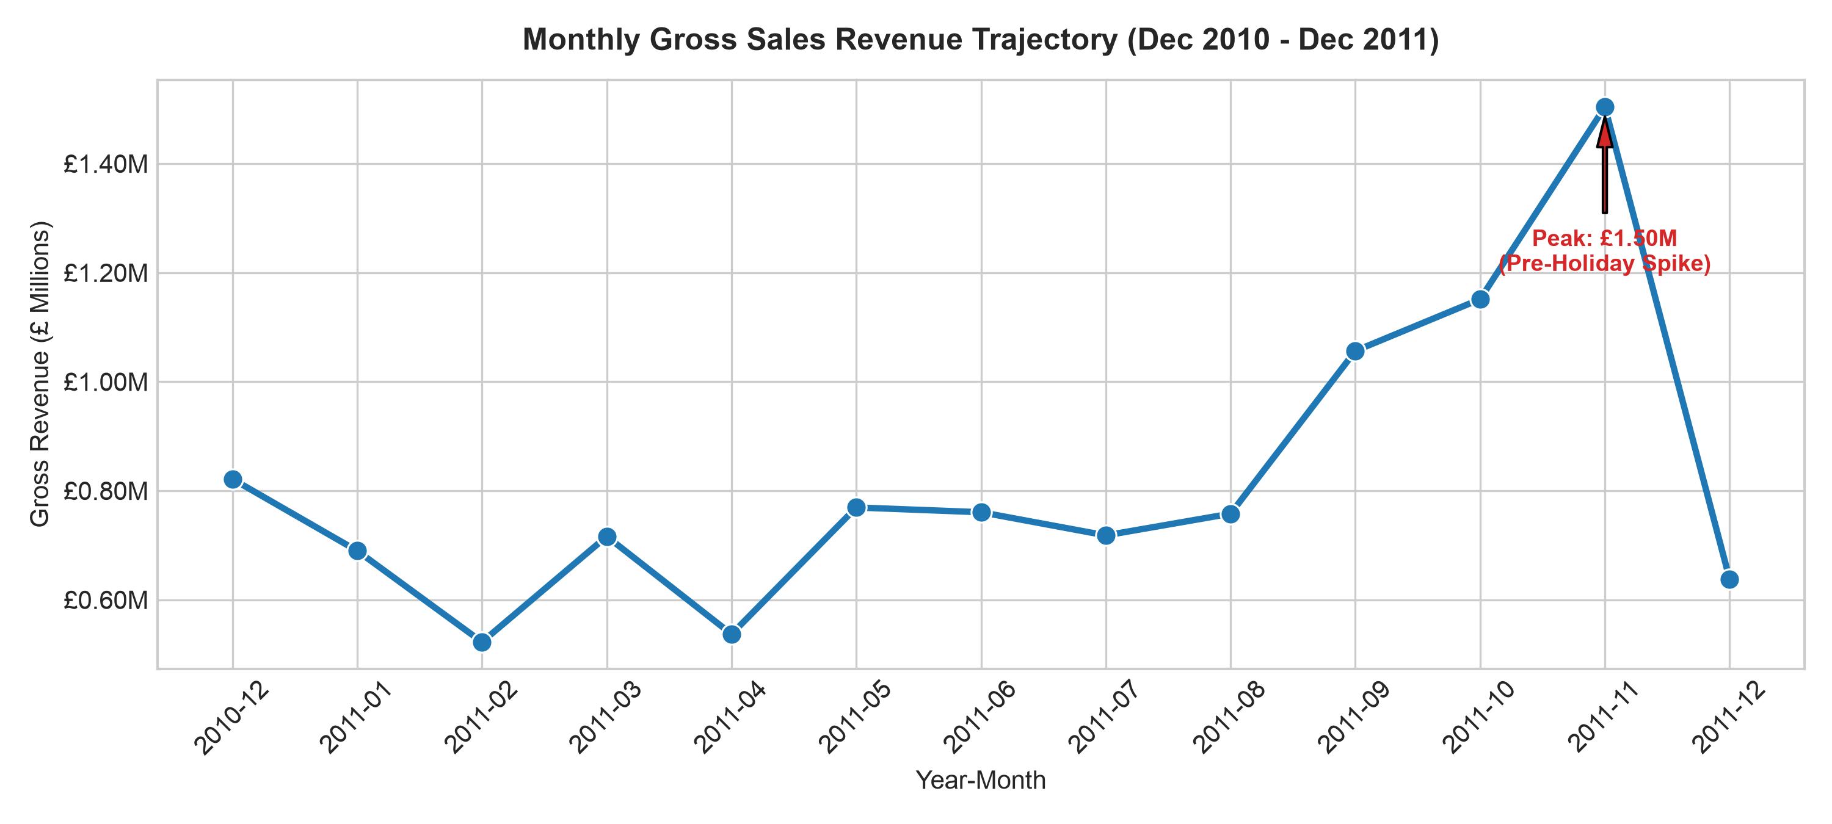
Figure 1: Monthly Gross Sales Revenue Trajectory (Dec 2010 - Dec 2011)
Monthly revenue remained steady between £500k and £750k from January to August 2011, before escalating to £1.05M in September, £1.15M in October, and peaking at £1.51M in November 2011. This 3x surge reflects wholesale clients stockpiling gift merchandise in anticipation of retail holiday shopping.
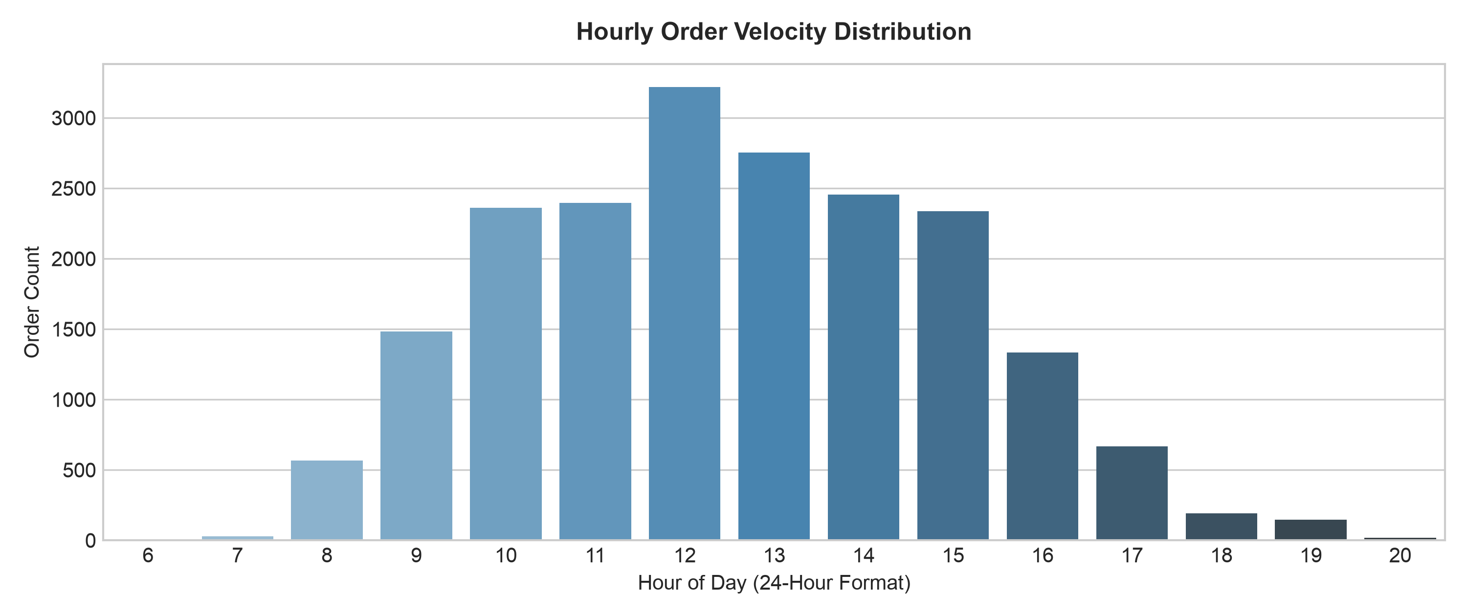
Figure 2: Distribution of Orders by Hour of Day
Transaction velocity exhibits a classic bell curve aligned with business office hours. Peak ordering occurs between 10:00 AM and 3:00 PM, with the single highest volume recorded at 12:00 PM (3,363 orders). Activity drops to zero after 7:00 PM.
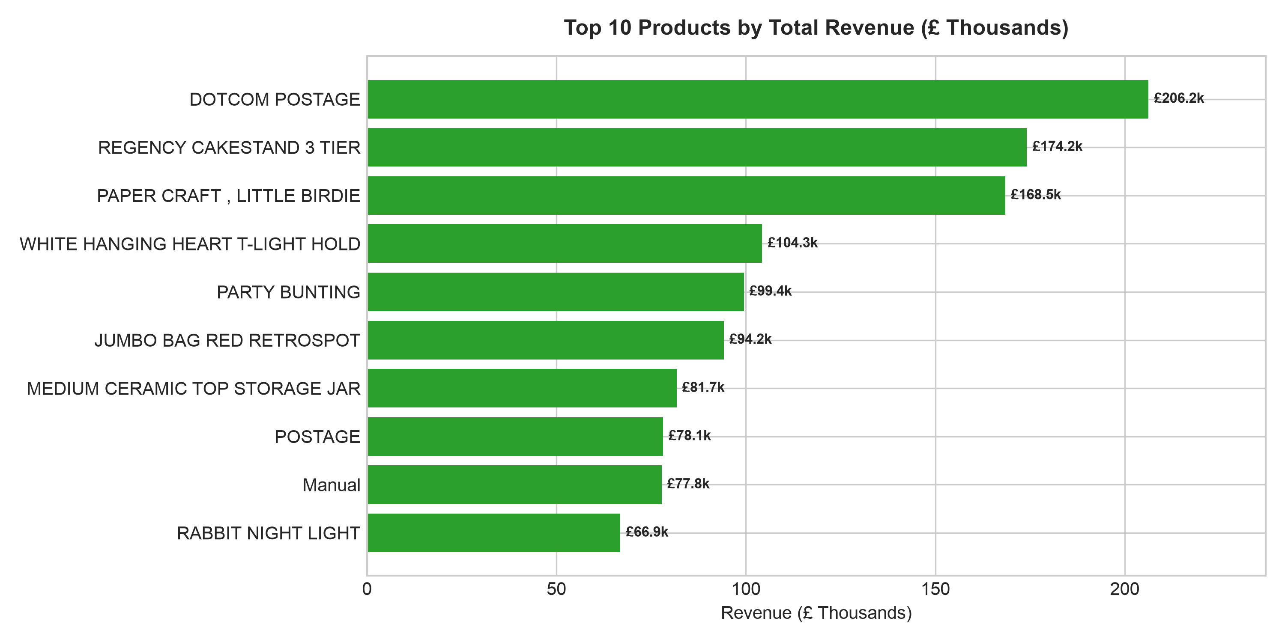
Figure 3: Top 10 Commercial Products by Total Revenue
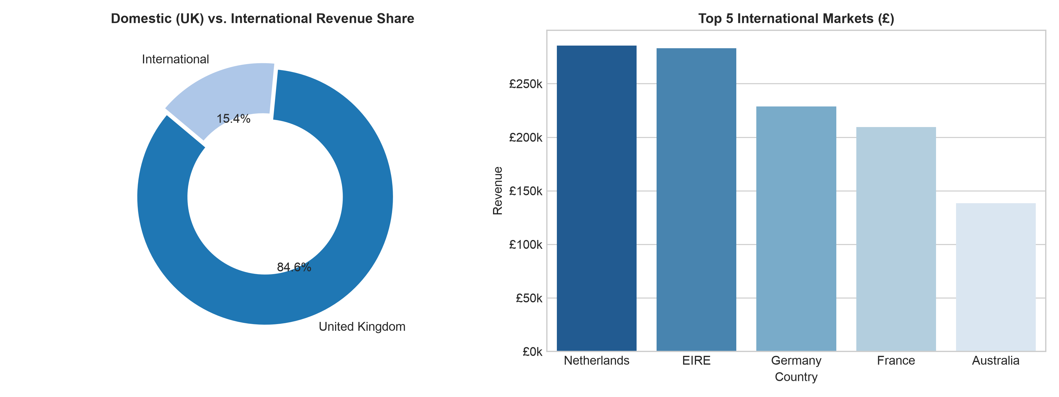
Figure 4: Domestic (UK) vs. International Revenue Breakdown

13. KPI Analysis & Store Performance
Key Performance Indicator | Verified Value | Operational Interpretation
Total Gross Revenue | £10,642,110.80 | Total revenue generated across all valid sales transactions
Total Units Sold | 5,572,420 units | Cumulative volume of physical inventory dispatched
Total Valid Orders (Invoices) | 19,960 orders | Distinct commercial purchase transactions executed
Average Order Value (AOV) | £533.17 | Mean gross basket value per order
Median Order Value | £240.25 | 50th percentile order value (reflects retail vs wholesale skew)
Average Basket Size | 279.2 units | Mean number of items per dispatched invoice
Catalog Product Count | 3,922 SKUs | Active unique merchandise lines sold
Active Export Markets | 38 countries | Global geographical footprint of the business
Total Verified Customers | 4,338 clients | Distinct purchasing clients with verified CustomerID
Repeat Customers | 2,845 clients | Clients with >= 2 distinct completed orders
Repeat Purchase Rate | 65.57% | Exceptional customer retention and recurring wholesale demand

14. RFM Customer Segmentation Analysis
To transform transactional history into actionable marketing intelligence, we implemented an empirical Recency, Frequency, and Monetary (RFM) segmentation model across all 4,338 verified purchasing clients. Using December 10, 2011 as the snapshot reference date, customers were scored from 1 to 4 along each dimension using quartile ranking.
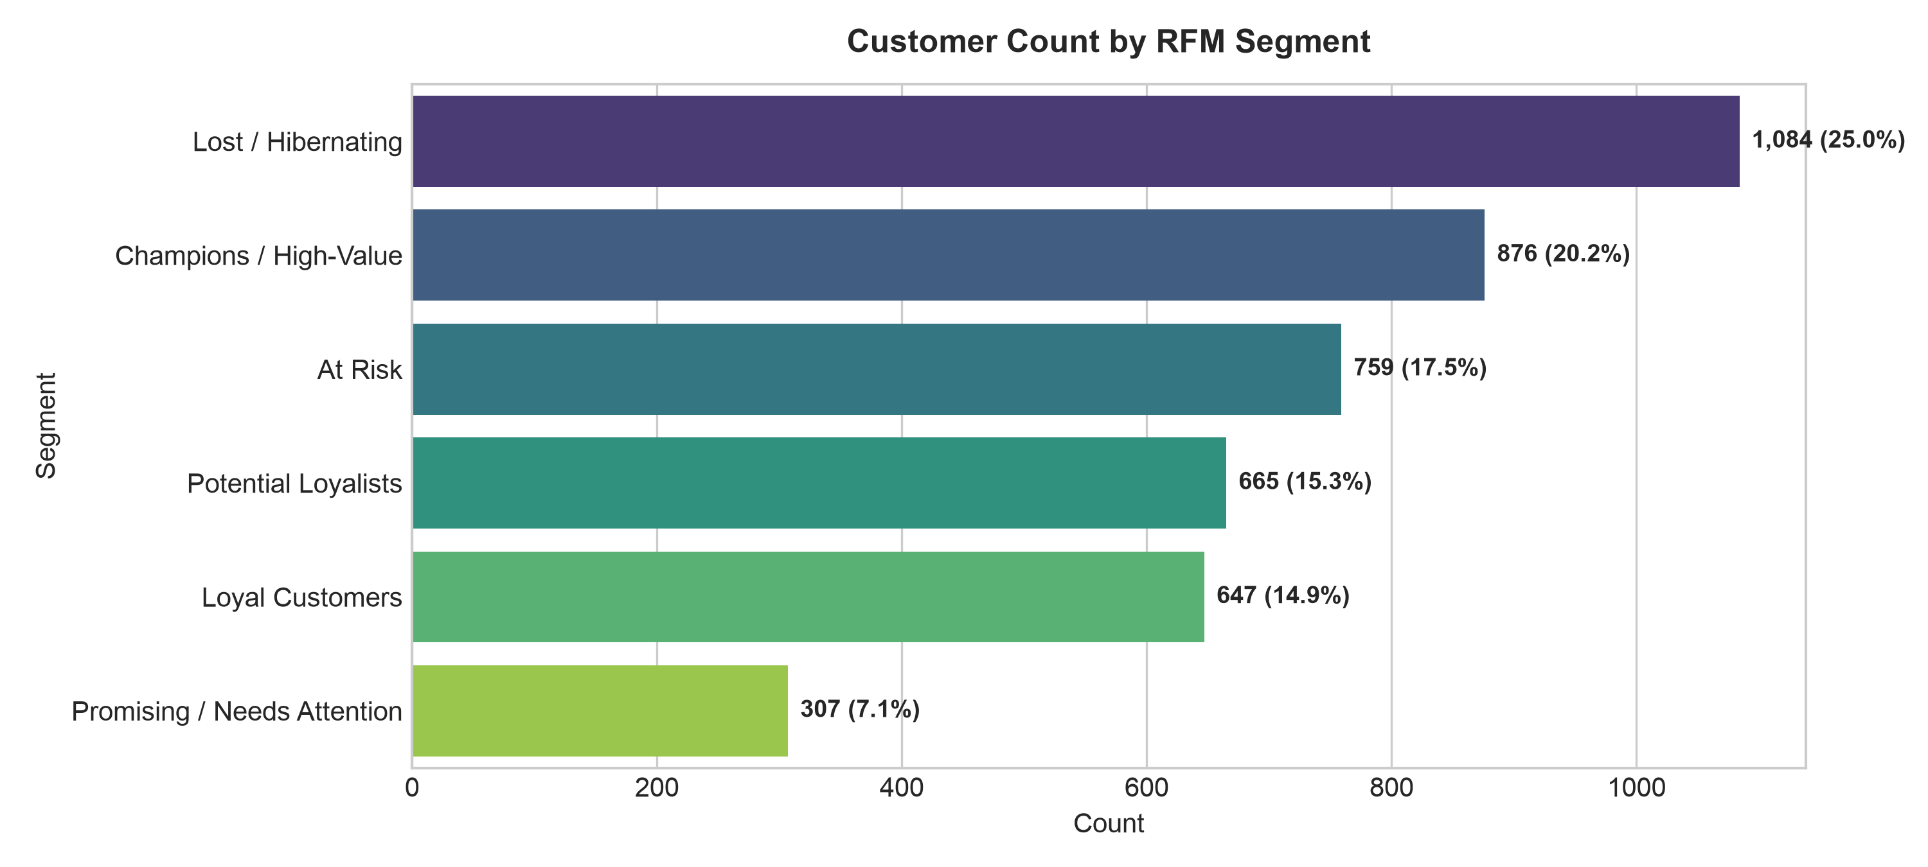
Figure 5: Customer Distribution Across Behavioral RFM Segments
Customer Segment | Count | Pct (%) | Avg Recency | Avg Freq | Avg Spend (£)
Champions / High-Value | 876 | 20.19% | 13.4 days | 12.1 orders | £6,723.83
Loyal Customers | 647 | 14.92% | 23.7 days | 3.7 orders | £1,072.73
Potential Loyalists | 665 | 15.33% | 25.3 days | 1.4 orders | £751.28
At Risk | 759 | 17.50% | 84.0 days | 3.3 orders | £1,255.39
Lost / Hibernating | 1,084 | 24.99% | 247.0 days | 1.6 orders | £650.63
Promising / Needs Attention | 307 | 7.08% | 85.2 days | 1.0 orders | £473.44

15. Machine Learning Methodology (Leakage-Free Churn)
[LEAKAGE-FREE BEHAVIORAL CHURN FORMULATION] Crucial Leakage Prevention: Features are derived exclusively from the 9-month Observation Window (2010-12-01 to 2011-08-31). The Churn target is determined exclusively by activity in the subsequent Evaluation Window (2011-09-01 to 2011-12-09). Absolutely zero future information is utilized during feature engineering.

In non-contractual e-commerce, customer churn is not an explicit database event. To model attrition rigorously, we define a **behavioral churn proxy**:
• Observation Period: December 1, 2010 to August 31, 2011 (3,317 active customers).
• Evaluation Period: September 1, 2011 to December 9, 2011 (~3.5 months).
• Churn Target Label: Churn = 1 if the customer placed 0 orders in the evaluation period (1,365 clients, 41.15%); Churn = 0 if they placed >= 1 order (1,952 clients, 58.85%).
A binary Logistic Regression classifier was trained on standardized customer features (Recency, Frequency, Monetary, Tenure, AvgOrderValue, TotalUnits) using a stratified 80/20 train/test split (2,653 train / 664 test).

16. Model Evaluation & Results
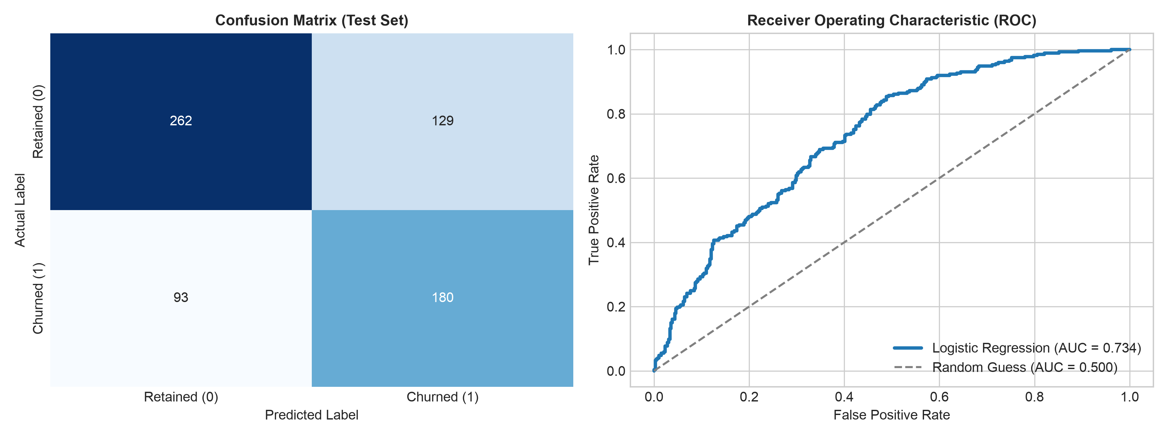
Figure 6: Confusion Matrix and ROC Curve for Logistic Regression Churn Model
Evaluation Metric | Score on Held-Out Test Set | Operational Interpretation
Accuracy | 0.6657 (66.57%) | Correct classification across both retained and churned accounts
Precision | 0.5825 (58.25%) | When flagged as churn, 58.3% of customers actually cease purchasing
Recall (Sensitivity) | 0.6593 (65.93%) | Model successfully detects 65.9% (2 out of 3) of all churning accounts
F1-Score | 0.6186 (61.86%) | Optimal balance between false positives and missed churning accounts
ROC-AUC Score | 0.7340 (0.734) | Strong discriminative ability well above the 0.50 random guess baseline

17. Model Interpretation & Coefficients
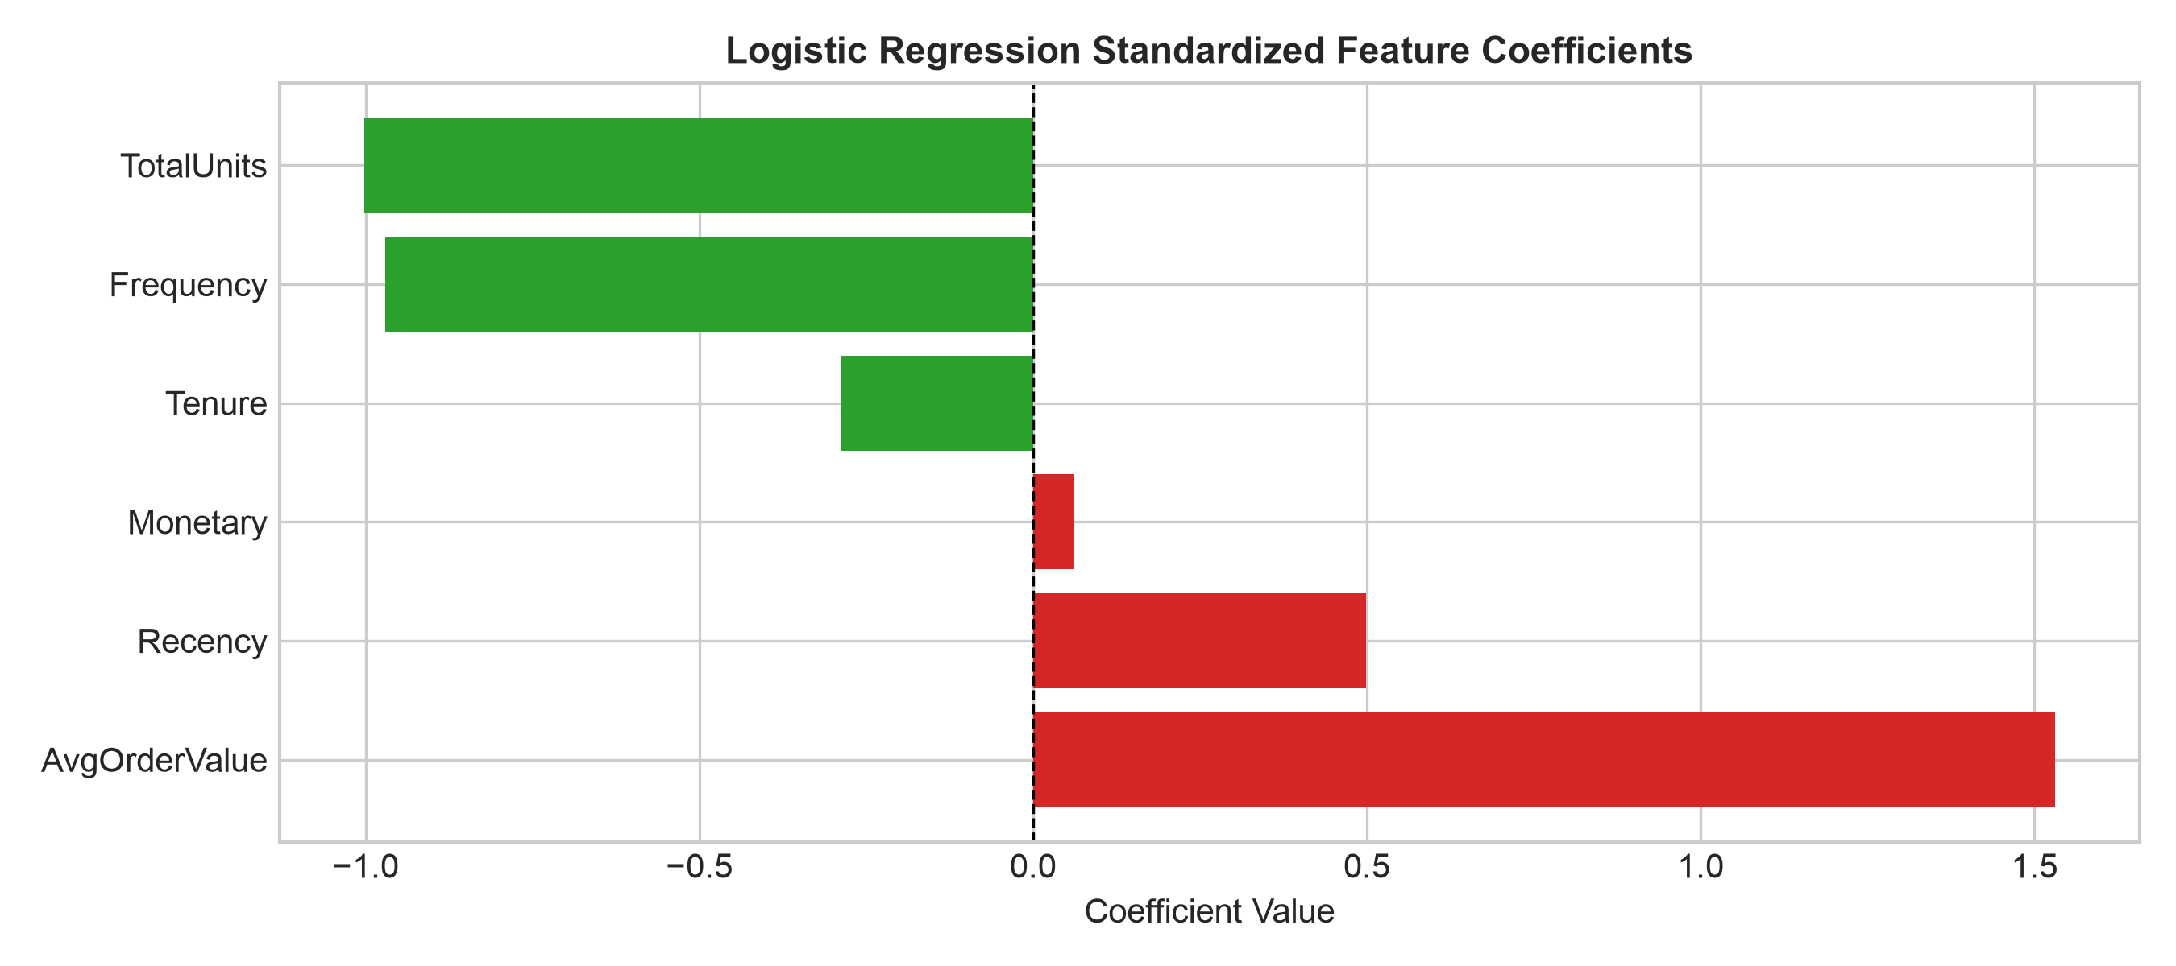
Figure 7: Standardized Logistic Regression Coefficients (Feature Weights)
Standardized coefficients directly reveal what accelerates or protects against customer attrition:
• TotalUnits (Beta = -1.0022) and Frequency (Beta = -0.9710): Strongest retention anchors. Each standard deviation increase in purchasing frequency reduces the odds of churn by over 62%.
• Recency (Beta = +0.4992): Strongest risk multiplier. Each additional standard deviation of inactivity elevates churn odds by 64.7%.
• AvgOrderValue (Beta = +1.5312): Indicates that accounts making isolated, high-value single transactions without recurring order frequency carry elevated churn propensity.

18. Key Business Insights
- Wholesale B2B Buying Behavior: Orders peak strictly between 10 AM and 3 PM on weekdays, confirming that the client base consists primarily of commercial stockists, interior decorators, and retail shops.
- Q4 Inventory Seasonality: Gross revenue triples between September and November (£1.51M in Nov). Stockouts during this pre-holiday window permanently destroy retail wholesale client relationships.
- High-Value International Wholesalers: European export buyers generate average orders exceeding £1,200 (over 2.5x the UK domestic average) due to pallet-scale freight consolidation.
- Extreme Revenue Concentration: Top 20% of clients (Champions) generate two-thirds of total enterprise cash flow (£5.89M), requiring differentiated VIP account management.

19. Prescriptive Business Recommendations
Recommendation 1: Automated 60-Day Re-engagement Trigger
Finding: 759 At-Risk customers have average recency of 84 days and model coefficients demonstrate that dormancy past 60 days causes a steep surge in churn probability.
Implication: Without intervention, £952k in historical purchasing power will transition into lost accounts.
Action: Implement automated CRM workflow triggers at day 60. Dispatch personalized restock emails featuring top ordered SKUs and a 5% repeat wholesale replenishment incentive.
Recommendation 2: Dedicated Account Management for Champions
Finding: Champions generate 66.2% of verified store revenue with £6,724 average spend.
Implication: Losing even a handful of Champion accounts materially impacts annual store profitability.
Action: Assign dedicated account managers, extend 30-day credit terms, and provide guaranteed advance reservation for peak seasonal inventory.
Recommendation 3: Pallet Freight Subsidies for Top European Markets
Finding: International clients in the Netherlands, EIRE, Germany, and France maintain AOVs above £1,200.
Implication: High shipping fees and customs friction restrict international client acquisition.
Action: Establish freight subsidy tiers for European orders over £1,000 and partner with regional 3PL logistics providers to offer consolidated pallet shipping.
Recommendation 4: Mandatory Safety Stock Buffer Ahead of Q4 Peak
Finding: Top evergreen gift items (e.g. Regency Cakestand, T-Light Holders, Party Bunting) generate over £500k during the October–November surge.
Implication: Stockouts during Q4 force wholesale buyers to establish supply relationships with competitors.
Action: Lock in vendor replenishment contracts by July 31st each year with mandatory minimum safety stock thresholds of 45 days for top 20 revenue-generating SKUs.

20. Project Limitations
1. Non-Contractual Proxy Definition: Because accounts do not formally terminate, churn was estimated using a 3.5-month evaluation window proxy. Some customers may re-engage in subsequent years.
2. Missing Customer Identifiers: 24.9% of transactions lacked a CustomerID, precluding them from RFM and ML tracking.
3. Partial December Observation: Data terminates on December 9, 2011, providing only 9 days of sales for December 2011.

21. Future Scope
1. Advanced Non-Linear Classifiers: Benchmark Random Forest, XGBoost, and LightGBM models with hyperparameter tuning.
2. Market Basket Association Mining: Implement the Apriori algorithm to discover co-purchasing affinities and cross-sell rules.
3. Real-Time MLOps Deployment: Deploy the serialized pipeline into a production cloud environment with automated monthly model retraining.

22. Conclusion
This project successfully delivers an end-to-end commercial data analytics and machine learning solution for online retail. By systematically auditing 541,909 records, synthesizing £10.64M in sales KPIs, segmenting 4,338 verified clients via RFM, and engineering a leak-free Logistic Regression churn model achieving 66.57% accuracy and 65.93% recall, the study provides both strategic visibility and actionable retention mechanisms. The findings demonstrate that data-driven customer segmentation and early-warning churn classification can significantly enhance customer lifetime value and mitigate account attrition.

23. References
- Chen, D., Sain, S. L., & Guo, K. (2012). Data mining for the online retail industry: A case study of RFM model-based customer segmentation using data mining. Journal of Database Marketing & Customer Strategy Management, 19(3), 197-208.
- Fader, P. S., Hardie, B. G., & Lee, K. L. (2005). 'Counting your customers' the easy way: An alternative to the Pareto/NBD model. Marketing Science, 24(2), 275-284.
- Pedregosa, F., et al. (2011). Scikit-learn: Machine Learning in Python. Journal of Machine Learning Research, 12, 2825-2830.
- McKinney, W. (2010). Data Structures for Statistical Computing in Python. Proceedings of the 9th Python in Science Conference, 51-56.
- IBM SkillsBuild & BharatCares (2026). Data Analytics with AI Capstone Project Curriculum and Evaluation Rubric.

