**JOB DEMANDS-RESOURCES MODEL**

(REVIEW – I)

*Submitted in partial fulfilment of the requirements for the degree of*

**Bachelor of Technology**

in

**Computer Science and Engineering**

*by*

**SHAURYA CHOUDHARY**

**18BCE2113**

**Under the guidance of**

**Prof. Remya L**

**School of Mechanical Engineering**

**VIT, Vellore.**



February, 2021

JOB DEMANDS – RESOURCES MODEL

**LITERATURE SURVEY:**

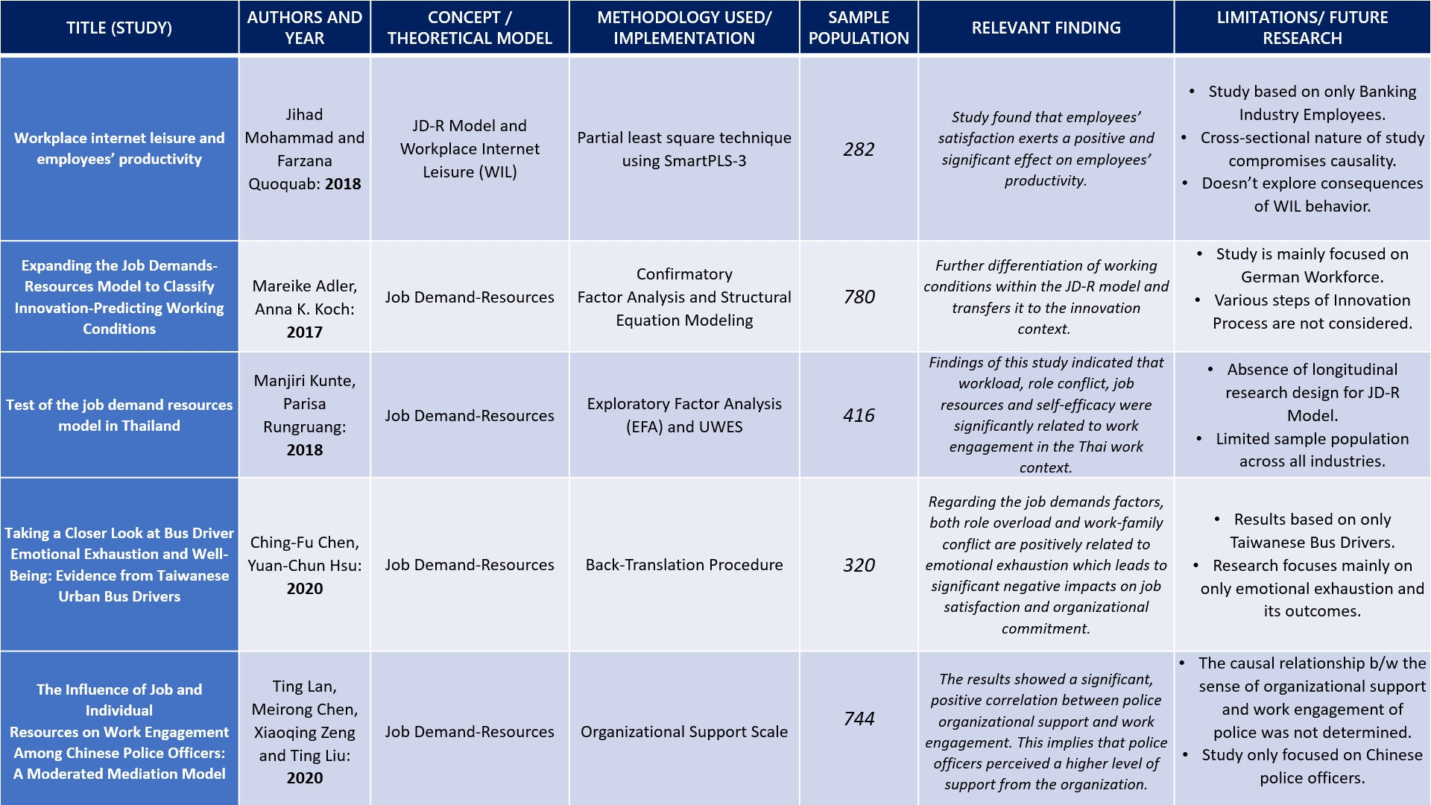

**JOURNALS SUMMARY:**

**[1]** **PAPER 1:** The main of this study is to explore about Workplace Internet Leisure Policy and its’ role in integration with JD-R model. It examines the effect of WIL on workplace outcome variables such as employee satisfaction (ES) and employee productivity in the Malaysian context. For studying the hypothesis, the research paper uses Partial least square technique using SmartPLS-3 on collected data of 282 respondents.

Findings reveal that workplace WIL, workplace WIL policy and workplace autonomy orientation (WAO) affect employees’ satisfaction. Additionally, the mediating role of ES was found to be significant. This is a pioneering study which suggests that moderate use of WIL can have a positive and significant effect on workplace outcome variables. Moreover, this study theorized ES as a mediating variable; this helps to explain how organizations can transform workplace resources in term of internet leisure, WILP and WAO into high productivity by elevating employees’ satisfaction.

**[2]** **PAPER 2:** The journal applies the JD-R model and a new categorization approach to study the relationship between working conditions and innovation. By applying confirmatory factor analysis and structural equation modelling to a cross-sectional online study, it showed that two types of demands, hindrance and challenge, and two types of job resources, task-related and social, represent different types of working conditions with respect to innovation.

Task-related and social job resources positively predicted individual innovation. Social job resources and challenge job demands revealed a positive association with perception of organizational innovation, whereas hindrance job demands were negatively related to it. The relevance of the studied types of working conditions for individual and perceived organizational innovation varied.

**[3]** **PAPER 3:** The purpose of this paper is to test the hypothesized relationships between job demands, job resources and personal resources toward work engagement, by utilizing a cross section of Thai employees. In this study, a group of 416 employees responded to a set of self-report surveys on job demands, job resources, personal resources and work engagement.

The results of the hierarchical regression analysis supported the relationships between job demands (i.e. workload and role conflict), job resources, personal resources (self-efficacy) and work engagement. In addition, the results supported the role of (positive) self-esteem as moderator in the role ambiguity and work engagement relationship, and the role of self-efficacy in buffering the effect of role conflict and workload on work engagement. The final model explained 43 percent of the variance in the dependent variable.

**[4]** **PAPER 4:** The paper is focused on Taiwanese Bus Drivers as compared with other occupations, urban bus drivers work under conditions that are among the most demanding, stressful, and unhealthy conditions with higher rates of mortality and morbidity. Bus drivers

must balance various requests from passengers and management, as well as follow traffic rules and regulations when they are on duty. Hence, these work-related expectations and requirements increase bus drivers’ workload and stress, subsequently leading to their job burnout and a negative impact on their well-being. In accordance with the job demand-resource (JD-R) model, job demands and job resources, two specific risk factors of every occupation, can explain employees’ well-being.

Burnout is theoretically characterized by three components, including emotional exhaustion, depersonalization, and reduced professional efficacy. This study uses emotional exhaustion to represent individual’s burnout. The results show that emotional exhaustion does play an important role in the work domain. It identifies role overload and work-family conflict as two stressors related to job demands and organizational support as the job resource factor to affect emotional exhaustion in bus driver context. Results reveal that only organizational support instead of supervisor support has a hindering effect on emotional exhaustion. It also implies that drivers’ perception of whether the bus company is concerned about them and cares about their needs and welfare plays an important role in lessening the occurrence of emotional exhaustion.

**[5]**  **PAPER 5:** This journal aims to explore the drivers of work engagement through perceived organizational support and regulatory emotional self-efficacy among Chinese police officers using a convenient sampling method. The study considers a sample population of 744 Chinese Police Officers. It assumes that a moderated mediation model, in which job satisfaction plays a mediating role in the relationship between perceived organizational support and work engagement regulatory emotional self-efficacy moderates not only the relationship between perceived organizational support and job satisfaction but also the relationship between job satisfaction and work engagement.

Job satisfaction mediated a positive relationship between organizational support and work engagement, and the perceived organizational support-job satisfaction and the job satisfaction-work engagement relationships were positively moderated by regulatory emotional self-efficacy, such that these relationships were stronger at higher levels of regulatory emotional self-efficacy. These findings have a practical significance for Chinese police officers’ work engagement advancement.

**CRITICAL ANALYSIS:**

* Employees’ satisfaction exerts a positive and significant effect on employees’ productivity.
* If individuals believe that their organization exerts significant effort to increase their happiness and satisfaction level at work, they will feel morally obliged to reciprocate by showing positive attitudes and behavior that can enhance and advance the productivity of their organization.
* Job resources are positively related to work engagement and enhance employee well-being.

**OBJECTIVES:**

* Identification of job demands.
* Addressing the Job demands and maintaining appropriate workplace environment.
* Proper utilization of available resources to ensure efficiency.
* Proper feedback and promotion of Job Resources.

**ALTERNATE METHODOLOGIES:**

* Implement longitudinal nature of research/study for better causal inferences.
* Survey of large sample population to ensure scalability of the model.
* Involvement of heterogeneous industries and population for generalized results.
* Selection of appropriate features/measures to perform research.

**PROJECT PROGRESS:**

* Learn about the recent researches in the JDR-M topic by going through Academic Journals.
* Explore the real-world implications of the theory.
* Find related and feasible database about the same to perform analysis.
* Extract attributes and form hypothesis for the analysis of data.
* Perform analysis and data visualization to get insights.

**REFERENCES:**

**[1]** *Mohammad, J., Quoquab, F., Halimah, S., & Thurasamy, R. (2019). Workplace internet leisure and employees’ productivity. Internet Research.*

**[2]** *Adler, M., & Koch, A. K. (2017). Expanding the job demands-resources model to classify innovation-predicting working conditions. management revue, 175-203.*

**[3]** *Kunte, M., & Rungruang, P. (2019). Test of the job demand resources model in Thailand. International Journal of Organization Theory & Behavior.*

**[4]** *Chen, C. F., & Hsu, Y. C. (2020). Taking a Closer Look at Bus Driver Emotional Exhaustion and Well-Being: Evidence from Taiwanese Urban Bus Drivers. Safety and Health at Work, 11(3), 353-360.*

**[5]** *Lan, T., Chen, M., Zeng, X., & Liu, T. (2020). The influence of job and individual resources on work engagement among Chinese police officers: a moderated mediation model. Frontiers in psychology, 11.*