STUDENT MARKS PREDICTOR

AN AI/ML MODEL

Name: Shaurya mehta
Reg no.: 25BAI10521
Faculty: Dr Pradeep kumar mishra

INTRODUCTION

Student Marks Predictor is a
minor ML model that predicts a student’s final exam score from internal assessment marks (assignment, quiz, attendance). Uses linear regression — simple, interpretable and perfect for a beginner project.

OBJECTIVES

1. Build a reproducible dataset of student internal marks and final marks.

2. Train a linear regression model to predict final exam score.

3. Provide simple CLI and a minimal web interface for demonstration.

4. Create documentation and a project report.
System Requirements

Hardware Requirements:
- Atleast 2GB of RAM
- Enough Storage to run any OS

Software Requirements:
- Python version 3.x
- Data entry: Comma Seperated values support
- Modules for Python
- It is important to train the code before executing

DATASET AND FILE MANAGEMENT

The ML model includes a number of files which need to be represented and understood in order.

1)’Student_marks.csv’: This file contains a list of marks secured in different category by students.
Additionaly it is essential for training the model.
2)’model.py’: This python file is responsible for executing the centerline logic of the code and evaluating the necessary output as contrasting with the value entered by user.
3) ‘ cli.py’ : This python file is responsible for executing the code in such a manner that proper structural output is given to the user. This file links the calculations made by the ML model to the console line command.

OUTPUT

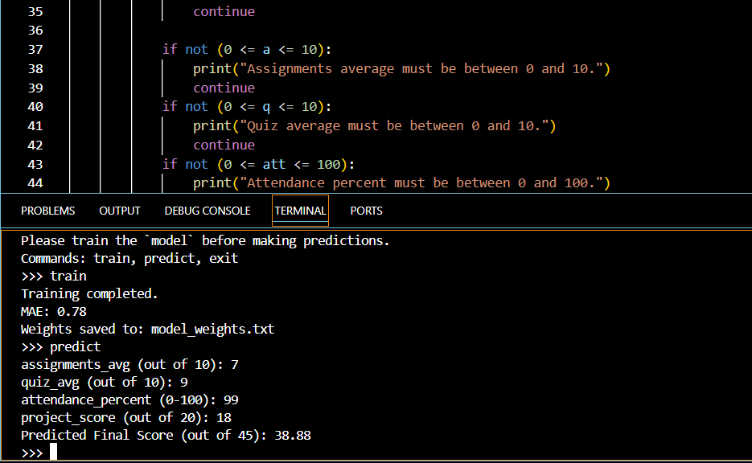

FUTURE ENHANCEMENTS

- More data given can be used to train the model

- A dedicated UI/GX design can be prepared for execution of higher level

- Analyse user data and suggest better recommendations.

- Sorts students as per slow or fast learners.

CONCLUSION

This program if executed on a larger scale can be converted into a software that can be implemented in every institution all across the world.
With the evolving state of AI/ML models, this programs holds immense potential.

THANK YOU

