📘 CLUSTERING — COMPLETE BEGINNER NOTES
(Conceptual + Practical + Intuition-Driven)

1️⃣ WHAT IS CLUSTERING?
Definition
Clustering is a technique used to group similar data points together based on their features, without knowing the groups in advance.
- No labels
- No correct answers beforehand
- Patterns are discovered, not predicted
👉 This makes clustering an unsupervised learning method.

2️⃣ INTUITION BEHIND CLUSTERING
Clustering works on a simple idea:
Similar things should be close together, different things should be far apart
Examples:
- Countries grouped by geography
- Customers grouped by behavior
- Pixels grouped by color
- People grouped by preferences
⚠️ Important:
The same data can be clustered in multiple valid ways, depending on:
- Features chosen
- Distance measure
- Number of clusters2
There is no single “correct” clustering.

3️⃣ GOAL OF CLUSTERING (VVIMP)
The formal goal is:
- Maximize similarity within clusters
- Maximize dissimilarity between clusters
This is always done with respect to selected features.

4️⃣ WHERE IS CLUSTERING USED?
🔹 Primary Use: Exploratory Analysis
Used when:
- You don’t know the structure of data
- You want to understand patterns
- You want ideas before modeling
Common applications:
- Market segmentation
- Customer profiling
- Image segmentation
- Recommendation systems
- Anomaly detection
- Preprocessing before ML models
Clustering is rarely the final method, but often the starting point.
Aspect | Supervised | Unsupervised
Labels | Known | Unknown
Goal | Predict | Discover
Examples | Regression, Classification | Clustering
Output | Predicted value/class | Group assignment
: Clustering does not predict, it reveals structure.

6️⃣ DISTANCE — THE FOUNDATION OF CLUSTERING
Clustering depends on distance measurement.
🔹 Euclidean Distance
Most common distance metric.
For two points:
$$d=\sqrt{\left(x_{2}-x_{1})^{2}+(y_{2}-y_{1})^{2}\right.}$$
Generalized to N dimensions:
$$d=\sqrt{\sum_{i=1}^{n}{(}x_{i}-y_{i})^{2}}$$
Used to measure:
- Distance between points
- Distance between point and cluster
- Distance between clusters

7️⃣ CENTROID (CORE CONCEPT)
A centroid is:
- The mean position of all points in a cluster
- Also called center of mass
Properties:
- Each cluster has exactly one centroid
- Centroid location changes as points change
- Used as reference for assigning points

8️⃣ K-MEANS CLUSTERING (MOST IMPORTANT)
What is K-Means?
A flat clustering algorithm that:
- Divides data into K clusters
- Uses centroids and distances
- Iteratively improves clustering
“K” must be chosen before clustering.

9️⃣ K-MEANS ALGORITHM (STEP-BY-STEP)
Step 1: Choose K
Decide how many clusters you want.

Step 2: Initialize Centroids (Seeds)
- Randomly OR
- Using K-Means++ (smart initialization)

Step 3: Assign Points
Each data point is assigned to the nearest centroid using distance.

Step 4: Recalculate Centroids
New centroid = mean of all points in the cluster.

Step 5: Iterate
Repeat Steps 3 & 4 until:
- No points change cluster
- Centroids stop moving
➡️ This is an iterative optimization process

🔟 OUTPUT OF K-MEANS
- Each point gets a cluster label (0,1,2,…)
- Labels have no inherent meaning
- Interpretation is done by humans

1️⃣1️⃣ FEATURE SELECTION IN CLUSTERING (VVIMP)
Clustering results depend entirely on features.
Possible scenarios:
- Numerical only
- Encoded categorical only
- Mixed features
⚠️ Choosing wrong features = meaningless clusters

1️⃣2️⃣ CATEGORICAL DATA IN CLUSTERING
Categorical variables must be encoded numerically.
Example:
- English → 0
- French → 1
- German → 2
⚠️ Simple encoding may impose false order
(used only for demonstration)

1️⃣3️⃣ WHY STANDARDIZATION IS CRITICAL ⭐⭐⭐
What is Standardization?
Transforms data so that:
- Mean = 0
- Standard deviation = 1
Purpose:
- Remove scale bias
- Give equal weight to features

Why K-Means Needs It
K-Means uses raw distances.
If one feature has:
- Large numerical range → dominates
- Small numerical range → ignored

Without Standardization
- Clusters depend on high-magnitude variables
- One feature controls everything

With Standardization
- All features contribute equally
- Clusters reflect true structure

When NOT to Standardize
- When domain knowledge says one variable is more important
- Example: Price > Size in buying decisions

1️⃣4️⃣ ELBOW METHOD (CHOOSING K)
Problem
K-Means requires K beforehand.

Solution: Elbow Method
Uses WCSS (Within-Cluster Sum of Squares)
WCSS measures:
- Compactness of clusters
- Distance of points from centroids

Key Properties
- WCSS decreases as K increases
- K = N → WCSS = 0 (useless)
- K = 1 → WCSS maximum (useless)

Elbow Logic Plot WCSS vs K
- Look for point where improvement slows
- That point = optimal K
⚠️ Heuristic, not exact science

1️⃣5️⃣ LIMITATIONS OF ELBOW METHOD
- No sharp elbow sometimes
- Multiple reasonable K values
- Requires interpretation
➡️ Try multiple K values and analyze meaning

1️⃣6️⃣ INTERPRETING & NAMING CLUSTERS (VVIMP)
Clustering gives groups, not meanings.
You must:
- Inspect feature distributions
- Understand domain
- Name clusters meaningfully
Example:
- Alienated customers
- Supporters
- Fans
- Roamers
👉 Naming is essential in unsupervised learning.

1️⃣7️⃣ USING CLUSTERING IN BUSINESS
Example: Market Segmentation
Clusters guide:
- Targeted marketing
- Resource allocation
- Customer retention strategies
- Product improvements
Strategy:
- Improve closest-to-fan clusters first
- Avoid wasting resources on far clusters

1️⃣8️⃣ K-MEANS: PROS & CONS
✅ Pros
- Simple and intuitive
- Fast and scalable
- Always produces output
- Easy to implement

❌ Cons (VERY IMPORTANT)
- Must choose K
- Sensitive to initialization
→ K-Means++ solves this
- Sensitive to outliers
→ Remove or re-cluster
- Assumes spherical clusters
- Requires feature scaling

1️⃣9️⃣ TYPES OF CLUSTERING
🔹 Flat Clustering
- No hierarchy
- Example: K-Means

🔹 Hierarchical Clustering
- Creates hierarchy of clusters
- Produces dendrogram

2️⃣0️⃣ HIERARCHICAL CLUSTERING
Two types:
🔹 Agglomerative (Bottom-Up)
- Start with each point as cluster
- Merge closest clusters step-by-step
- Most commonly used

🔹 Divisive (Top-Down)
- Start with one cluster
- Split recursively
- Computationally expensive

2️⃣1️⃣ DENDROGRAM (VVIMP)
A dendrogram:
- Visualizes hierarchical clustering
- Shows all possible cluster solutions
- Height of merge = dissimilarity
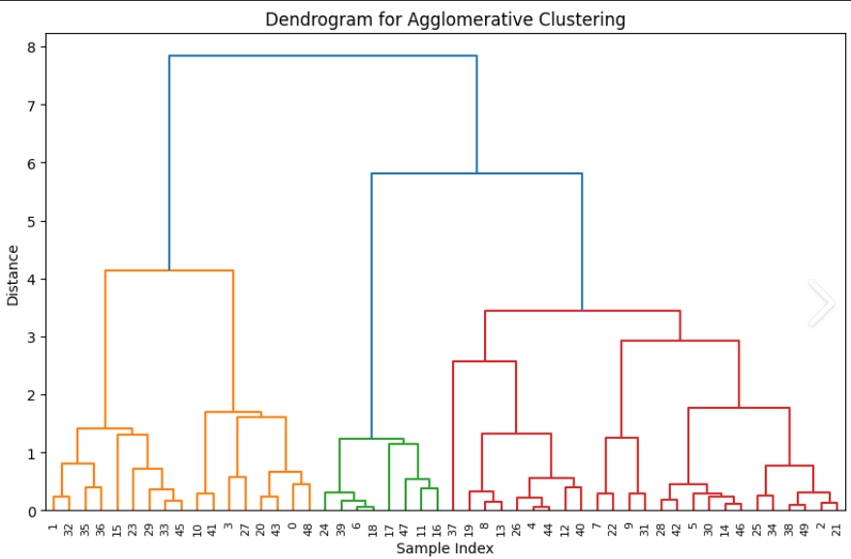

Reading a Dendrogram
- Lower merge → more similar
- Higher merge → less similar
- Horizontal cut determines number of clusters
- Number of broken links = number of clusters

2️⃣2️⃣ CHOOSING CLUSTERS FROM DENDROGRAM
Rules:
- Look for large vertical gaps
- Cut before big distance jump
- Use intuition + problem context

2️⃣3️⃣ PROS & CONS OF HIERARCHICAL CLUSTERING
✅ Pros
- No need to preselect K
- Rich structural insight
- Easy interpretation

❌ Cons
- Poor scalability
- Computationally expensive
- Hard to read for large datasets

2️⃣4️⃣ HEATMAPS & CLUSTERMAPS
Heatmaps:
- Color-based feature visualization
- Show similarity patterns visually
Cluster maps:
- Combine heatmap + dendrogram
- Allow clustering observations and features
- Powerful exploratory tool

2️⃣5️⃣ AGGLOMERATIVE CLUSTERING
(Bottom-up Hierarchical Clustering)
What it is
- Starts with each data point as its own cluster
- Iteratively merges the closest clusters
- Continues until:
  - One single cluster remains
  - Or a stopping criterion is met
How “closeness” is defined (Linkage methods)
- Single linkage → closest points
- Complete linkage → farthest points
- Average linkage → average distance
- Ward’s method → minimizes variance (most common)
✅ Pros
- No need to choose K initially
- Produces dendrogram (visual hierarchy)
- Works well for small–medium datasets
❌ Cons
- Expensive for large datasets
- Once merged, clusters cannot be undone
- Sensitive to noise & distance metric
When to use
- Exploratory analysis
- When hierarchy matters
- When dataset size is manageable

2️⃣6️⃣ DBSCAN (Density-Based Spatial Clustering)
What it is
- Groups points based on density
- Identifies:
  - Core points (dense areas)
  - Border points
  - Noise / outliers
Key parameters
- ε (epsilon) → neighborhood radius
- MinPts → minimum points to form a dense region
How it works
- Finds dense regions
- Expands clusters from core points
- Labels sparse points as noise
✅ Pros
- No need to choose K
- Detects arbitrary-shaped clusters
- Handles noise & outliers very well
❌ Cons
- Sensitive to parameter choice (ε, MinPts)
- Struggles with varying density
- Not ideal for very high-dimensional data
When to use
- Data with noise
- Non-spherical clusters
- Spatial / real-world datasets

2️⃣7️⃣ HEATMAPS & CLUSTERMAPS (Recap)
Heatmaps
- Visualize values using color intensity
- Show:
  - Correlations
  - Similarity patterns
  - Feature behavior
Clustermaps
- Heatmap + dendrogram
- Automatically clusters:
  - Rows (observations)
  - Columns (features)
- Excellent for exploratory analysis

Algorithm | Needs K? | Shape | Noise Handling | Scalability
K-Means | Yes | Spherical | Poor | High
Agglomerative | No (initially) | Flexible | Poor | Medium
DBSCAN | No | Arbitrary | Excellent | Medium

🧠 BIG-PICTURE SUMMARY
- Clustering is discovery, not prediction
- There is no single correct clustering
- Interpretation > algorithm choice
- Standardization is often essential
- Always try multiple parameters
- Clustering guides strategy, not final decisions

✅ FINAL ONE-LINE DEFINITION
Clustering is an unsupervised learning technique that groups data based on similarity, helping us explore structure, behavior, and hidden patterns in unknown data.

