**STATA Research Project**

***Analysis of Swachh Bharat Abhiyan in the state of U.P. in terms of access to sanitation***

Good sanitation is one of the basic necessities of life and ironically India has been struggling to ensure the same for its citizens. A well-built toilet along with good drainage and water supply is  fundamental to ensuring good sanitation. The Government of India through various initiatives over many decades has tried to increase the focus on these issues, especially construction of latrines. But it was only after the launch of Swachh Bharat Mission in 2014 that the pace of latrine construction picked up in India. The Government of India has made very bold claims about the achievements of the mission through its Swatch Bharat Surveys. This is an attempt to verify these claims using data from the nationally representative surveys of NSSO between the period 2014-2017.

**Objectives :-**

1.To analyse the distribution of latrine availability across social groups, religion, main drinking water source and districts of Uttar Pradesh in the period 2014-2017.

2. To analyse whether there is a statistically significant difference between 2014 and 2017 in the number of households lacking latrines after adjusting for socio- economic factors .

Null Hypothesis: There is no difference between 2014 and 2017 in the households lacking latrines.

Data and Methodology:

NSSO rounds on Social Consumption (Healthcare utilisation)- 71st Round (2014) and 75th Round (2017)  have been selected for the data analysis. The sample for UP was extracted from these rounds. Before beginning with analysing the dataset, it was essential for us to clean this huge data. We decided to rename the variables in individual datasets. After importing the datasets, we used the recode function to generate different variables. This includes variables such as Rel_Recoded, Latrine_Rec, y etc. To combine the two datasets for the year 2014 and 2017 we used the merge function through the 1:1 procedure and removed insignificant variables that were not under the purview of our study.

Cross tabulations of socio- economic variables against availability of latrine is analysed separately for both years and chi- squared test has been employed to test association between these socio- economic factors and latrine availability separately for 2014 and 2017. We have used a loop for numerous variables (social group, religion etc.) to be more time efficient and avoid writing individual lines of code. We then used labellist function for 2014 as “1” and 2017 as “2”.

Then a binary logistic regression is performed using “logit” with our target variable as latrine records. We have used two other commands with “logit”. First incorporating the “i.” command to create dummy variables. Secondly using “,or” option so as to acquire odds ratio after regressing (and not the coefficient). The null hypothesis stated above is tested using a Wald test (following chi -square distribution). The regression is done to adjust for other socio-economic factors. The Wald Test was a post estimation test. By converting the odds ratio to a log scale, we accounted for the problem of asymmetry and extreme values (0-∞)

Literature Review:-

**1. UN Economic and Social Commission for Asia and the Pacific**

**Demand for household sanitation: The case of India**

This paper analyses the supply side initiative of Swachh Bharat initiative, for the success of the policy. The author looks at household demand for toilets, and study’s the factors leading towards open defecation. The paper uses Demographic and Health survey data to create a wealth index, and use it to rank households' preference for toilets vis-à-vi’s 20 other different consumer durables. Our results suggest, amongst the list of household items that any individual wants to have, toilets get a lower preference. The paper also examines structure for using toilets among residents from federal states in India. We find that the result suggests, education and public awareness, among the population is very important for the development of toilets in households.

The author ranks households in terms of preferences, and whether they do have other consumer durables like cycle, cot, watch, mattress, chair, bicycle, table, electric fan, television, radio, motorbike, water pump, pressure cooker, sewing machine, refrigerator, tractor, animal drawn cart, thresher and computer.

This study utilises the first large data set- Demographic and health survey data collected in 2005-06. The Indian version of DHS data, the third round of National Family and Health Survey (NFHS-3) data contains information about uses of toilets by various households characteristics, namely, gender, religion, area and geography.

We use this paper in our research to determine what are the factors affecting access to sanitation and hygiene and the result showcases that urban areas have 19 times more probability to have access to toilet rather than people in rural areas.

This paper also suggested that financial inclusion is another pressing factor for people to develop toilets in their homes. People who have a bank account are found to be building toilets for their families. Their standards of living are much higher than those who don’t have a bank account.

We are utilising these information to inculcate a multi dimensional approach towards the study of factors which prevent people towards basic necessities.

**2. Sanitation in Rural India: Exploring the Associations between Dwelling Space and Household Latrine Ownership**

This paper hypothesise is based upon the current interventions focused upon individual level determinants, such as attitude, and beliefs, instead of considering all possible social determinants of latrine ownership. Given this, the researcher asks two questions: what is the association between the amount of dwelling space owned by households in rural India, and their likelihood of toilet ownership and what proportion of variation in household latrine ownership. Furthermore, considerable variation in latrine ownership is attributable to villages and states, suggesting that additional research is required to elucidate the contextual effects of villages and states on household latrine ownership.

Thus, sanitation interventions should consider household dwelling space and village and state context as important social determinants of latrine ownership in rural India. Doing so could bolster progress towards Sustainable Development Goals. We analyse this paper to get the idea of the developments done by the Central Rural Sanitation Programme 1986 evolving later into Total Sanitation Campaign 1999, subsequently developing into the Swachh Bharat Abhiyan(SBA) 2014. The researcher suggested that A growing body of literature has started examining the possible social determinants of latrine ownership and use in places such as India. Social determinants can be defined as “ . . . specific features of and pathways by which societal conditions affect health and that potentially can be altered by informed action”. In other words, social context is thought to influence various health behaviours and outcomes.

For example, Novotny et al. conclude that sanitation change will not be achieved

“through specific interventions alone without addressing structural constraints related to educational, economic, and sociocultural inequalities”. Coffey et al. examined one such sociocultural inequality, India’s deeply entrenched caste system, which might perpetuate open defecation. They found that the notions of untouchability that stem from India’s caste hierarchy deter people from using their pit latrines as they do not want to clean them out when they fill up.

We are using this paper to analyse data from the 69th round of National Sample Survey in India to demonstrate the association between the amount of dwelling space owned by a household and latrine ownership, and examine the proportion of the variation in households. We are looking at the multi staged sampling design to determine household level access to drinking water, sanitation, and other housing characteristics, to select a set of descriptive statistics and understand the chi square test values for all the covariates.

**3. The World Bank’s Consumer Research for Rural Sanitation in Uttar Pradesh.**

The researcher establishes a baseline sanitation and hygiene practices and identifies the factors which influence sanitation behaviour, he also analyses the Chanel’s of communication of people to the government. This research gives us an helpful insight into both the qualitative and quantitative aspects of the research. Mainly, the researcher has divided the state’s district and has adopted a sample survey methodology where the observed conclusions at the micro level are representatives of the macro level.

He has mainly included certain criteria for the sample such as the agro-climatic zones, distance from the state capital (Lucknow) and the Economic status(backward and forward blocks). He identifies that households where there is no access to toilets there is high probabilities of infections and lack of hygiene creates more frequency of hospital visits. When questioned on why is there lack of access the research helps us to get a clearer perspective that it’s not due any social stigma or false dogma, rather it is more related towards the lack of money resources or inadequate space in their homes. Further the research helps us learn about the stark difference among the households and areas where access to toilets is greater, this highlights the education, occupational and income difference between regions of the western and eastern UP. Where we learn the reasons for the stark differences arises.

We are using this research to understand our state which we have taken under consideration for our research. We learn about the innate differences between social stigma and scientific pragmatism that exist in the state which creates social attitudes, that has an effect on the implementation of Swachh Bharat Abhiyan in the state. We try to inculcate the finding of this research study in our data and further the case put forth on how many have access to sanitation and draw up resins behind it.

**4. Drinking Water And Sanitation In Uttar Pradesh: A Regional Analysis.**

This paper highlights the inter regional disparity in coverage of drinking water and sanitation services in Uttar Pradesh and measures the impact of literacy rate, female literacy restrictions and per capita income on sanitation. The secondary level data are collected from the National Family Health Survey, District Level Health Survey, Uttar Pradesh HDR Report, Census and the NSSP to assess the above objective.

The analysis of access to drinking water and sanitation shows that the provision of piped water supply still remains an unachieved goal in Uttar Pradesh. Moreover, it shows that a large part of the Uttar Pradesh households depend on their own private tube-wells and pumps for their daily water needs. Uttar Pradesh has low coverage for both household sanitation and drainage service compared to all India level. As per the Census 2001, there are about 2.58 crores of households in the State and only 28 per cent households have individual household toilets. The paper reveals inter-regional disparity in Uttar Pradesh in the availability of drinking water and sanitation.

We have taken the example of multiple linear regression model which is used in this research to estimate the impact of various determining factors, i.e. literacy rate, female literacy rate and per capita income on sanitation facilities. The results reveal that female literacy rate plays a significant role for improving access to sanitation facilities. So, the highest priority to female literacy and schooling should be given in the development programmes for improving the conditions.

Results :

The cross tabulations reveal that the percentage of households having latrines has increased across every category of the socio-economic variables between 2014 and 2017. In the case of social groups(Table 3), the highest increase has been among the OBCs(~13% point increase) with impressive strides in the case of SCs also(~10% point increase).

In case of religion(table 4), both Hindus and Muslims register equal increase in latrine coverage(~11-12% point increase). However, the increase in latrine coverage(Table 5) in rural areas is almost twice of that in urban areas.  Across the main source of drinking water(Table 6), the highest increase of latrine coverage has been among those who use other inferior sources (~24% point increase) and tube-well(~10% point increase).

The chi- square test results also confirm these facts with statistically significant results of association between these socio-economic factors and availability of latrine in both rounds.

In the combined sample, among the social groups, compared to STs, OBCs and other well- off groups have higher and statistically significant odds to have latrines. Compared to Hindus, Muslims and other religious communities have higher and statistically significant odds to have latrines. Also, compared to rural areas, urban areas have higher and statistically odds to have toilets. A larger household size is associated with lower and statistically significant odds to have latrines. The Monthly Household Consumption expenditure (MHCE) nor the square of the household size have any impact on the odds of having a latrine. Among the districts, compared to Saharanpur, most of the districts have lower and statistically significant odds to have latrines. When the main source of drinking water is considered , we observe that compared to households with access to tap, households with tube-well other sources have lower odds of having latrines.

 The district wise proportion (Table 1) of each year also shows in which districts the availability of latrine has increased the most. It was concluded that Jyotiba Phole Nagar, Manipuri, Unnao, Kannauj(highest improvement in the availability of latrine), Kanpur Dehat, Jhasi, Hamirpur, Mahoba, Fatepur, Kaushambi, Mau, Mirzapur, Sonbadra and Sant Ravidas Nagar were the districts which had significant changes in the three years.

In the regression (Table 2), the p value of 2017 year is coming out be less than 0.05 which gives us enough evidence to reject the null hypothesis. It means the availability of latrine in the 3 years has increased.

 Most importantly, our variable of interest is the difference in odds of having a toilet between 2014 and 2017. It is seen that in 2017 - almost 4 years into the Swatch Bharat mission, there is a higher and statistically odds to have latrines compared to 2014. Moreover, the hypothesis testing post the regression on the log odds of year (log odds to not have a latrine) yields statistically significant result with a strong Wald statistic value of 120(Table 7).

Annexure

1. District wise access to sanitation

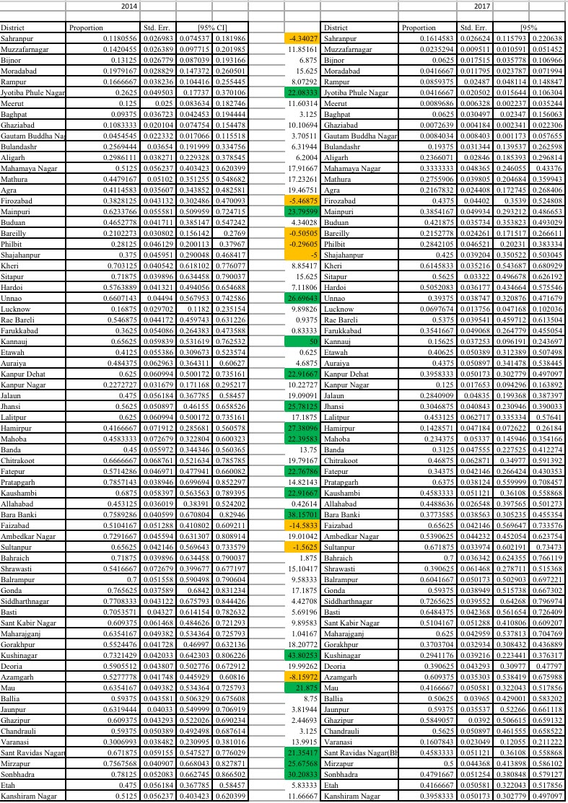

1. Logistical Regression and hypothesis testing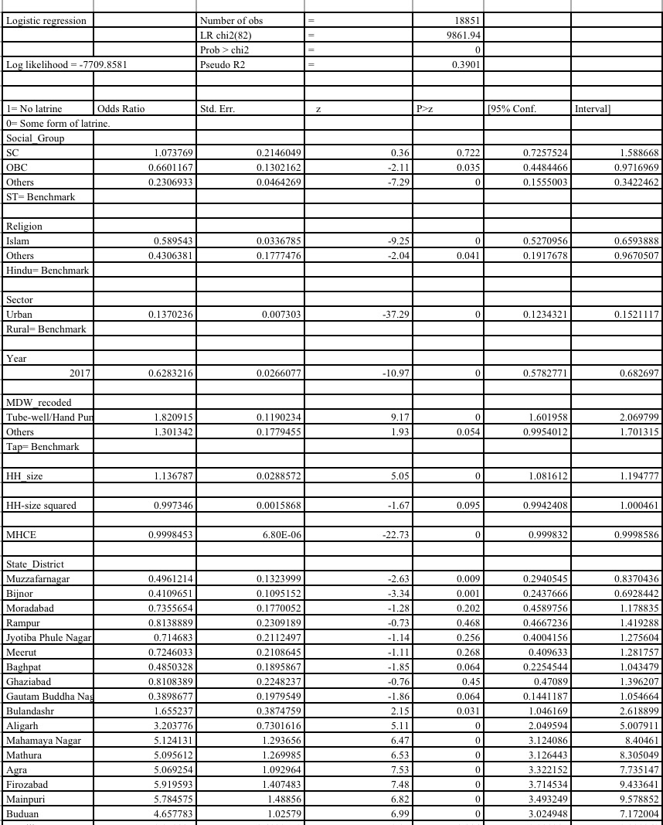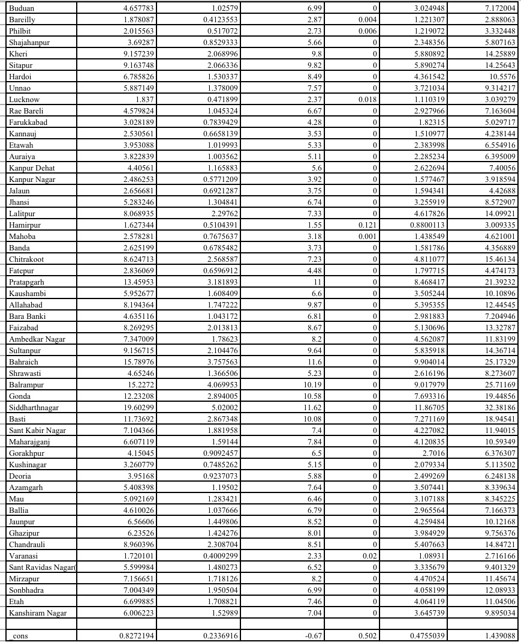
2. Chi square test with respect to social group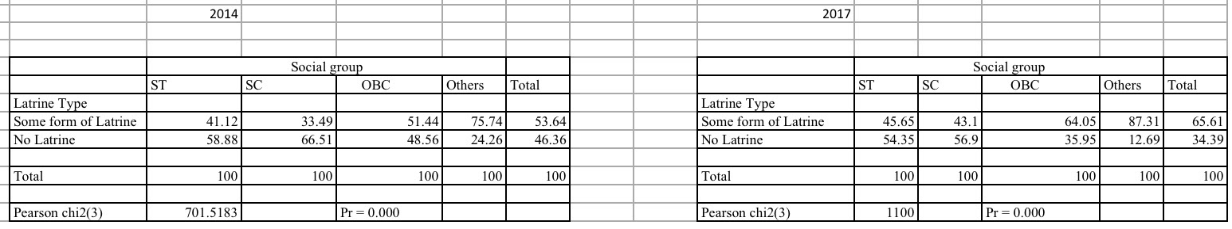
3. Chi square test with respect to religion 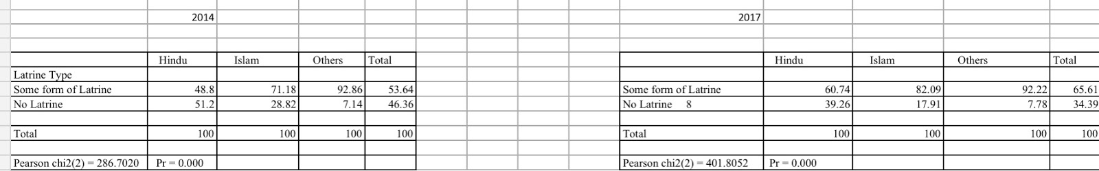
4. Chi square test with respect to urban rural sectoral composition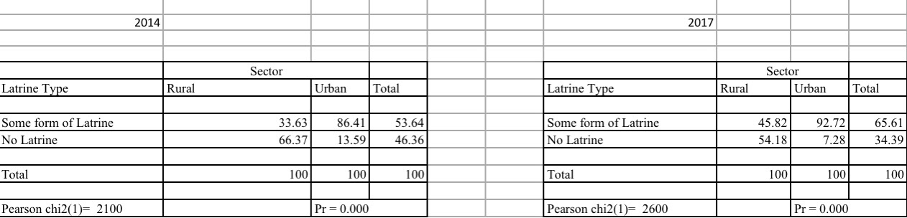
5. Chi square test with respect to access to drinking water 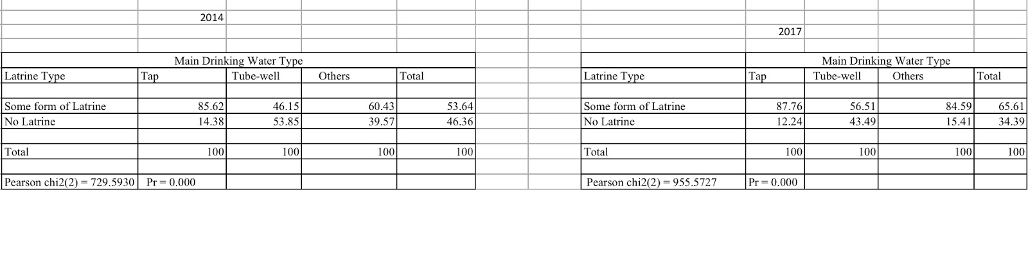
6. Post estimation test (WALD Test)

