EXPERIMENT-7

AIM: ADDING JSP TO HTML FORM.

JavaServer Pages (JSP) is a technology for developing Webpages that supports dynamic content. This helps developers insert java code in HTML pages by making use of special JSP tags, most of which start with <% and ends with %>.

A JavaServer Pages component is a type of Java servlet that is designed to fulfill the role of a user interface for a Java web application. Web developers write JSPs as text files that combine HTML or XHTML code, XML elements, and embedded JSP actions and commands.

Using JSP, you can collect input from users through Webpage forms, present records from a database or another source, and create Webpages dynamically.

JSP tags can be used for a variety of purposes, such as retrieving information from a database or registering user preferences, accessing JavaBeans components, passing control between pages, and sharing information between requests, pages etc.

Why Use JSP?
JavaServer Pages often serve the same purpose as programs implemented using the Common Gateway Interface (CGI). But JSP offers several advantages in comparison with the CGI.
- Performance is significantly better because JSP allows embedding Dynamic Elements in HTML Pages itself instead of having separate CGI files.
- JSP are always compiled before they are processed by the server unlike CGI/Perl which requires the server to load an interpreter and the target script each time the page is requested.
- JavaServer Pages are built on top of the Java Servlets API, so like Servlets, JSP also has access to all the powerful Enterprise Java APIs, including JDBC, JNDI, EJB, JAXP, etc
- JSP pages can be used in combination with servlets that handle the business logic, the model supported by Java servlet template engines.

CODE:

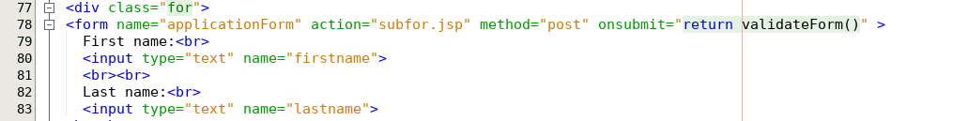
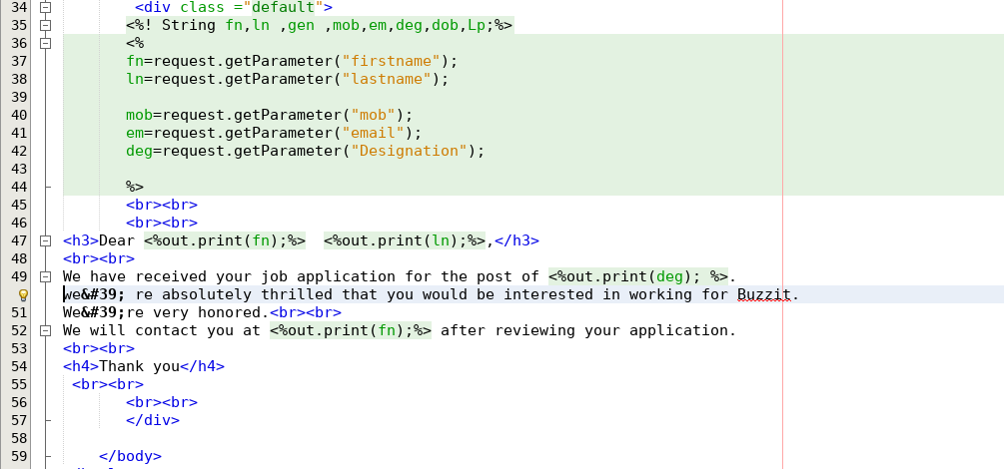

OUTPUT:

