EXPERIMENT-5

AIM: TO ADD A MENU TO WEBPAGE.

CODE:
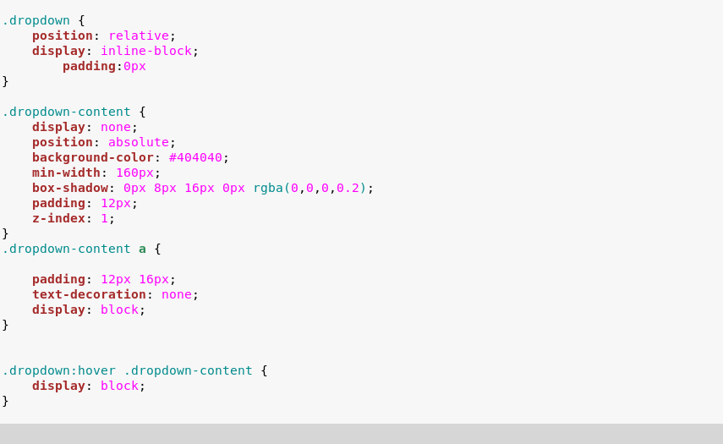

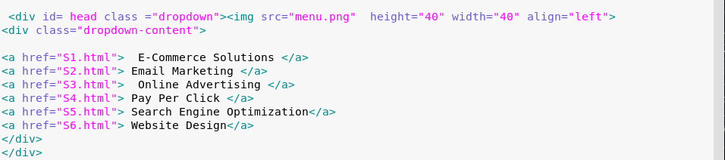

OUTPUT:

