EXPERIMENT-1

AIM: TO MAKE A STATIC HOME PAGE OF A E-LEARNING WEBSITE USING HTML.

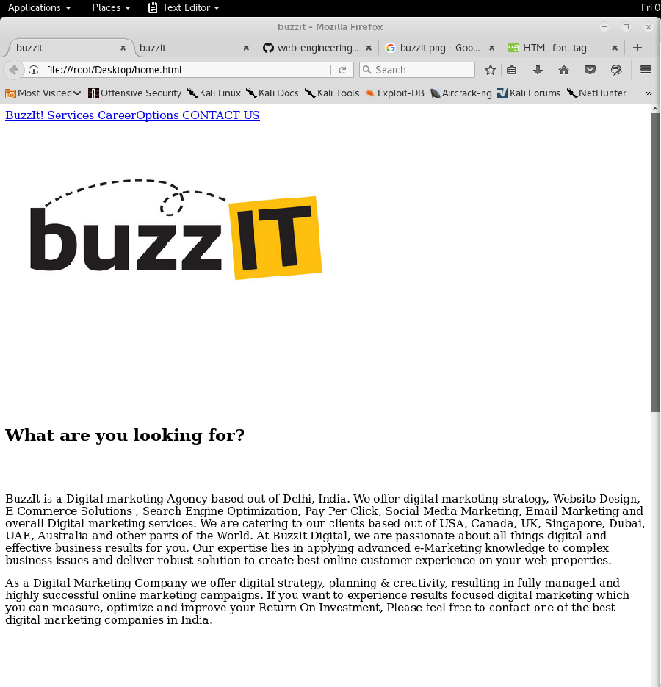

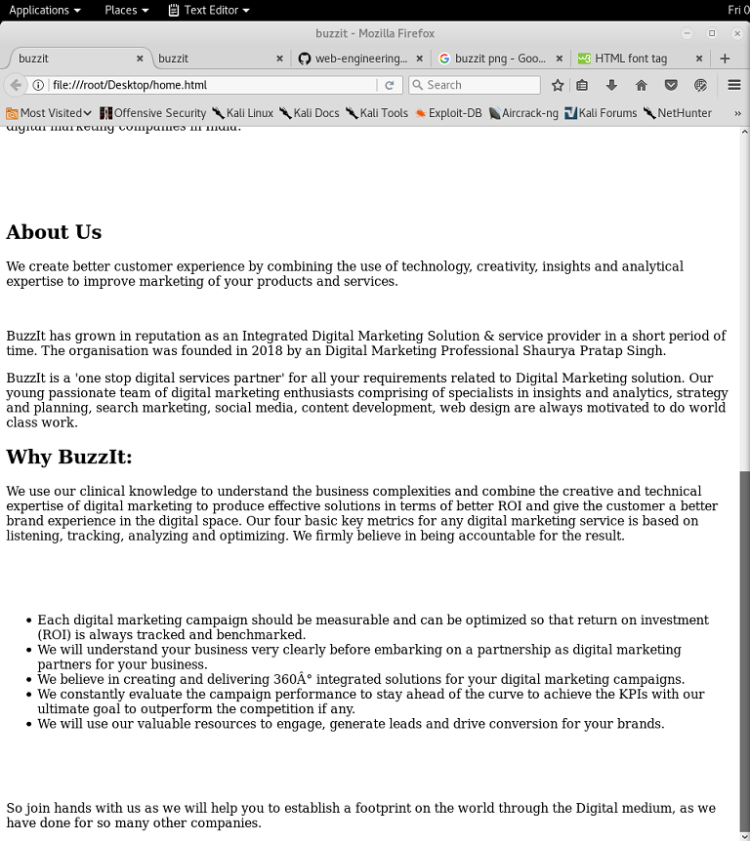

Source:

<HTML>
<HEAD>
<TITLE>buzzit</TITLE>
</HEAD>
<body>
<div class="pw" >
<a href="#"> BuzzIt! </a>
<a href="#band"> Services </a>
<a href="#tour" > CareerOptions </a>
<a href="#contact"> CONTACT US </a>
</div>
<br><br><br>
<img src="buzzitweb.jpg" height="250" width="500">
<br><br>
<font size="5" color="white" >Your Brand's Digital Marketing Performance Optimized</font>
<br><br>
<br><br>
</div>
<div class="default">
<br><br>
<h2>What are you looking for?</h2>
<br><br>
<p>BuzzIt is a Digital marketing Agency based out of Delhi, India. We offer digital marketing strategy, Website Design, E Commerce Solutions , Search Engine Optimization, Pay Per Click, Social Media Marketing, Email Marketing and overall Digital marketing services. We are catering to our clients based out of USA, Canada, UK, Singapore, Dubai, UAE, Australia and other parts of the World. At BuzzIt Digital, we are passionate about all things digital and effective business results for you. Our expertise lies in applying advanced e-Marketing knowledge to complex business issues and deliver robust solution to create best online customer experience on your web properties.</p>
<p>As a Digital Marketing Company we offer digital strategy, planning & creativity, resulting in fully managed and highly successful online marketing campaigns. If you want to experience results focused digital marketing which you can measure, optimize and improve your Return On Investment, Please feel free to contact one of the best digital marketing companies in India.</p>
<br><br>
<br><br>
<h2>About Us</h2>
<p>We create better customer experience by combining the use of technology, creativity, insights and analytical expertise to improve marketing of your products and services.</p>
<br>
<p>BuzzIt has grown in reputation as an Integrated Digital Marketing Solution & service provider in a short period of time. The organisation was founded in 2018 by an Digital Marketing Professional Shaurya Pratap Singh.</p>
<p>BuzzIt is a &#39;one stop digital services partner&#39; for all your requirements related to Digital Marketing solution. Our young passionate team of digital marketing enthusiasts comprising of specialists in insights and analytics, strategy and planning, search marketing, social media, content development, web design are always motivated to do world class work.</p>
<h2 >Why BuzzIt:</h2>
<p>We use our clinical knowledge to understand the business complexities and combine the creative and technical expertise of digital marketing to produce effective solutions in terms of better ROI and give the customer a better brand experience in the digital space. Our four basic key metrics for any digital marketing service is based on listening, tracking, analyzing and optimizing. We firmly believe in being accountable for the result.</p>
<br><br><br>
<ul>
<li>Each digital marketing campaign should be measurable and can be optimized so that return on investment (ROI) is always tracked and benchmarked.</li>
<li>We will understand your business very clearly before embarking on a partnership as digital marketing partners for your business.</li>
<li>We believe in creating and delivering 360° integrated solutions for your digital marketing campaigns.</li>
<li>We constantly evaluate the campaign performance to stay ahead of the curve to achieve the KPIs with our ultimate goal to outperform the competition if any.</li>
<li>We will use our valuable resources to engage, generate leads and drive conversion for your brands.</li>
</ul>
<br><br><br>
<p>So join hands with us as we will help you to establish a footprint on the world through the Digital medium, as we have done for so many other companies.</p>

</div>
</body>

</HTML>

