Sentiment Analysis of Amazon Fine Food Reviews
Project Report — NLTK VADER Sentiment Scoring

1. Objective
This project analyzes the sentiment of real Amazon Fine Food Reviews using NLTK's VADER (Valence Aware Dictionary and sEntiment Reasoner), a lexicon-based sentiment tool, and compares the resulting sentiment scores against each review's actual star rating to see how well text sentiment agrees with the rating the customer gave.

2. Dataset
The dataset contains 568,454 Amazon food product reviews, each with a star rating (1–5) and free-text review content. Ratings are heavily skewed toward 5 stars (363,122 reviews, 63.9%), with 1-star reviews as the next largest group (52,268, 9.2%).
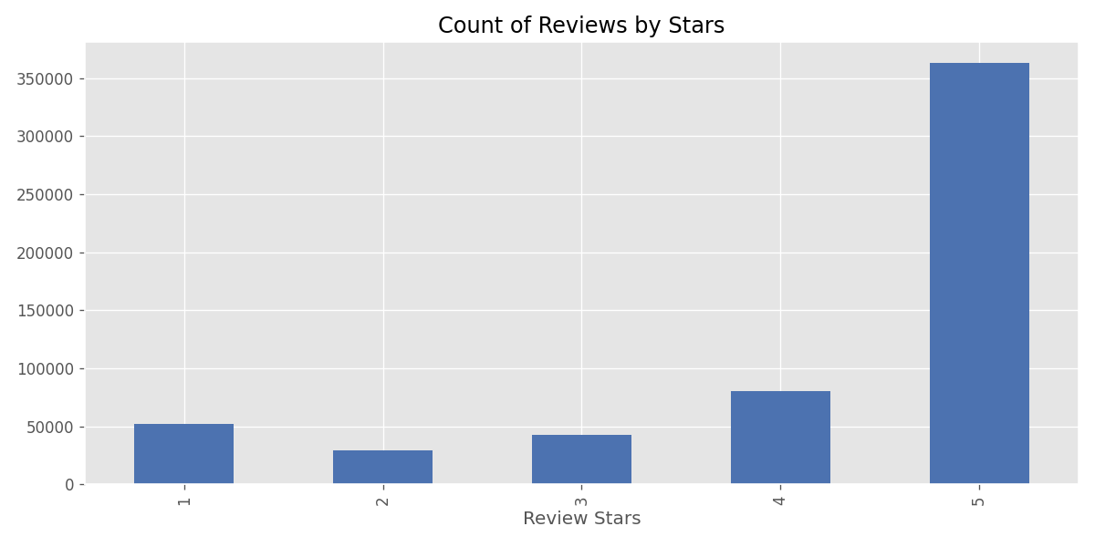
Figure 1: Number of reviews per star rating.

3. Methodology
Text was tokenized and POS-tagged with NLTK, and named-entity recognition correctly identified product/brand mentions (e.g. ‘Quaker Oats’ tagged as an organization) in a sample review. VADER's polarity_scores() function was then run on each review's text, producing a negative, neutral, positive, and compound sentiment score.
Running VADER on all 568,454 reviews individually was too slow for this session, so it was run on a random sample of 100,000 reviews (17.6% of the data, seed=42) — large enough to be statistically representative. Note: this project's code also included a Step 2 using a RoBERTa transformer model (cardiffnlp/twitter-roberta-base-sentiment) for context-aware scoring; that step could not be run here because this environment has no access to Hugging Face's model hub, so all results below are VADER-only.

4. Results
Average VADER sentiment scores rise consistently with star rating, confirming the model captures the overall sentiment trend correctly:
Star Rating | Mean Compound | Mean Positive | Mean Negative
1 star | 0.034 | 0.096 | 0.096
2 stars | 0.262 | 0.114 | 0.077
3 stars | 0.479 | 0.139 | 0.056
4 stars | 0.698 | 0.185 | 0.039
5 stars | 0.774 | 0.222 | 0.032
Table 1: Mean VADER sentiment scores by star rating (100,000-review sample).
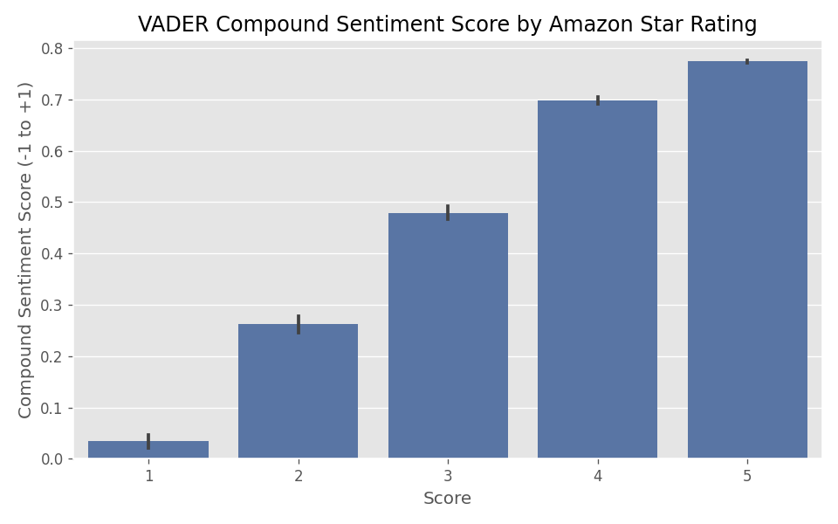
Figure 2: VADER compound sentiment score by star rating.
Treating compound ≥ 0.05 as “Positive,” ≤ −0.05 as “Negative,” and the rest as “Neutral,” and comparing against star-based ground truth (4–5★ = positive, 1–2★ = negative, 3★ = neutral), VADER agrees with the star rating’s polarity 79.8% of the time overall — but accuracy is uneven across classes:
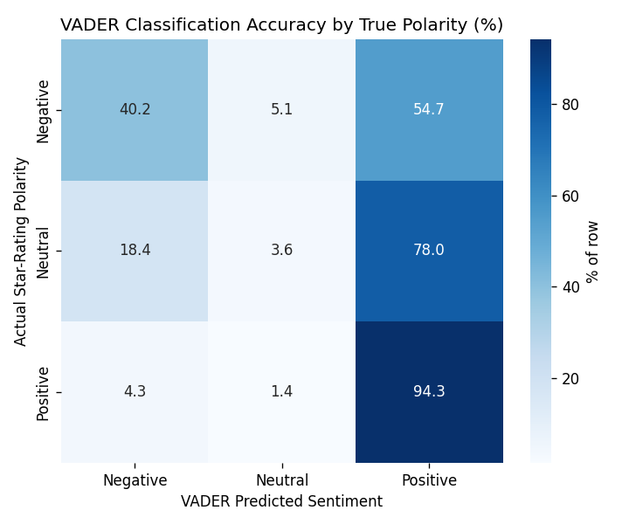
Figure 3: % of each true polarity class VADER classified correctly.
- Positive reviews: 94.3% correctly identified as positive — VADER's strongest case.
- Negative reviews: only 40.2% correctly identified as negative; 54.7% were misclassified as positive.
- Neutral (3★) reviews: only 3.6% classified as neutral; most (78.0%) were scored positive.
This asymmetry has a clear cause: VADER scores text as a bag of words, so a critical review that still uses positive descriptive words about the product (“great flavor, but arrived broken”) or that relies on negation (“no mess, no gas, no cruelty” — the most negative-scored 5-star review in the sample, despite being high praise) confuses its lexicon-based scoring.

5. Conclusion
VADER is a fast, dependency-light baseline that correctly captures the broad sentiment trend across star ratings and excels at identifying positive reviews (94.3% accuracy). However, it is notably weaker at detecting negative and neutral sentiment, mainly due to its inability to understand context, sarcasm, and negation the way a full sentence would be read by a human. For production use, pairing VADER with a context-aware transformer model (such as the RoBERTa model this project's code also included) would likely close much of this gap, particularly for negative-review detection — which matters most for catching genuine customer complaints.

