

Technical Safety Concept Lane Assistance

**Document Version: [Version]**

**Template Version 1.0, Released on 2017-06-21**



# Document history

**[Instructions: Fill in the date, version and description fields. You can fill out the Editor field with your name if you want to do so. Keep track of your editing as if this were a real world project.**

**For example, if this were your first draft or first submission, you might say version 1.0. If this is a second submission attempt, then you'd add a second line with a new date and version 2.0]**

|  |  |  |  |
| --- | --- | --- | --- |
| Date | Version | Editor | Description |
| 21-5-2018 | 1.0 | Shaurya Dwivedi | First Attempt |
|  |  |  |  |
|  |  |  |  |
|  |  |  |  |
|  |  |  |  |

# 

# Table of Contents

**[Instructions: We have provided a table of contents. If the table of contents is not showing up correctly in your word processor of choice, please update it. The table of contents should show each section of the document and page numbers or links. Most word processors can do this for you. In** [**Google Docs**](https://support.google.com/docs/answer/116338?co=GENIE.Platform%3DDesktop&hl=en)**, you can use headings for each section and then go to Insert > Table of Contents.** [**Microsoft Word**](https://support.microsoft.com/en-us/help/285059/how-to-create-a-table-of-contents-by-marking-text-in-word) **has similar capabilities]**

Document history

Table of Contents

Purpose of the Technical Safety Concept

Inputs to the Technical Safety Concept

Functional Safety Requirements

Refined System Architecture from Functional Safety Concept

Functional overview of architecture elements

Technical Safety Concept

Technical Safety Requirements

Refinement of the System Architecture

Allocation of Technical Safety Requirements to Architecture Elements

Warning and Degradation Concept

# Purpose of the Technical Safety Concept

**[Instructions: Answer what is the purpose of a technical safety concept?]**

The purpose of the technical safety concept is to go into the technical details of the systems whoes bird’s eye view was taken from the functional safety system .Here we have to identify new requirement and allocate the required resource(hardware and software) to the system diagram.

# Inputs to the Technical Safety Concept

## Functional Safety Requirements

**[Instructions: Provide the functional safety requirements derived in the functional safety concept ]**

|  |  |  |  |  |
| --- | --- | --- | --- | --- |
| **ID** | **Functional Safety Requirement** | **ASIL** | **Fault Tolerant Time Interval** | **Safe State** |
| Functional  Safety  Requirement  01-01 | The ECU should ensure that the oscillating torque amplitude for lane departure is below the MAX_Torque_Amplitude | C | 50 ms | Turn off the lane departure warning system |
| Functional  Safety  Requirement  01-02 | The ECU should ensure that the oscillating torque frequency for lane departure is below the MAX_Torque_Frequency | C | 50 ms | Turn off the lane departure warning system |
| Functional  Safety  Requirement  02-01 | The ECU should ensure that the oscillating torque duration for lane departure is not exceeding the MAX_Duration | B | 500 ms | Turn off the lane departure warning system |

## Refined System Architecture from Functional Safety Concept

**[Instructions: Provide the refined system architecture from the functional safety concept]**

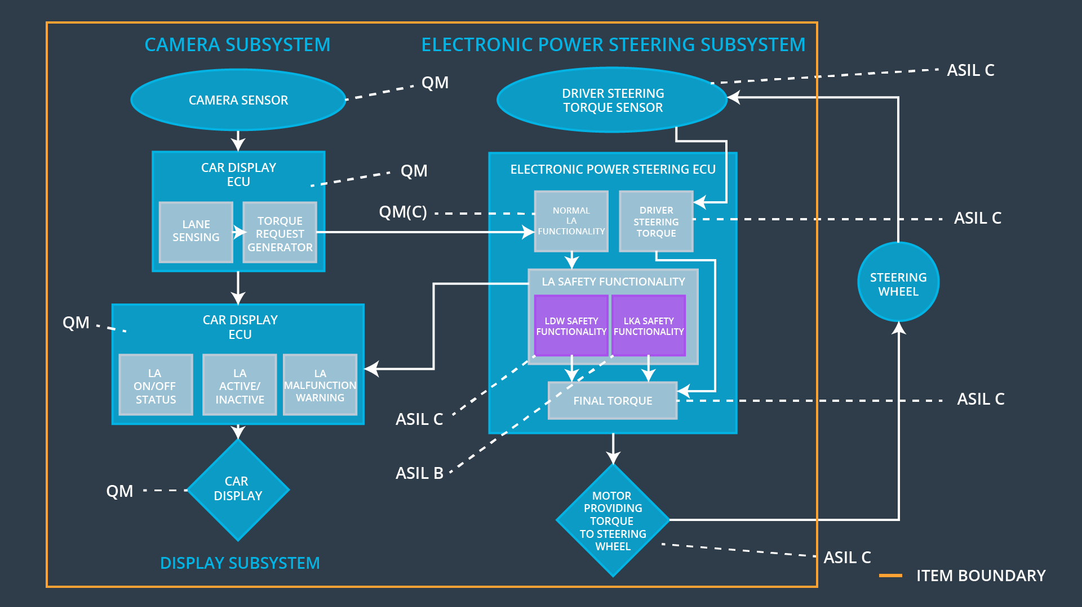

### 

### Functional overview of architecture elements

**[Instructions: Provide a description for each functional safety element; what is each element's purpose in the lane assistance item? ]**

|  |  |
| --- | --- |
| **Element** | **Description** |
| Camera Sensor | Provides lane images to the Camera Sensor ECU |
| Camera Sensor ECU - Lane Sensing | Gets the position of the car on lane by the image provided by the camera sensor |
| Camera Sensor ECU - Torque request generator | It is used to send the required torque to the power steering ECU |
| Car Display | It is uses to display warnings to the driver |
| Car Display ECU - Lane Assistance On/Off Status | Indicate the status of the Lane Assistance functionality |
| Car Display ECU - Lane Assistant Active/Inactive | Indicate if the Lane Assistance functionality is properly functioning |
| Car Display ECU - Lane Assistance malfunction warning | It receives the status of the lane assistant function from the power steering ECU in form of signals and if there is any malfunction in the signal it conveys the same to the car display system. |
| Driver Steering Torque Sensor | Measure the torque applied by the driver on the steering wheel by the driver. |
| Electronic Power Steering (EPS) ECU - Driver Steering Torque | Software module receiving the driver’s torque request from the steering wheel. |
| EPS ECU - Normal Lane Assistance Functionality | Software module receiving the Camera Sensor ECU torque request. |
| EPS ECU - Lane Departure Warning Safety Functionality | It ensure the LDW safety functionality |
| EPS ECU - Lane Keeping Assistant Safety Functionality | It receives the request from the camera subsystem and conveys it to the steering wheel through the motor. |
| EPS ECU - Final Torque | Combine the torque request from the Lane Keeping and Lane Departure Warning functionalities and sends them to the Motor. |
| Motor | Receives the torque from the ECU and applies it to the steering wheel |

# Technical Safety Concept

## Technical Safety Requirements

**[Instructions: Fill in the technical safety requirements for the lane departure warning first functional safety requirement. We have provided the associated functional safety requirement in the first table below. Hint: The technical safety requirements were discussed in the lesson videos. The architecture allocation column should contain element names such as LDW Safety block, Data Transmission Integrity Check, etc. Allocating the technical safety requirements to the "EPS ECU" does not provide enough detail for a technical safety concept.]**

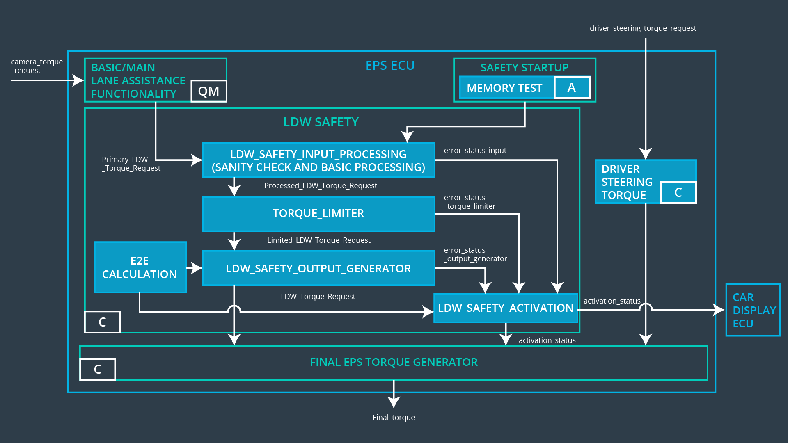

**Lane Departure Warning (LDW) Requirements:**

Functional Safety Requirement 01-01 with its associated system elements

(derived in the functional safety concept)

|  |  |  |  |  |
| --- | --- | --- | --- | --- |
| **ID** | **Functional Safety Requirement** | **Electronic Power Steering ECU** | **Camera ECU** | **Car Display ECU** |
| Functional  Safety  Requirement  01-01 | The lane keeping item shall ensure that the lane departure oscillating torque amplitude is below Max_Torque_Amplitude | X |  |  |

Technical Safety Requirements related to Functional Safety Requirement 01-01 are:

|  |  |  |  |  |  |
| --- | --- | --- | --- | --- | --- |
| **ID** | **Technical Safety Requirement** | **ASIL** | **Fault Tolerant Time Interval** | **Architecture Allocation** | **Safe State** |
| Technical  Safety  Requirement  01 | LDW safety component should ensure the amplitude of `LDW_Torque_Requesr` is below ‘Max_Torque_Amplitude’ | C | 50 ms | LDW safety | LDW torque request should be zero |
| Technical  Safety  Requirement  02 | The validity and integrity of the data transmission for LDW_Torque_Request signal shall be ensured. | C | 50 ms | Data Transmission integrity check. | **LDW torque request should be zero** |
| Technical  Safety  Requirement  03 | If a failure is detected by the LDW function it shall deactivate the LDW feature and set the torque to zero | C | 50 ms | LDW safety | LDW torque request should be zero |
| Technical  Safety  Requirement  04 | As soon as the LDW feature is deactivated by the LDW function the car display ECU should show a warning light. | C | 50 ms | LDW safety | LDW torque request should be zero |
| Technical  Safety  Requirement  05 | Memory test shall be conducted at start up of the EPS ECU to check for any memory problems | A | ignition cycle | **Safety startup - Memory test** | LDW torque request should be zero |

**[Instructions: Fill in the technical safety requirements for the lane departure warning second functional safety requirement. We have provided the associated functional safety requirement in the table below. Hint:. Most of the technical safety requirements will be the same. At least one technical safety requirement will have to be slightly modified because we are talking about frequency instead of amplitude. These requirements were not given in the lessons]**

Functional Safety Requirement 01-2 with its associated system elements

(derived in the functional safety concept)

|  |  |  |  |  |
| --- | --- | --- | --- | --- |
| **ID** | **Functional Safety Requirement** | **Electronic Power Steering ECU** | **Camera ECU** | **Car Display ECU** |
| Functional  Safety  Requirement  01-02 | The lane keeping item shall ensure that the lane departure oscillating torque frequency is below Max_Torque_Frequency | X |  |  |

Technical Safety Requirements related to Functional Safety Requirement 01-02 are:

|  |  |  |  |  |  |
| --- | --- | --- | --- | --- | --- |
| **ID** | **Technical Safety Requirement** | **ASIL** | **Fault Tolerant Time Interval** | **Architecture Allocation** | **Safe State** |
| Technical  Safety  Requirement  01 | The LDW security component should ensure that the frequency of "LDW_Torque_Request" is below "Max_Torque_Frequency" | C | 50 ms | LDW safety | LDW torque  frequency request should be zero |
| Technical  Safety  Requirement  02 | The validity and integrity of the data transmission for Max_Torque_Frequency signal shall be ensured. | C | 50 ms | Data Transmission integrity check. | **LDW torque frequency request should be zero** |
| Technical  Safety  Requirement  03 | If a failure is detected by the LDW function it shall deactivate the LDW feature and set the ‘Max_Torque_Frequency to zero | C | 50 ms | LDW safety | LDW torque  frequency request should be zero |
| Technical  Safety  Requirement  04 | As soon as the LDW feature is deactivated by the LDW function the car display ECU should show a warning light. | C | 50 ms | LDW safety | LDW torque  frequency request should be zero |
| Technical  Safety  Requirement  05 | Memory test should be done at start of the EPS ECU to check for any faults in memory | A | ignition cycle | **Safety startup - Memory test** | LDW torque  frequency request should be zero |

**Lane Departure Warning (LDW) Verification and Validation Acceptance Criteria:**

**[OPTIONAL: For each technical safety requirement, identify both the verification and validation acceptance criteria. “Validation” asks whether or not you chose the appropriate parameters. “Verification” involves testing to make sure the vehicle behaves as expected when the parameter value is crossed. There is not necessarily one right answer. Look at your verification and validation acceptance criteria from the functional safety concept for inspiration.]**

**Lane Keeping Assistance (LKA) Requirements:**

**[Instructions: Fill in the technical safety requirements for the lane keeping assistance functional safety requirement 02-01. We have provided the associated functional safety requirement in the table below. Hint:. You can reuse the technical safety requirements from functional safety requirement 01-01. But you need to change the language because we are now looking at a different system. The ASIL and Fault Tolerant Time Interval are different as well.]**

Functional Safety Requirement 02-1 with its associated system elements

(derived in the functional safety concept)

|  |  |  |  |  |
| --- | --- | --- | --- | --- |
| **ID** | **Functional Safety Requirement** | **Electronic Power Steering ECU** | **Camera ECU** | **Car Display ECU** |
| Functional  Safety  Requirement  02-01 | The lane keeping item shall ensure that the lane keeping assistance torque is applied for only Max_Duration | X |  |  |

Technical Safety Requirements related to Functional Safety Requirement 02-01 are:

|  |  |  |  |  |  |
| --- | --- | --- | --- | --- | --- |
| **ID** | **Technical Safety Requirement** | **ASIL** | **Fault Tolerant Time Interval** | **Allocation to Architecture** | **Safe State** |
| Technical  Safety  Requirement  01 | LKA security component should ensure that the amplitude of `LKA_Torque_Requesr` is below 'Max_Torque_Amplitude' | B | 500 ms | LKA safety | LKA torque request should be zero |
| Technical  Safety  Requirement  02 | The validity and integrity of the data transfer for the LKA_Torque_Request signal must be guaranteed. | B | 500 ms | Data Transmission integrity check. | **LKA torque request should be zero** |
| Technical  Safety  Requirement  03 | If an error is detected by the LKA function, the LKA function must be deactivated and the torque set to zero | B | 500 ms | LKA safety | LKA torque request should be zero |
| Technical  Safety  Requirement  04 | Sobald die LKA-Funktion durch die LKA-Funktion deaktiviert wird, sollte das Steuergerät des Auto-Displays eine Warnlampe anzeigen. | B | 500 ms | LKA safety | LKA torque request should be zero |
| Technical  Safety  Requirement  05 | The memory test should be performed when starting the EPS controller to check for memory errors | A | ignition cycle | **Safety startup - Memory test** | LKA torque request should be zero |

**Lane Keeping Assistance (LKA) Verification and Validation Acceptance Criteria:**

**[OPTIONAL: For each technical safety requirement, identify both the verification and validation acceptance criteria. “Validation” asks whether or not you chose the appropriate parameters. “Verification” involves testing to make sure the vehicle behaves as expected when the parameter value is crossed. There is not necessarily one right answer. Look at your verification and validation acceptance criteria from the functional safety concept for inspiration.]**

## Refinement of the System Architecture

**[Instructions: Include the refined system architecture. Hint: The refined system architecture should include the system architecture from the end of the technical safety lesson, including all of the ASIL labels.]**

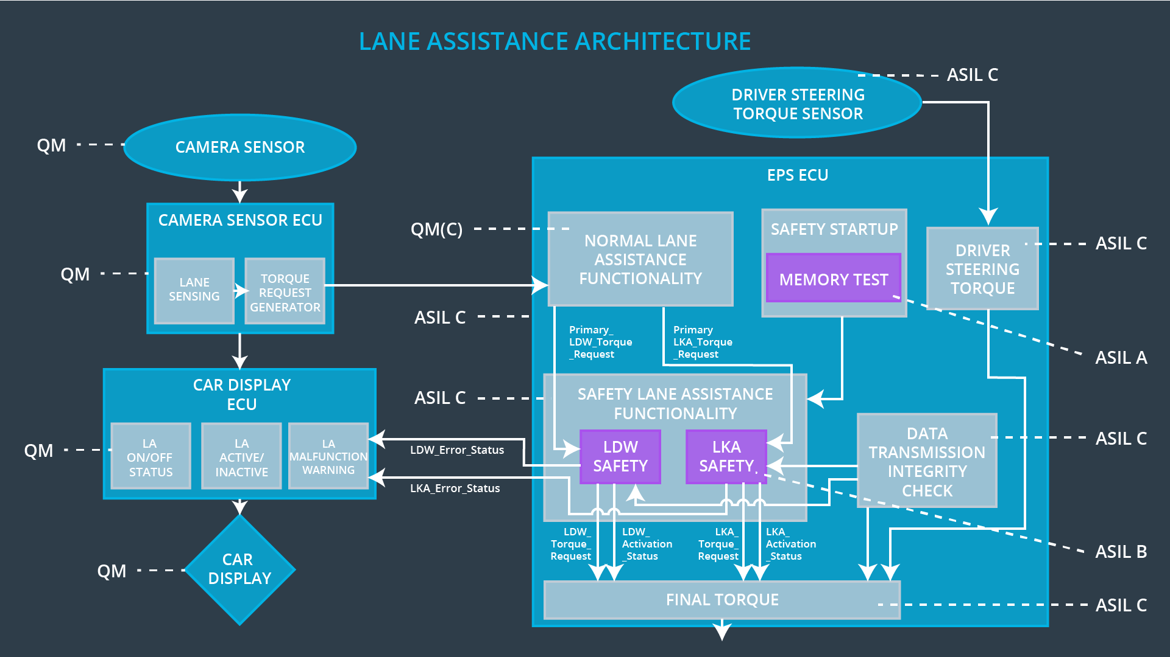

## Allocation of Technical Safety Requirements to Architecture Elements

**[Instructions: We already included the allocation as part of the technical requirement tables. Here you can state that for this particular item, all technical safety requirements are allocated to the Electronic Power Steering ECU]**

All technical safety requirements are allocated to the electronic power steering ECU. For exact allocation with EPS ECU compare the technical requirement table above.

## Warning and Degradation Concept

**[Instructions: We've already identified that for any system malfunction, the lane assistance functions will be turned off and the driver will receive a warning light indication. The technical safety requirements have not changed how functionality will be degraded or what the warning will be.**

**So in this case, the warning and degradation concept is the same for the technical safety requirements as for the functional safety requirements. You can copy the functional safety warning and degradation concept here.**

**Oftentimes, a technical safety analysis will lead to a more detailed warning and degradation concept.]**

|  |  |  |  |  |
| --- | --- | --- | --- | --- |
| **ID** | **Degradation Mode** | **Trigger for Degradation Mode** | **Safe State invoked?** | **Driver Warning** |
| WDC-01 | Turn off the lane assistance functionality | Malfucntion_01  Malfucntion_02 | Yes | Turn on warning light on car display |
| WDC-02 | Turn off the lane assistance functionality | Malfucntion_03 | Yes | Turn on warning light on car display |