Final Report

Secure Autonomous Braking System
Sobhi Zeidan, Abdo Mohsen and Shaurya Doger
Course Professor: Randy Boone
College of Engineering & Computer Science
University of Michigan – Dearborn

ABSTRACT
Secure Autonomous Braking scheme is an ever-emerging technology that has been on the rise for several years. Recent studies have shown this to reduce the number of traffic-related deaths that are mainly caused by drivers themselves. This paper emphasizes the project focused on developing autonomous braking systems within object-detection situations along with cyber protocols that would help prevent attacks into the systems. To get closer to more realistic scenarios, the development and testing was simulated through the MATLAB/Simulink components that would pave a path for Advanced Driver Assistance Systems.
INTRODUCTION
The objective of this project is to design and simulate a Collision Imminent Braking (CIB) system using Simulink. The CIB system is an advanced driver-assistance system (ADAS) designed to automatically apply the brakes when a potential collision is detected. This report details the creation of the Simulink model, the components used, and the results of the simulation.
System Overview:
The Collision Imminent Braking System consists of the following key components:
- Vehicle Model: A simple model that takes in accelerator pedal and brake torque and calculates the vehicle speed.
- Braking System: Models the braking mechanism.
- Collision Detection Module: Identifies potential collisions based on sensor (user-driven) inputs.
- Controller: Decides when to apply the brakes.

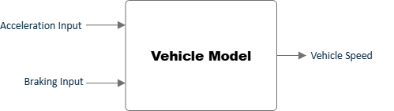
Figure 1: Vehicle Model Block Diagram
Vehicle model: The vehicle model simulates the vehicle speed. It includes the following components:
Acceleration Input: Represents the acceleration provided by the driver. This driver input is controlled via the MATLAB GUI and referenced by the Simulink model by (AccelPdlInput)
Driver Braking Input: Represents the braking percentage applied by the driver. This driver input is controlled through the MATLAB GUI and referenced by the Simulink model by (BrkPdlInput)
Velocity Calculation Output: Integrates acceleration to determine vehicle speed. The output vehicle speed is determined after considering other vehicle factors such as braking and vehicle torque.
High Overview of the Secure Auto Braking Simulink Model
Braking System: The braking system models the deceleration of the vehicle when the brakes are applied. It includes:
Brake-Force Calculation – Determines the force applied by the brakes.
Deceleration Calculation – Uses the brake force to calculate the resulting deceleration.
Updated-Velocity Calculation – Updates the vehicle's speed based on deceleration.
Brake-Torque Block:
Input – Attains input as a braking percentage from either the driver ‘or’ autonomous braking mode, as decided by “Autobraking” block.
Function – Utilizes product of the following variables to calculate total brake torque:
- k is a constant representing the system’s mechanical and hydraulic gains.
- P is the pedal position as a percentage (e.g., 50%) as stated for the above input.
- A is the area of the brake piston.
- R is the effective radius of the rotor.
- μ is the coefficient of friction.
Output – The total brake torque required gets fed as an input to the “Vehicle-Forces” Block shown below.
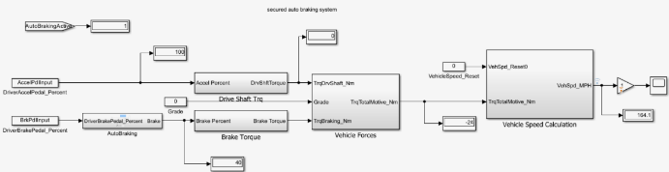
Figure 2: Secure Auto Braking System Simulink Model
Vehicle-Speed Calculation Block:
Inputs – Attains Overall Net Torque from the previous Vehicle Forces Block as input.
Function – This section performs several calculation steps shown below to attain final output of Instantaneous Velocity:
Total Motive Force – This gets calculated by dividing Total Torque with Wheel Radius.
Vehicle Acceleration – This gets calculated through this formula (Total-Motive-Force / Vehicle-Mass).
Vehicle Velocity – This is attained through integral calculus of Vehicle Acceleration value as a time function.
Output – As stated above, velocity as the final output gets sent back to the GUI display via workspace.
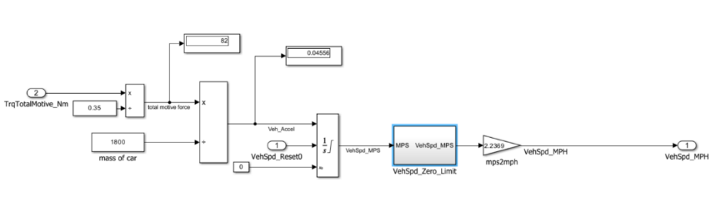
Figure 3: vehicle Speed block used to calculate output vehicle speed
Collision Detection Module & Controller (Autobraking block): In a real-world application, collision detection is a software algorithm that determines potential vehicle accident events based on data acquired from different types of vehicle sensors such as the camera, radar, or LIDAR:
Autobraking block:
Inputs – Auto-braking percentage, Driver-braking percentage, Object-Detection sensors, Distance-from-Object, and Authentication.
Function – The microprocessor performs computation on this data and determines if a collision is imminent, then transmits a signal to other vehicle modules to perform other functions like auto steering or auto braking:
Following conditions are required for autonomous-braking functionality:
- Object-Detection = True
- Authentication-Key = 9245
- Distance-from-Object < 3m
Output – Based on the inputs for this module, either the driver-braking-percentage ‘or’ auto-braking will get activated but never at the same time.
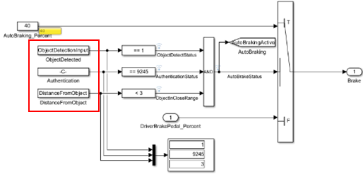
Figure 4: Auto Braking Block
In the Simulink model, both the object detection and distance sensor inputs are controlled by the user through MATLAB GUI and considered in the Auto Braking Block within Simulink. The user can set the object detection signal (ObjectDetectionInput) value to 1 (Object Detection = True) or 0 (Object Detection = False).
Similarly, the user can set the distance from object (DistanceFromObject) value as long it’s less than the requirements 3m. These values are two of the critical criteria that are considered by the Simulink algorithm to determine if the distance to an obstacle is less than a safe threshold, then object detection is set, thus Auto Braking event will occur.
Cyber Security Authentication: The system scheme was implemented with a system where user must provide input-value of “9245” for the system to be functional. Any other input-value will cause authentication-error that will disable autobraking system functionality. This is extremely essential so that any intrusion ‘and’ false object-detections get counteracted.
Functional safety: System should bring the vehicle speed down to a safe level or to zero according to the distance from the object. We can expand on this theoretically but mention that we did not count for timing of auto deceleration in the model.
GUI-Overview:
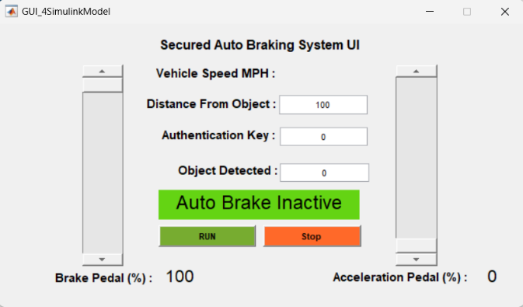
Figure 5: Default MATLAB GUI for Secure Auto Braking Simulink Model

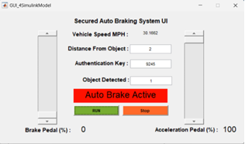
Figure 6: Auto braking is activated as distance; authentication key and object detection conditions are met.
Brake Pedal (%): This element mimics a vehicle’s brake pedal and returns an integer value between 0 and 100% which is used in the model (BrkPdlInput) to control vehicle braking behavior.
Acceleration Pedal (%): This element of the UI mimics vehicle’s acceleration pedal and returns an integer range between 0 and 100% which is used by the model (AccelPdlInput) to determine vehicle.
Object Detection: This is an input and returns a 0 or 1 value which behaves as a vehicle sensor (Radar/Camera…). This input provides information to the model (ObjectDetectionInput) to determine if an object has been detected or undetected for 0 and 1 respectively.
Authentication key: This is an input which is used in the model (AuthKeyInput = 9245) for security purposes. This is defined to prevent false auto braking that can occur due to unauthorized security overrides. If this value matches the security key within the model, the auto braking is authenticated, thus vehicle auto braking is allowed.
Distance from Object: This mimics another vehicle’s sensor input that measures the distance between the vehicle and the detected object. In the model (DistanceFromObject < 3) is defined so that when the vehicle is close, less than 3m, then auto braking is engaged.
The GUI also includes other elements such as Run/Stop to initiate and abort the simulation. In addition, the GUI provides other useful visual information to the user such as vehicle speed, Auto braking status, and brake and acceleration pedal percentage traveled.
Results:
After running the script, both Simulink model and Matlab GUI launched successfully, and the end user can manipulate the model’s parameters flawlessly. When the model receives acceleration input, and the brakes are depressed, the model will determine the output vehicle speed, brake status and total torque as shown in figure 7 and figure 8.
Figure 7 below shows the vehicle speed's behavior with respect to the acceleration and brake pedal. Vehicle decelerates when brake pedal is applied by the driver or autonomously. Vehicle accelerates when acceleration pedal is pressed, and torque is applied.

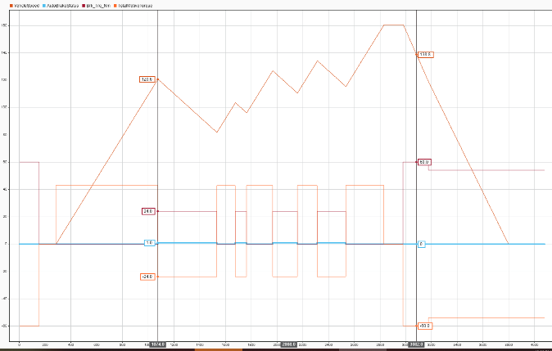
Figure 7: Vehicle Speed, Brake status and Total Motive Torque
Figure 8 below shows desired torque to be zero when Brake is applied resulting in vehicle deceleration and non-zero when Brake is not applied, as expected.
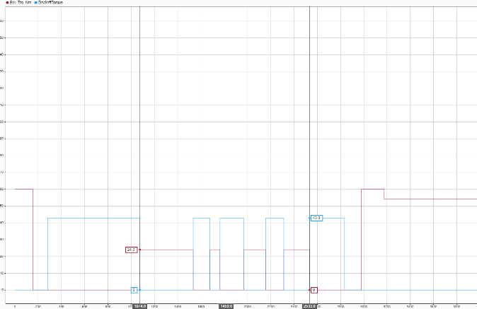
Figure 8: Brake Torque and Desired Torque
Figure 9 below shows that autonomous braking is only engaged when an object is detected, you are close to the object (less than 3 meters), and the authentication key is valid. When all these are valid, automatic braking status will be set to 1 and automatic braking is engaged. Signal in light blue shows Automatic braking engaged. Notice when that is valid, brake torque ramps up (Burgendy signal) and when it’s not valid, total motive torque ramps up (orange signal).

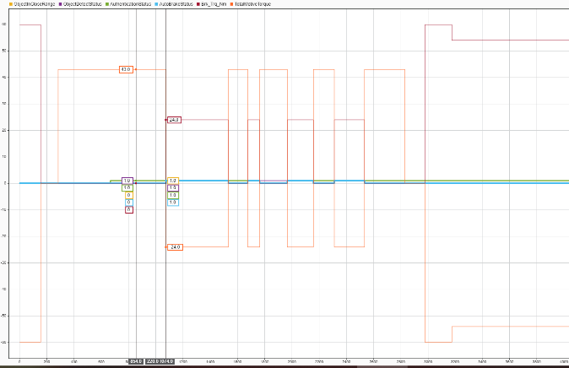
Figure 9: Auto Brake Status, Brake Torque and Total Motive Torque
Conclusion:
The Simulink model successfully simulates a Collision Imminent Braking system. The model demonstrates how the vehicle's speed is controlled to prevent collisions based on sensor inputs. The system can be further enhanced by incorporating more realistic vehicle dynamics, advanced sensor models, and sophisticated control algorithms.
Project Files:
To open the model in Matlab you will need version 2022a or newer. Open the FinalProjectModel.slx file and then run the GUI GUI_4SimulinkModel.m. Download all the content in one folder.
The model has signal logs that can be viewed in Data Inspector. The workspace has a logsout file that is saved after model run is completed.

References:
[1] Macher, G., Messnarz, R., Armengaud, E., Riel, A., Brenner, E., & Kreiner, C. (2017). Integrated Safety and Security Development in the Automotive Domain. SAE Technical Paper 2017-01-1661. SAE International. https://doi.org/10.4271/2017-01-1661

[2] T. Stolte, G. Bagschik and M. Maurer, "Safety goals and functional safety requirements for actuation systems of automated vehicles," 2016 IEEE 19th

[3] International Conference on Intelligent Transportation Systems (ITSC), Rio de Janeiro, Brazil, 2016, pp. 2191-2198, doi: 10.1109/ITSC.2016.7795910. keywords: {Safety;Vehicles;Actuators;Wheels;Vehicle dynamics;Brakes;Dynamics},

[4] Engineers Edge. "Braking Torque Equation and Calculator," accessed August 8, 2024. [Online]. Available: https://engineersedge.com/mechanics_machines/braking_torque_13635.htm.
[5] The Engineering ToolBox. "Disk Brakes - Torque and Force," . [Online]. Available: https://www.engineeringtoolbox.com/disk-brakes-d_1808.html.
[6] Sciencing. "How to Calculate Brake Torque," . [Online]. Available: https://sciencing.com/calculate-brake-torque-6076252.html.
[7] Simulink getting started Guide- MathWorks Get Started with Simulink (mathworks.com)
[8] Chien, S., Lingxi Li, A. M. Ari, A. Meadows, H. Banvait, Yaobin Chen, M. T. Moury, and G.
R. Widmann. “A New Scoring Mechanism for Vehicle Crash Imminent Braking Systems.” IEEE
Intelligent Transportation Systems Magazine 4, no. 4 (2012). https://doi.org/10.1109/MITS.2012.2217561

