

ECE 544 – Mobile Robots
Instructor: Dr. Guilherme Vieira Hollweg
Winter 2025
Final Project Report
Apr 22,2025

Comparison of PID, LQR, SMC, MRAC-Model Reference Adaptive Controller for Autonomous Car Trajectory Tracking

- Karthik Rengarajan
- Shaurya Doger
- Introduction

Trajectory tracking plays a critical role in the “Act” phase of the See–Think–Act cycle (Fig. 1), especially in autonomous vehicles where accuracy and safety are paramount. These systems must operate reliably in dynamic and uncertain environments, which include sensor noise, road irregularities, and unexpected obstacles. The ability to accurately follow a planned trajectory ensures smooth and stable vehicle motion, forming a key part of the high-level control loop.

Numerous control strategies have been proposed over the years, ranging from classical model-based methods to adaptive and learning-based approaches. Recently, there has been increasing interest in hybrid control methods that integrate AI with traditional control techniques to improve robustness and adaptability in real-world scenarios.
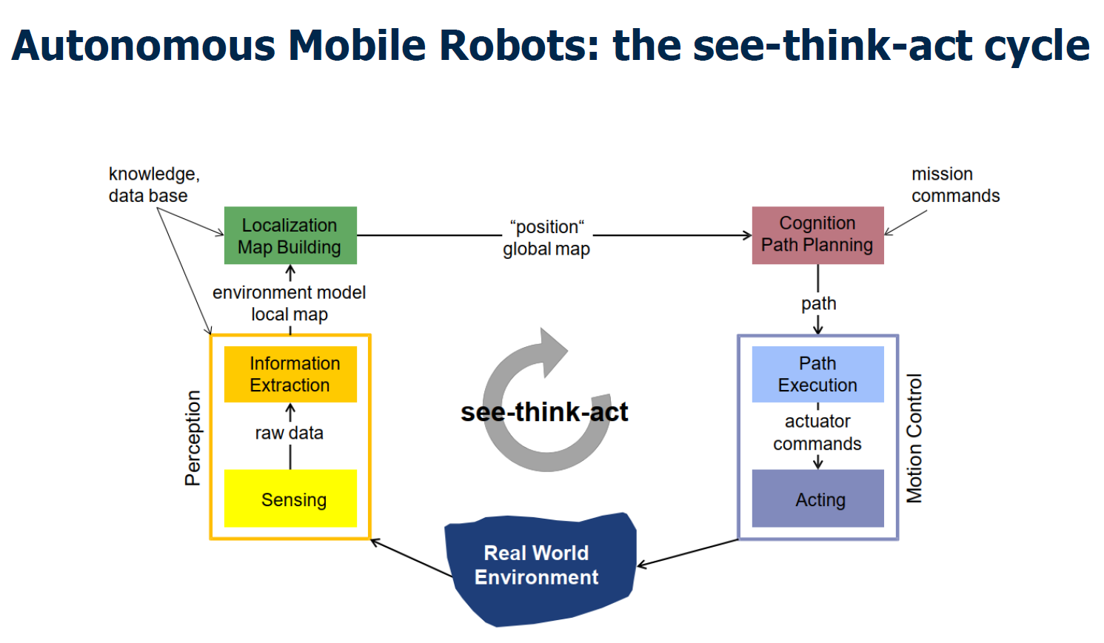
Fig:1 “See-Think-Act” cycle

- Project Overview
This project compares four commonly used trajectory tracking controllers under different driving scenarios:
- PID – Proportional-Integral-Derivative Controller
- LQR – Linear Quadratic Regulator
- SMC – Sliding Mode Controller
- MRAC – Model Reference Adaptive Controller
The goal is to gain hands-on experience in implementing and tuning these controllers within a simulated autonomous vehicle environment using MATLAB/Simulink. The following toolboxes were utilized:
- Vehicle Dynamics Toolbox – to simulate realistic car behavior
- Automated Driving Toolbox – to visualize the tracking performance
Three different maneuvers have been picked for this project:
- Low Speed Curved trajectory
- High Speed Curved trajectory
- US City maneuver (varying vehicle speed)
The following figure Fig.2 shows the base simulation setup in Simulink outlining the Controller block which is the primary work of this project.
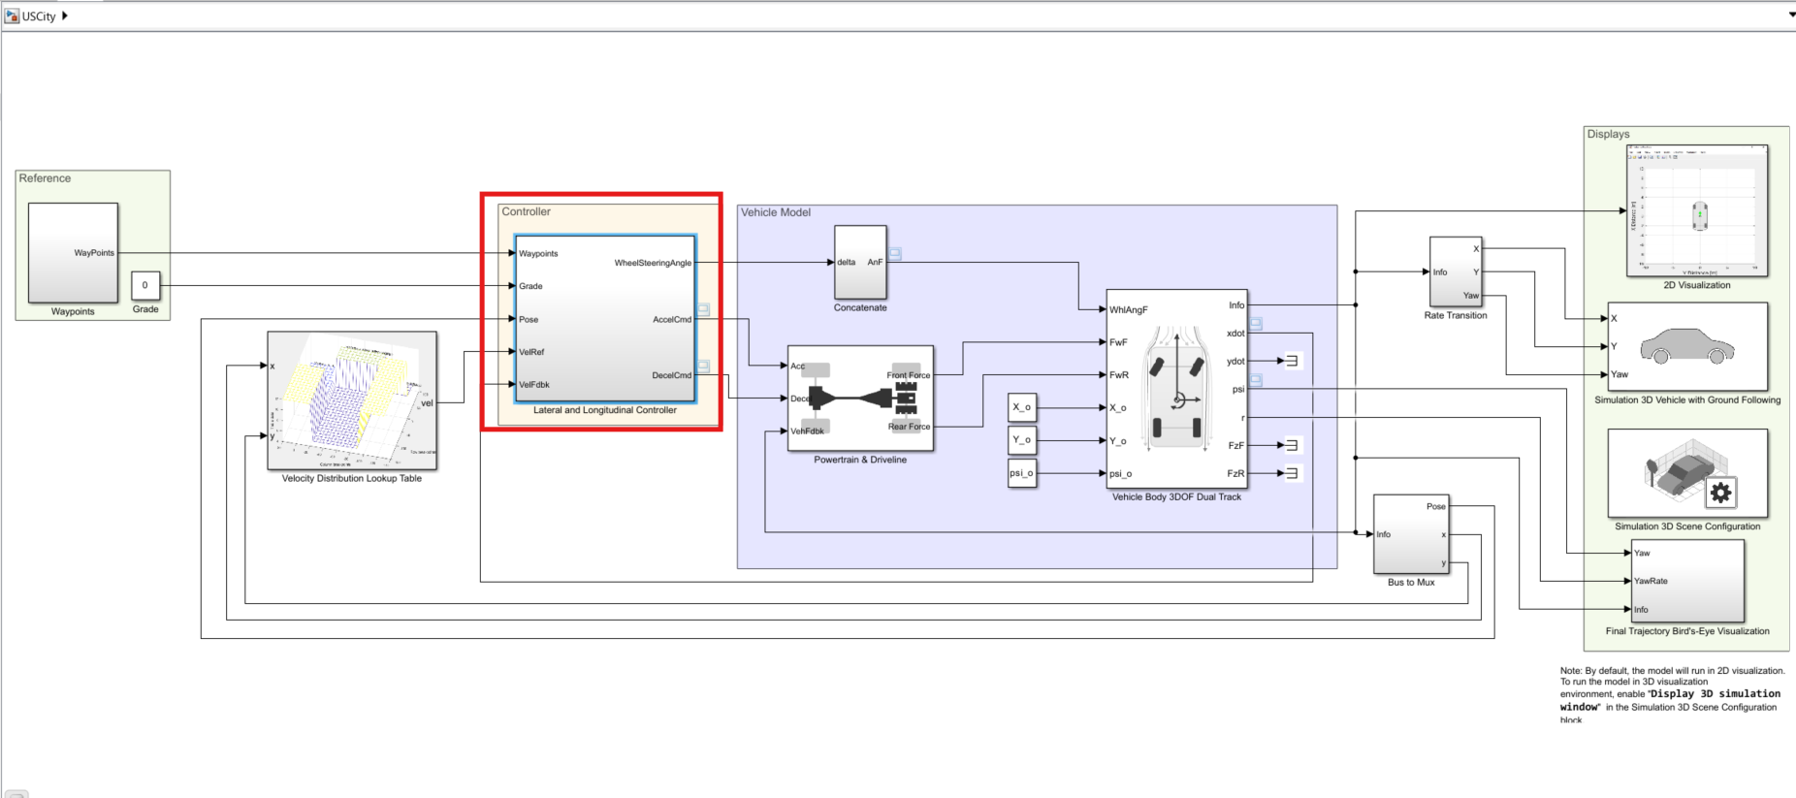
Fig.2 MATLAB Simulink Simulation Set-Up

The controller is divided into two parts:
- Longitudinal Controller – for acceleration and braking (reused)
- Lateral Controller – the focus of this project (custom-built)
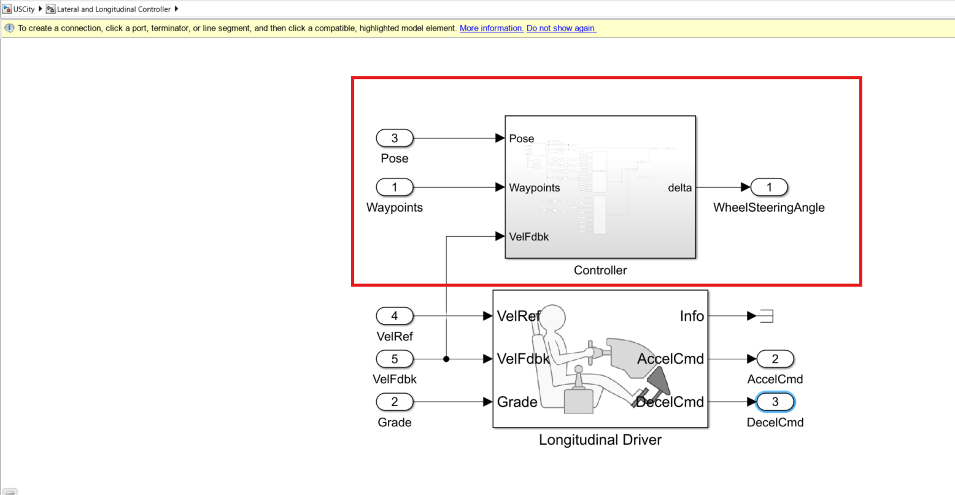
Fig.3 Controller

The simulation setup, except the lateral controller, was adapted from a MathWorks repository: https://www.mathworks.com/matlabcentral/fileexchange/77798-vehicle-path-tracking-using-pure-pursuit-controller
Key reused components include:
- Waypoint generator
- Target velocity profile
- 3DOF vehicle dynamics model
- Driveline and powertrain simulation
- Longitudinal driver (acceleration/brake logic)
- Visualization tools
The original Pure Pursuit controller was replaced with the custom controllers designed for this project.
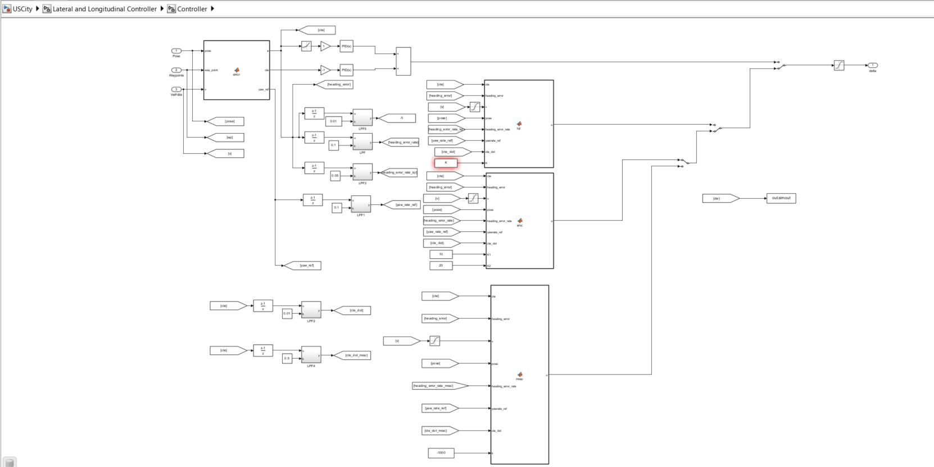
Fig. 4 Lateral Controller block

The main components of this block are:
- Lateral Error calculation: This function takes in the current ego vehicle pose, waypoints and the current vehicle speed to calculate the cross track and heading error of the vehicle. The error is calculated by looking at the nearest waypoint from the vehicle and determining the perpendicular distance from the vehicle to the nearest waypoint. Along with this, it calculates the heading error by taking the current vehicle yaw and the slope of the waypoint at the identified nearest waypoint.
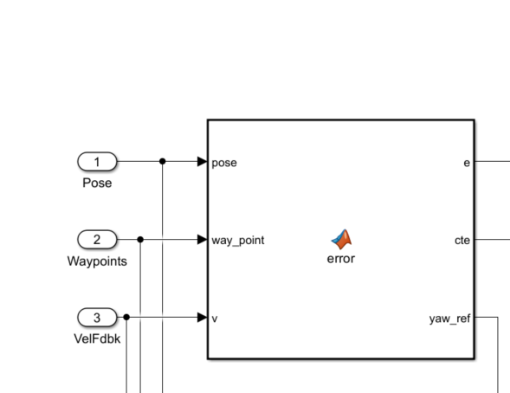
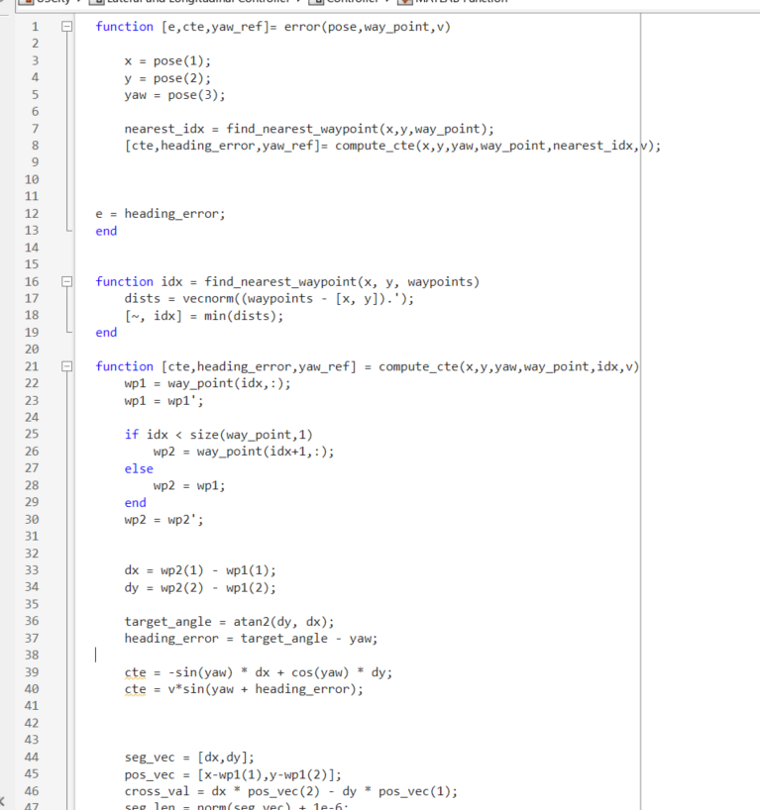
Fig. 5 Error calculation function

- PID Controller – Used Simulink’s PID controller block to implement this
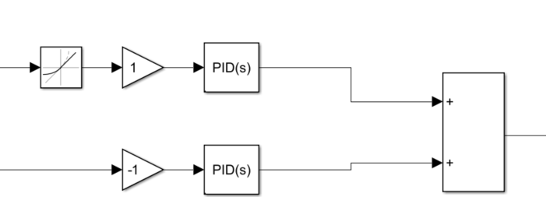

Fig 6 PID Controller

All the controllers below use the Linear Bicycle model equations as the system as
the base system.
$\ddot{y}= -2*\frac{C_{af}+C_{ar}}{m*V_{x}}*\dot{y}-\left(V_{x}+2*\frac{C_{af}*l_{f}-C_{ar}*l_{r}}{m*V_{x}}\right)*\dot{ψ}+2*\frac{C_{af}}{m}*δ$

$\ddot{ψ}= -2*\frac{l_{f}*C_{af}-l_{r}*C_{ar}}{I_{z}*V_{x}}*\dot{y}-2*\frac{l_{f}^{2}*C_{af}+l_{r}^{2}*C_{ar}}{I_{z}*V_{x}}*\dot{\dot{ψ}+2*l_{f}*\frac{C_{af}}{I_{z}}*δ}$

Here,
$ψ=Yaw of the vehicle$
$y=Lateral displacement of the vehicle$

- LQR Controller – Wrote a custom function from to execute the controller. The LQR gain is pre-computed offline using a custom written script for the given vehicle speed by setting up Infinite Horizon optimization problem and using Simulink’s library to solve the Riccati equation. The primary reason to pre-compute the LQR gain was to avoid solving the Riccati equation online as the existing MATLAB libraries did not support online simulation of the block. Linear Bicycle model has been used to set up this controller.

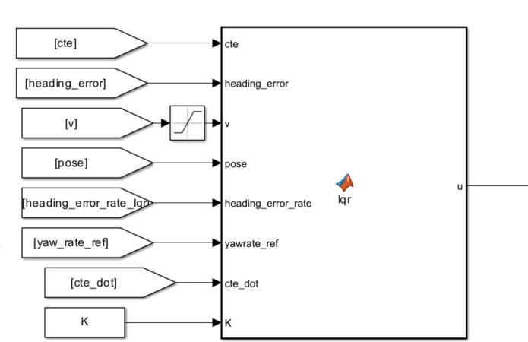

The following equation is the basis for this controller:

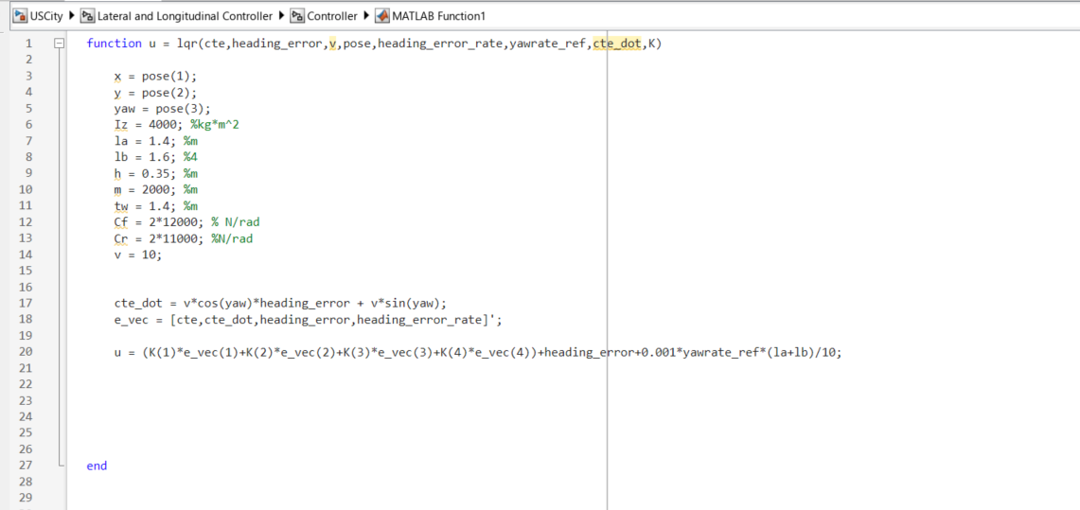
Fig. 7 LQR Controller Function

- Sliding Mode Controller – A custom defined Sliding Mode controller function has been written here. Linear Bicycle model has been used to set up this controller. Different sliding surfaces were chosen for the fixed speed case and the US City driving case.

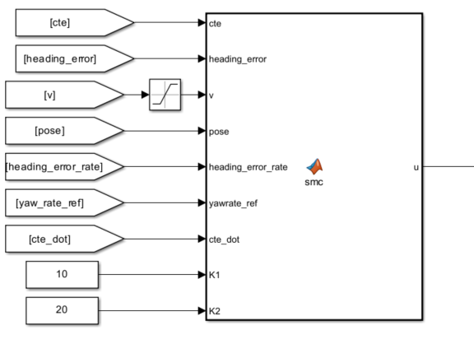
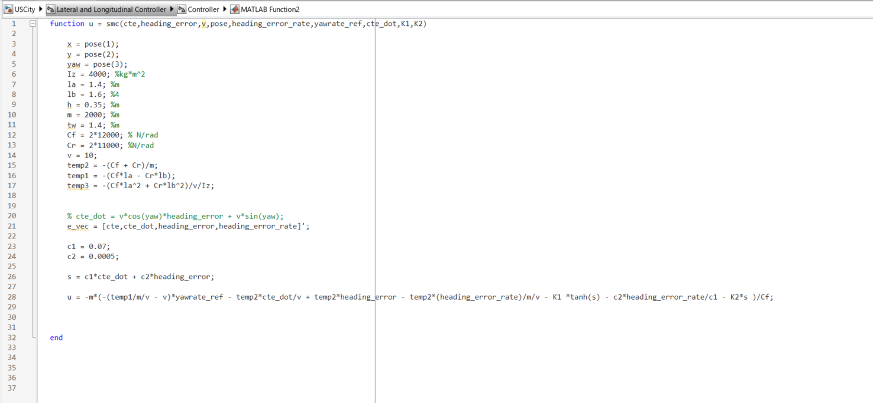
Fig. 8 SMC Controller Function

- Model Reference Adaptive Controller – Custom defined Controller function has been written here using Linear Bicycle Model.

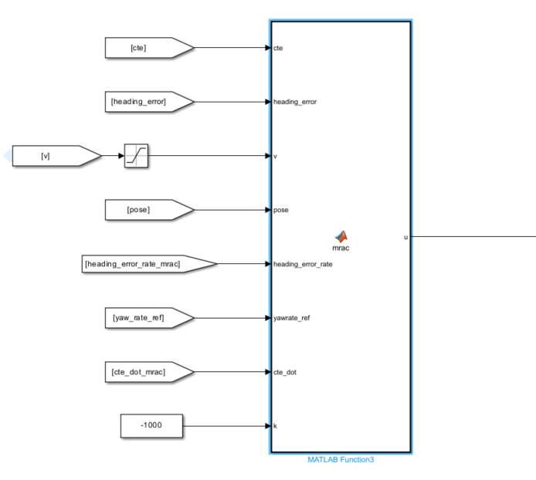
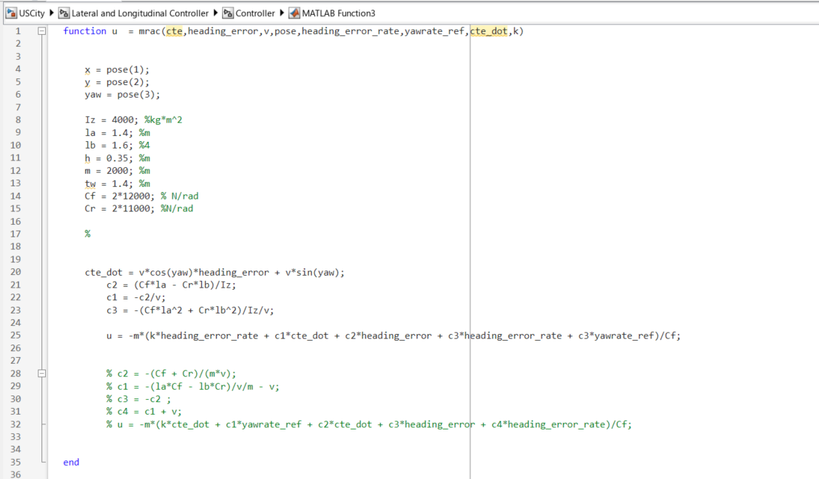
Fig. 9 SMC Controller Function
The control block also has certain signal processing and Switch block to enable these different controllers.

- Project Results and Potential Opportunities

Key Challenges Encountered:
- LQR Controller: Solving the Riccati equation online was difficult, so ended up calculating the gain offline for a fixed vehicle speed. This led to a sub-optimal performance for US City driving which has a varying vehicle speed.
- SMC: Defining effective sliding surfaces and tuning gains were difficult, especially for US City which has varying vehicle speed.
- MRAC: Reference model selection for US City driving and the tuning was nontrivial.
- AI-Based Controllers: Due to time constraints, reinforcement learning or neural network controllers could not be implemented.

The tuning of US City driving was particularly challenging and had to come up with different sliding surfaces for SMC and had to use different Reference models for MRAC. The low speed and high speed was just a Model Reference Controller without any Adaptive laws whereas for the US City driving, the Adaptive part had to be added to improve performance.

Comparison of Performance of PID vs LQR vs SMC vs MRAC

Low Speed Curve maneuver

PID
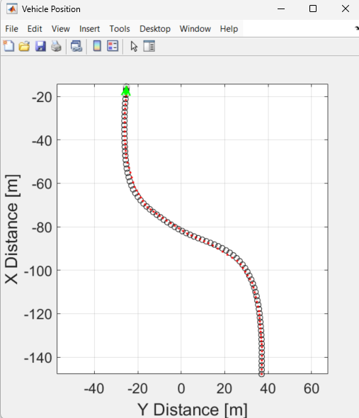
Fig. 10 PID Low Speed
LQR
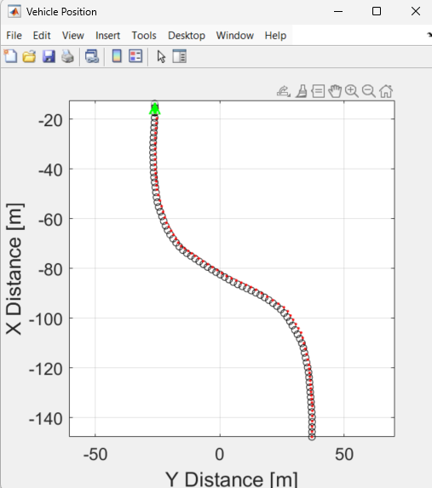
Fig. 11 LQR Low Speed
SMC
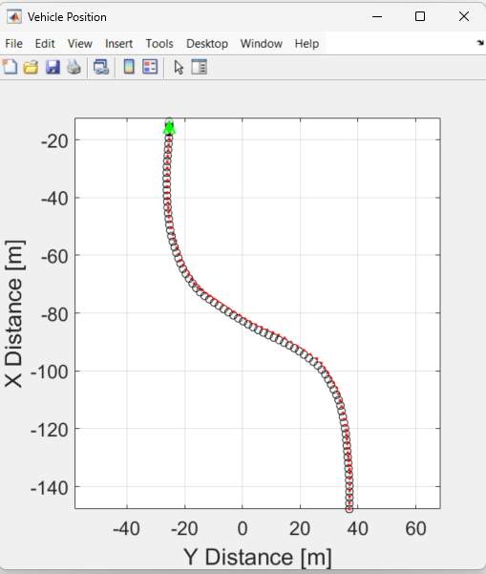
Fig. 12 SMC Low Speed

MRAC
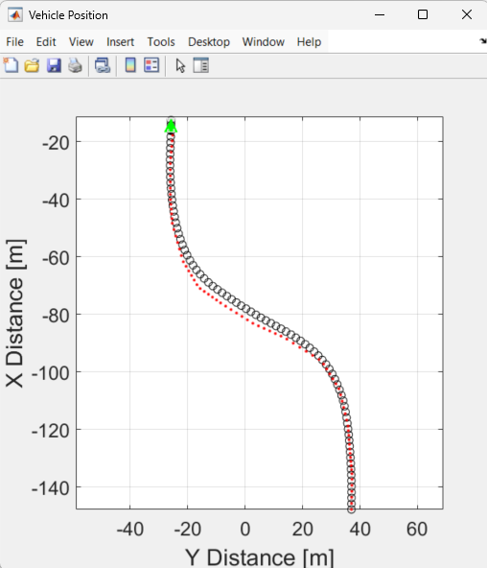
Fig. 13 MRAC Low Speed
High Speed Curve maneuver
PID

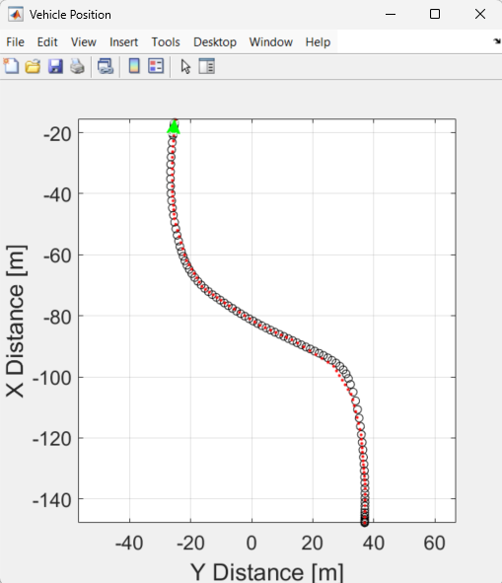
Fig. 14 PID High Speed

LQR
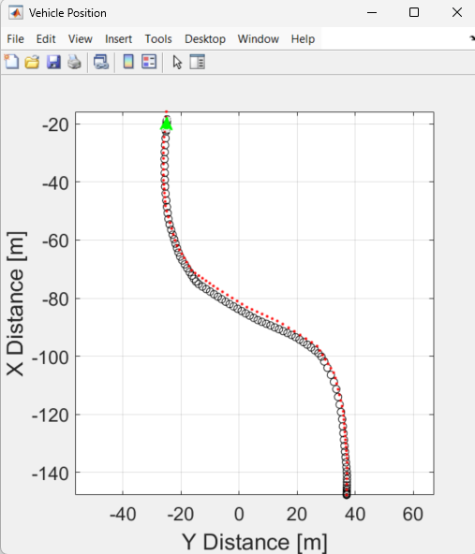
Fig. 15 LQR High Speed
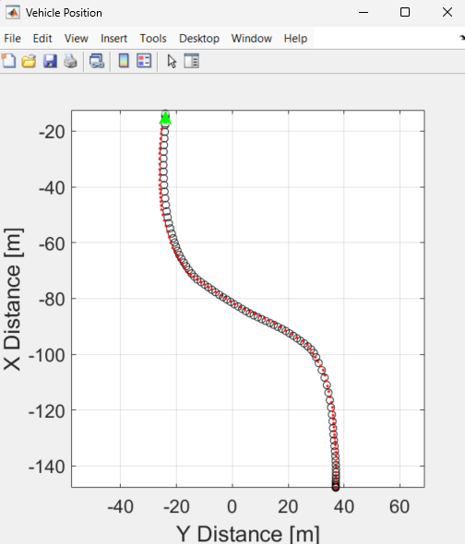
Fig. 16 SMC High Speed

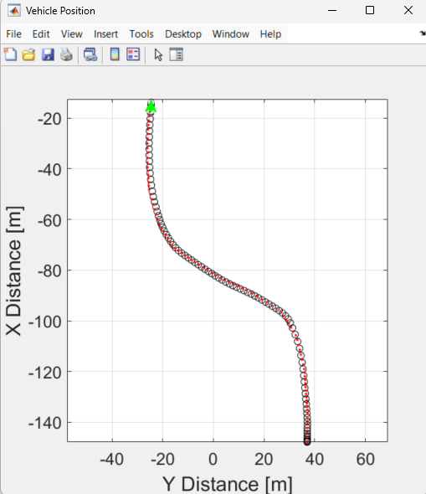
Fig. 17 MRAC High Speed

US City Driving

PID

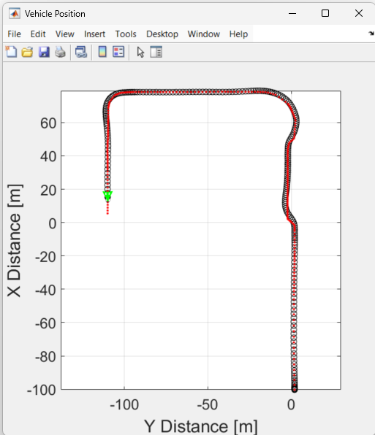
Fig. 18 PID US City

LQR
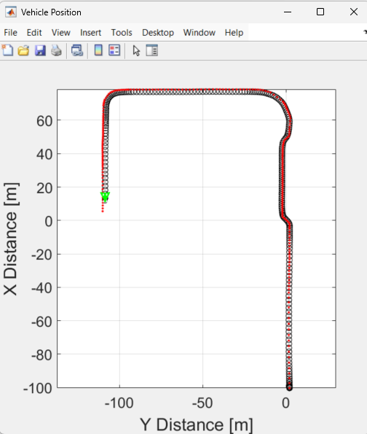
Fig. 19 LQR US City

SMC
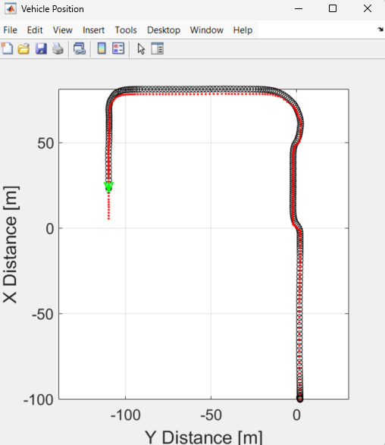
Fig. 20 SMC US City

MRAC
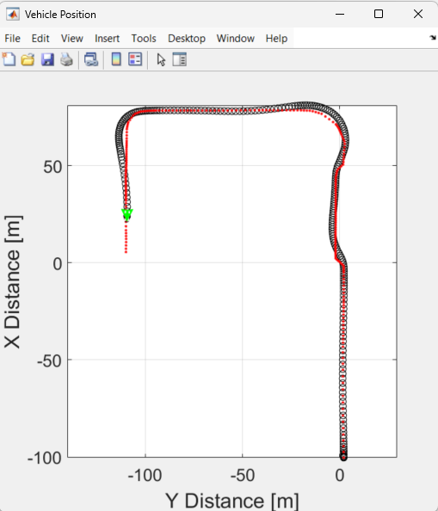
Fig. 21 MRAC US City

- Division of Work
Task | Responsible Individual
Simulation Set up and Clean Up | Karthik Rengarajan & Shaurya Doger
Presentation Part - I Writing | Karthik Rengarajan
Presentation Part - I Recording | Karthik Rengarajan & Shaurya Doger
Presentation Part - III Writing | Karthik Rengarajan
Presentation Part - III Recording | Karthik Rengarajan & Shaurya Doger
Code for Error Calculation, LQR Controller, SMC Controller, MRAC Controller | Karthik Rengarajan
Neural Network based Controller * | Shaurya Doger
Final Report | Karthik Rengarajan
Demo Video | Karthik Rengarajan

* This was not successful and is not included here.

- Conclusion

This project provided a deeper understanding of lateral control strategies for autonomous systems. Implementing and comparing different controller architectures offered practical insights into their performance trade-offs, design complexities, and tuning challenges. Future work could focus on extending this framework to include AI-based or hybrid control systems to further enhance adaptability and robustness.

