
Database Management Systems
PROJECT REPORT
Design and Implementation of a Database Management System for Student Attendance and Leave Approval System
Submitted by
Team Member | Roll Number
Shaurya Mittal | 25WU0101128
Samarth Samanekar | 25WU0101119
Vanshika Rao | 25WU0701027

Academic Year 2026–2027

Abstract
Attendance and leave are normally handled on paper registers and informal approvals. This causes calculation errors, lost leave applications, and disputes over whether a student meets the minimum attendance requirement. This project designs and implements a relational database that records session-wise attendance and runs every leave application through a two-level approval, first the student’s mentor and then the Head of Department.
The database has ten normalized tables in Third Normal Form, enforced with primary keys, foreign keys, unique and check constraints. A stored procedure validates leave applications, two triggers enforce the approval order and automatically mark attendance as On Leave when a leave is finally approved, and views report attendance percentage and pending approvals. The database is implemented in MySQL 8, and a web front end demonstrates the complete workflow for students and faculty.
Keywords: DBMS, MySQL, attendance management, leave approval, triggers, stored procedures, normalization.

Contents
1. Introduction
2. Problem Statement
3. Objectives
4. Scope and Requirements
5. System Design
6. Normalization
7. Database Implementation
8. Workflow of the System
9. User Interface
10. Testing and Results
11. Conclusion and Future Scope
References
Appendix A: Report Queries

1. Introduction
A college must track whether each student attends enough classes, and must also decide fairly when a student asks for time off. In many institutions both tasks are done separately and by hand. The attendance register records absences without knowing whether the absence was approved, and the leave application is a paper slip that moves between offices.
A Database Management System (DBMS) removes this separation. Storing attendance and leave in one database means a rule such as “an approved leave must not reduce attendance” can be enforced by the database itself instead of depending on someone remembering to apply it. This project builds such a system for a university department.

2. Problem Statement
Design and implement a database for a Student Attendance and Leave Approval System that:
- stores students, faculty, courses, enrollments, and class sessions without redundancy;
- records attendance for every student in every class session;
- accepts leave applications and routes each one through Mentor and HOD approval;
- adjusts attendance automatically when a leave is approved; and
- reports attendance percentages and identifies students below the 75% requirement.
The problems with the manual process are:
- Attendance percentages are calculated by hand and often wrongly.
- Approved leave is not reflected in the register, so students are wrongly shown as having a shortage.
- There is no record of who approved a leave, when, and with what remarks.
- Overlapping or excessive leave requests are not detected.

3. Objectives
- To design an Entity–Relationship model and a normalized relational schema for the system.
- To implement the schema in MySQL with proper integrity constraints.
- To implement a two-level (Mentor, then HOD) leave approval workflow in the database.
- To use triggers and a stored procedure so that business rules are enforced inside the database.
- To provide views and queries that report attendance percentage, shortages, and pending leaves.
- To build a user interface that demonstrates the complete workflow.

4. Scope and Requirements

4.1 Users
User | Responsibilities
Student | View own attendance, apply for leave, track and cancel requests.
Faculty (Mentor) | Mark attendance for classes; approve or reject leave of mentee students as the first level.
Head of Department | Give the final approval or rejection after the mentor has approved.

4.2 Functional requirements
- Maintain master data: departments, faculty, students, courses, leave types.
- Enroll students in courses and schedule class sessions.
- Mark each student Present, Absent, or On Leave for each session.
- Apply for leave; reject overlapping requests and requests that exceed the semester limit for that leave type.
- Allow the HOD to act only after the mentor has approved.
- On final approval, change the student’s attendance in the leave period to On Leave.
- Compute attendance percentage per course and overall, and list students below 75%.

4.3 Non-functional requirements
- Integrity: invalid data (for example a leave ending before it starts) must be rejected by the database.
- Auditability: every approval decision is stored with approver, level, remarks, and time.
- Consistency: no duplicate attendance entry for the same student and session.
- Performance: indexes on the columns used most in queries.

4.4 Software used
Component | Tool
DBMS | MySQL 8.0
Database client | MySQL Workbench / mysql command-line client
Front end | HTML, CSS and JavaScript web page
Diagrams | Entity–Relationship diagram of the final schema

5. System Design

5.1 Entities and relationships
The system has ten entities. Two many-to-many relationships are resolved with link tables: Student and Course through Enrollment, and Class Session and Student through Attendance.
Relationship | Cardinality / Meaning
Department – Faculty, Student, Course | 1 : N. A department has many faculty, students and courses.
Faculty (mentor) – Student | 1 : N. Each student has one mentor; a mentor has many mentees.
Faculty – Course | 1 : N. A faculty member teaches many courses.
Student – Course | M : N through Enrollment.
Course – Class Session | 1 : N. A course has many sessions.
Class Session – Student | M : N through Attendance, which stores the status.
Student – Leave Request | 1 : N. A student can raise many requests.
Leave Type – Leave Request | 1 : N. Each request belongs to one leave type.
Leave Request – Leave Approval | 1 : N (at most 2). One decision per level: Mentor and HOD.

5.2 ER diagram
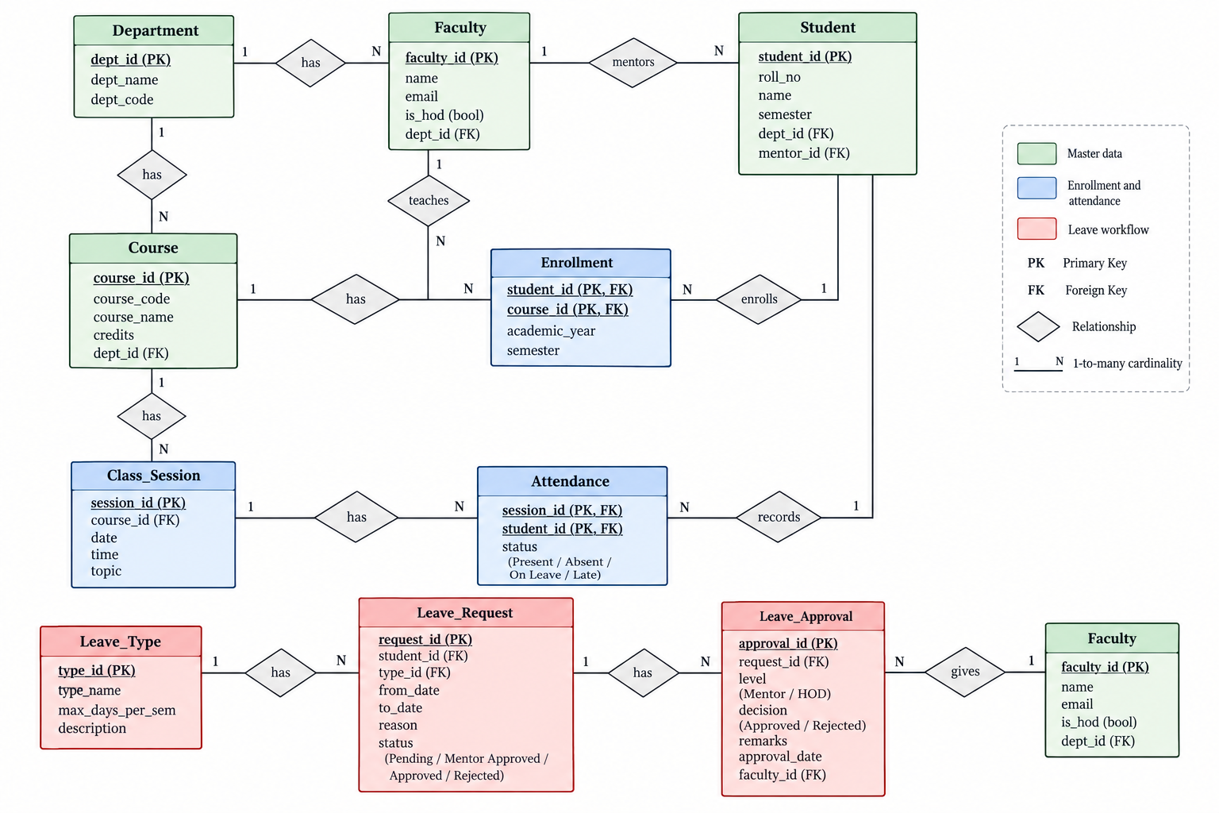
Figure 5.1: ER diagram of the system. Master data is shown in green, enrollment and attendance in blue, and the leave workflow in red. Faculty is repeated at the bottom right to show the “gives” relationship with Leave_Approval.

5.3 Relational schema
Primary keys are underlined in the figure. The relational schema, with foreign keys marked, is:
DEPARTMENT(dept_id, dept_name)
FACULTY(faculty_id, full_name, email, dept_id*, is_hod)
STUDENT(student_id, roll_no, full_name, email, phone, dept_id*, semester, mentor_id*)
COURSE(course_id, course_code, course_name, credits, dept_id*, faculty_id*)
ENROLLMENT(enrollment_id, student_id*, course_id*, academic_year)
CLASS_SESSION(session_id, course_id*, session_date, start_time, end_time, topic)
ATTENDANCE(attendance_id, session_id*, student_id*, status, marked_by*, marked_at)
LEAVE_TYPE(leave_type_id, type_name, max_days_per_sem)
LEAVE_REQUEST(leave_id, student_id*, leave_type_id*, from_date, to_date, reason, status, applied_on)
LEAVE_APPROVAL(approval_id, leave_id*, approver_id*, level, decision, remarks, decided_on)
* marks a foreign key.

5.4 Data dictionary of the main tables
Table | Column | Description and constraint
student | roll_no | Unique roll number; NOT NULL
student | semester | CHECK between 1 and 8
student | mentor_id | FK to faculty; mentor who gives first-level approval
attendance | status | ENUM: Present, Absent, On Leave
attendance | (session_id, student_id) | UNIQUE; one record per student per session
class_session | end_time | CHECK end_time > start_time
leave_request | to_date | CHECK to_date >= from_date
leave_request | status | ENUM: Pending, Mentor Approved, Approved, Rejected, Cancelled
leave_type | max_days_per_sem | Maximum leave days of this type per semester
leave_approval | level | ENUM: Mentor, HOD
leave_approval | (leave_id, level) | UNIQUE; one decision per level per request

6. Normalization
First Normal Form (1NF). All attributes hold single atomic values, there are no repeating groups, and every table has a primary key. For example, a student’s several courses are not stored in one column; they are separate rows in Enrollment.
Second Normal Form (2NF). There are no partial dependencies. In the link tables Enrollment and Attendance, the non-key attributes depend on the whole key. The attendance status depends on both the session and the student, not on either alone.
Third Normal Form (3NF). There are no transitive dependencies. Department names, course details, and the leave limit of each leave type are stored once in their own tables and referenced by key. A leave request stores only leave_type_id, not the type name or its limit, so changing a limit is a single update.
As a result, there is no update, insertion, or deletion anomaly in the schema. A mentor’s name is stored once in Faculty, and changing it does not require touching any student row.

7. Database Implementation
The complete script is in the file attendance_leave_system.sql. It creates the database, tables, indexes, views, procedure, triggers, sample data, and the report queries. The main parts are shown below.

7.1 Table creation (DDL)
The two tables at the centre of the leave workflow:
CREATE TABLE leave_request (
leave_id INT AUTO_INCREMENT PRIMARY KEY,
student_id INT NOT NULL,
leave_type_id INT NOT NULL,
from_date DATE NOT NULL,
to_date DATE NOT NULL,
reason VARCHAR(255) NOT NULL,
status ENUM('Pending','Mentor Approved','Approved',
'Rejected','Cancelled') NOT NULL DEFAULT 'Pending',
applied_on TIMESTAMP NOT NULL DEFAULT CURRENT_TIMESTAMP,
CHECK (to_date >= from_date),
FOREIGN KEY (student_id) REFERENCES student(student_id) ON DELETE CASCADE,
FOREIGN KEY (leave_type_id) REFERENCES leave_type(leave_type_id)
);

CREATE TABLE leave_approval (
approval_id INT AUTO_INCREMENT PRIMARY KEY,
leave_id INT NOT NULL,
approver_id INT NOT NULL,
level ENUM('Mentor','HOD') NOT NULL,
decision ENUM('Approved','Rejected') NOT NULL,
remarks VARCHAR(255),
decided_on TIMESTAMP NOT NULL DEFAULT CURRENT_TIMESTAMP,
UNIQUE (leave_id, level),
FOREIGN KEY (leave_id) REFERENCES leave_request(leave_id) ON DELETE CASCADE,
FOREIGN KEY (approver_id) REFERENCES faculty(faculty_id)
);

7.2 Views
The view v_attendance_percentage calculates attendance for each student and course. Sessions with status On Leave are removed from the count, so approved leave never lowers the percentage.
CREATE VIEW v_attendance_percentage AS
SELECT s.student_id, s.roll_no, s.full_name, c.course_code,
SUM(a.status = 'Present') AS attended,
SUM(a.status <> 'On Leave') AS conducted,
ROUND(100 * SUM(a.status = 'Present')
/ NULLIF(SUM(a.status <> 'On Leave'),0), 2) AS attendance_pct
FROM attendance a
JOIN student s ON s.student_id = a.student_id
JOIN class_session cs ON cs.session_id = a.session_id
JOIN course c ON c.course_id = cs.course_id
GROUP BY s.student_id, s.roll_no, s.full_name, c.course_id, c.course_code;

Attendance % = Present sessions ÷ (Total sessions − On Leave sessions) × 100.
A second view, v_pending_leaves, lists requests that are waiting for a mentor or HOD decision.

7.3 Stored procedure: applying for leave
The procedure sp_apply_leave refuses a request whose dates are reversed, whose dates overlap an existing active request of the same student, or which would take the student over the semester limit for that leave type. Only a valid request is inserted.
CREATE PROCEDURE sp_apply_leave(
IN p_student_id INT, IN p_leave_type_id INT,
IN p_from DATE, IN p_to DATE, IN p_reason VARCHAR(255))
BEGIN
DECLARE v_used INT DEFAULT 0; DECLARE v_max INT; DECLARE v_req INT;
IF p_to < p_from THEN
SIGNAL SQLSTATE '45000' SET MESSAGE_TEXT = 'To-date cannot be before from-date';
END IF;
IF EXISTS (SELECT 1 FROM leave_request
WHERE student_id = p_student_id
AND status IN ('Pending','Mentor Approved','Approved')
AND p_from <= to_date AND p_to >= from_date) THEN
SIGNAL SQLSTATE '45000' SET MESSAGE_TEXT = 'Overlapping leave request exists';
END IF;
SET v_req = DATEDIFF(p_to, p_from) + 1;
SELECT max_days_per_sem INTO v_max FROM leave_type WHERE leave_type_id = p_leave_type_id;
SELECT COALESCE(SUM(DATEDIFF(to_date, from_date) + 1), 0) INTO v_used
FROM leave_request
WHERE student_id = p_student_id AND leave_type_id = p_leave_type_id
AND status IN ('Approved','Mentor Approved','Pending');
IF v_used + v_req > v_max THEN
SIGNAL SQLSTATE '45000' SET MESSAGE_TEXT = 'Leave balance exceeded for this leave type';
END IF;
INSERT INTO leave_request(student_id, leave_type_id, from_date, to_date, reason)
VALUES (p_student_id, p_leave_type_id, p_from, p_to, p_reason);
END

7.4 Triggers: enforcing the approval order
The BEFORE INSERT trigger on leave_approval blocks decisions that are out of order, for example an HOD decision before the mentor has approved. The AFTER INSERT trigger then updates the request status and, on final approval, changes attendance.
CREATE TRIGGER trg_approval_before_insert BEFORE INSERT ON leave_approval
FOR EACH ROW
BEGIN
DECLARE v_status VARCHAR(20);
SELECT status INTO v_status FROM leave_request WHERE leave_id = NEW.leave_id;
IF v_status IN ('Approved','Rejected','Cancelled') THEN
SIGNAL SQLSTATE '45000' SET MESSAGE_TEXT = 'Leave request is already closed';
END IF;
IF NEW.level = 'Mentor' AND v_status <> 'Pending' THEN
SIGNAL SQLSTATE '45000' SET MESSAGE_TEXT = 'Mentor decision already recorded';
END IF;
IF NEW.level = 'HOD' AND v_status <> 'Mentor Approved' THEN
SIGNAL SQLSTATE '45000' SET MESSAGE_TEXT = 'HOD can act only after mentor approval';
END IF;
END

CREATE TRIGGER trg_approval_after_insert AFTER INSERT ON leave_approval
FOR EACH ROW
BEGIN
IF NEW.decision = 'Rejected' THEN
UPDATE leave_request SET status = 'Rejected' WHERE leave_id = NEW.leave_id;
ELSEIF NEW.level = 'Mentor' THEN
UPDATE leave_request SET status = 'Mentor Approved' WHERE leave_id = NEW.leave_id;
ELSE
UPDATE leave_request SET status = 'Approved' WHERE leave_id = NEW.leave_id;
UPDATE attendance a
JOIN class_session cs ON cs.session_id = a.session_id
JOIN leave_request lr ON lr.leave_id = NEW.leave_id
AND lr.student_id = a.student_id
SET a.status = 'On Leave'
WHERE cs.session_date BETWEEN lr.from_date AND lr.to_date;
END IF;
END

7.5 Indexes
Indexes were created on attendance(student_id), leave_request(student_id, status), and class_session(session_date), because attendance reports and leave lookups filter on these columns.

8. Workflow of the System

- The student applies for leave. The request is validated and saved with status Pending.
- The mentor reviews the request. If rejected, the request is closed with status Rejected. If approved, the status becomes Mentor Approved.
- The HOD reviews the request. The database allows this step only after mentor approval. If rejected, the request is closed.
- On HOD approval the status becomes Approved, and every attendance record of that student within the leave dates changes to On Leave.
- The attendance percentage is recalculated automatically by the view, excluding On Leave sessions.
The student can cancel a request while it is Pending or Mentor Approved. Every decision is saved in leave_approval with the approver, level, remarks and time, which gives a complete audit trail.

9. User Interface
A web interface demonstrates the workflow. A user chooses who to log in as: a student or a faculty member, and sees only the screens for that role. The interface applies the same rules as the database: overlap and balance checks on leave applications, mentor-before-HOD ordering, and automatic On Leave marking.
Role | Screens
Student | My Attendance (percentage per course, shortage warning, session log); Apply Leave; My Leaves (status, approval trail, cancel)
Faculty | Mark Attendance; Leave Approvals (approve or reject with remarks); Attendance Report with shortage highlighted

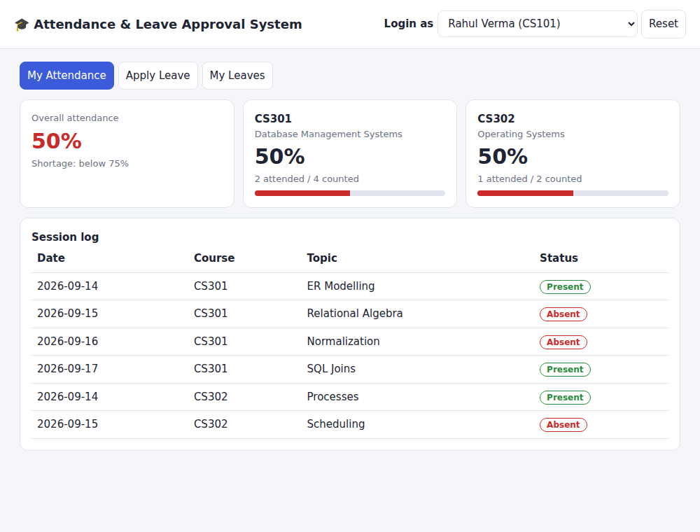
Figure 9.1: Student view of attendance before leave approval
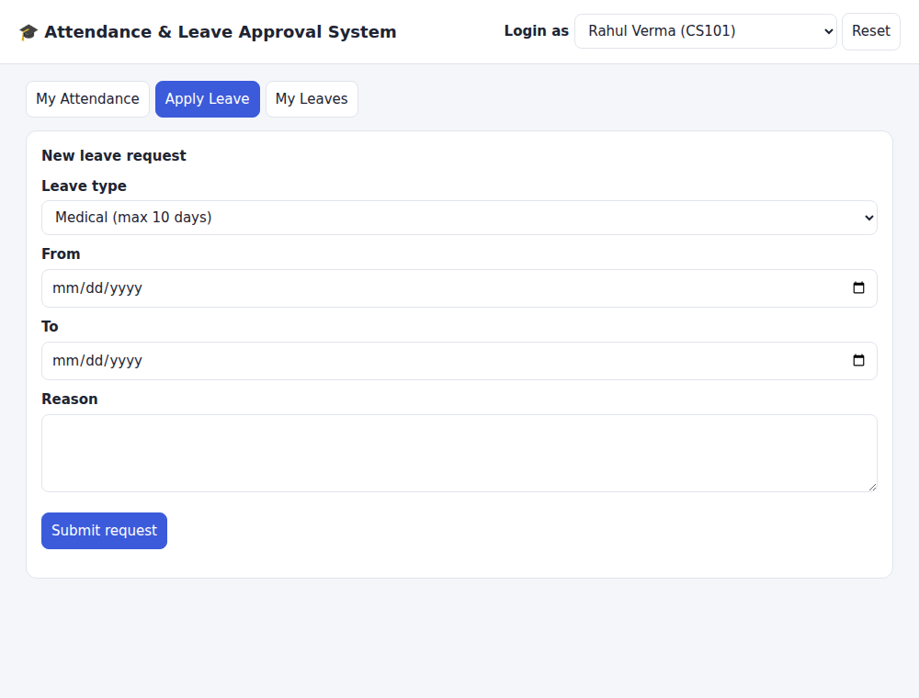
Figure 9.2: Leave application form
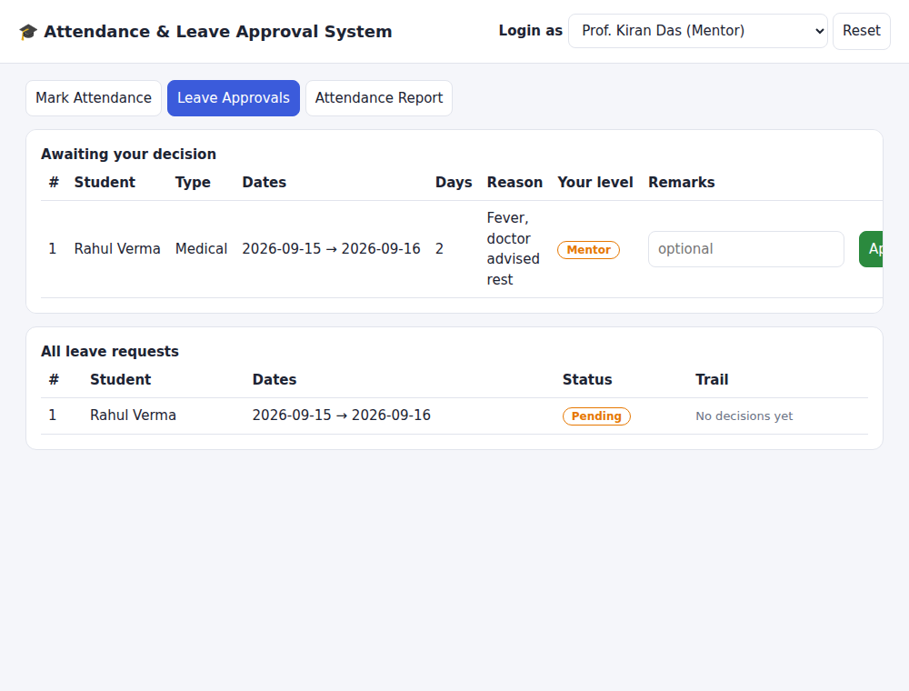
Figure 9.3: Mentor’s approval queue
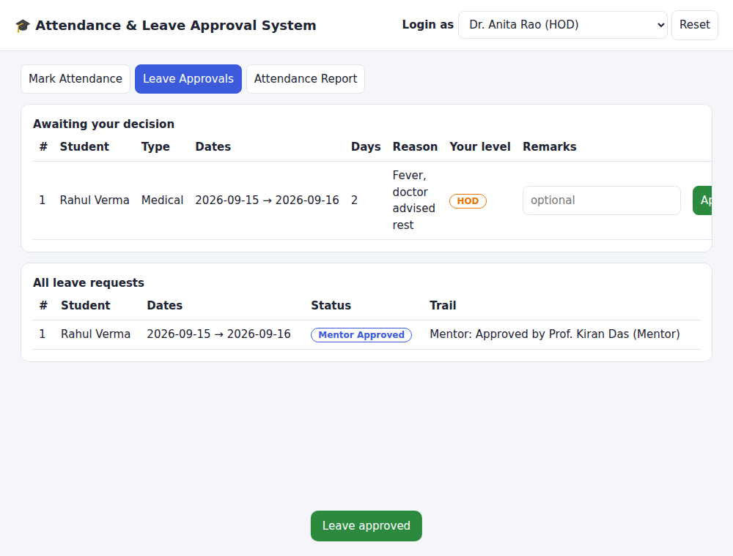
Figure 9.4: HOD’s queue after the mentor has approved
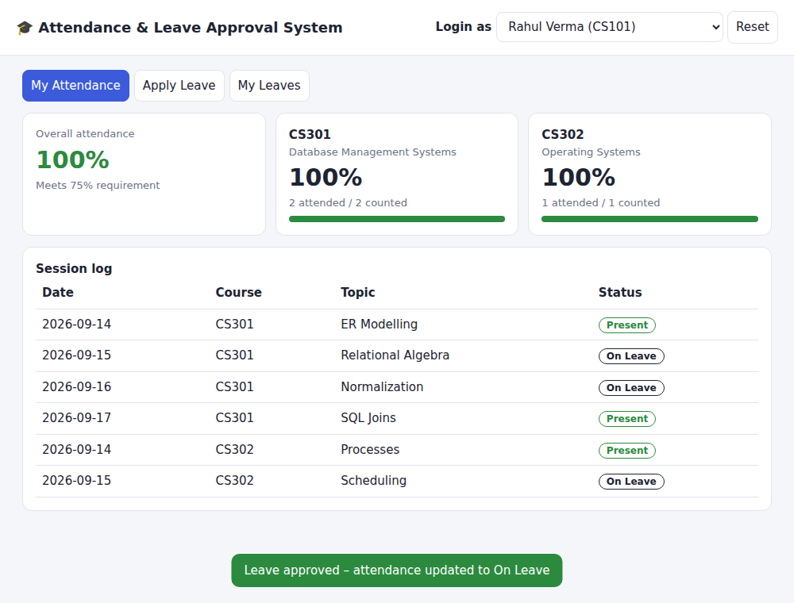
Figure 9.5: Student view after final approval; the leave days now show On Leave
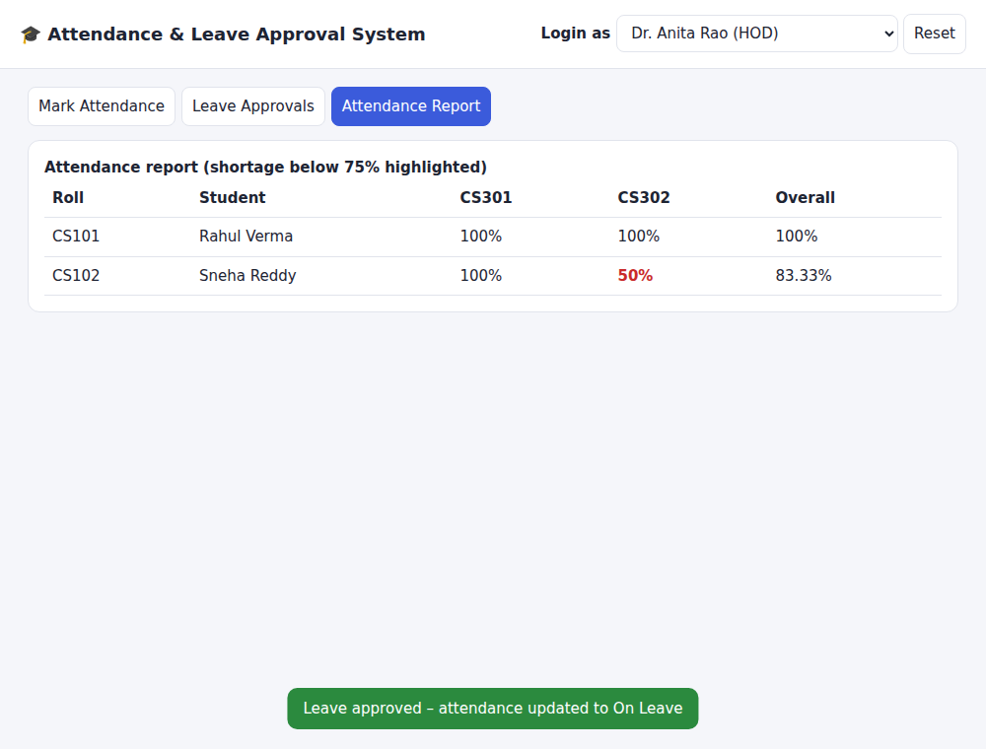
Figure 9.6: Faculty attendance report
The interface is a front-end demonstration. It keeps its sample data in the browser and is not connected to the MySQL server; the MySQL script is the database implementation.

10. Testing and Results
The sample data has three students, three faculty members, two courses, six class sessions, and three leave types. Rahul Verma (CS101) is absent on 15 and 16 September and applies for medical leave covering those dates. The tests below check the rules of the system.
No. | Test | Expected result | Rule checked
1 | Apply leave with to-date before from-date | Rejected: “To-date cannot be before from-date” | CHECK / procedure
2 | Apply leave overlapping an existing active request | Rejected: “Overlapping leave request exists” | Overlap check
3 | Apply 11 days of Medical leave (limit 10) | Rejected: “Leave balance exceeded” | Balance check
4 | HOD decides before the mentor | Rejected: “HOD can act only after mentor approval” | BEFORE trigger
5 | Mentor approves | Status changes Pending → Mentor Approved | AFTER trigger
6 | Mentor rejects | Status changes to Rejected; request closed | AFTER trigger
7 | HOD approves after mentor | Status Approved; attendance on leave dates becomes On Leave | AFTER trigger
8 | Mark same student twice for a session | Rejected by UNIQUE (session_id, student_id) | Unique constraint
9 | Decide on an already closed request | Rejected: “Leave request is already closed” | BEFORE trigger

10.1 Result with sample data
Rahul attended 2 of 4 DBMS sessions, so his DBMS attendance was 50%. After the mentor and the HOD approved his leave, the two absent sessions changed to On Leave and were removed from the count, so his attendance became 2 of 2, or 100%. Sneha Reddy’s leave was rejected by the mentor, so her record is unchanged.
Student (DBMS course) | Before approval | After approval | Reason
Rahul Verma | 50% | 100% | Two absences became On Leave
Sneha Reddy | 100% | 100% | Leave rejected; no change

The report queries (Appendix A) were used to list students with shortage, the approval trail of each request, and leave usage against the semester limit. The screenshots in Section 9 show the same behaviour in the interface.

11. Conclusion and Future Scope
This project built a normalized relational database that links attendance and leave in one system. Because the rules are written as constraints, a stored procedure, and triggers, they apply however the data is entered. Approved leave no longer causes false attendance shortages, every decision has an audit trail, and invalid or overlapping leave is stopped before it is stored.
Possible extensions:
- Connect the interface to MySQL through a back-end such as Flask or Java Servlets, with secure login and role-based access.
- Send email or SMS notifications when a request is approved or attendance falls below 75%.
- Add QR-code or biometric attendance marking.
- Add a document upload for medical certificates and an academic-calendar table for holidays.
- Add semester-wise archiving and graphical dashboards for administrators.

References

- Silberschatz, A., Korth, H. F., and Sudarshan, S. Database System Concepts. McGraw-Hill.
- Elmasri, R. and Navathe, S. B. Fundamentals of Database Systems. Pearson.
- Oracle Corporation. MySQL 8.0 Reference Manual: CREATE TRIGGER, CREATE PROCEDURE, SIGNAL, and CHECK constraints. dev.mysql.com/doc.
- Course lecture notes, Database Management Systems, Woxsen University.

Appendix A: Report Queries
Query 1: attendance percentage per student per course.
SELECT * FROM v_attendance_percentage ORDER BY roll_no, course_code;

Query 2: students with a shortage (below 75%) in any course.
SELECT roll_no, full_name, course_code, attendance_pct
FROM v_attendance_percentage
WHERE attendance_pct < 75;

Query 3: leave requests with their approval trail.
SELECT lr.leave_id, s.full_name, lt.type_name, lr.from_date, lr.to_date,
lr.status, la.level, f.full_name AS approver, la.decision, la.remarks
FROM leave_request lr
JOIN student s ON s.student_id = lr.student_id
JOIN leave_type lt ON lt.leave_type_id = lr.leave_type_id
LEFT JOIN leave_approval la ON la.leave_id = lr.leave_id
LEFT JOIN faculty f ON f.faculty_id = la.approver_id
ORDER BY lr.leave_id, la.decided_on;

Query 4: approved leave days used against the semester limit.
SELECT s.full_name, lt.type_name,
SUM(DATEDIFF(lr.to_date, lr.from_date) + 1) AS days_used, lt.max_days_per_sem
FROM leave_request lr
JOIN student s ON s.student_id = lr.student_id
JOIN leave_type lt ON lt.leave_type_id = lr.leave_type_id
WHERE lr.status = 'Approved'
GROUP BY s.student_id, s.full_name, lt.leave_type_id, lt.type_name, lt.max_days_per_sem;

Query 5: pending leave requests for a given mentor.
SELECT * FROM v_pending_leaves WHERE mentor_id = 2;

Query 6: number of leave requests rejected by each mentor.
SELECT f.full_name AS mentor, COUNT(*) AS rejected
FROM leave_approval la JOIN faculty f ON f.faculty_id = la.approver_id
WHERE la.level = 'Mentor' AND la.decision = 'Rejected'
GROUP BY f.faculty_id, f.full_name;

