Honors Research
Comprehensive Data Analysis Report
Ball-and-Jar Bayesian Probability Updating Experiment

N = 23 participants | 2,277 experiment trials

HONORS THESIS - COMPLETE DATA ANALYSIS
Ball-and-Jar Bayesian Probability Updating Experiment

1. SAMPLE OVERVIEW
N = 23 complete participants
Total trials = 2277
Trials per participant = 99 (33 per phase x 3 phases)
Mean |Red% - Green%| = 36.7% (SD=26.0%, range 1-88%)

2. HYPOTHESIS 1: CONSERVATISM
Prediction: Participants under-weight evidence, updating ~1/3 of Bayesian magnitude.
Calibration regression: Participant = 4.3 + 0.885 x Bayesian
R² = 0.669, p < 0.001
Slope = 0.885 (1.0 = perfect Bayesian)
-> CONSERVATISM CONFIRMED: slope < 1.0
Update Magnitude Analysis (Phillips & Edwards 1966 metric):
Mean |participant update| / |Bayesian update| = 2.97
Median = 0.80
(1.0 = perfect Bayesian, <1.0 = conservative, Phillips & Edwards found ~0.33)
Directional accuracy: 46.9% (chance = 50%)
t = -2.94, p = 3.30e-03
Overall accuracy:
Mean estimate = 47.8%, Mean Bayesian = 49.1%
Mean signed error = -1.4%
MAE = 10.7%, RMSE = 16.6%
r(estimate, Bayesian) = 0.818
t-test (error ≠ 0): t(2276) = -3.95, p = 8.06e-05

3. HYPOTHESIS 2: PRIOR RETRIEVAL
Prediction: At trial 67 (Phase 3 start), estimates should match trial 33
(end of Phase 1), NOT trial 66 (end of Phase 2).
Trial 33 (end P1) mean estimate: 50.4%
Trial 66 (end P2) mean estimate: 47.3%
Trial 67 (start P3) mean estimate: 52.2%
|est_67 - est_33| (retrieval distance): 22.6% (SD=20.2)
|est_67 - est_66| (continuation distance): 39.4% (SD=25.8)
Paired t-test (retrieval < continuation = prior stored):
t(22) = -2.413, p = 0.0246
-> PRIOR RETRIEVAL SUPPORTED: trial 67 is closer to trial 33 than trial 66
Bayesian-Reset vs Bayesian-Retrieve model comparison (Phase 3):
Bayesian-Reset RMSE: 12.6% (SD=9.1)
Bayesian-Retrieve RMSE: 15.0% (SD=10.3)
Paired t-test: t(22) = -2.019, p = 0.0559
Retrieve model better for 9/23 participants
Transition Point Analysis:
|delta_34| (P1→P2 switch): 37.6% (bound 1/34 = 2.9%)
t = 6.72, p = 0.0000 (test: > 2.9%)
22/23 participants exceed bound
|delta_67| (P2→P3 switch): 39.4% (bound 1/67 = 1.5%)
t = 6.90, p = 0.0000 (test: > 1.5%)
23/23 participants exceed bound

4. PHASE EFFECTS
Phase N Mean Est Mean Bayes MAE RMSE r
Phase 1 ( Red) 759 48.3 49.1 11.7 18.3 0.784
Phase 2 (Green) 759 47.5 52.4 10.0 15.7 0.835
Phase 3 ( Red) 759 47.4 45.9 10.5 15.6 0.849
P1→P3 learning: RMSE 14.9 → 12.6
Paired t = 1.616, p = 0.1202

5. CONFIDENCE ANALYSIS
Mean = 6.1/10, SD = 2.4
Confidence vs |Error|: r = -0.145, p = 4.17e-12
Confidence at transitions:
End P1 (last 5): 6.4
Start P2 (first 5): 3.9
End P2 (last 5): 6.8
Start P3 (first 5): 4.8
P1 end → P2 start: t = 3.91, p = 0.0008
P2 end → P3 start: t = 2.92, p = 0.0079

6. REACTION TIME ANALYSIS
Mean = 12576ms, Median = 8526ms, SD = 14740ms
Phase 1: Mean=15582ms, Median=10333ms
Phase 2: Mean=11965ms, Median=8291ms
Phase 3: Mean=10181ms, Median=7122ms
RT vs |Error|: r = -0.036, p = 0.0887

7. ASYMMETRIC UPDATING
Mean update after BLACK: +1.93% (SD=11.6)
Mean update after WHITE: -1.69% (SD=11.5)
Mean |update| after BLACK: 5.18%
Mean |update| after WHITE: 4.78%
t-test |updates|: t = 0.876, p = 0.3812

8. INDIVIDUAL DIFFERENCES
Code Red% Grn% RMSE r MAE Conf
4374 20 29 3.2 0.830 1.6 6.2
3477 45 47 5.1 0.924 3.2 4.8
9395 100 40 6.9 0.985 4.4 7.5
1152 14 84 7.3 0.976 5.3 6.2
8451 47 67 8.2 0.955 6.5 7.1
4544 63 9 9.0 0.971 7.4 7.3
2124 25 26 9.4 0.747 8.5 3.6
4157 17 57 9.5 0.909 7.3 6.5
9080 46 71 10.3 0.871 5.7 7.3
9373 84 36 10.5 0.927 6.3 7.1
9225 59 72 11.0 0.826 8.0 6.1
8667 28 85 11.2 0.925 7.4 3.4
1771 24 59 11.3 0.879 7.8 3.6
2609 6 79 11.7 0.913 9.8 7.4
2084 88 8 12.5 0.952 9.4 7.1
7227 41 63 13.2 0.953 10.4 7.8
6833 84 28 14.0 0.902 12.8 4.2
9574 35 66 14.3 0.414 9.6 8.6
2333 83 79 17.4 0.459 11.0 6.5
9407 77 73 25.6 0.202 16.5 6.5
4286 37 12 27.1 0.720 23.1 5.6
8486 78 52 29.8 -0.087 24.2 5.0
2267 6 94 42.8 -0.072 40.6 5.5

Figures
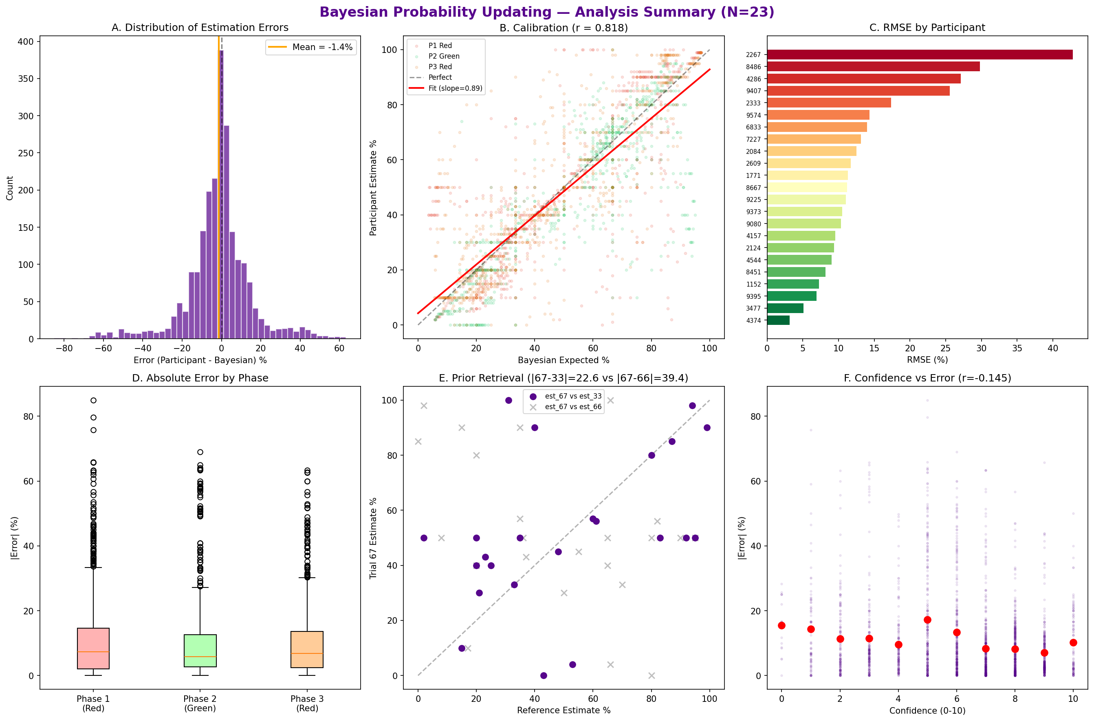
Figure 1: Six-panel analysis summary — error distribution, calibration, individual differences, phase effects, prior retrieval, and confidence.

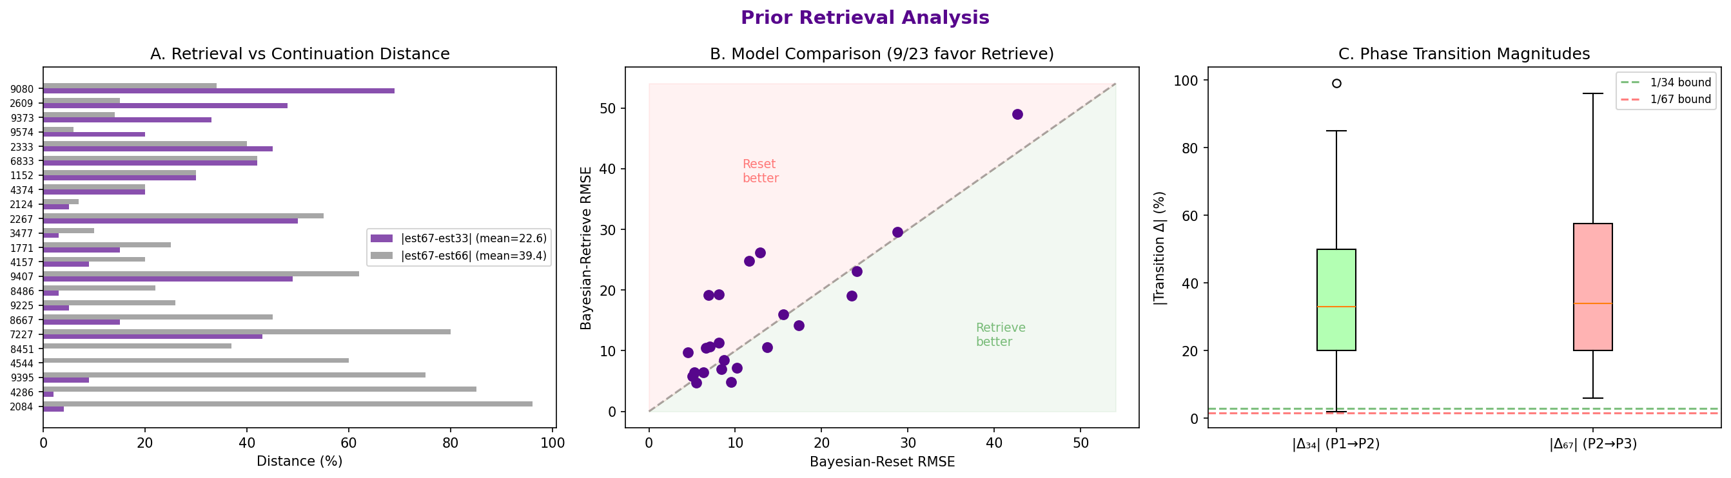
Figure 2: Prior retrieval analysis — retrieval vs continuation distances, Bayesian model comparison, and transition point magnitudes.

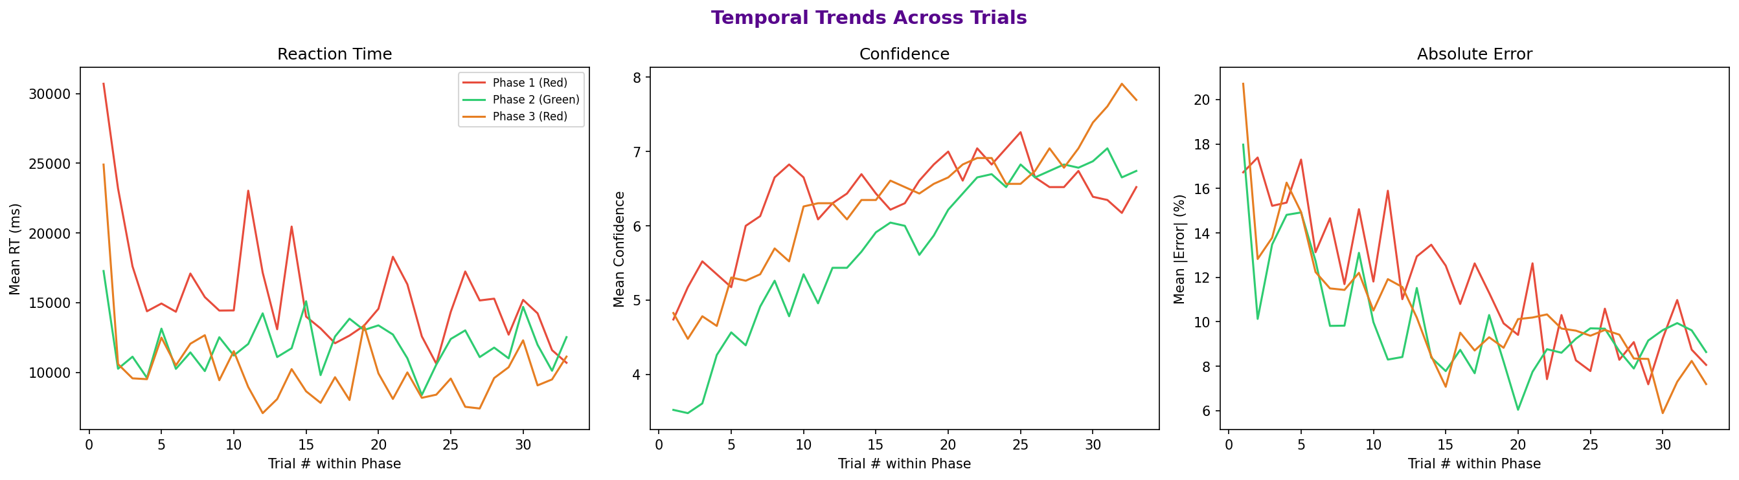
Figure 3: Temporal trends across trials — reaction time, confidence, and absolute error by phase.

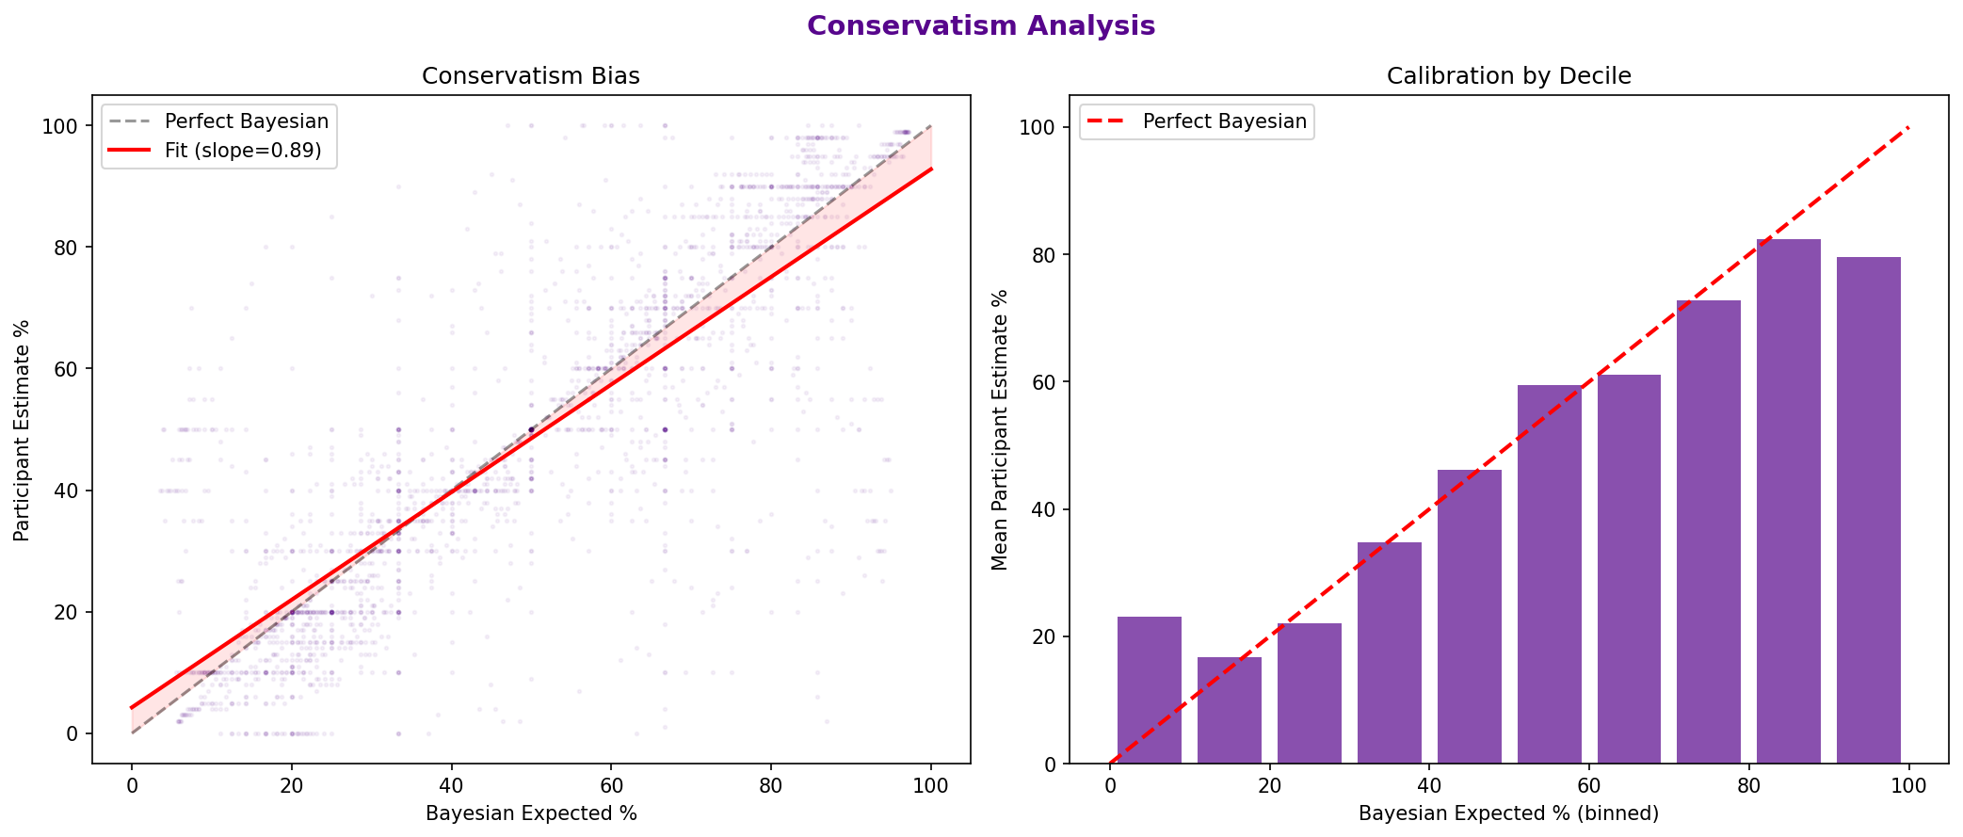
Figure 4: Conservatism analysis — scatter plot with regression line and calibration by Bayesian decile.

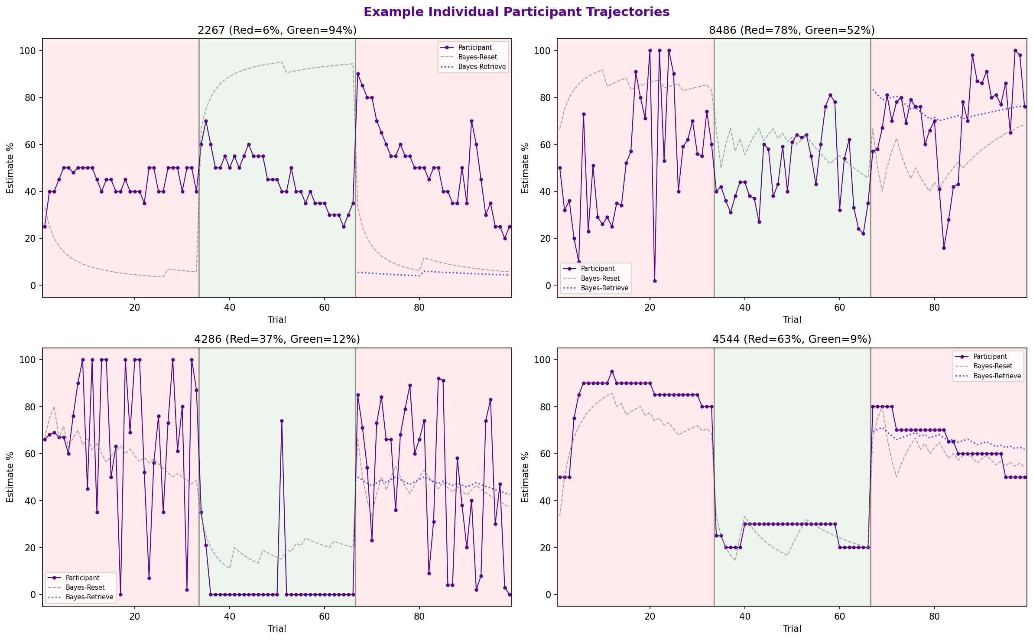
Figure 5: Example individual participant trajectories with Bayesian-Reset and Bayesian-Retrieve overlays.

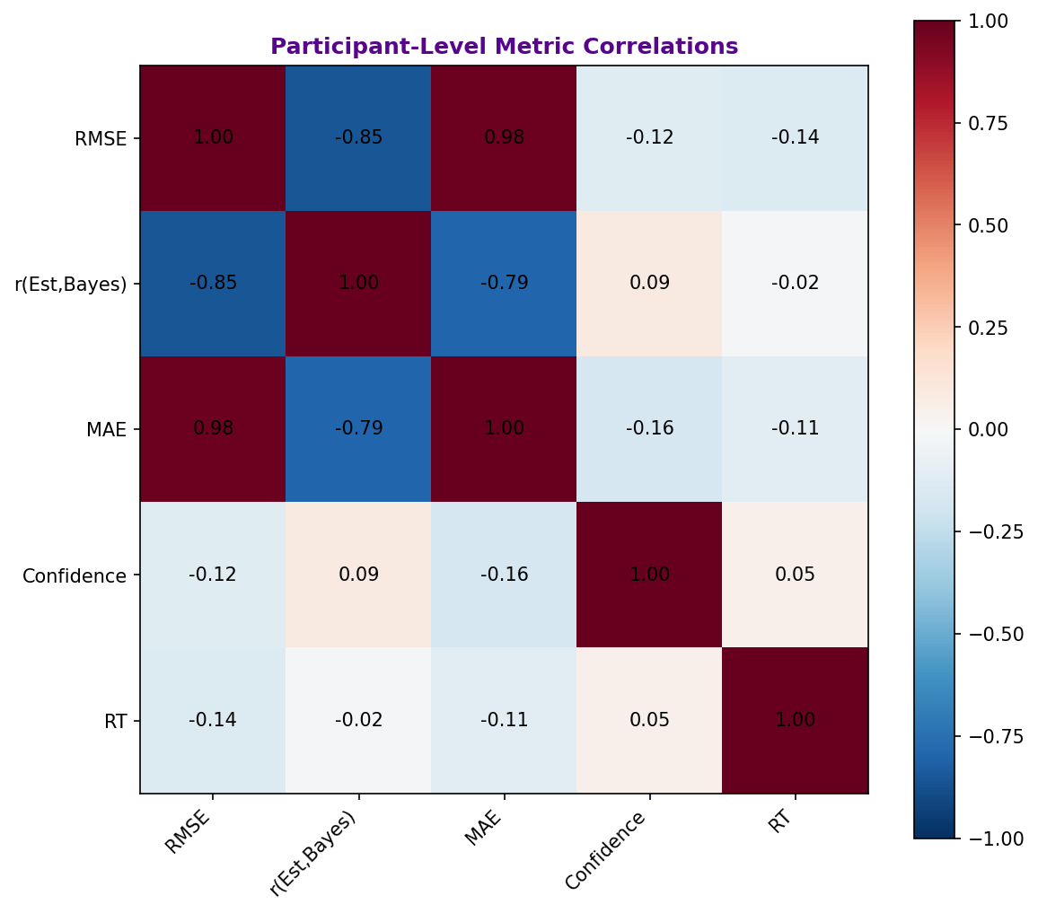
Figure 6: Participant-level metric correlation matrix.

