Class: | SE | Div: | A | Semester: | 3
Course Code: | 2013115 |  |  | Course Name: | AI(DS)

Name of Student: | Shaurya Ramkrishna Jamsandekar
Roll No. : | 22
Experiment No.: | 6
Title of the Experiment: | All Pair Shortest path, Dynamic Programming: Floyd Warshall
Date of Performance: | 02/09/2026
Date of Submission: | 09/09/2026
Evaluation
Performance Indicator | Max. Marks | Marks Obtained
Performance | 5
Understanding | 5
Journal work and timely submission | 10
Total | 20

Performance Indicator | Exceed Expectations (EE) | Meet Expectations (ME) | Below Expectations (BE)
Performance | 4-5 | 2-3 | 1
Understanding | 4-5 | 2-3 | 1
Journal work and timely submission | 8-10 | 5-8 | 1-4

Checked by

Name of Faculty : Mrs. Sneha Yadav
Signature :
Date :

Experiment No. 6
Title: All Pair Shortest path, Dynamic Programming: Floyd Warshall

Aim: To study and implement All Pair Shortest path, Dynamic Programming: Floyd Warshall.

Objective: To introduce Dynamic Programming Approaches

Theory:

the Floyd–Warshall algorithm is an algorithm for finding shortest paths in a directed weighted graph with positive or negative edge weights (but with no negative cycles). A single execution of the algorithm will find the lengths (summed weights) of shortest paths between all pairs of vertices. Although it does not return details of the paths themselves, it is possible to reconstruct the paths with simple modifications to the algorithm. Versions of the algorithm can also be used for finding the transitive closure of a relation ‘R’, or (in connection with the Schulze voting system) widest paths between all pairs of vertices in a weighted graph.

Example:
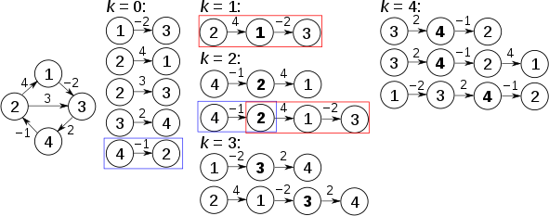

Algorithm:

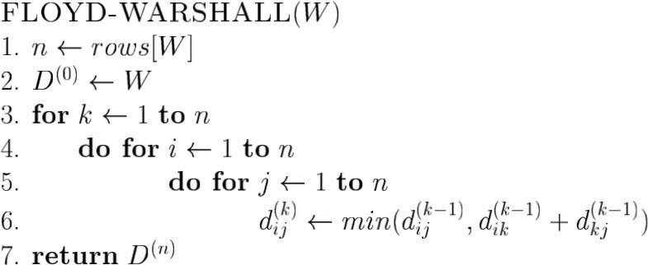

Implementation:
#include <stdio.h>
#define INF 999

void printMatrix(int dist[][20], int n)
{
int i, j;
for (i = 0; i < n; i++)
{
for (j = 0; j < n; j++)
{
if (dist[i][j] == INF)
printf("INF\t");
else
printf("%d\t", dist[i][j]);
}
printf("\n");
}
}

void floydWarshall(int graph[][20], int n)
{
int dist[20][20];
int i, j, k;

for (i = 0; i < n; i++)
{
for (j = 0; j < n; j++)
{
dist[i][j] = graph[i][j];
}
}

printf("\nInitial Matrix:\n");
printMatrix(dist, n);

for (k = 0; k < n; k++)
{
for (i = 0; i < n; i++)
{
for (j = 0; j < n; j++)
{
if (dist[i][k] != INF && dist[k][j] != INF &&
dist[i][k] + dist[k][j] < dist[i][j])
{
dist[i][j] = dist[i][k] + dist[k][j];
}
}
}
printf("\nAfter Iteration %d (Vertex %d as Intermediate):\n",
k + 1, k + 1);
printMatrix(dist, n);
}

printf("\nFinal All Pair Shortest Path Matrix:\n");
printMatrix(dist, n);
}

int main()
{
int graph[20][20];
int n, i, j;

printf("Enter number of vertices: ");
scanf("%d", &n);

printf("\nEnter the adjacency matrix:\n");
printf("Enter %d for INF (no direct edge).\n\n", INF);

for (i = 0; i < n; i++)
{
for (j = 0; j < n; j++)
{
scanf("%d", &graph[i][j]);
if (i == j)
graph[i][j] = 0;
}
}

floydWarshall(graph, n);

return 0;
}

Output:
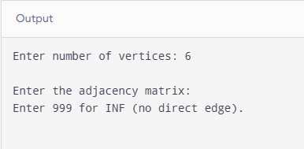

Conclusion: The Floyd–Warshall technique was effectively executed utilizing dynamic programming to address the all-pair shortest path scenario. By recursively analyzing every node as a potential transit point, it determined and updated the minimal distance metrics across all node pairs with a computational complexity of O(V³) and space requirement of O(V²). The sequential matrix updates illustrated how multi-step paths refine direct connection values, verifying its utility for fully connected networks containing non-negative loop costs.

