Class: | SE | Div: | A | Semester: | 3
Course Code: | 2013115 |  |  | Course Name: | AiDs

Name of Student: | Shaurya R. Jamsandekar
Roll No. : | 22
Experiment No.: | 8
Title of the Experiment: | Backtracking and Branch-Bound methods
Date of Performance: | 26/09/2026
Date of Submission:
Evaluation
Performance Indicator | Max. Marks | Marks Obtained
Performance | 5
Understanding | 5
Journal work and timely submission | 10
Total | 20

Performance Indicator | Exceed Expectations (EE) | Meet Expectations (ME) | Below Expectations (BE)
Performance | 4-5 | 2-3 | 1
Understanding | 4-5 | 2-3 | 1
Journal work and timely submission | 8-10 | 5-8 | 1-4

Checked by

Name of Faculty : Mrs. Sneha Yadav
Signature :
Date :

Experiment No. 8
Title: N-Queen
Aim: To study and implement N-Queen
Objective: To introduce Backtracking and Branch-Bound methods

Theory:
Given an integer n, place n queens on an n × n chessboard such that no two queens attack each other. A queen can attack another queen if they are placed in the same row, the same column, or on the same diagonal. For example, following is a solution for 4 Queen problem.
Example:
Input: n = 4

Output: [[2, 4, 1, 3], [3, 1, 4, 2]]
Explanation: Below is Solution for 4 queen problem
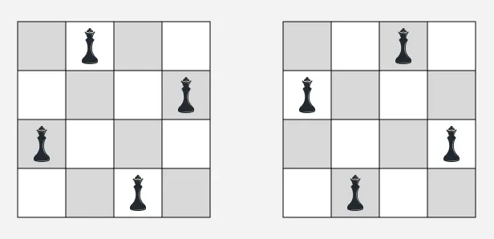

State Space Tree:
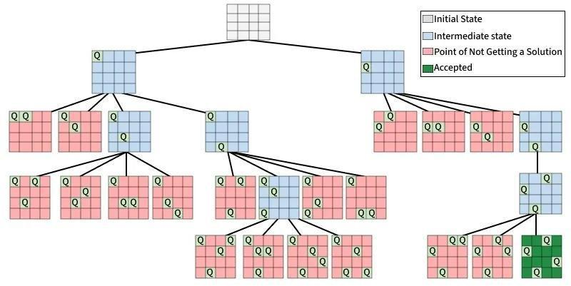

Implementation:
#include <stdio.h>
#include <stdbool.h>

#define N 4

// Function to print the chessboard layout
void printSolution(int board[N][N])
{
for (int i = 0; i < N; i++)
{
for (int j = 0; j < N; j++)
{
if (board[i][j])
printf(" Q ");
else
printf(" . ");
}
printf("\n");
}

printf("\n");
}

// Function to check if a queen can be safely placed at board[row][col]
bool isSafe(int board[N][N], int row, int col)
{
int i, j;

// 1. Check the vertical column above the current row
for (i = 0; i < row; i++)
{
if (board[i][col])
return false;
}

// 2. Check upper-left diagonal
for (i = row, j = col; i >= 0 && j >= 0; i--, j--)
{
if (board[i][j])
return false;
}

// 3. Check upper-right diagonal
for (i = row, j = col; i >= 0 && j < N; i--, j++)
{
if (board[i][j])
return false;
}

return true;
}

// Recursive function to solve N-Queens using Backtracking
bool solveNQUtil(int board[N][N], int row)
{
// Base Case: All queens are placed successfully
if (row >= N)
return true;

// Try placing a queen in all columns for the current row
for (int col = 0; col < N; col++)
{
if (isSafe(board, row, col))
{
// Place the queen
board[row][col] = 1;

// Recur to place the rest of the queens in the next row
if (solveNQUtil(board, row + 1))
return true;

// BACKTRACK: Remove the queen
// if it didn't lead to a valid solution
board[row][col] = 0;
}
}

// If no column in this row can safely accommodate a queen
return false;
}

// Main solver function
bool solveNQ()
{
int board[N][N] = {0};

if (!solveNQUtil(board, 0))
{
printf("Solution does not exist for N = %d\n", N);
return false;
}

printf("One valid solution for N = %d:\n\n", N);
printSolution(board);

return true;
}

// Main function
int main()
{
solveNQ();

return 0;
}

Output:

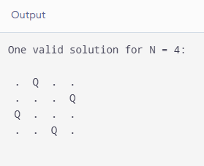

Conclusion: The n-queen problem has been implemented.

