Academic Year 2026-27(ODD Semester)

Class: | SE | Div: | A | Semester: | 3
Course Code: | 2013115 |  |  | Course Name: | Analysis of Algorithm

Name of Student: | Shaurya Ramkrishna Jamsandekar
Roll No. : | 22
Experiment No.: | 1
Title of the Experiment: | Insertion Sort and Selection Sort
Date of Performance: | 13-7-26
Date of Submission: | 20-7-26
Evaluation
Performance Indicator | Max. Marks | Marks Obtained
Performance | 5
Understanding | 5
Journal work and timely submission | 10
Total | 20

Performance Indicator | Exceed Expectations (EE) | Meet Expectations (ME) | Below Expectations (BE)
Performance | 4-5 | 2-3 | 1
Understanding | 4-5 | 2-3 | 1
Journal work and timely submission | 8-10 | 5-8 | 1-4

Checked by

Name of Faculty : Mrs. Sneha Yadav
Signature :
Date :

Experiment No. 1

Title: Insertion Sort and Selection Sort

Aim: To implement Insertion and Selection sort with Comparative analysis for large values of ‘n’

Objective: To introduce the methods of designing and analyzing algorithms

Theory:

Insertion sort is a simple sorting algorithm that works similarly to the way you sort playing cards in your hands. The array is virtually split into a sorted and an unsorted part. Values from the unsorted part are picked and placed at the correct position in the sorted part.

Example:
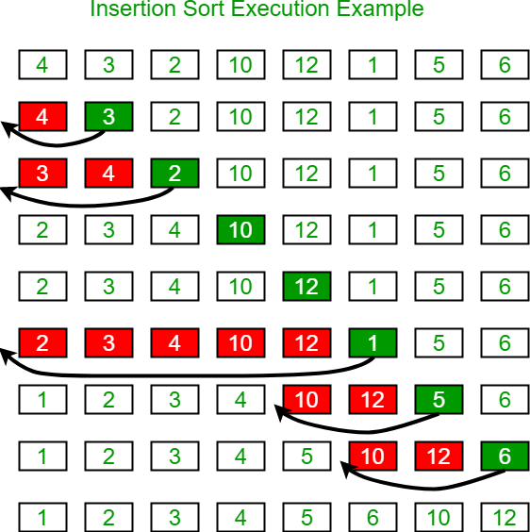

Algorithm and Complexity:
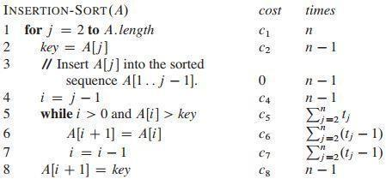

Selection sort is a sorting algorithm, specifically an in-place comparison sort. Selection sort is noted for its simplicity, and it has performance advantages over more complicated algorithms in certain situations, particularly where auxiliary memory is limited.

The algorithm divides the input list into two parts: the sub list of items already sorted, which is built up from left to right at the front (left) of the list, and the sub list of items remaining to be sorted that occupy the rest of the list. Initially, the sorted sub list is empty, and the unsorted sub list is the entire input list. The algorithm proceeds by finding the smallest (or largest, depending on sorting order) element in the unsorted sub list, exchanging it with the leftmost unsorted element (putting it in sorted order), and moving the sub list boundaries one element to the right.

Example:

arr[] = 64 25 12 22 11
// Find the minimum element in arr[0...4] // and place it at beginning
11 25 12 22 64
// Find the minimum element in arr[1...4] // and place it at beginning of arr[1...4] 11 12 25 22 64
// Find the minimum element in arr[2...4] // and place it at beginning of arr[2...4] 11 12 22 25 64
// Find the minimum element in arr[3...4] // and place it at beginning of arr[3...4] 11 12 22 25 64

Algorithm and Complexity:
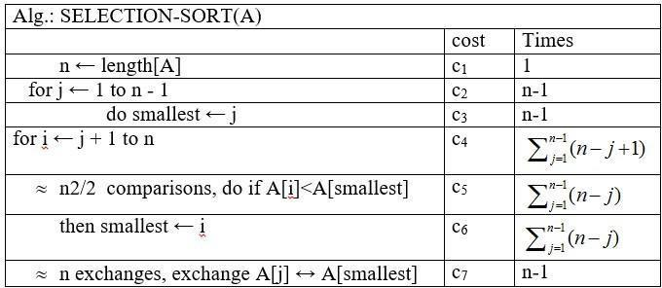

Implementation:

#include <stdio.h>
#include <conio.h>

void insertionSort(int a[], int size)
{
int i, j, value;

for (i = 1; i < size; i++)
{
value = a[i];
j = i - 1;

while (j >= 0 && a[j] > value)
{
a[j + 1] = a[j];
j--;
}

a[j + 1] = value;
}
}

void selectionSort(int a[], int size)
{
int i, j, smallest, temp;

for (i = 0; i < size - 1; i++)
{
smallest = i;

for (j = i + 1; j < size; j++)
{
if (a[j] < a[smallest])
smallest = j;
}

temp = a[i];
a[i] = a[smallest];
a[smallest] = temp;
}
}

int main()
{
int size, option, i;

printf("Enter number of elements: ");
scanf("%d", &size);

int numbers[size];

printf("Enter %d elements:\n", size);
for (i = 0; i < size; i++)
{
scanf("%d", &numbers[i]);
}

printf("\nOriginal Array: ");
for (i = 0; i < size; i++)
{
printf("%d ", numbers[i]);
}

printf("\n\n--- Sorting Menu ---");
printf("\n1. Insertion Sort");
printf("\n2. Selection Sort");
printf("\nEnter your choice: ");
scanf("%d", &option);

switch (option)
{
case 1:
insertionSort(numbers, size);
printf("\nSorted using Insertion Sort: ");
break;

case 2:
selectionSort(numbers, size);
printf("\nSorted using Selection Sort: ");
break;

default:
printf("\nInvalid choice!");
return 0;
}

for (i = 0; i < size; i++)
{
printf("%d ", numbers[i]);
}

printf("\n");

return 0;
}

Output :
Enter number of elements: 6
Enter 6 elements:
45
12
78
23
9
31

Original Array: 45 12 78 23 9 31

--- Sorting Menu ---
1. Insertion Sort
2. Selection Sort
Enter your choice: 1

Sorted using Insertion Sort: 9 12 23 31 45 78

Enter number of elements: 6
Enter 6 elements:
45
12
78
23
9
31

Original Array: 45 12 78 23 9 31

--- Sorting Menu ---
1. Insertion Sort
2. Selection Sort
Enter your choice: 2

Sorted using Selection Sort: 9 12 23 31 45 78

Conclusion:

The practical execution and comparative study of Insertion Sort and Selection Sort were completed with a focus on high-volume datasets. Analysis indicates that while both methods exhibit quadratic time complexity in their least favorable cases, Insertion Sort demonstrates superior efficiency for partially ordered sequences, whereas Selection Sort is optimized for minimizing memory write operations.

