Academic Year 2026-27(ODD Semester)

Class: | SE | Div: | A | Semester: | 3
Course Code: | 2013115 |  |  | Course Name: | Analysis of Algorithm

Name of Student: | Shaurya Ramkrishna Jamsandekar
Roll No. : | 22
Experiment No.: | 2
Title of the Experiment: | Binary Search Algorithm
Date of Performance: | 20-7-26
Date of Submission: | 25-7-26
Evaluation
Performance Indicator | Max. Marks | Marks Obtained
Performance | 5
Understanding | 5
Journal work and timely submission | 10
Total | 20

Performance Indicator | Exceed Expectations (EE) | Meet Expectations (ME) | Below Expectations (BE)
Performance | 4-5 | 2-3 | 1
Understanding | 4-5 | 2-3 | 1
Journal work and timely submission | 8-10 | 5-8 | 1-4

Checked by

Name of Faculty : Mrs. Sneha Yadav
Signature :
Date :

Experiment No. 2

Title: Binary Search Algorithm

Aim: To study and implement Binary Search Algorithm Objective: To introduce Divide and Conquer based algorithms Theory:
Search a sorted array by repeatedly dividing the search interval in half. Begin with an interval covering the whole array. If the value of the search key is less than the item in the middle of the interval, narrow the interval to the lower half. Otherwise, narrow it to the upper half. Repeatedly check until the value is found or the interval is empty
- Binary search is efficient than linear search. For binary search, the array must be sorted, which is not required in case of linear search.
- It is divide and conquer based search technique.

- In each step the algorithms divides the list into two halves and check if the element to be searched is on upper or lower half the array
- If the element is found, algorithm returns.
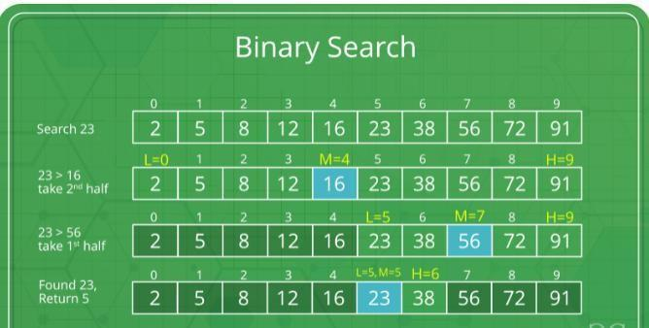
The idea of binary search is to use the information that the array is sorted and reduce the time complexity to O(Log n).

- Compare x with the middle element.
- If x matches with the middle element, we return the mid index.
- Else If x is greater than the mid element, then x can only lie in the right half subarray after the mid element. So we recur for the right half.
- Else (x is smaller) recur for the left half.
- Binary Search reduces search space by half in every iterations. In a linear search, search space was reduced by one only.
- n=elements in the array
- Binary Search would hit the bottom very quickly.

 | Linear Search | Binary Search
2nd iteration | n-1 | n/2
3rd iteration | n-2 | n/4

Example:
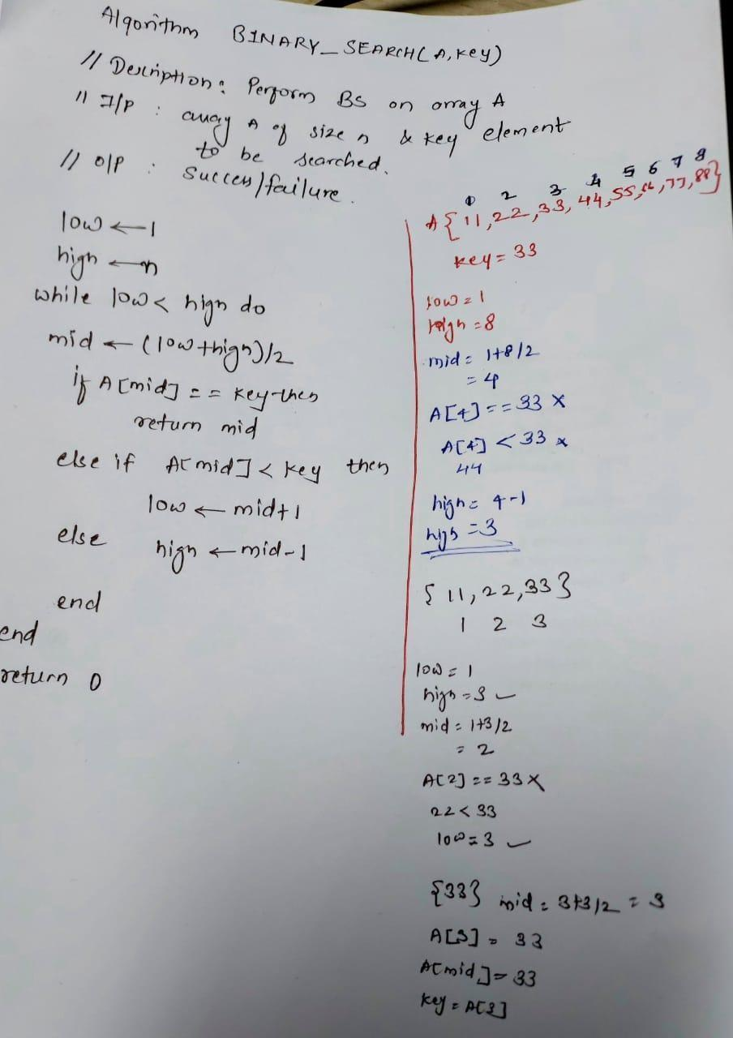

Algorithm and Complexity:

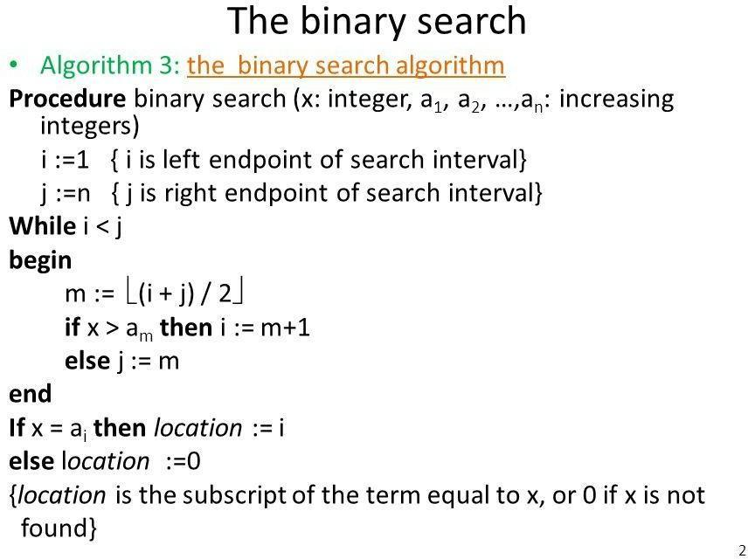
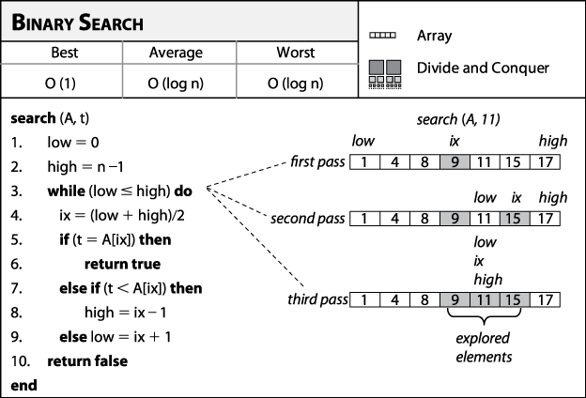
Best Case:
Key is first compared with the middle element of the array.
The key is in the middle position of the array, the algorithm does only one comparison, irrespective of the size of the array.
T(n)=1

Worst Case:
In each iteration search space of BS is reduced by half, Maximum log n(base 2) array divisions are possible.
Recurrence relation is T(n)=T(n/2) +1
Running Time is O(logn).

Average Case:

Key element neither is in the middle nor at the leaf level of the search tree. It does half of the log n(base 2).
Base case=O(1)
Average and worst case=O(logn)

Implementation:

#include <stdio.h>

int binarySearch(int values[], int n, int key)
{
int start = 0;
int end = n - 1;

while (start <= end)
{
int middle = start + (end - start) / 2;

if (values[middle] == key)
{
return middle;
}
else if (values[middle] < key)
{
start = middle + 1;
}
else
{
end = middle - 1;
}
}

return -1;
}

int main()
{
int n, searchValue;

printf("Enter the size of the array: ");
scanf("%d", &n);

int values[n];

printf("\nEnter the elements in sorted order:\n");

for (int i = 0; i < n; i++)
{
printf("Enter element %d: ", i + 1);
scanf("%d", &values[i]);
}

printf("\nEnter the element you want to search: ");
scanf("%d", &searchValue);

int position = binarySearch(values, n, searchValue);

if (position >= 0)
{
printf("\nElement %d found at index %d.\n",
searchValue, position);
}
else
{
printf("\nElement %d was not found in the array.\n",
searchValue);
}

return 0;
}

Output :

Enter the size of the array: 7

Enter the elements in sorted order:
Enter element 1: 10
Enter element 2: 20
Enter element 3: 30
Enter element 4: 40
Enter element 5: 50
Enter element 6: 60
Enter element 7: 70

Enter the element you want to search: 50

Element 50 found at index 4.

IF ELEMENT NOT FOUND:

Enter the size of the array: 7

Enter the elements in sorted order:
Enter element 1: 10
Enter element 2: 20
Enter element 3: 30
Enter element 4: 40
Enter element 5: 50
Enter element 6: 60
Enter element 7: 70

Enter the element you want to search: 45

Element 45 was not found in the array.

Conclusion:
The practical implementation of the Binary Search Algorithm was achieved by utilizing the Divide and Conquer methodology. By systematically partitioning the search interval into halves, the process optimizes temporal complexity to O(log n) for both typical and worst-case scenarios, exhibiting far greater efficiency than sequential search methods when processing extensive sorted data structures.

