Academic Year 2026-27(ODD Semester)
Class: | SE | Div: | A | Semester: | 3
Course Code: | 2013115 |  |  | Course Name: | Analysis of Algorithm

Name of Student: | Shaurya Ramrishna Jamsandekar
Roll No. : | 22
Experiment No.: | 3
Title of the Experiment: | Quick Sort
Date of Performance: | 25-7-26
Date of Submission: | 27-7-26
Evaluation
Performance Indicator | Max. Marks | Marks Obtained
Performance | 5
Understanding | 5
Journal work and timely submission | 10
Total | 20

Performance Indicator | Exceed Expectations (EE) | Meet Expectations (ME) | Below Expectations (BE)
Performance | 4-5 | 2-3 | 1
Understanding | 4-5 | 2-3 | 1
Journal work and timely submission | 8-10 | 5-8 | 1-4

Checked by

Name of Faculty : Mrs. Sneha Yadav
Signature :
Date :

Experiment No. 3

Title: Quick Sort

Aim: To implement Quick Sort and Comparative analysis for large values of ‘n’.

Objective: To introduce the methods of designing and analyzing algorithms.

Theory:

The merge sort algorithm closely follows the divide-and-conquer paradigm. Intuitively, it operates as follows:
- Divide: Divide the n-element sequence to be sorted into two subsequences of n=2 elements each.
- Conquer: Sort the two subsequences recursively using merge sort.
- Combine: Merge the two sorted subsequences to produce the sorted answer.

Partition-exchange sort or quicksort algorithm was developed in 1960 by Tony Hoare. He developed the algorithm in order to sort the words to be translated, to make them more easily matched to an already-sorted Russian-to-English dictionary that was stored on magnetic tape.
Quick sort algorithm on average, makes O(n log n) comparisons to sort n items. In the worst case, it makes O(n2) comparisons, though this behavior is rare. Quicksort is often faster in practice than other O(n log n) algorithms. Additionally, quicksort's sequential and localized memory references work well with a cache. Quicksort is a comparison sort and, in efficient implementations, is not a stable sort. Quicksort can be implemented with an in-place partitioning algorithm, so the entire sort can be done with only O(log n) additional space used by the stack during the recursion.
Quicksort is a divide and conquer algorithm. Quicksort first divides a large list into two smaller sub-lists: the low elements and the high elements. Quicksort can then recursively sort the sublists.
- Elements less than pivot element.

- Pivot element.

- Elements greater than pivot element.

Where pivot as middle element of large list. Let’s understand through example:

List : 3 7 8 5 2 1 9 5 4

In above list assume 4 is pivot element so rewrite list as:

3 1 2 4 5 8 9 5 7

Here, I want to say that we set the pivot element (4) which has in left side elements are less than and right hand side elements are greater than. Now you think, how’s arrange the less than and greater than elements? Be patient, you get answer soon.

Example:
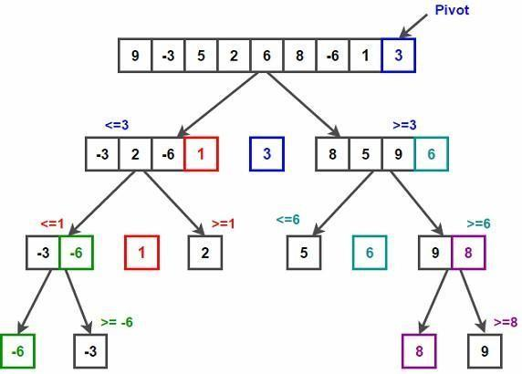

/* low --> Starting index, high --> Ending index */ quickSort(arr[], low, high)
{
if (low < high)
{
/* pi is partitioning index, arr[pi] is now at right place */ pi = partition(arr, low, high);
quickSort(arr, low, pi - 1); // Before pi quickSort(arr, pi + 1, high); // After pi
}
}
/* This function takes last element as pivot, places the pivot element at its correct position in sorted array, and places all smaller (smaller than pivot) to left of pivot and all greater elements to right of pivot */
partition (arr[], low, high)
{
// pivot (Element to be placed at right position) pivot = arr[high];

i = (low - 1) // Index of smaller element and indicates the
// right position of pivot found so far for (j = low; j <= high- 1; j++)
{
// If current element is smaller than the pivot if (arr[j] < pivot)
{
i++; // increment index of smaller element swap arr[i] and arr[j]
}
}
swap arr[i + 1] and arr[high]) return (i + 1)
}
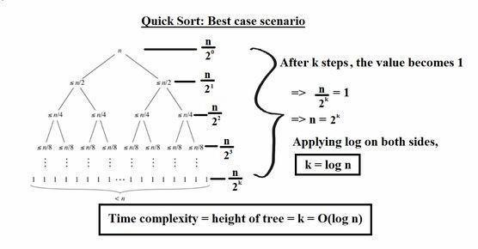
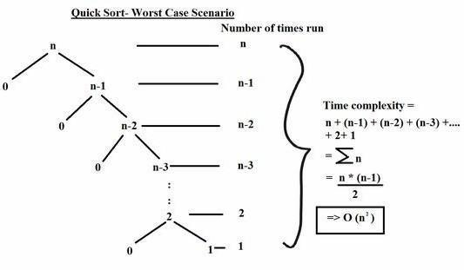

Implementation:

#include <iostream>
using namespace std;

int countStep = 1;

void display(int a[], int size)
{
for (int i = 0; i < size; i++)
{
cout << a[i] << " ";
}
cout << endl;
}

int divide(int a[], int start, int end, int size)
{
int pivot = a[end];
int smaller = start - 1;

for (int current = start; current < end; current++)
{
if (a[current] < pivot)
{
smaller++;
swap(a[smaller], a[current]);
}
}

swap(a[smaller + 1], a[end]);

int pivotPos = smaller + 1;

cout << "\nStep " << countStep++ << endl;
cout << "Range considered : " << start << " to " << end << endl;
cout << "Pivot value : " << pivot << endl;
cout << "Pivot position : " << pivotPos << endl;
cout << "Array after step : ";

display(a, size);

cout << "-----------------------------------" << endl;

return pivotPos;
}

void quickSort(int a[], int start, int end, int size)
{
if (start < end)
{
int pivotPos = divide(a, start, end, size);

quickSort(a, start, pivotPos - 1, size);
quickSort(a, pivotPos + 1, end, size);
}
}

int main()
{
int size;

cout << "Enter array size: ";
cin >> size;

int numbers[size];

cout << "Enter " << size << " values: ";
for (int i = 0; i < size; i++)
{
cin >> numbers[i];
}

cout << "\nGiven Array: ";
display(numbers, size);

cout << "-----------------------------------" << endl;

quickSort(numbers, 0, size - 1, size);

cout << "\nSorted Array: ";
display(numbers, size);

return 0;
}

Output:
Enter array size: 6
Enter 6 values: 45 12 78 23 9 31

Given Array: 45 12 78 23 9 31
-----------------------------------

Step 1
Range considered : 0 to 5
Pivot value : 31
Pivot position : 3
Array after step : 12 23 9 31 78 45
-----------------------------------

Step 2
Range considered : 0 to 2
Pivot value : 9
Pivot position : 0
Array after step : 9 23 12 31 78 45
-----------------------------------

Step 3
Range considered : 1 to 2
Pivot value : 12
Pivot position : 1
Array after step : 9 12 23 31 78 45
-----------------------------------

Step 4
Range considered : 4 to 5
Pivot value : 45
Pivot position : 4
Array after step : 9 12 23 31 45 78
-----------------------------------

Sorted Array: 9 12 23 31 45 78

Conclusion:
The Quick Sort algorithm was successfully implemented using the divide-and-conquer strategy. Tracing the execution step-by-step confirms that each partitioning phase correctly places the chosen pivot element into its final sorted position, placing smaller elements to its left and larger elements to its right.
Average Time Complexity: O(n log n), making it fast and efficient for large datasets.

Worst-Case Time Complexity: O(n²), occurring when the pivot choices result in highly unbalanced partitions.

Space Complexity: O(log n) auxiliary stack space, making it an efficient in-place sorting method.

