Class: | SE | Div: | A | Semester: | 3
Course Code: | 2013115 |  |  | Course Name: | AIDS

Name of Student: | Shaurya Ramkrishna Jamsandekar
Roll No. : | 22
Experiment No.: | 4
Title of the Experiment: | Fraction Knapsack
Date of Performance: | 16-08-26
Date of Submission: | 20-08-26
Evaluation
Performance Indicator | Max. Marks | Marks Obtained
Performance | 5
Understanding | 5
Journal work and timely submission | 10
Total | 20

Performance Indicator | Exceed Expectations (EE) | Meet Expectations (ME) | Below Expectations (BE)
Performance | 4-5 | 2-3 | 1
Understanding | 4-5 | 2-3 | 1
Journal work and timely submission | 8-10 | 5-8 | 1-4

Checked by

Name of Faculty : Mrs. Sneha Yadav
Signature :
Date :

Experiment No. 4

Title: Fraction Knapsack

Aim: To study and implement Fraction Knapsack Algorithm

Objective: To introduce Greedy based algorithms

Theory:

Greedy method or technique is used to solve Optimization problems. A solution that can be maximized or minimized is called Optimal Solution.
The knapsack problem or rucksack problem is a problem in combinatorial optimization: Given a set of items, each with a mass and a value, determine the number of each item to include in a collection so that the total weight is less than or equal to a given limit and the total value is as large as possible. It derives its name from the problem faced by someone who is constrained by a fixed size knapsack and must fill it with the most valuable items. The most common problem being solved is the 0-1 knapsack problem, which restricts the number xi of copies of each kind of item to zero or one.
In Knapsack problem we are given:1) n objects 2) Knapsack with capacity m, 3) An object i is associated with profit Wi , 4) An object i is associated with profit Pi , 5) when an object i is placed in knapsack we get profit Pi Xi .
Here objects can be broken into pieces (Xi Values) The Objective of Knapsack problem is to maximize the profit.

Example:

In this version of Knapsack problem, items can be broken into smaller pieces. So, the thief may take only a fraction xi of i^{th} item.
0⩽xi⩽1

The i^{th} item contributes the weight xi.wi to the total weight in the knapsack and profit xi.pi to the total profit.

Algorithm:
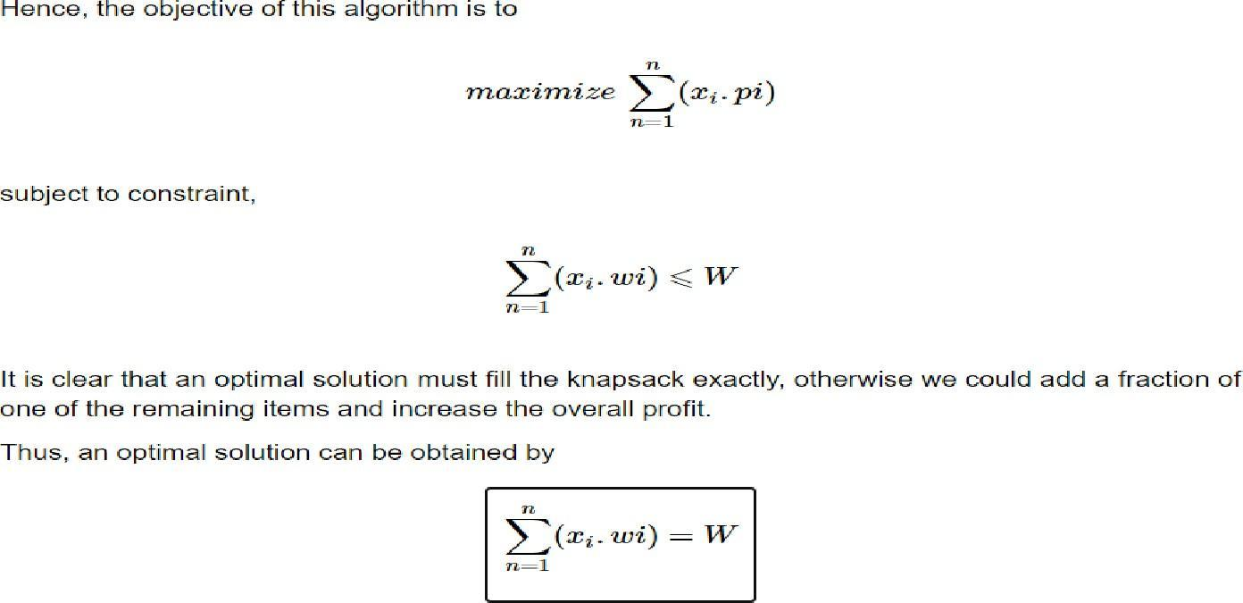
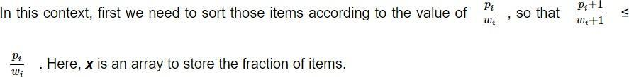

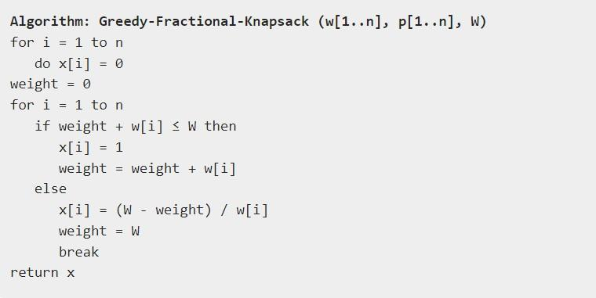

Implementation:

#include <stdio.h>

// Displays the current state of item metrics
void displayItemStats(int totalItems, float profits[], float weights[], float densities[]) {
printf("Profit:\t");
for (int i = 0; i < totalItems; i++) {
printf("%.1f\t", profits[i]);
}

printf("\nWeight:\t");
for (int i = 0; i < totalItems; i++) {
printf("%.1f\t", weights[i]);
}

printf("\nRatio:\t");
for (int i = 0; i < totalItems; i++) {
printf("%.2f\t", densities[i]);
}
printf("\n\n");
}

int main() {
int itemCount;
float maxCapacity, optimizedProfit = 0.0;

printf("Enter number of items: ");
if (scanf("%d", &itemCount) != 1 || itemCount <= 0) return 1;

float itemProfits[itemCount], itemWeights[itemCount], profitRatios[itemCount], selectionFractions[itemCount];

printf("Enter profits: ");
for (int i = 0; i < itemCount; i++) {
scanf("%f", &itemProfits[i]);
}

printf("Enter weights: ");
for (int i = 0; i < itemCount; i++) {
scanf("%f", &itemWeights[i]);
}

printf("Enter knapsack capacity: ");
scanf("%f", &maxCapacity);

// Calculate value-to-weight ratios and reset selections
for (int i = 0; i < itemCount; i++) {
profitRatios[i] = itemProfits[i] / itemWeights[i];
selectionFractions[i] = 0.0;
}

printf("\n=== Source Data ===\n");
displayItemStats(itemCount, itemProfits, itemWeights, profitRatios);

// Sort items descending using Insertion Sort (More professional than Bubble Sort)
for (int i = 1; i < itemCount; i++) {
float keyRatio = profitRatios[i];
float keyProfit = itemProfits[i];
float keyWeight = itemWeights[i];
int j = i - 1;

while (j >= 0 && profitRatios[j] < keyRatio) {
profitRatios[j + 1] = profitRatios[j];
itemProfits[j + 1] = itemProfits[j];
itemWeights[j + 1] = itemWeights[j];
j--;
}
profitRatios[j + 1] = keyRatio;
itemProfits[j + 1] = keyProfit;
itemWeights[j + 1] = keyWeight;
}

printf("=== Processed Data (Sorted by Efficiency) ===\n");
displayItemStats(itemCount, itemProfits, itemWeights, profitRatios);

// Greedy knapsack packing execution
float currentLeftover = maxCapacity;
for (int i = 0; i < itemCount; i++) {
if (itemWeights[i] <= currentLeftover) {
selectionFractions[i] = 1.0;
optimizedProfit += itemProfits[i];
currentLeftover -= itemWeights[i];
} else {
selectionFractions[i] = currentLeftover / itemWeights[i];
optimizedProfit += itemProfits[i] * selectionFractions[i];
break;
}
}

// Output final results
printf("=== Solution Vector ===\nSelection Matrix: [ ");
for (int i = 0; i < itemCount; i++) {
printf("%.2f ", selectionFractions[i]);
}
printf("]\n\n");

printf("Maximum Achievable Profit = %.2f\n", optimizedProfit);

return 0;
}
//END OF CODE

Output:
Enter number of items: 3
Enter profits: 60 100 120
Enter weights: 10 20 30
Enter knapsack capacity: 50

=== Source Data ===
Profit: 60.0 100.0 120.0
Weight: 10.0 20.0 30.0
Ratio: 6.00 5.00 4.00

=== Processed Data (Sorted by Efficiency) ===
Profit: 60.0 100.0 120.0
Weight: 10.0 20.0 30.0
Ratio: 6.00 5.00 4.00

=== Solution Vector ===
Selection Matrix: [ 1.00 1.00 0.67 ]

Maximum Achievable Profit = 240.00

Conclusion:The Fractional Knapsack algorithm was successfully implemented with user inputs in C. The program computes profit-to-weight ratios, sorts the items, and computes the optimal fraction array to achieve maximum profit.

