Class: | SE | Div: | A | Semester: | 3
Course Code: | 2013115 |  |  | Course Name: | AIDS

Name of Student: | Shaurya Ramkrishna Jamsandekar
Roll No. : | 22
Experiment No.: | 5
Title of the Experiment: | Prim’s Algorithm and Kruskal’s Algorithm
Date of Performance: | 20-08-26
Date of Submission: | 20-08-26
Evaluation
Performance Indicator | Max. Marks | Marks Obtained
Performance | 5
Understanding | 5
Journal work and timely submission | 10
Total | 20

Performance Indicator | Exceed Expectations (EE) | Meet Expectations (ME) | Below Expectations (BE)
Performance | 4-5 | 2-3 | 1
Understanding | 4-5 | 2-3 | 1
Journal work and timely submission | 8-10 | 5-8 | 1-4

Checked by

Name of Faculty : Mrs. Sneha Yadav
Signature :
Date :

Experiment No. 5
Title: Prim’s Algorithm and Kruskal’s Algorithm

Aim: To study and implement Prim’s and Kruskal’s Minimum Cost Spanning TreeAlgorithm
Objective: To introduce Greedy based algorithms.

Theory:

Prim's algorithm is a greedy algorithm that finds a minimum spanning tree for a weighted undirected graph. This means it finds a subset of the edges that forms a tree that includes every vertex, where the total weight of all the edges in the tree is minimized. The algorithm operates by building this tree one vertex at a time, from an arbitrary starting vertex, at each step adding the cheapest possible connection from the tree to another vertex.

Example:
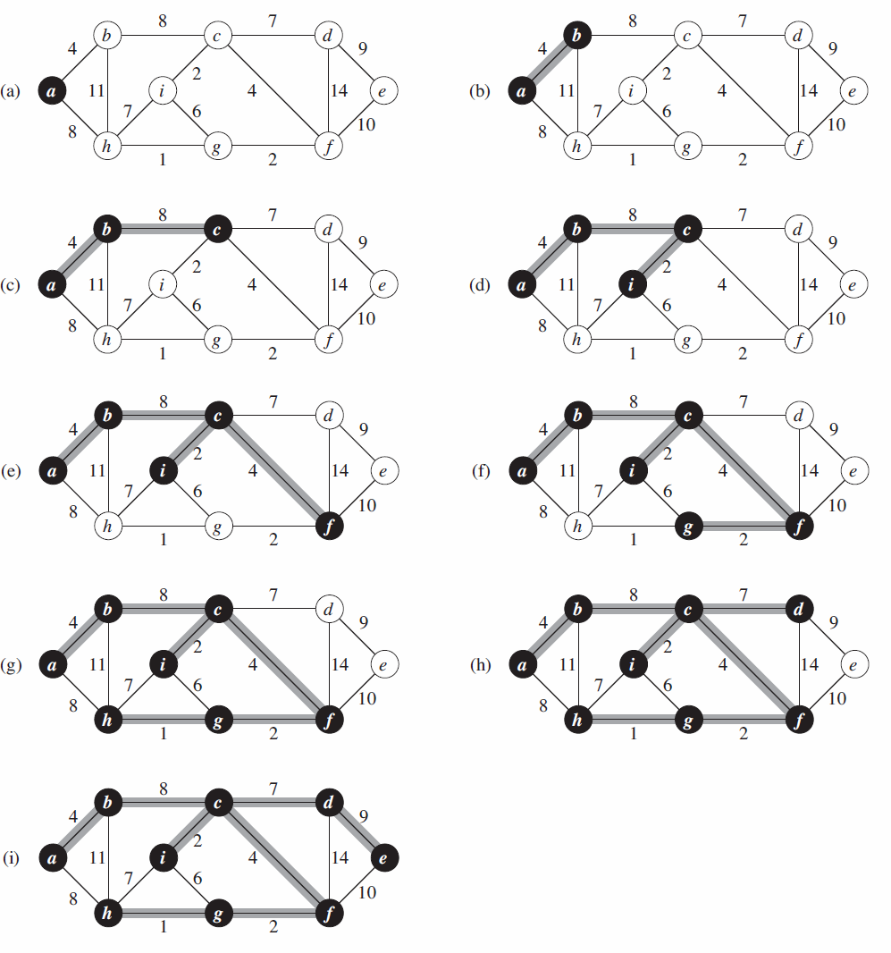

Algorithm and Complexity:
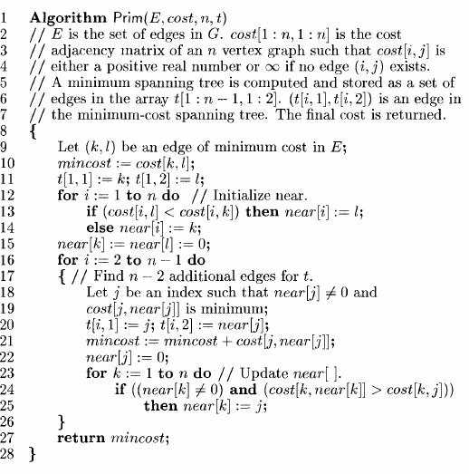

Time Complexity is O( n2 ), Where, n = number of vertices Theory:

Implementation:
#include <stdio.h>
#include <limits.h>

int main() {
int vertices, mst_cost = 0, count = 0;

printf("Enter the number of nodes: ");
scanf("%d", &vertices);

int graph[vertices][vertices];
int visited[vertices];

printf("Enter the adjacency matrix (use 0 for no connection):\n");
for (int r = 0; r < vertices; r++) {
visited[r] = 0;
for (int c = 0; c < vertices; c++) {
scanf("%d", &graph[r][c]);
if (graph[r][c] == 0) {
graph[r][c] = INT_MAX;
}
}
}

visited[0] = 1;
printf("\nStarting Visited List: [ ");
for (int r = 0; r < vertices; r++) {
printf("%d ", visited[r]);
}
printf("]\n\n");

while (count < vertices - 1) {
int min_weight = INT_MAX;
int node1 = 0, node2 = 0;

for (int r = 0; r < vertices; r++) {
if (visited[r]) {
for (int c = 0; c < vertices; c++) {
if (!visited[c] && graph[r][c] < min_weight) {
min_weight = graph[r][c];
node1 = r;
node2 = c;
}
}
}
}

visited[node2] = 1;
mst_cost += min_weight;
count++;

printf("Picked Edge (%d, - %d) with weight %d\n", node1, node2, min_weight);
printf("Updated Visited List: [ ");
for (int r = 0; r < vertices; r++) {
printf("%d ", visited[r]);
}
printf("]\n\n");
}

printf("Final Minimum Spanning Tree Cost = %d\n", mst_cost);
return 0;
}
Output:
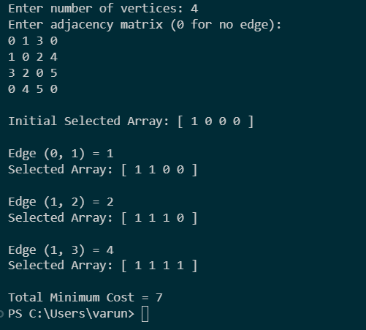

Conclusion:Prim's Algorithm was successfully implemented in C using the Greedy method. The algorithm generated the Minimum Spanning Tree by connecting the nearest unvisited vertices step-by-step with a time complexity of $O(V^{2})$.

