Project Name -
AIRBNB BOOKING ANALYSES

Project by :- Shaurya Pradhan

Project Summary -
Airbnb is an online marketplace that connects people who want to rent out their homes with people who are looking for accommodations in specific area.Airbnb offers people an easy, relatively stress-free way to earn some income from their property.
Since 2008, guests and hosts have used Airbnb to travel in a more unique, personalized way. This dataset describes all the listing activity of homestays in New York City.NYC is not only the most famous city in the world but also top global destination for visitors drawn to its museums, entertainment, restaurants and commerce.
Dataset has 48895 observations across 16 attributes, ranges from host information, geographical information, booking logistics, house/room information to reviews and availability.
Our motivation to explore this dataset is because we want to provide guidance for travelers to New York City before they make any decisions in terms of Airbnbs. Specifically, we want the travelers to have a general understanding of where would be the cheapest and best reviewed homestays.
Different variables: price, name, host id, host name, Neighborhood-group, neighborhood, latitude, longitude, room-type, minimum-nights, number of reviews, last review, review per month, calculated host listings, and availability 365 days.

Problem Statement
Write Problem Statement Here.
- One of the biggest challenges for companies is to maintain positive customer experience along with having a financially profitable business model for property owners. How factors are affecting the price for the Airbnb listing in NYC? What is the overall location distribution of Airbnb NYC? Which neighborhood has a better average price for the Airbnb listing?
- We will be doing analysis on every Airbnb listing based on their location, including their price range, room type, listing name, and other related factors.
- Our objective would be to find out the key metrics that influence the listing of properties on the platform.

Define Your Business Objective?
Trying to answering following question for airbnb :
Q1. In New York where are the highest share of airbnb hotels ?
Q2. Which room type has the highest and the lowest number of booking ?
Q3. According to the neighborhood group which room type has the most number of booking ?
Q4. What is the average price per night for different room type based on neighborhood group ?
Q5. What are the Top ten neighborhoods with the most expensive prices ?
Q6. What are the Top ten neighborhoods with the cheapest prices ?
Q7. What are the top ten neighborhoods with most number of booking ?
Q8. What are the top ten neighborhoods with the least number of booking ?
Q9. Which neighborhood group have most number of reviews ?
Q10. Which neighborhood group has the most booking show using scatter plot ?
Q11. Show a relation between neighborhood group and price using box plot ?
Q13. Who are the top earning host ?
Q14. Which room type has been occupied for the most number of nights ?

Let's Begin !

1. Know Your Data
# Importing Libraries
import numpy as np
import pandas as pd
import matplotlib.pyplot as plt
%matplotlib inline
import seaborn as sns
import missingno as msno
# Loading Dataset
from google.colab import drive
drive.mount('/content/drive')
Drive already mounted at /content/drive; to attempt to forcibly remount, call drive.mount("/content/drive", force_remount=True).
airbnb = pd.read_csv('/content/drive/MyDrive/Airbnb NYC 2019.csv')
# Dataset First Look
airbnb
id name host_id \
0 2539 Clean & quiet apt home by the park 2787
1 2595 Skylit Midtown Castle 2845
2 3647 THE VILLAGE OF HARLEM....NEW YORK ! 4632
3 3831 Cozy Entire Floor of Brownstone 4869
4 5022 Entire Apt: Spacious Studio/Loft by central park 7192
... ... ... ...
48890 36484665 Charming one bedroom - newly renovated rowhouse 8232441
48891 36485057 Affordable room in Bushwick/East Williamsburg 6570630
48892 36485431 Sunny Studio at Historical Neighborhood 23492952
48893 36485609 43rd St. Time Square-cozy single bed 30985759
48894 36487245 Trendy duplex in the very heart of Hell's Kitchen 68119814
host_name neighbourhood_group neighbourhood latitude \
0 John Brooklyn Kensington 40.64749
1 Jennifer Manhattan Midtown 40.75362
2 Elisabeth Manhattan Harlem 40.80902
3 LisaRoxanne Brooklyn Clinton Hill 40.68514
4 Laura Manhattan East Harlem 40.79851
... ... ... ... ...
48890 Sabrina Brooklyn Bedford-Stuyvesant 40.67853
48891 Marisol Brooklyn Bushwick 40.70184
48892 Ilgar & Aysel Manhattan Harlem 40.81475
48893 Taz Manhattan Hell's Kitchen 40.75751
48894 Christophe Manhattan Hell's Kitchen 40.76404
longitude room_type price minimum_nights number_of_reviews \
0 -73.97237 Private room 149 1 9
1 -73.98377 Entire home/apt 225 1 45
2 -73.94190 Private room 150 3 0
3 -73.95976 Entire home/apt 89 1 270
4 -73.94399 Entire home/apt 80 10 9
... ... ... ... ... ...
48890 -73.94995 Private room 70 2 0
48891 -73.93317 Private room 40 4 0
48892 -73.94867 Entire home/apt 115 10 0
48893 -73.99112 Shared room 55 1 0
48894 -73.98933 Private room 90 7 0
last_review reviews_per_month calculated_host_listings_count \
0 2018-10-19 0.21 6
1 2019-05-21 0.38 2
2 NaN NaN 1
3 2019-07-05 4.64 1
4 2018-11-19 0.10 1
... ... ... ...
48890 NaN NaN 2
48891 NaN NaN 2
48892 NaN NaN 1
48893 NaN NaN 6
48894 NaN NaN 1
availability_365
0 365
1 355
2 365
3 194
4 0
... ...
48890 9
48891 36
48892 27
48893 2
48894 23
[48895 rows x 16 columns]
# Dataset Rows & Columns count
airbnb.shape
(48895, 16)
Our dataframe have 48895 rows and 16 columns.
# Dataset Info
airbnb.info()
<class 'pandas.core.frame.DataFrame'>
RangeIndex: 48895 entries, 0 to 48894
Data columns (total 16 columns):
# Column Non-Null Count Dtype
--- ------ -------------- -----
0 id 48895 non-null int64
1 name 48879 non-null object
2 host_id 48895 non-null int64
3 host_name 48874 non-null object
4 neighbourhood_group 48895 non-null object
5 neighbourhood 48895 non-null object
6 latitude 48895 non-null float64
7 longitude 48895 non-null float64
8 room_type 48895 non-null object
9 price 48895 non-null int64
10 minimum_nights 48895 non-null int64
11 number_of_reviews 48895 non-null int64
12 last_review 38843 non-null object
13 reviews_per_month 38843 non-null float64
14 calculated_host_listings_count 48895 non-null int64
15 availability_365 48895 non-null int64
dtypes: float64(3), int64(7), object(6)
memory usage: 6.0+ MB

Removing the Duplicates
# Dataset Duplicate Value Count
airbnb.duplicated().sum()
airbnb.drop_duplicates(inplace = True)
####Checking Missing Values
# Missing Values
airbnb.isnull().sum()
id 0
name 16
host_id 0
host_name 21
neighbourhood_group 0
neighbourhood 0
latitude 0
longitude 0
room_type 0
price 0
minimum_nights 0
number_of_reviews 0
last_review 10052
reviews_per_month 10052
calculated_host_listings_count 0
availability_365 0
dtype: int64
# Visualizing the missing values
plt.rcParams['figure.figsize'] = (10,5)
msno.bar(airbnb)
<AxesSubplot:>
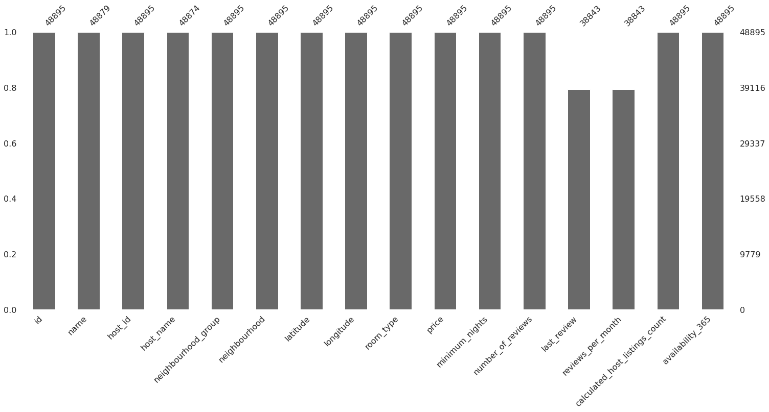

What did you know about your dataset?
As of now we know our dataset have 48895 rows and 16 columns and out of them last_review and reviews_per_month columns are the one which have largest number of missing values. Hence we should remove them

2. Understanding Your Variables
# Dataset Columns
airbnb.columns
Index(['id', 'name', 'host_id', 'host_name', 'neighbourhood_group',
'neighbourhood', 'latitude', 'longitude', 'room_type', 'price',
'minimum_nights', 'number_of_reviews', 'last_review',
'reviews_per_month', 'calculated_host_listings_count',
'availability_365'],
dtype='object')
# Dropping columns that are unnecessary for our analysis
airbnb.drop(['id','name','last_review'], axis = 'columns', inplace = True)
# Replacing all NaN value in reviews_per_months with 0.
airbnb.reviews_per_month.fillna(0,inplace = True)
airbnb.host_name.fillna(0,inplace = True)
# Write your code to make your dataset analysis ready.
airbnb.isnull().any()
host_id False
host_name False
neighbourhood_group False
neighbourhood False
latitude False
longitude False
room_type False
price False
minimum_nights False
number_of_reviews False
reviews_per_month False
calculated_host_listings_count False
availability_365 False
dtype: bool
# Descriptive statistics for numerical values
airbnb.describe()
host_id latitude longitude price minimum_nights \
count 4.889500e+04 48895.000000 48895.000000 48895.000000 48895.000000
mean 6.762001e+07 40.728949 -73.952170 152.720687 7.029962
std 7.861097e+07 0.054530 0.046157 240.154170 20.510550
min 2.438000e+03 40.499790 -74.244420 0.000000 1.000000
25% 7.822033e+06 40.690100 -73.983070 69.000000 1.000000
50% 3.079382e+07 40.723070 -73.955680 106.000000 3.000000
75% 1.074344e+08 40.763115 -73.936275 175.000000 5.000000
max 2.743213e+08 40.913060 -73.712990 10000.000000 1250.000000
number_of_reviews reviews_per_month calculated_host_listings_count \
count 48895.000000 48895.000000 48895.000000
mean 23.274466 1.090910 7.143982
std 44.550582 1.597283 32.952519
min 0.000000 0.000000 1.000000
25% 1.000000 0.040000 1.000000
50% 5.000000 0.370000 1.000000
75% 24.000000 1.580000 2.000000
max 629.000000 58.500000 327.000000
availability_365
count 48895.000000
mean 112.781327
std 131.622289
min 0.000000
25% 0.000000
50% 45.000000
75% 227.000000
max 365.000000

What all manipulations have you done and insights you found?
First we have checked for duplicate values and then droped them secondly we have cheched for null values in our data set and found there are two variables with highest number of null values to solve this we have droped last_review and filled review_per_months with zero. Thirdly we have droped all the variables which is not useful for our analysis.
airbnb.head(5)
host_id neighbourhood_group neighbourhood latitude longitude \
0 2787 Brooklyn Kensington 40.64749 -73.97237
1 2845 Manhattan Midtown 40.75362 -73.98377
2 4632 Manhattan Harlem 40.80902 -73.94190
3 4869 Brooklyn Clinton Hill 40.68514 -73.95976
4 7192 Manhattan East Harlem 40.79851 -73.94399
room_type price minimum_nights number_of_reviews \
0 Private room 149 1 9
1 Entire home/apt 225 1 45
2 Private room 150 3 0
3 Entire home/apt 89 1 270
4 Entire home/apt 80 10 9
reviews_per_month calculated_host_listings_count availability_365
0 0.21 6 365
1 0.38 2 355
2 0.00 1 365
3 4.64 1 194
4 0.10 1 0

4. Data Vizualization, Storytelling & Experimenting with charts : Understand the relationships between variables
airbnb.head(5)
host_id host_name neighbourhood_group neighbourhood latitude \
0 2787 John Brooklyn Kensington 40.64749
1 2845 Jennifer Manhattan Midtown 40.75362
2 4632 Elisabeth Manhattan Harlem 40.80902
3 4869 LisaRoxanne Brooklyn Clinton Hill 40.68514
4 7192 Laura Manhattan East Harlem 40.79851
longitude room_type price minimum_nights number_of_reviews \
0 -73.97237 Private room 149 1 9
1 -73.98377 Entire home/apt 225 1 45
2 -73.94190 Private room 150 3 0
3 -73.95976 Entire home/apt 89 1 270
4 -73.94399 Entire home/apt 80 10 9
reviews_per_month calculated_host_listings_count availability_365
0 0.21 6 365
1 0.38 2 355
2 0.00 1 365
3 4.64 1 194
4 0.10 1 0

Neighborhood Group

Q1. In New York where are the highest share of airbnb hotels ?
# Chart - 1 visualization
plt.style.use('fivethirtyeight')
plt.figure(figsize=(10,7))
plt.title('Neighbourhood Group')
plt.pie(airbnb.neighbourhood_group.value_counts(), labels =airbnb.neighbourhood_group.value_counts().index,autopct='%.2f%%' )
plt.show()
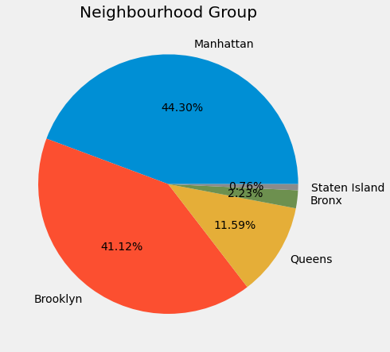
#Observation
The above pie chart shows that the highest number of airbnb listing is from Manhattan and Brooklyn Boroughs of New York city.
And Manhattan boroughs have most active number of host.

The same can be drived from the map of neighborhood group.
plt.figure(figsize = (10,7))
sns.scatterplot(x = airbnb.longitude, y = airbnb.latitude, hue = airbnb.neighbourhood_group)
plt.show()
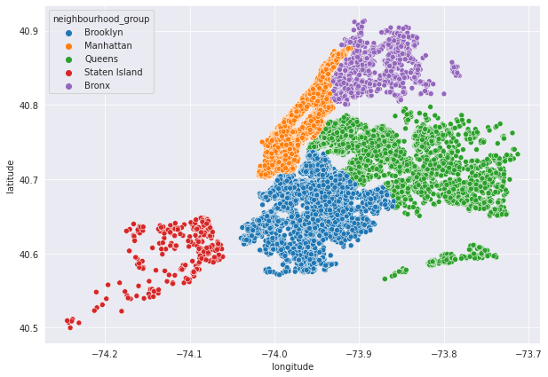

Room details

Q2. Which room type has the highest and the lowest number of booking ?
# Chart - 2 visualization code
plt.figure(figsize = (10,5))
plt.title('Types of Rooms')
sns.countplot(airbnb.room_type)
fig = plt.gcf()
plt.show()
/usr/local/lib/python3.8/dist-packages/seaborn/_decorators.py:36: FutureWarning: Pass the following variable as a keyword arg: x. From version 0.12, the only valid positional argument will be `data`, and passing other arguments without an explicit keyword will result in an error or misinterpretation.
warnings.warn(
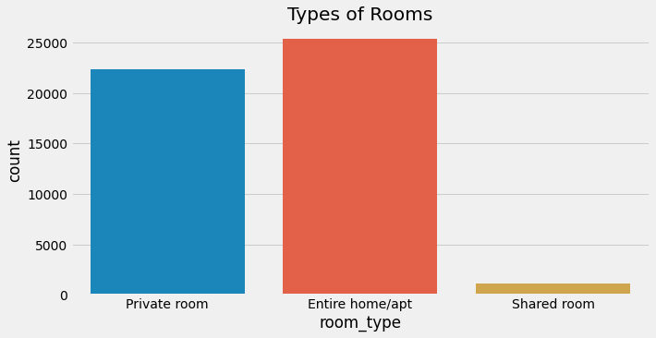

Insight found from the chart?
We can see that entire home/apt have the highest booking followed by private room and the least booked is shared room.

Chart - 3

Room type for neighborhood group

Q3. According to the neighborhood group which room type has the most number of booking ?
# Chart - 3 visualization code
plt.figure(figsize = (10,5))
plt.title('Room type for neighbourhood group')
sns.countplot(airbnb.neighbourhood_group, hue = airbnb.room_type)
plt.show()
/usr/local/lib/python3.8/dist-packages/seaborn/_decorators.py:36: FutureWarning: Pass the following variable as a keyword arg: x. From version 0.12, the only valid positional argument will be `data`, and passing other arguments without an explicit keyword will result in an error or misinterpretation.
warnings.warn(
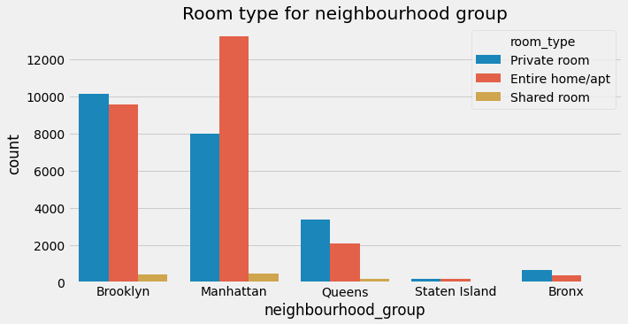

Insight found from the chart?
It clearly shows in Manhattan entire home/apt is the most booked while in Brooklyn private room is the most booked which is also same in queens and bronx but in staten island entire home/apt is slightly higher.

Price Exploration

#checking null values
airbnb['price'].isna().sum()
0
airbnb['price'].head(10)
0 149
1 225
2 150
3 89
4 80
5 200
6 60
7 79
8 79
9 150
Name: price, dtype: int64
airbnb['price'].describe()
count 48895.000000
mean 152.720687
std 240.154170
min 0.000000
25% 69.000000
50% 106.000000
75% 175.000000
max 10000.000000
Name: price, dtype: float64

Observation
From statistics summary the price range is from 0-10000. But the maximum price is of 10000 which can be due to location,room type, neighbourhood , season etc. we also have minimum price of 0 which can be due to dynamic pricing or the willingness of not to share the price with the Airbnb or may be there was no booking at all.
airbnb['price'][airbnb['price'] == 0].value_counts()
0 11
Name: price, dtype: int64
# Replacig a 0 with mean in price column
airbnb['price'].replace(to_replace = 0,value = airbnb['price'].mean(), inplace = True)
airbnb['price'].describe()
count 48895.000000
mean 152.755045
std 240.143242
min 10.000000
25% 69.000000
50% 106.000000
75% 175.000000
max 10000.000000
Name: price, dtype: float64
#Highest Prices in 5 boroughs of New York city
#high prices
high_price = airbnb.groupby('neighbourhood_group',as_index = False)['price'].max()
high_price
neighbourhood_group price
0 Bronx 2500.0
1 Brooklyn 10000.0
2 Manhattan 10000.0
3 Queens 10000.0
4 Staten Island 5000.0
#Observation From above table we can see Brooklyn, Manhattan and Queens have prices of 10,000.
#low prices
low_price = airbnb.groupby('neighbourhood_group', as_index = False)['price'].min()
low_price
neighbourhood_group price
0 Bronx 10.0
1 Brooklyn 10.0
2 Manhattan 10.0
3 Queens 10.0
4 Staten Island 13.0
#Observation Lowest prices are at places Bronx, Brooklyn, Manhattan and queens.
airbnb['price'].describe()
count 48895.000000
mean 152.755045
std 240.143242
min 10.000000
25% 69.000000
50% 106.000000
75% 175.000000
max 10000.000000
Name: price, dtype: float64
hist_price = airbnb['price'].hist()
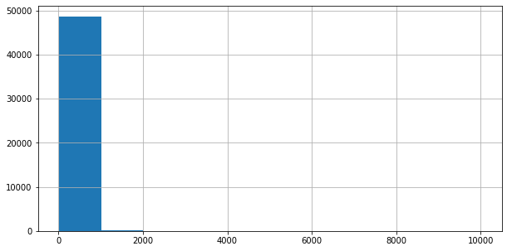

Observation :

Most value is less than 1000. So the most dominanting price range is under 1000 which hold nearly 48,000 properties.
So there are 48,000 properties with price less than 1000.
# Focusing on rental rate which are less than 1000
hist_price = airbnb['price'][airbnb['price']<=1000].hist()
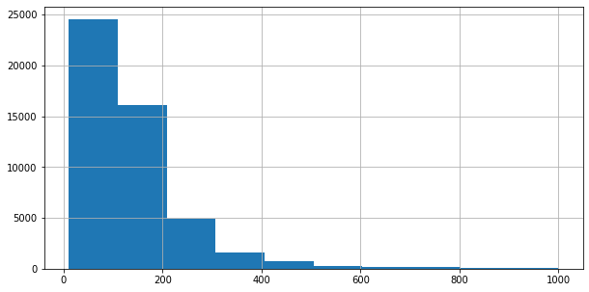
#Observation Price range is more dominating under 200. which means even if we know that most properties are under price range 1000 even inside it the most dominating one is with 200.
# Rantel rate greater than 1000
hist_price = airbnb["price"][airbnb['price'] > 1000].hist()
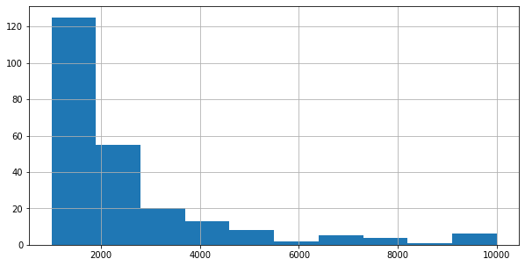
#Observation It is safe to say that most of the properties fall under the price range of 2000 in it. And most dominanting range is from 1000 to 4000.
# Counting price greater than 1000
price_greater_than_2000 = airbnb[airbnb['price'] > 1000].value_counts()
print(price_greater_than_2000)
host_id host_name neighbourhood_group neighbourhood latitude longitude room_type price minimum_nights number_of_reviews reviews_per_month calculated_host_listings_count availability_365
8730 Allison Manhattan Chelsea 40.73692 -73.99219 Entire home/apt 1495.0 1 11 0.22 1 0 1
75110137 Christina Brooklyn Gowanus 40.68494 -73.98850 Private room 1333.0 50 0 0.00 1 365 1
60535711 Bruce Manhattan Midtown 40.76040 -73.97410 Entire home/apt 1100.0 2 20 0.53 2 268 1
63492343 Lenore Manhattan Chelsea 40.73971 -73.99611 Entire home/apt 1050.0 2 0 0.00 1 365 1
65562107 Gina Manhattan Tribeca 40.71868 -74.00765 Entire home/apt 1200.0 5 13 0.98 1 347 1
..
11460768 Brian Manhattan Upper West Side 40.80020 -73.96045 Entire home/apt 1500.0 1 0 0.00 1 0 1
11461854 Lauren Manhattan West Village 40.73295 -74.00755 Entire home/apt 1500.0 1 0 0.00 1 0 1
11490872 Nick Manhattan Kips Bay 40.74422 -73.97822 Entire home/apt 1550.0 2 0 0.00 1 0 1
11492501 Victoria Manhattan Stuyvesant Town 40.73205 -73.98094 Entire home/apt 1500.0 1 0 0.00 1 0 1
272166348 Mary Rotsen Manhattan Upper East Side 40.78132 -73.95262 Entire home/apt 1999.0 30 0 0.00 1 270 1
Length: 239, dtype: int64

Observation

We can easily see their are 239 listing whose prices are greater than 1000.

So they might be luxurious property or it can be a error during input.

Average room price for locality
Q4. What is the average price per night for different room type based on neighborhood group ?
# Average room price per night
plt.figure(figsize=(12,8))
df = airbnb[airbnb['minimum_nights']==1]
df1 = df.groupby(['room_type','neighbourhood_group'])['price'].mean().sort_values(ascending=True)
df1.plot(kind='bar', color =('#e33030', '#e35d30','#e39830','#e3c230','#dae330','#b0e330','#7be330','#39e330','#30e37e','#30e3b0','#30dde3','#30a4e3','#3081e3','#3d2ee6','#6e2ee6'))
plt.title('Average Price for rooms in neighbourhood group')
plt.ylabel('Average Daily Price')
plt.xlabel('Neighbourhood Group')
plt.show()
print('List of Average Price per night based on the neighbourhood group')
pd.DataFrame(df1).sort_values(by='room_type')
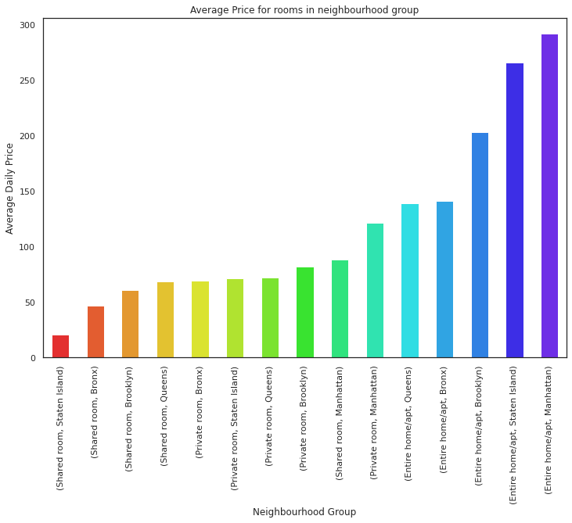
List of Average Price per night based on the neighbourhood group
price
room_type neighbourhood_group
Entire home/apt Queens 139.036260
Bronx 141.541176
Brooklyn 202.895245
Staten Island 266.205128
Manhattan 291.784595
Private room Bronx 69.025862
Staten Island 71.394366
Queens 72.454958
Brooklyn 81.713284
Manhattan 121.434183
Shared room Staten Island 21.000000
Bronx 46.711111
Brooklyn 60.921212
Queens 68.459459
Manhattan 88.462898

Observation
From looking at plot few things are clear
- Shared room at staten Island is the most cheapest stay per night whereas Renting a Entire apartment/Home at Manhattan per night is the most expensive.
- Average price for Private room is also considerably expensive at manhattan so is the shared room at Manhattan is expensive than other private rooms of the neighbourhood. This clearly states that Manhattan is the expensive stay than any other locality.
- Bronx is the most cheapest stay in terms of neighbourhood group comparison in respect to room type.
- Though Shared room at Staten Island is the cheapest whereas Apartment renting is not cheapest at Staten Island

Costly Neighborhood

Q5. Top ten neighborhoods with the most expensive prices ?
# Now we will be checking average prices across each neighborhood
# Top 10 neighborhood
print('Top 10 most expensive locality in Airbnb listing are :')
df4 = airbnb.dropna(subset=["price"]).groupby("neighbourhood")[["neighbourhood", "price"]].agg("mean").sort_values(by="price",
ascending=False).rename(index=str, columns={"price": "Average price per night based on neighbourhood"}).head(10)
df4.plot(kind='bar', color = (''))
plt.show()
pd.DataFrame(df4)
Top 10 most expensive locality in Airbnb listing are :
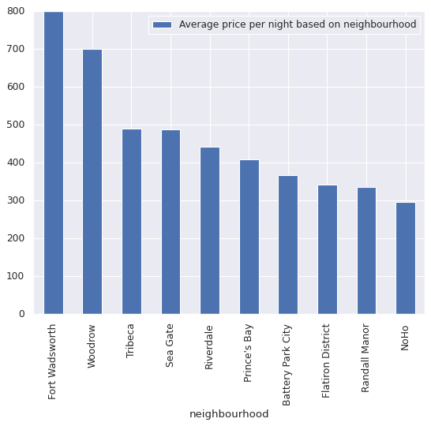
Average price per night based on neighbourhood
neighbourhood
Fort Wadsworth 800.000000
Woodrow 700.000000
Tribeca 490.638418
Sea Gate 487.857143
Riverdale 442.090909
Prince's Bay 409.500000
Battery Park City 367.557143
Flatiron District 341.925000
Randall Manor 336.000000
NoHo 295.717949

Observation

According to the graph and data Fort Wadsworth is most costly neighborhood.
Q6. Top ten neighborhoods with the cheapest prices ?
# top ten least costly neighborhood
print('Least expensive neighbourhood according to Airbnb listing are')
df4 = airbnb.dropna(subset=["price"]).groupby("neighbourhood")[["neighbourhood", "price"]].agg("mean").sort_values(by="price",
ascending=False).rename(index=str, columns={"price": "Average price per night based on neighbourhood"}).tail(10)
df4.plot(kind='bar')
plt.show()
pd.DataFrame(df4)
Least expensive neighbourhood according to Airbnb listing are
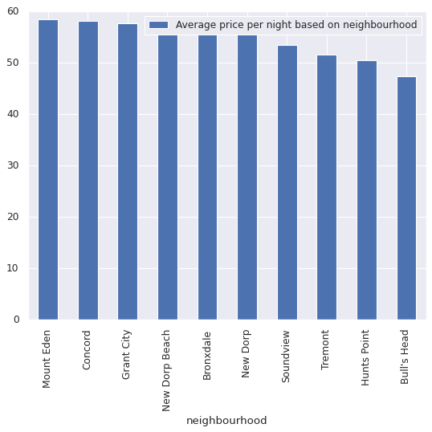
Average price per night based on neighbourhood
neighbourhood
Mount Eden 58.500000
Concord 58.192308
Grant City 57.666667
New Dorp Beach 57.400000
Bronxdale 57.105263
New Dorp 57.000000
Soundview 53.466667
Tremont 51.545455
Hunts Point 50.500000
Bull's Head 47.333333

Observation
Least costly or the cheapest neighborhood to stay is Bull's Head.

Neighborhood which have most number of booking

Q7. What are the top ten neighborhoods with most number of booking ?
# Top 10 listing based on neighborhood
df5 = airbnb.groupby('neighbourhood')[['neighbourhood','host_name']].agg(['count']
)['host_name'].sort_values(by='count',ascending=False).rename(index=str,columns={'Count':'Listing Count'})
df5.head(10).plot(kind='barh')
plt.show()
pd.DataFrame(df5.head(10))
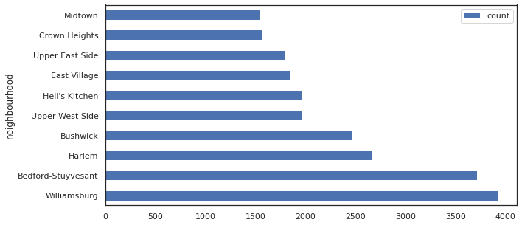
count
neighbourhood
Williamsburg 3920
Bedford-Stuyvesant 3714
Harlem 2658
Bushwick 2465
Upper West Side 1971
Hell's Kitchen 1958
East Village 1853
Upper East Side 1798
Crown Heights 1564
Midtown 1545

Observation
We can see Williamsburg has most number of listing count.
Q8. What are the top ten neighborhoods with the least number of booking ?
# Bottom 10 listing based on neighborhood
print('Least Listing number of count')
df5 = airbnb.groupby('neighbourhood')[['neighbourhood','host_name']].agg(['count']
)['host_name'].sort_values(by='count',ascending=False).rename(index=str,columns={'Count':'Listing Count'})
df5.tail(10).plot(kind='barh')
plt.show()
pd.DataFrame(df5.tail(10))
Least Listing number of count
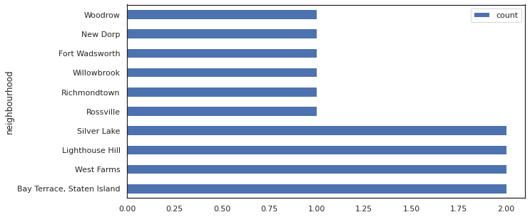
count
neighbourhood
Bay Terrace, Staten Island 2
West Farms 2
Lighthouse Hill 2
Silver Lake 2
Rossville 1
Richmondtown 1
Willowbrook 1
Fort Wadsworth 1
New Dorp 1
Woodrow 1

Observation
So Rossville, Richmondtown, Willowbrook, Fort Wadsworth, New Dorp and Woodrow have least number of booking.

Analysis on number of reviews neighborhood groups have got

Q9. Which neighborhood group have most number of reviews ?
fig = plt.figure(figsize=(12,4))
review_50 = airbnb[airbnb['number_of_reviews']>=50]
df2 = review_50['neighbourhood_group'].value_counts()
df2.plot(kind='bar',color=['r','b','g','y','m'])
plt.title('Location and Review Score(Min of 50)')
plt.ylabel('Number of Review')
plt.xlabel('Neighbourhood Group')
plt.show()
print(' Count of Review v/s neighbourhood group')
pd.DataFrame(df2)
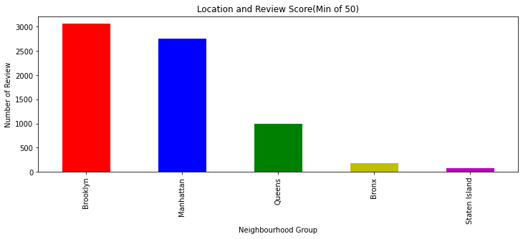
Count of Review v/s neighbourhood group
neighbourhood_group
Brooklyn 3065
Manhattan 2751
Queens 997
Bronx 187
Staten Island 81

Observation
So brooklyn have most number of reviews where as staten island have least number of reviews.

Neighbourhood Group Price Distribution

Q10. Which neighborhood group has the most booking show using scatter plot ?
plt.figure(figsize=(13,7))
plt.title("Map of Price Distribution")
ax=plt.gca()
ax=airbnb[airbnb.price>1000].plot(kind='scatter', x='longitude',y='latitude',label='availability_365',c='price',ax = ax, cmap=plt.get_cmap('jet'),colorbar=True,alpha=0.4)
ax.legend()
plt.ioff()
plt.show()
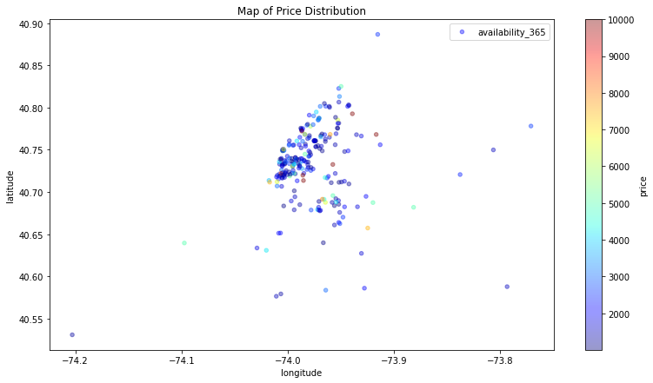

Observation

Most listing with prices greater than 1000 are from Manhattan which means Manhattan has the highest prices.
Q11. Show a relation between neighborhood group and prices using box plot ?
plt.style.use('classic')
plt.figure(figsize=(13,7))
plt.title("Neighbourhood Group Price Distribution < 500")
sns.boxplot(y="price",x ='neighbourhood_group' ,data = airbnb[airbnb.price<500])
plt.show()
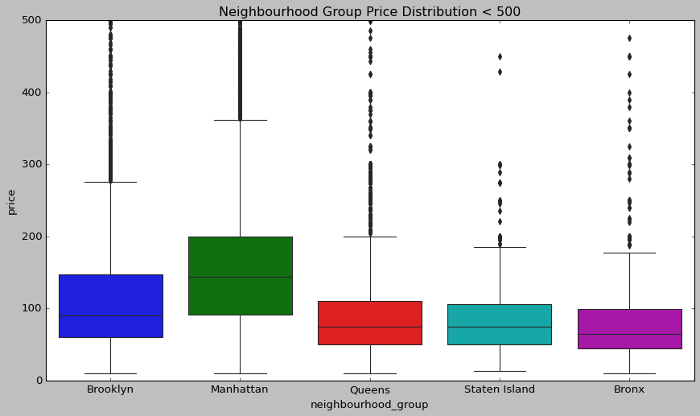

Observation
Boxplot above, we can observe a couple of things about the distribution of prices for Airbnb in NYC.
- We observe that Manhattan has the highest prices for the listing with average being 140 which is followed by Brooklyn with 90.
- Queens and Staten Island seem to have a very similar distribution.
- Cheapest listing are from Bronx.

Host Name

Q13. Who are the top earning host ?
airbnb['host_name'][airbnb['host_name'] == 0].value_counts()
0 21
Name: host_name, dtype: int64
top_host=airbnb.groupby(['host_name','host_id'])['price'].sum().reset_index()
top_host.rename(columns={'price':'total_price'},inplace=True)
top_host.head()
host_name host_id total_price
0 0 415290 325
1 0 526653 50
2 0 919218 86
3 0 5162530 145
4 0 5300585 220
top_3=top_host.sort_values('total_price',ascending=False).iloc[:3,:3]
top_3
host_name host_id total_price
33240 Sonder (NYC) 219517861 82795
4876 Blueground 107434423 70331
31247 Sally 156158778 37097
sns.set(rc={'figure.figsize':(8,10)})
sns.set_style('white')
abc= sns.barplot(x='host_name',y='total_price',data = top_3)
abc.set_title('three hosts based on their turnover')
abc.set_ylabel('host name')
abc.set_xlabel('total price')
abc.set_xticklabels(abc.get_xticklabels(),rotation = 45,size='15')
[Text(0, 0, 'Sonder (NYC)'), Text(1, 0, 'Blueground'), Text(2, 0, 'Sally')]
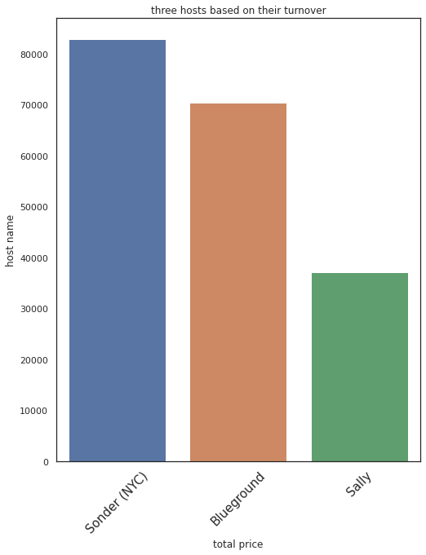
#Observation So sonder, blueground, sally are the top hosts.
Q14. Which room type has been occupied for the most number of nights ?
# Finding the sum of minimum_nights
sum_room = airbnb.groupby('room_type')['minimum_nights'].sum().reset_index()
sum_room
room_type minimum_nights
0 Entire home/apt 216152
1 Private room 120067
2 Shared room 7511
# Ploting the chart
plt.style.use('fivethirtyeight')
plt.figure(figsize=(10,7))
plt.title('Relationship between room type and number of night')
plt.pie(sum_room['minimum_nights'],labels =sum_room['room_type'],autopct='%.2f%%' )
plt.show()
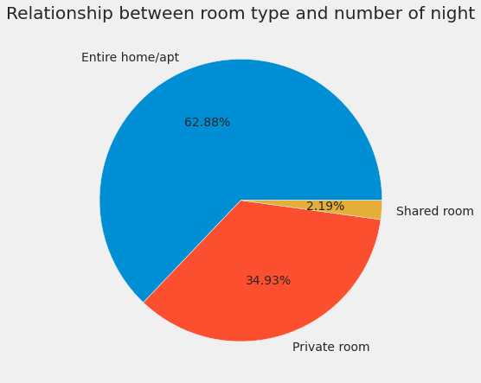
#Observation
- From pie chart we can determine that 63.2% customers spend night in entire home/apt.
- Only 1.6% customers spend night in shared room.
#Correlational matrix
# Corelation between different variables
corr = airbnb.corr(method='kendall')
plt.figure(figsize=(13,10))
plt.title("Correlation Between Different Variables\n")
sns.heatmap(corr, annot=True)
plt.show()
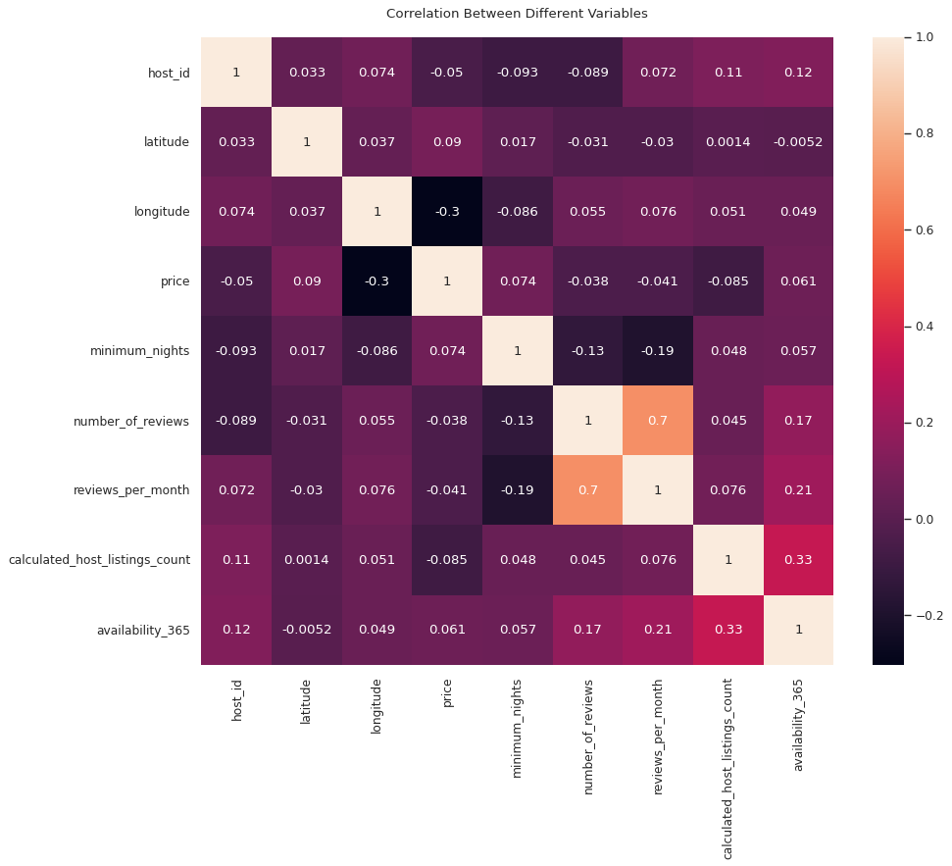
#Observation positive correlation with minimum number of nights, availability of 365 days. Calculated host listings have negative correlation with price and the above graph also shows least correlation with number of reviews.
#Pair Plot
# Visualizating our data set through pairplot
plt.figure(figsize=(30, 30))
sns.pairplot(airbnb, height=3, diag_kind="hist")
plt.show()
<Figure size 2160x2160 with 0 Axes>
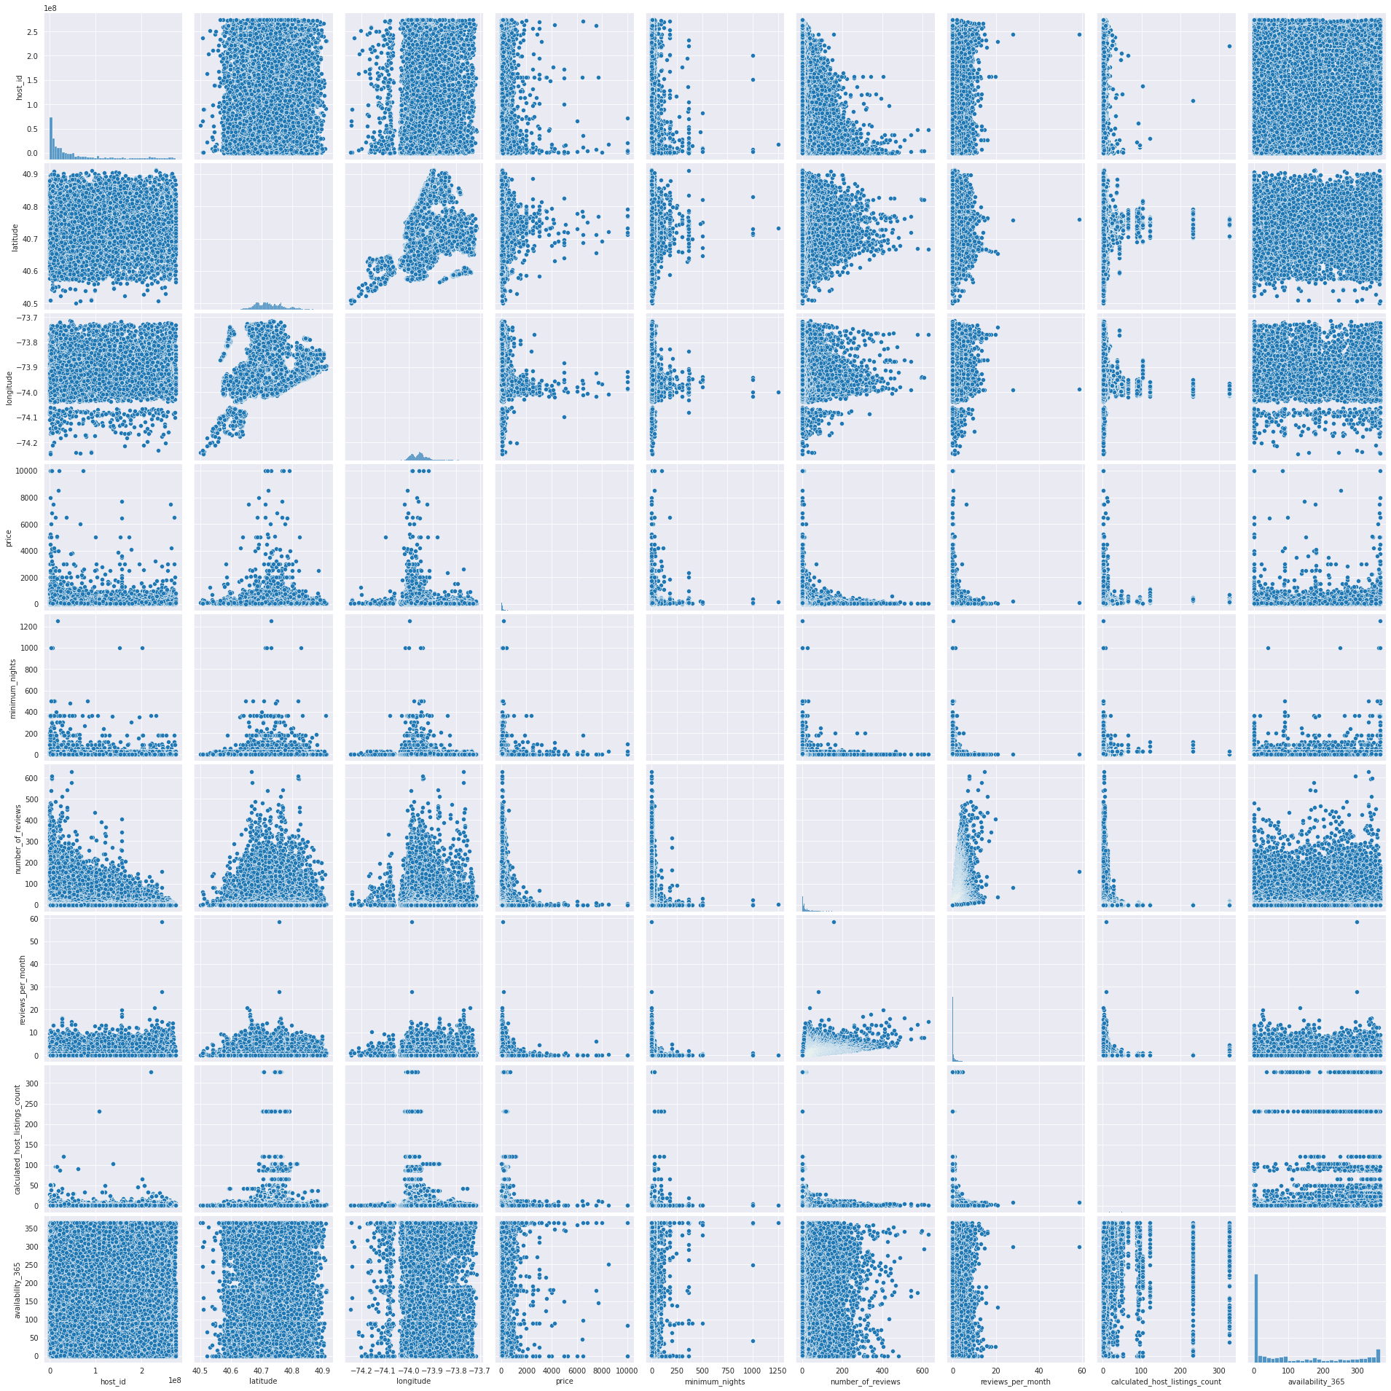

Observation
- latitude and longitude have a normal distribution, most of the hosts are concetrated in specific area.
- reviews_per_month has a lot of outlayers, because of the missing values filled by average.
- availability_365 the most of the hosts are not available all the year.
- price most the host has a price under $1000
airbnb.head(5)
host_id host_name neighbourhood_group neighbourhood latitude \
0 2787 John Brooklyn Kensington 40.64749
1 2845 Jennifer Manhattan Midtown 40.75362
2 4632 Elisabeth Manhattan Harlem 40.80902
3 4869 LisaRoxanne Brooklyn Clinton Hill 40.68514
4 7192 Laura Manhattan East Harlem 40.79851
longitude room_type price minimum_nights number_of_reviews \
0 -73.97237 Private room 149 1 9
1 -73.98377 Entire home/apt 225 1 45
2 -73.94190 Private room 150 3 0
3 -73.95976 Entire home/apt 89 1 270
4 -73.94399 Entire home/apt 80 10 9
reviews_per_month calculated_host_listings_count availability_365
0 0.21 6 365
1 0.38 2 355
2 0.00 1 365
3 4.64 1 194
4 0.10 1 0
# Selecting required columns
col_to_plot = ['price','number_of_reviews','reviews_per_month','calculated_host_listings_count','availability_365','room_type']
# Ploting pairplot
sns.set_style('darkgrid')
sns.pairplot(airbnb[col_to_plot], kind='reg', diag_kind='kde',
plot_kws={'line_kws':{'color':'red'}})
<seaborn.axisgrid.PairGrid at 0x7f291521d790>
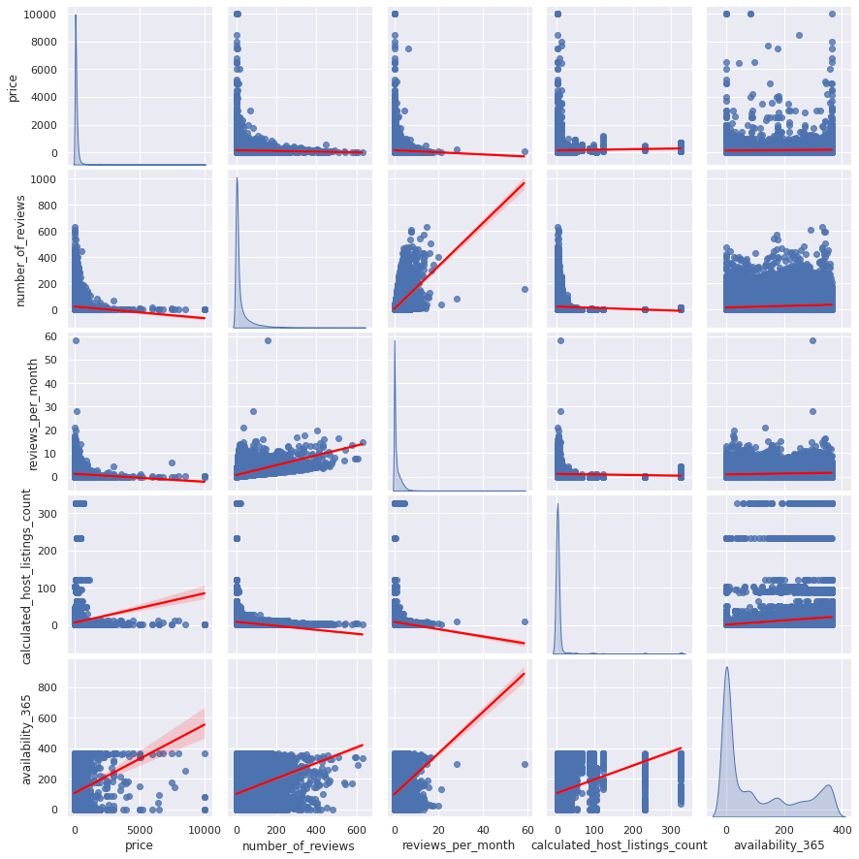
sns.pairplot(airbnb[col_to_plot], hue ='room_type')
<seaborn.axisgrid.PairGrid at 0x7f294e572670>
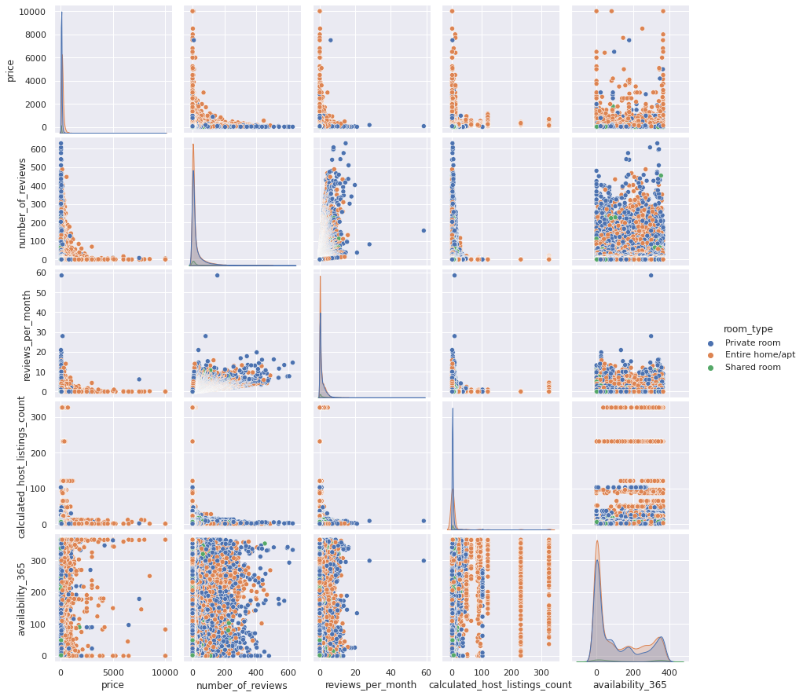
# Selecting required columns
col_to_plot = ['price','number_of_reviews','reviews_per_month','calculated_host_listings_count','availability_365','neighbourhood_group']
# Ploting pairplot
sns.set_style('darkgrid')
sns.pairplot(airbnb[col_to_plot], hue = 'neighbourhood_group')
<seaborn.axisgrid.PairGrid at 0x7f290bec3e20>
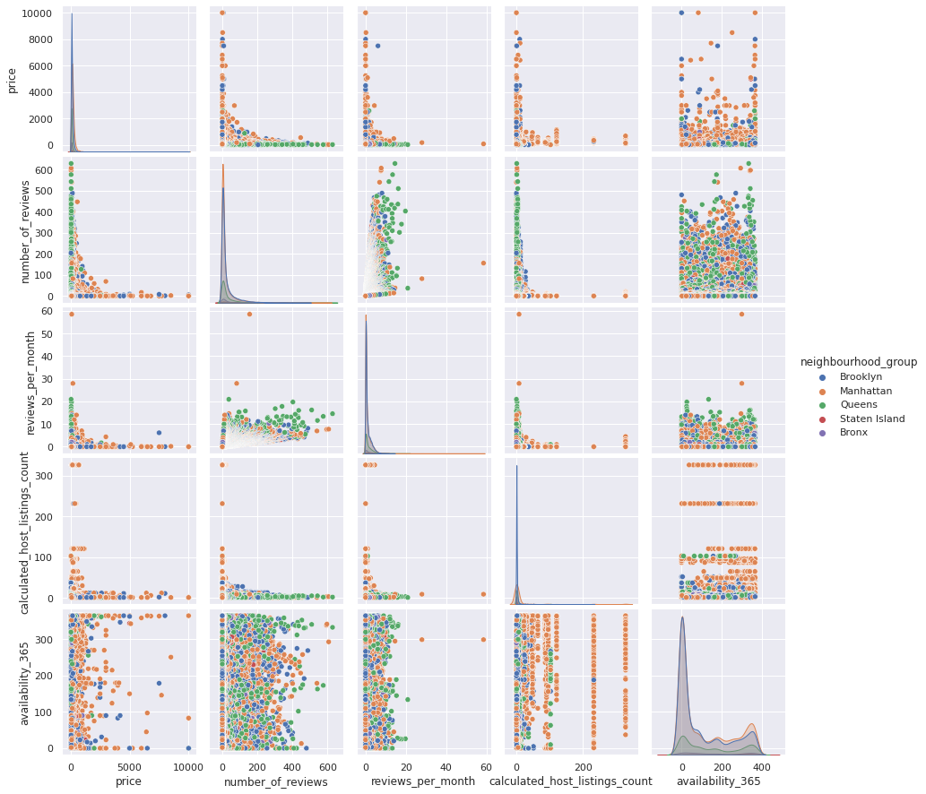

Conclusion
- Manhattan is the cream of the croop for airbnb as it has most number of customer as compared to other Boroughs of new york city.
- Customer pays highest amount of 10,000 for airbnb booking in Manhattan, Brooklyn and queens and the lowest amount is of 10.
- As we know that the entire home/apt has been occupied for the most number of night which is exactly 2,16,152 and in percentile it will 62.88% of all room type.
- So the average price for entire home/apt per night in different neighborhoods groups are as follows:

Queens 139.036260
- #####Bronx 141.541176
- #####Brooklyn 202.895245
- #####Staten Island 266.205128
- #####Manhattan 291.784595
- Most expensive neighborhood in airbnb listing are Fort Wadsworth with the average price of 800.000000 followed by Woodrow with 700.000000 and then Tribeca with 490.638418
- And the neighborhood with the cheapest price are Mount Eden wih the average price of 58.500000 followed by Concord 58.192308 and Grant City with 57.666667.
- Top three neighborhoods with the most number of booking are Williamsburg with 3920 followed by Bedford-Stuyvesant with 3714 and then Harlem with 2658.
- Neighborhood with the least number of booking are Rossville Richmondtown Willowbrook Fort Wadsworth New Dorp Woodrow all which have only one booking.
- Neighborhood groups according to there reviews Brooklyn 3065 Manhattan 2751 Queens 997 Bronx 187 Staten Island 81.
- Top earning hosts are sonder with amount of about 82,795.0, blueground with 70331.0 and sally with 37097.0 .

