**Foundation of coding**

1. A set of numbers are being entered from keyboard till -1 is entered. Find **third** maximum number amongst them.
2. The function exponential(x) is written to approximately calculate ex where e is 2.7183 using the expansion 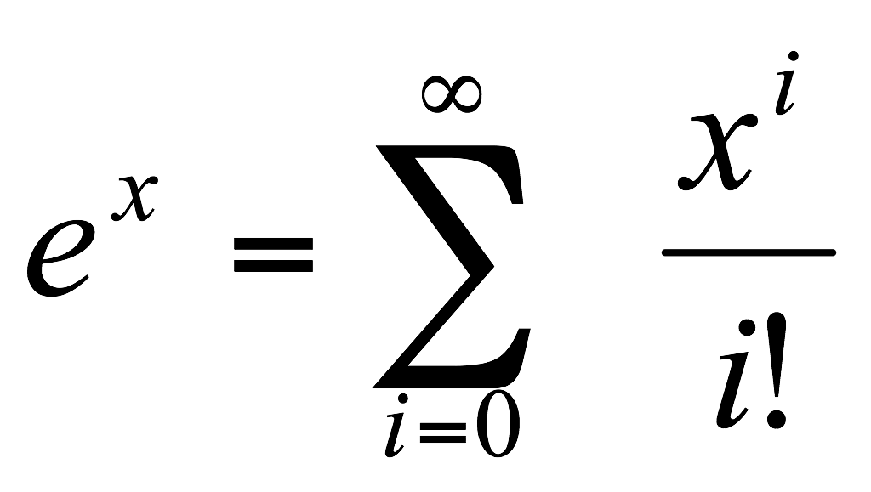. A program is desired to calculate exponential of a function to a reasonable degree of accuracy.
3. A person invests Rs1000.00 in a savings account yielding 5 percent interest. Assuming that all interest is left on deposit in the account, calculate and print the amount of money in the account at the end of each year for 10 years. Use the following formula for determining these amounts: final_amount = initial_amount(1+rate)number
4. Write a **function** mult_matrix that inputs two matrices and returns the product of the two. Use another function ouput_matrix to get the output displayed to the console.
5. Write a function that accepts 2 equations as argument, and returns its solution to the calling function.
6. Shown below is a Floyd’s triangle (n=5):Write a program to print above for given n

1

2 3

4 5 6

7 8 9 10

11. . . . . . 15

7. Selection Sort

8. Insertion Sort

9. Find out unique elements in the matrix and prints them. Ex: if input matrix is

1 4 9 3

1 5 8 1

2 7 6 2

3 2 3 7

The unique elements are 4, 5, 6, 8, 9

10. Write a function with name magic and the input parameters A and n. A is a quadratic integer matrix of order n. The function should check if the matrix A fulfils the conditions for being a magic square. It should return the magic number if A is “magic”. Otherwise zero should be returned. The function should be able to handle matrices declared as: int matA[10][10].

Example of a magic square of order 3 with the magic number 24

7 11 6

7 8 9

10 5 9

i.e., if all row sums, all column sums and both the diagonal sums should be equal to same value (in the above example 24) then the matrix is known as a magic square.