**Data Flow Diagram**

**Context Level Diagram (0 Level)**

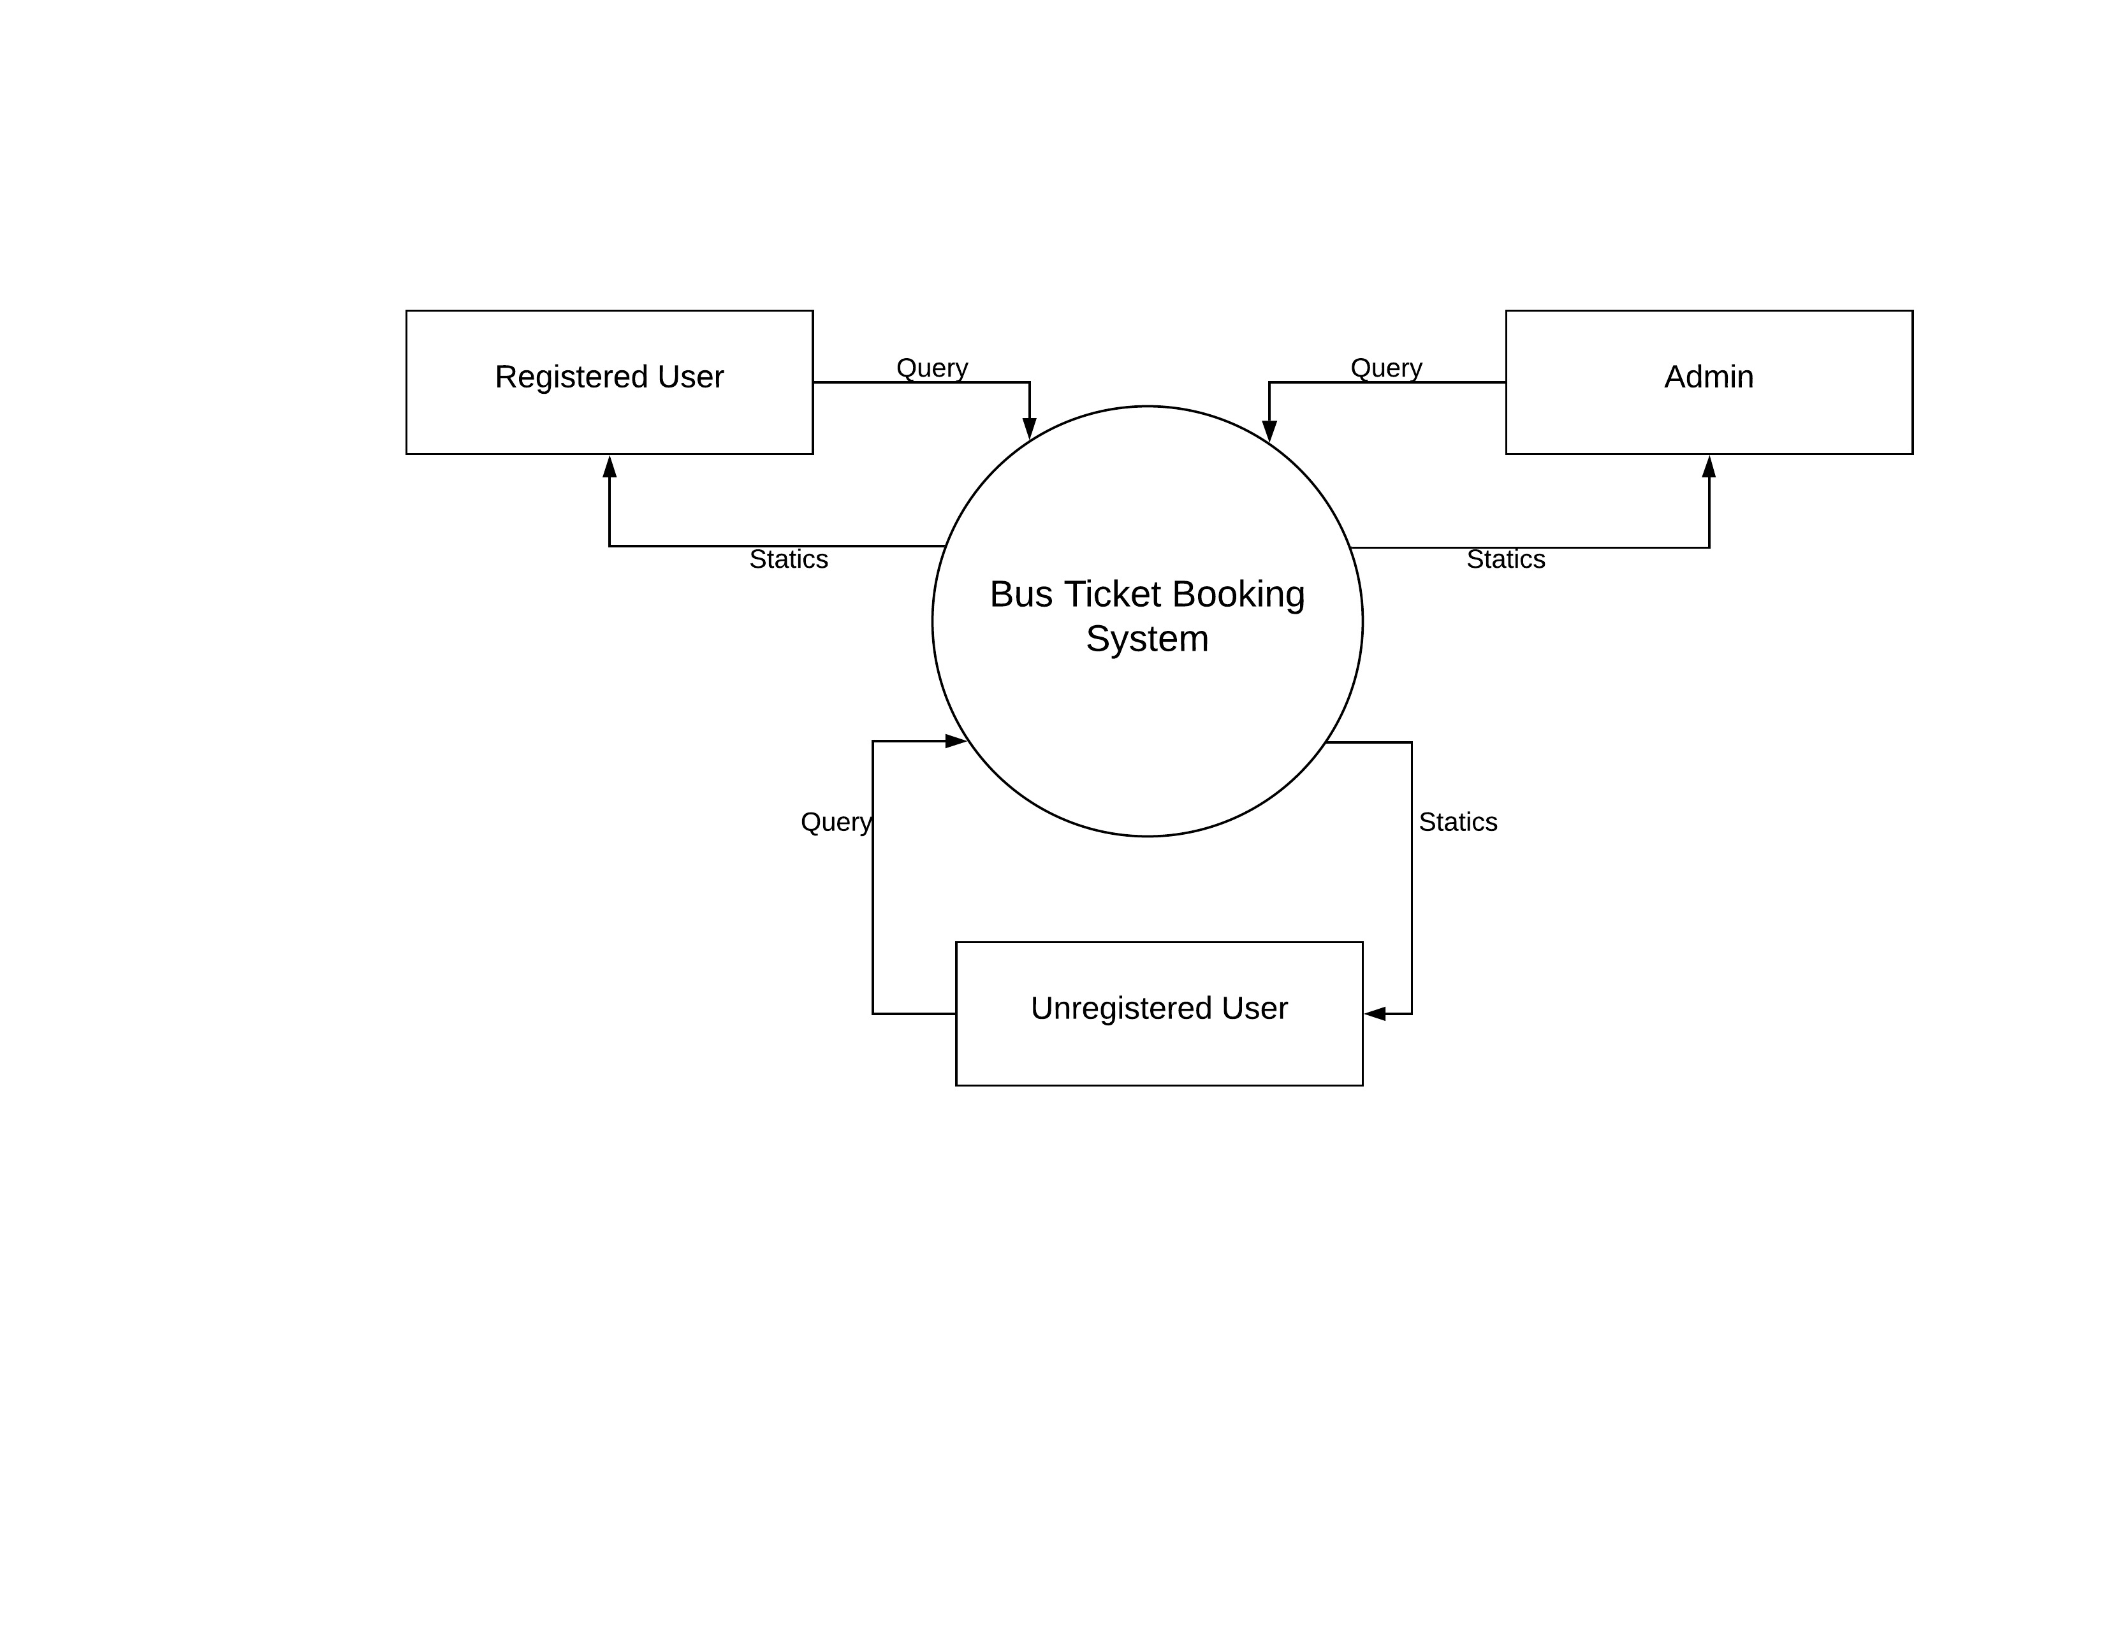

**DFD For Registered User**

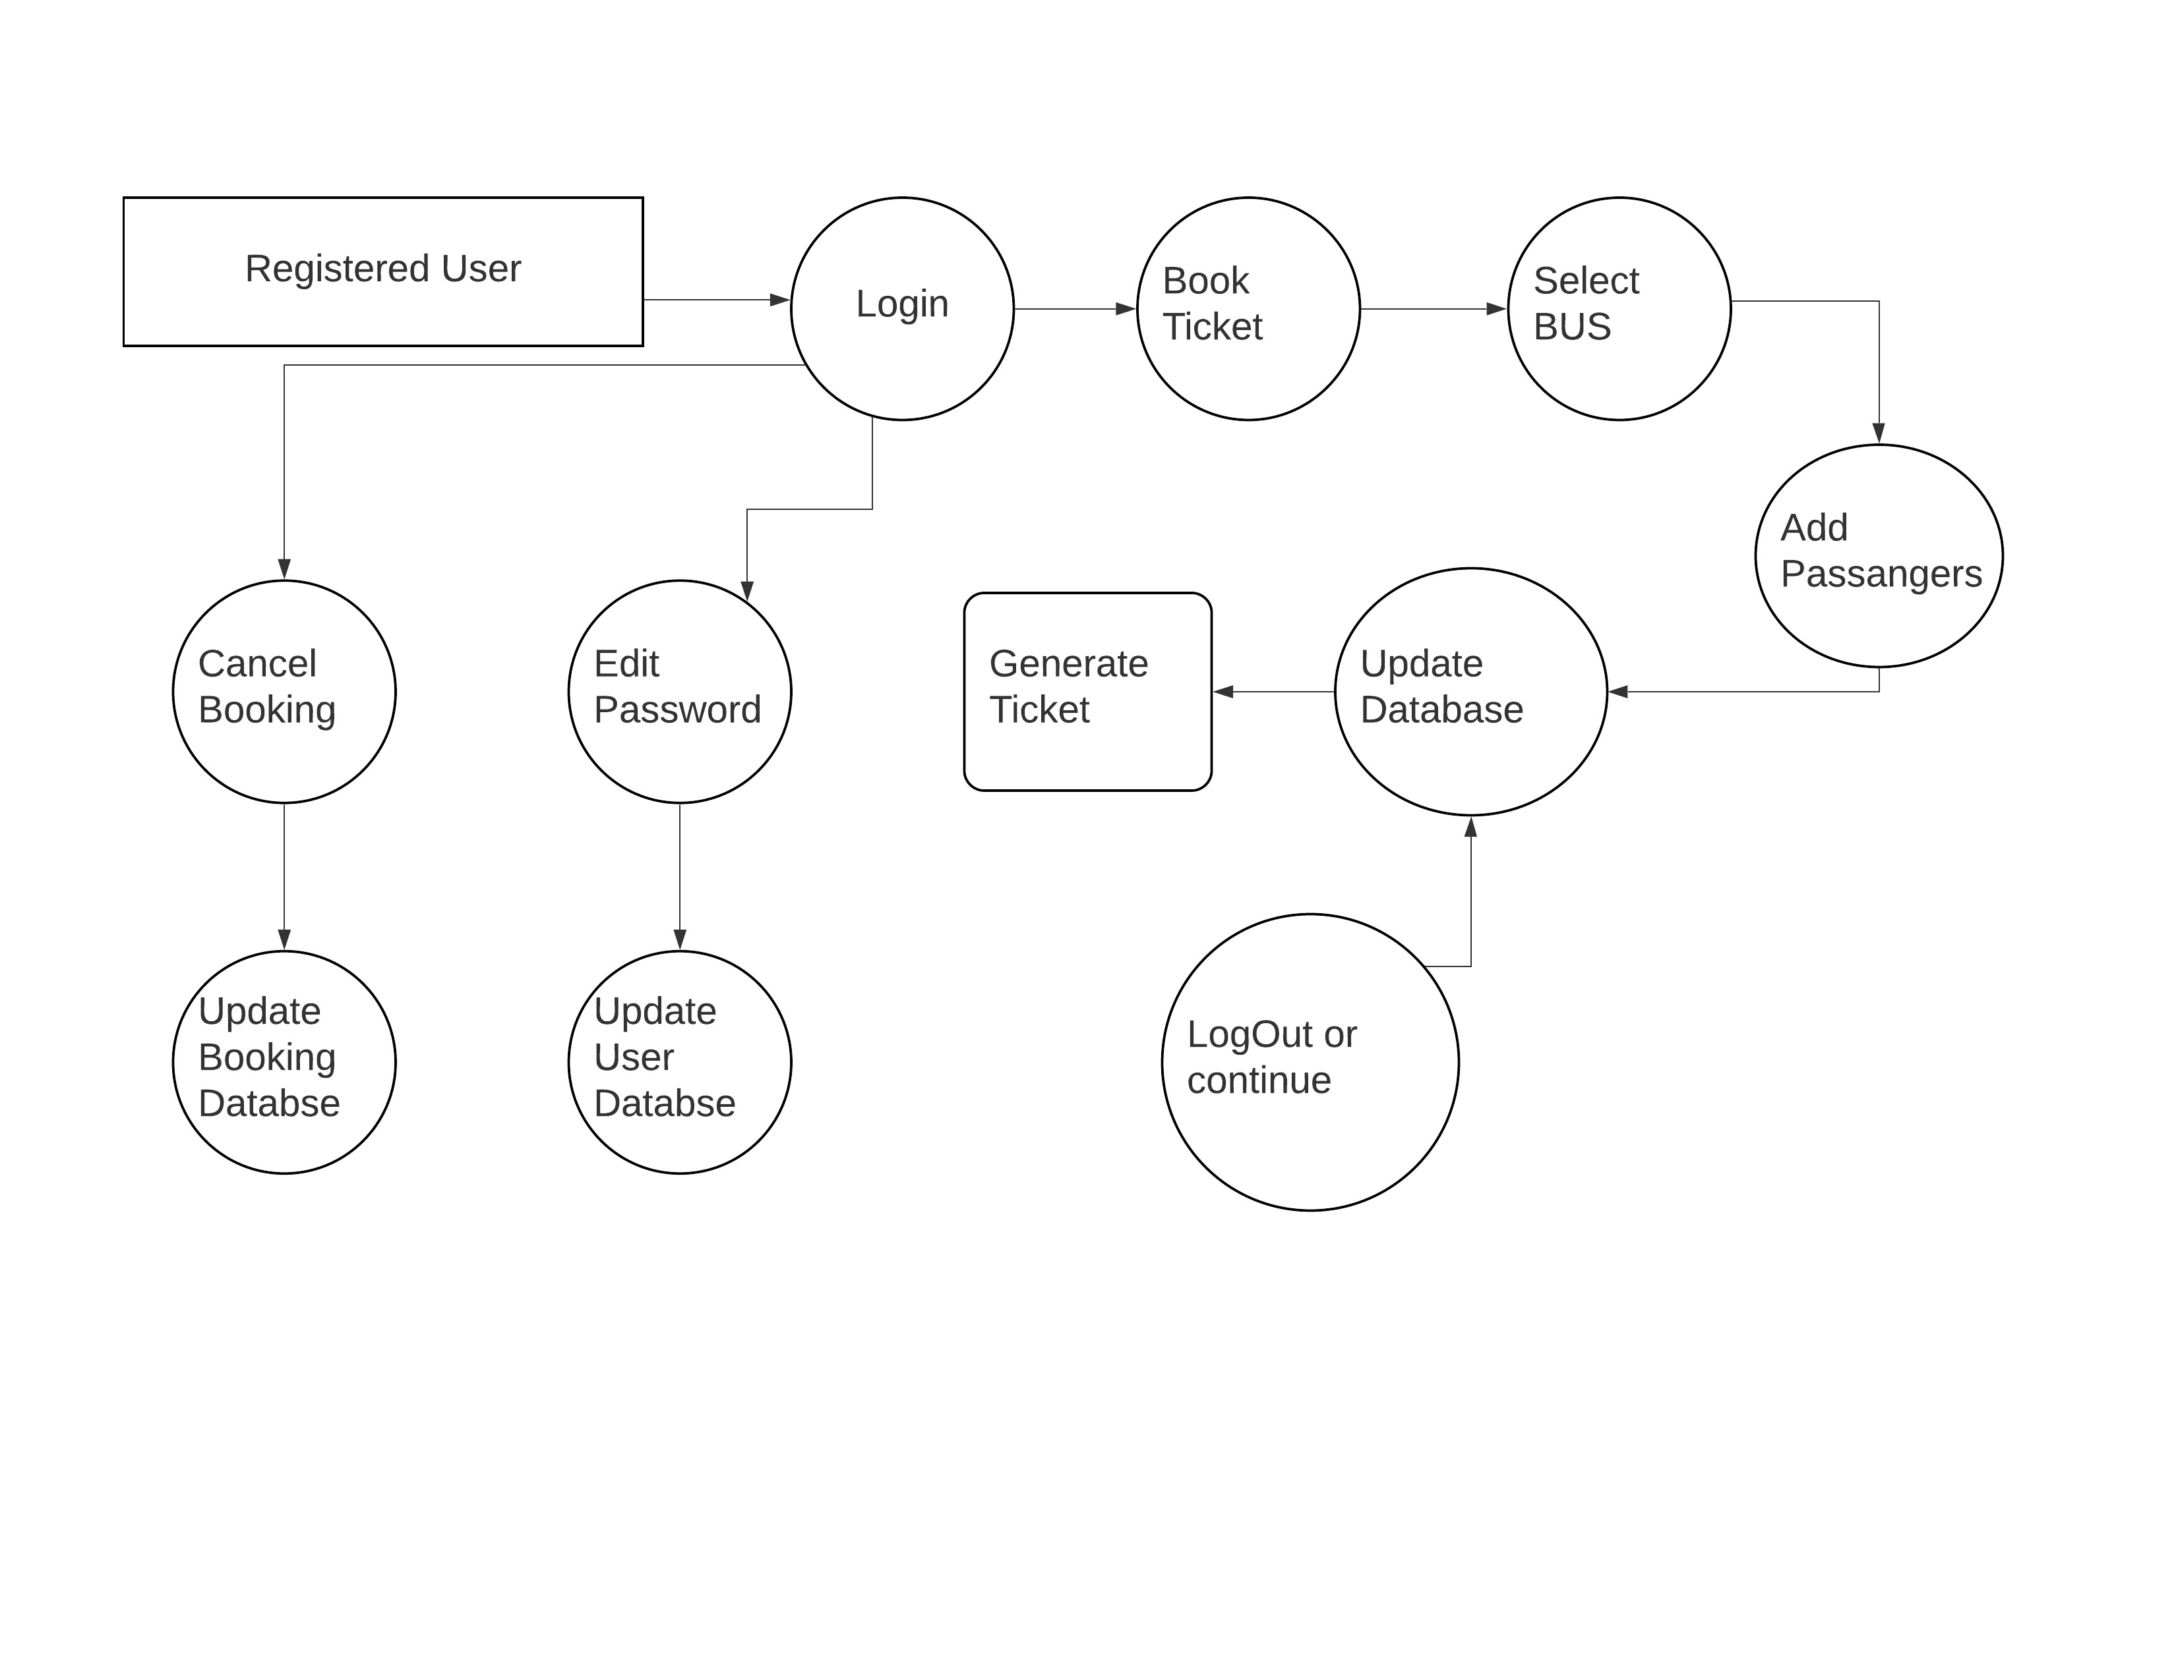

**Context Level Diagram (Level1)**

**DFD for Admin**

