Online Bus Ticket Booking System

Synopsis

Submitted By

Shaurya Verma(03411404419)

Shristi Jain(01511404419)

MCA (2nd Semester)

**Synopsis of Bus Ticket Booking System**

**Contents**

**Title Pg No**

Introduction 4.

Problem Statement 5.

Objective 6.

Technology Used 7.

System Requirements 8

Data Flow Diagram (Level 0) 9.

Data Flow Diagram (Level 1) 10.

Conclusion 11.

Biblography 12.

**Introduction**

This **Online Bus Ticket Booking System** project will provide an **Online Bus Ticket Booking** platform and thereby leverage the tedious manual ticket booking activity for a customer. We can provide a feature that will allow the customer to get a ticket booked without much hassle.

Initially, customers used to book tickets manually by queuing in lines at bus stations or go to travel agents who in turn used to book tickets for them. This was actually a tedious process and was leading to wastage of time. It also had issues like having incorrect names or other information used to book tickets.

We can eliminate the drawbacks by developing an application which will allow customers to register themselves and book tickets cancel tickets or postpone or propone travel dates with feasibility. This actually is a welcome step for customers as they can access the application from anywhere and will also avoid wastage of time that was caused due to the drawbacks in the previous way of booking tickets manually.

**Problem Statement**

With an increasing number of customers, standing in long queues at the bus stop. The bus ticket managers were facing the challenge of providing their customers a “hassle free ticket booking”. Customers desperately wanted an easy way of booking their tickets without the delays and inconvenience of standing in long queues. The management needed a mechanism to administer their loyalty program” of hassle-free booking which saves time of user in booking tickets.

**Solution**

The online bus ticket booking platform which would enable passengers to book their tickets electronically over the Internet from the comfort of their office or home. With the advent of the modern age, the typical user didn't have enough time to stand in line at bus stop. The online solution allows users to select their bus, book and print their tickets. This guarantees them a ticket even before they arrive at the bus stop.

**Objective**

The main objective of the Project on Online Bus Ticket Booking System is to manage the details of Bus, Tickets, Booking, Bus Timing, Passengers. It manages all the information about Bus, Customer, Movie. The project is totally built at administrative end and thus only the administrator is guaranteed the access. The purpose of the project is to build an application program to reduce the manual work for managing the Bus Tickets booking. It tracks all the details about the Booking, Bus Timing, Customer.

**Functionalities provided by Online Bus Ticket Booking System**

**To Admin**

* Admin Login
* Add Bus, edit bus timings.
* Manage Bookings
* Edit Users

**To User**

* User Login
* View Bus Details
* Book Tickets
* Print Tickets
* Edit Password

**Technology Used**

**HTML**: HTML elements are the building blocks of HTML pages. With HTML constructs, images and other objects such as interactive forms may be embedded into the rendered page. It is used for giving eye catching look to the website. And also providing easy to use GUI.

**CSS**: CSS stands for Cascading **S**tyle **S**heets CSS describes how HTML elements are to be displayed on screen, paper, or in other media CSS saves a lot of work. It can control the layout of multiple web pages all at once CSS is cascading style sheet which is used to give designer look to HTML using the external file.

**Javascript**: –JavaScript often abbreviated as JS, is a high-level, interpreted programming language. It is a language which is also characterized as dynamic, weakly typed, prototype-based and multi-paradigm Java script is used for client side scripting which can help in using validation on the website and many more other functions.

**PHP**: HypertextPreprocessor (or simply PHP) is a server-side scripting language designed for Web development, but also used as a general-purpose programming language. PHP code may be embedded into HTML code, or it can be used in combination with various web template systems, web content management systems, and web frameworks.

**Bootstrap**: Bootstrap is a free and open-source CSS framework directed at responsive, mobile-first front-end web development. It contains CSS- and (optionally) JavaScript-based design templates for typography, forms, buttons, navigation, and other interface components.

**System Requirements**

**Hardware:** Hardware includes the physical features, which are every part that you can either see or touch, for example: monitor, case, keyboard, mouse and printer.

**Software:** The part which activates the physical components called software. It includes the features that responsible for directing the work to the hardware. Software can be divided into the programs and data.

**Hardware Specification (Minimum)**:

Disc Space : 40 GB

Memory : 512 MB RAM

File System : 32 Bit/64 Bit

**Software Specification:**

Operating System (Server Side) : Windows 7/8/10.

Operating System (Client Side) : Windows 7/8/10.

Client End Language : HTML, CSS, Javascript

Local Validation : PHP

Server Side Language : PHP

Web Server : XAMPP server

Web Browser : Mozilla Firefox/ Chrome

**Data Flow Diagram**

**Context Level Diagram**

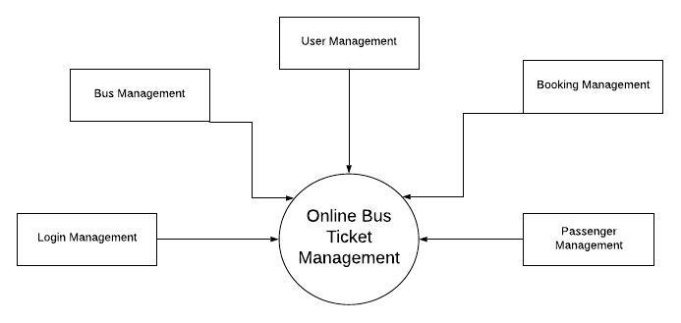

**Context Level 1 DFD**

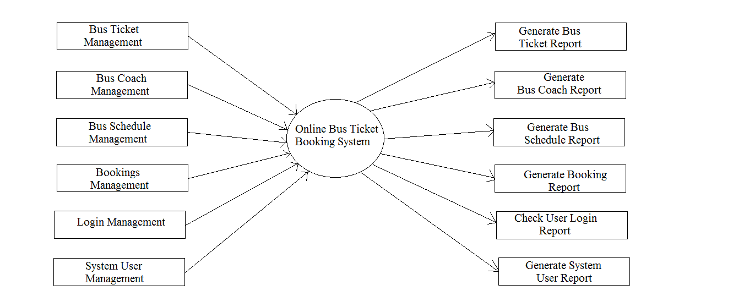

**Conclusion**

The entire project has been developed and deployed as per the requirements stated by the user, it is found to be bug free as per the testing standards that is implemented. Any specification-untraced errors will be concentrated in the coming versions, which are planned to be developed in near future. The system at present does not take care of the money payment methods, as the consolidated constructs need SSL standards and are critically to be initiated in the first face. The system needs more elaborative technicality for its inception and evolution

**Biblography**

* <https://www.php.com>
* <https://www.w3school.com>
* <https://www.mysql.com>
* <https://www.tutorialpoint.com>