COSC344 Assignment 1 MINI WORLD
TEAM: Pharmacists
Leader: Benjamin McCarthy
Members:
- Benjamin McCarthy
- Dominic Stufkens
- Leon Hook
- Usman Shah

- Mini World Description:
We select the pharmacy as our mini-world for this assignment. The pharmacy database keeps track of the pharmacies’ employees, customers, products, branches, vendors, doctors, sales and prescriptions. We are modelling the following parts of the pharmacy in the assignment.
- The pharmacy is made up of different branches which have a branch ID and an address. This allows us to track all other entities to a specific location.
- The employees are kept track of, this is done by having an employee entity, we store their name, employee ID, IRD number, phone number, salary, job title, address, and birthdate. This allows for checking of employee details and resources for contacting them.
- We also keep track of customers. This is important so that drugs that are sold can be tracked to a specific customer so as to not allow misuse of drugs. We store their name, address, allergies, birthdate, and a customer ID.
- Each product is stored in the system as well for fast management of profit. We store the name, price, vendor ID, type, and product ID. We need to be able to track the drugs to their vendor in the case of problems arising.
- We keep track of the vendors. This is so that the drugs sold to customers can be tracked in case complications arise with them. We store name, product ID’s sold, address, and the vendor ID.
- The doctors who work in tandem with the pharmacy need to be kept track of so that when a prescription comes through. It's from a verified doctor. This way all prescriptions given out from a doctor authorised to do so. We store the name, office location, specialisation, birthdate, and registration id.
- Prescriptions also must be kept recorded. If there is a problem where the wrong prescription is handed out, then we must be able to verify our prescriptions to check who was at fault. We store the doctor ID, patient ID, date and time, and the product required.
- We will keep track of sales as well in a sale entity. We will store the sale ID, customer ID, employee ID, date, and the total price.

2. Entities and Attributes
EMPLOYEE
- Name: composite(First_Name, Middle_Name, Last_Name),single-valued, string
- Employee-Id: simple, key attribute, single-valued, string
- IRD_Num: simple, single-valued, int
- Phone_Num: simple, single-valued, string
- Salary: simple, single-valued, real
- Job_Title: simple, single-valued, string
- Address: simple, single-valued, string
- Birth_Date simple, single-valued, date

PRODUCT
- Product_Id: simple, key attribute, single-valued, int
- Name: simple, single-valued, string
- Price: simple, single-valued, real
- Discount: simple, single-valued, real
- Vendor_Id: simple, single-valued, int
- Type: simple, single-valued, string

CUSTOMER
- Customer_Id: simple, key attribute, single-valued, int
- Name: composite(First_Name, Middle_Name, Last_Name),single-valued, string
- Address: simple, single-valued, string
- Allergies: simple, multi-valued, string
- Birth_Date: simple, single-valued, date

VENDOR
- Vendor_Id: simple, key attribute, single-valued, int
- Name: simple, single-valued, string
- Product_id_sold:simple, multi-valued, int
- Address: simple, single-valued, string

BRANCH
- Pharmacy_ID: simple, key attribute, single-valued, int
- Address: simple, single-valued, string

DOCTOR
- Registration_ID:simple, key attribute, single-valued, int
- Name: composite(First_Name, Middle_Name, Last_Name),single-valued, string
- Office_Location:simple, single-valued, string
- Specialization: simple, single-valued, string
- Birth_Date: simple, single-valued, date

PRESCRIPTION (weak entity)
- Registration_ID: simple, weak key attribute, single-valued, int
- Patient_ID: simple, single-valued, int
- Date_Of_Issue: simple, single-valued, date
- Product_Required:simple, multi-valued, int

SALE (weak entity)
- Employee_ID: simple, weak key attribute, single-valued, int
- Product_ID: simple, multi-valued, int
- Customer_ID: simple, single-valued, int
- Date: simple, single-valued, date
- Total_Price: simple, single-valued, real

3. Relationships

- SUPPLIES:
- M:N relationship.
- A vendor can supply many products, and a product can be supplied by many vendors.
- VENDOR is total participation, PRODUCT is partial participation.
- STOCKS:
- M:N relationsship.
- A branch stocks many products, and products can be stocked at many branches.
- PRODUCT is total participation, BRANCH is partial participation.
- MANAGER:
- 1:1 relationship.
- A branch has a single employee as its manager, and only one employee can be a branch manager.
- BRANCH is total participation, EMPLOYEE is partial participation.
- EMPLOYS:
- 1:N relationship.
- A branch employs many employees, but employees only work at a single branch.
- Both are total participation.
- MANAGES:
- 1:N relationship.
- One single employee manages several employees, but employees have only one manager.
- Both are partial participation.
- SELLS:
- 1:1 relationship.
- A sale must be made by an employee, and only one employee makes the sale.
- SALE is total participation, EMPLOYEE is partial participation.
- BUYS:
- 1:1 relationship.
- A sale must be bought by a customer, and only one customer buys the sale.
- SALE is total participation, CUSTOMER is partial participation.
- PRESCRIBED_TO:
- 1:1 relationship.
- A single prescription belongs to one customer, and only that customer is prescribed the prescription.
- CUSTOMER is partial participation, PRESCRIPTION is total participation.
- PRESCRIBES:
- 1:1 relationship.
- A single prescription is prescribed by a doctor, and only one doctor prescribes the prescription.
- DOCTOR is partial participation, PRESCRIPTION is total participation.

4. ERD Diagram

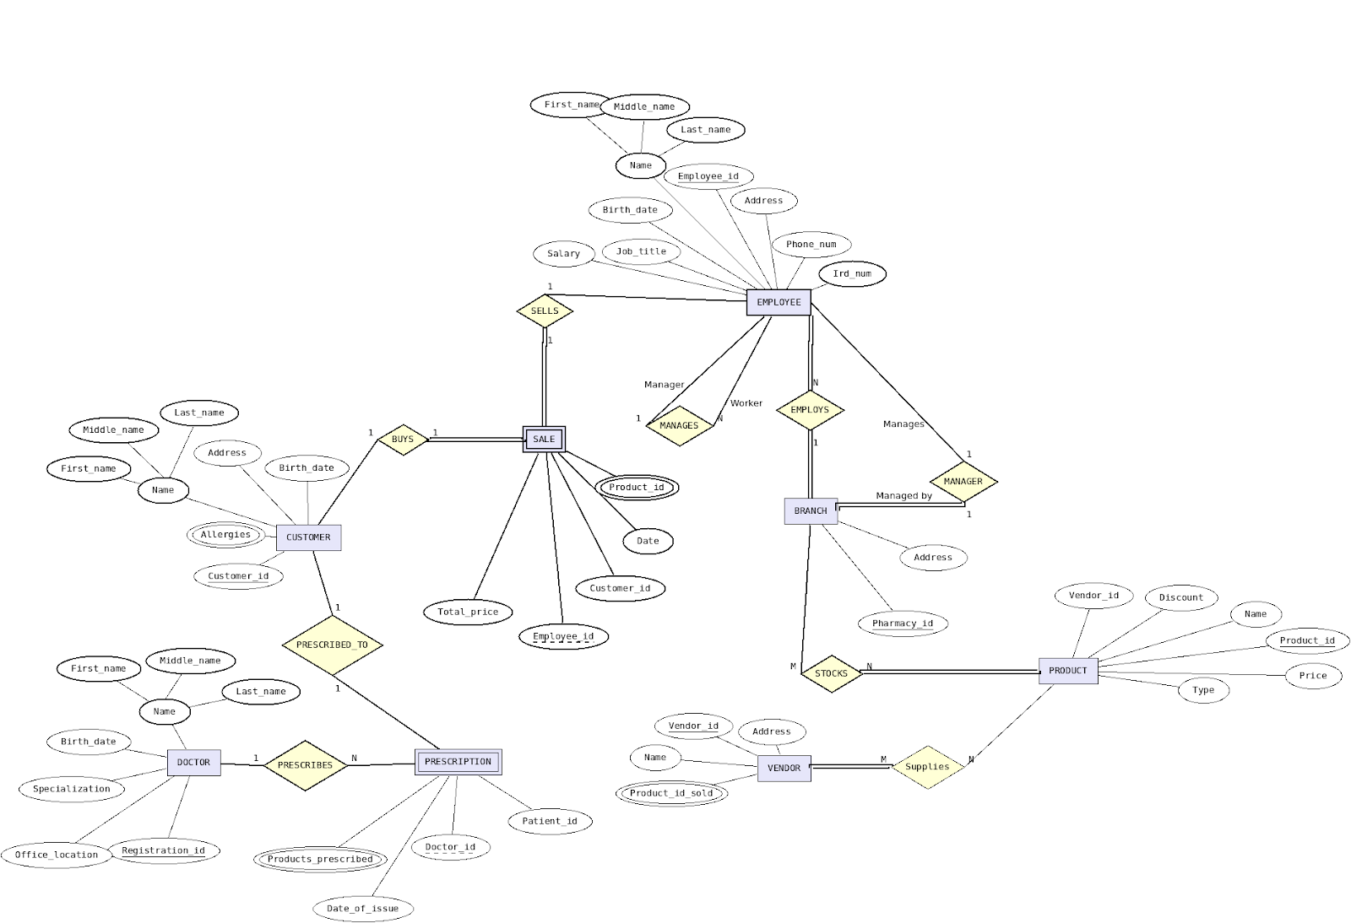

5. Teamwork Summary
- We had an initial meeting to meet each other and delegate a team leader. Benjamin was elected team leader. Usman came up with the idea of modelling a pharmacy.
- Leon modelled the EMPLOYEE and CUSTOMER entities and their attributes, and also the associated weak entity SALE. He also modelled the relationships between EMPLOYEE and SALE, and CUSTOMER and SALE.
- Benjamin had the idea to split the pharmacies into branches, so took care of the BRANCH entity, as well as the relationships between EMPLOYEE and BRANCH, and also the relationships between EMPLOYEE and EMPLOYEE.
- Dominic modelled the VENDOR and PRODUCT entities as well as their attributes, and the relationships between those and the BRANCH entity.
- Usman modelled the DOCTOR and PRESCRIPTION entities, and the relationships between them.
- We originally had an ADDRESS entity, but collectively decided to get rid of it in favour of others.
- We had another team meeting where we showed our entities and made some modifications here and there, including the idea to keep addresses as string values.
- Usman and Benjamin started working on the ERD in the lab, and were later joined by Dominic and Leon. The final ERD was finished on Usman’s lab computer, but later Benjamin modified it to include the appropriate participation lines.
- We had one final meeting where we all signed off on the final document before submission.

