ChurnGuard AI: Customer Churn Prediction and Retention Intelligence
A Data Analytics Project Report
Submitted by: Shavan Chauhan
Program: AICTE | IBM SkillsBuild Data Analytics with AI Internship 2026
Conducted by: BharatCares in association with AICTE
Date: September 2026

1. Problem Statement
A telecommunications company is losing customers every month without a clear understanding of who is leaving, why they are leaving, or how much revenue is at stake. Customer churn directly reduces recurring revenue and increases the cost of acquiring new customers.
The aim of this project is to analyze customer data to understand churn behavior, build a machine learning model that predicts which customers are likely to leave, identify the key drivers of churn, quantify the revenue at risk, and design a retention strategy to save high-value customers.
This project follows the Business Intelligence framework: Data → Information → Insight → Decision → Action.
2. Dataset Description
The dataset used in this project is the Telco Customer Churn dataset, publicly available on Kaggle.
- Source: https://www.kaggle.com/datasets/blastchar/telco-customer-churn
- Original size: 7,043 rows and 21 columns
- Size after cleaning: 7,032 rows
- File name: telco_churn.csv
The dataset contains the following types of information:
- Customer demographics: gender, senior citizen status, partner, dependents
- Account information: tenure, contract type, paperless billing, payment method
- Services subscribed: phone service, multiple lines, internet service, online security, online backup, device protection, tech support, streaming TV, streaming movies
- Charges: monthly charges, total charges
- Target variable: churn (whether the customer left or stayed)
3. Steps Used for Analysis
- Loaded the CSV dataset using pandas.
- Inspected the data for structure, data types, and missing values.
- Cleaned the data: converted TotalCharges to numeric, handled missing values, dropped customerID, and encoded the Churn column as binary.
- Calculated key performance indicators such as churn rate and revenue at risk.
- Performed exploratory data analysis with eight visualizations.
- Engineered features by encoding categorical variables.
- Trained a Random Forest classifier with class balancing.
- Evaluated the model using accuracy, ROC-AUC, and confusion matrix.
- Extracted feature importance to identify the top churn drivers.
- Segmented customers into High Risk, Medium Risk, and Low Risk groups.
- Calculated annual revenue at risk.
- Designed a retention playbook with specific business actions.
4. Key Performance Indicators
The following KPIs were calculated from the dataset:
KPI | Value
Total customers | 7,032
Retained customers | 5,163
Churned customers | 1,869
Overall churn rate | 26.58%
Annual revenue lost to churn | 1,669,570
Average monthly charges | 64.80
5. Live Analysis
5.1 What is the overall churn rate?
Out of 7,032 customers, 1,869 have churned. The overall churn rate is 26.58%, meaning more than one in four customers leaves the company.
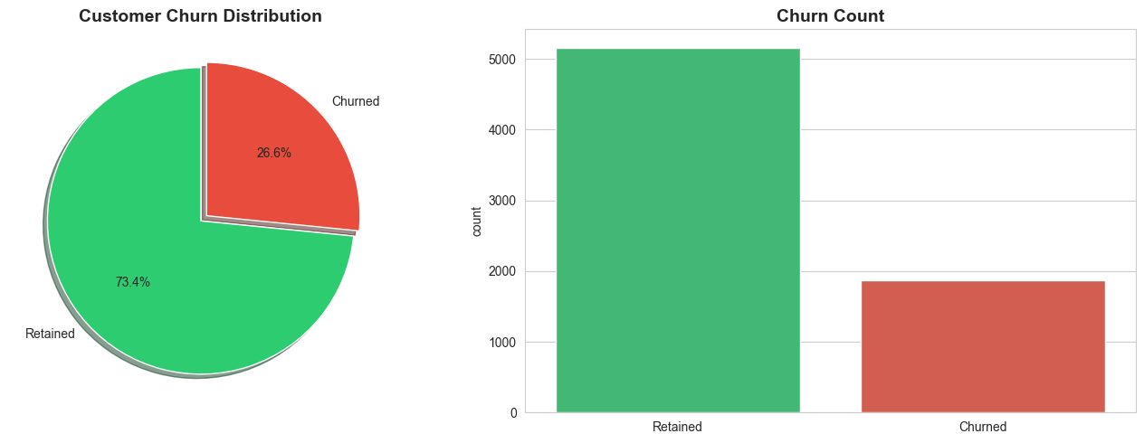
5.2 Which contract type has the highest churn?
Customers on month-to-month contracts churn at a much higher rate than those on one-year or two-year contracts. The churn rate decreases sharply as contract length increases.
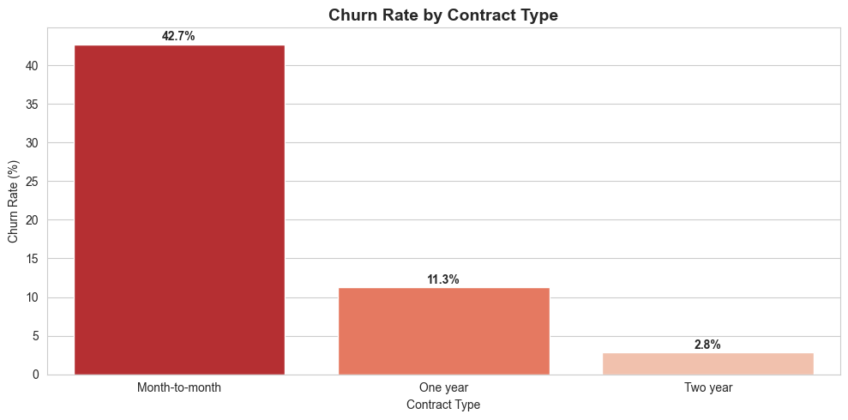
5.3 How does tenure affect churn?
Customers who churn tend to have shorter tenures. Churn is highest in the first few months and drops steadily as tenure increases. This suggests that early customer experience is critical.
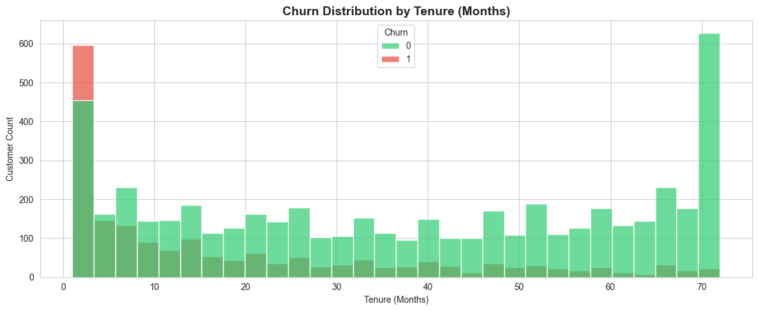
5.4 Do higher monthly charges lead to more churn?
Yes. Customers who churned had a noticeably higher median monthly charge compared to retained customers. Higher bills are associated with a higher likelihood of leaving.
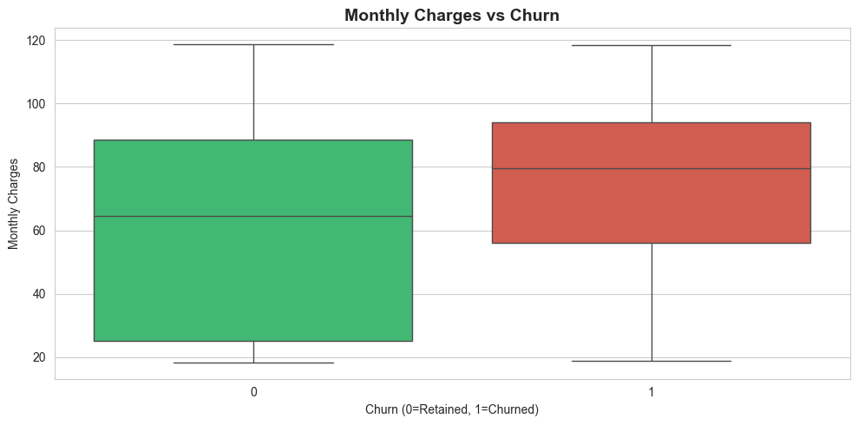
5.5 How does internet service affect churn?
Fiber optic customers churn at a significantly higher rate than DSL customers. This may indicate service quality issues, higher pricing, or unmet expectations for fiber customers.
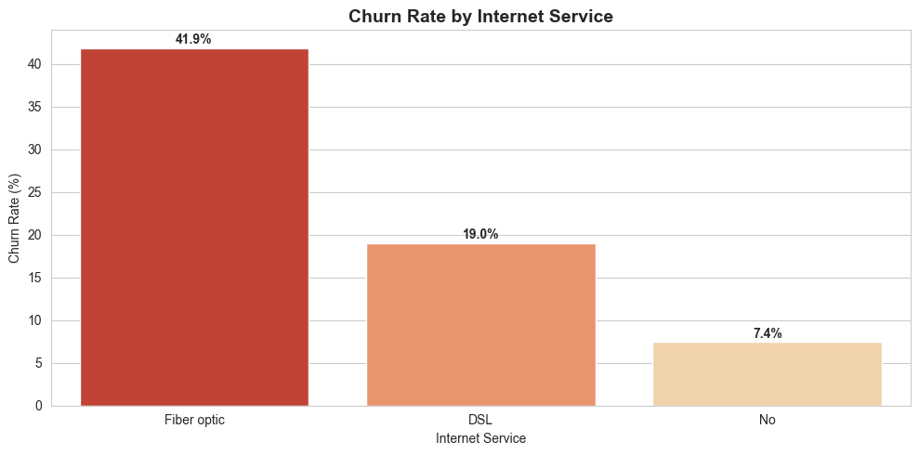
5.6 How well does the machine learning model perform?
The Random Forest model achieved:
- Accuracy: 78.32%
- ROC-AUC: 0.8122
The confusion matrix shows the model correctly identifies a strong proportion of both retained and churned customers.
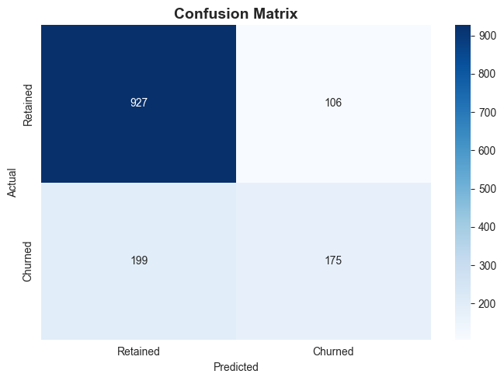
5.7 What does the ROC curve tell us?
The ROC curve confirms the model's strong ability to distinguish between customers who will churn and those who will stay. An AUC of 0.8122 is considered good for a first-generation churn model.
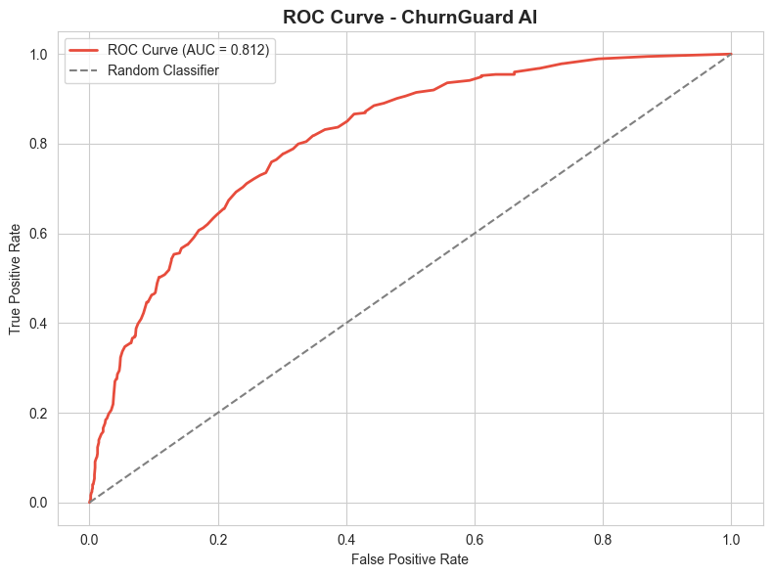
5.8 What are the top churn drivers?
The top five drivers of churn, ranked by feature importance, are:
- TotalCharges (0.178) — customers with lower total charges are more likely to leave
- Tenure (0.166) — shorter tenure strongly predicts churn
- MonthlyCharges (0.153) — higher monthly bills increase churn risk
- Contract: Two year (0.055) — long-term contracts reduce churn
- Internet Service: Fiber optic (0.040) — fiber customers churn more
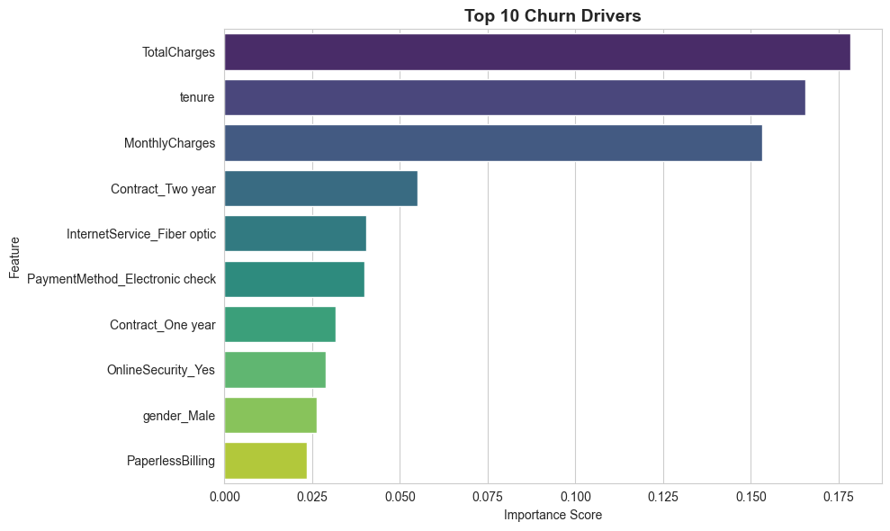
6. Risk Segmentation
Customers were segmented by predicted churn probability:
Segment | Probability Range
High Risk | 70% or above
Medium Risk | 40% to 69%
Low Risk | Below 40%
High-risk customers identified: 1,425
Annual revenue at risk: 1,301,935
7. Business Decisions and Retention Playbook
Based on the analysis, the following retention actions are recommended.
Driver 1: Month-to-Month Contracts
Many customers are on month-to-month contracts, and they churn at the highest rate.
Action: Offer a 15% discount on upgrading to a one-year contract, targeting high-risk month-to-month customers.
Driver 2: New Customers (Tenure under 12 months)
Customers in their first year are the most likely to leave.
Action: Launch a structured 90-day onboarding and check-in program to build early loyalty.
Driver 3: Fiber Optic Customers
Fiber optic customers churn more than DSL customers despite paying more.
Action: Investigate service quality complaints and offer loyalty credits to high-value fiber customers.
Opportunity Summary
- Total annual revenue at risk: 1,301,935
- If 30% of high-risk customers are saved: 390,580 recovered
- If 50% of high-risk customers are saved: 650,967 recovered
The retention playbook can recover a significant portion of at-risk revenue with targeted, low-cost interventions.
8. Conclusion
This project demonstrates how raw customer data can be transformed into actionable business intelligence. By cleaning and analyzing the Telco Customer Churn dataset, building a predictive model with 78.32% accuracy and an ROC-AUC of 0.8122, and identifying the top drivers of churn, the business can take targeted action to retain customers and protect revenue.
The analysis shows that churn is driven primarily by pricing (MonthlyCharges, TotalCharges), customer lifetime (Tenure), and contract structure (Month-to-month versus long-term). By acting on these insights, the company can reduce churn, improve customer satisfaction, and recover a meaningful portion of the 1.3 million in annual revenue currently at risk.
This project follows the Business Intelligence process — Data → Information → Insight → Decision → Action — and shows that even a simple, well-structured analysis can create measurable business value.

