Contents
Web Request Input parameters: 1
Delete file request 1
Create file request 2
Get file request 2
Update file request 3
List repository tree request 4
List repository commits request 5
Retrieve a commit request 6
Retrieve a single user request 6
Retrieve a test report for a pipeline request 6
Create issue request 7
Create a commit request 9

Web Request Input parameters:
In this section are the parameters each web request can receive.

Delete file request
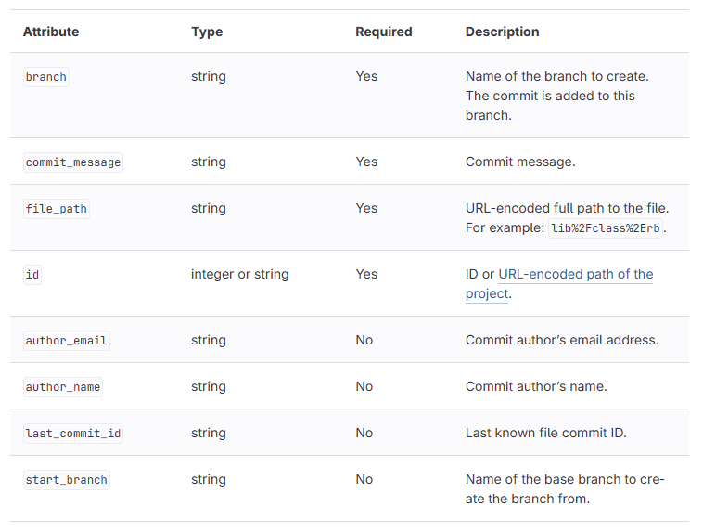

Create file request
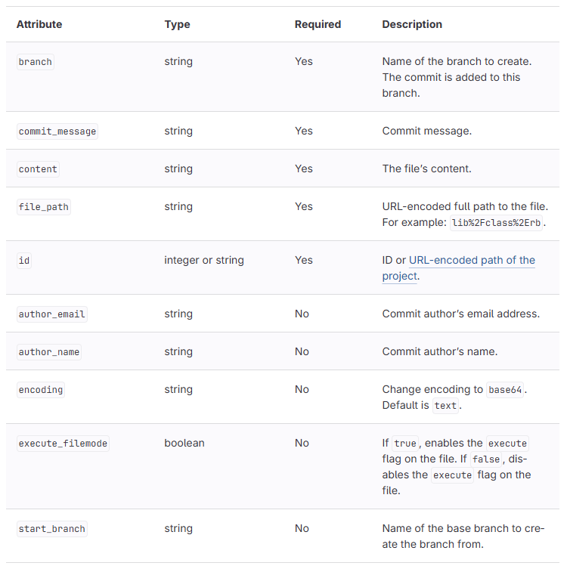

Get file request
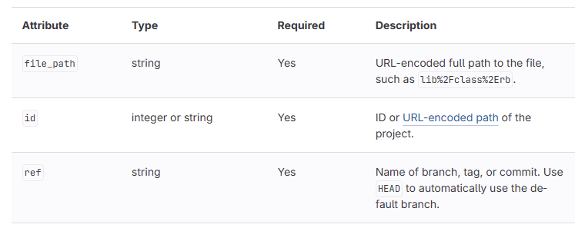

Update file request
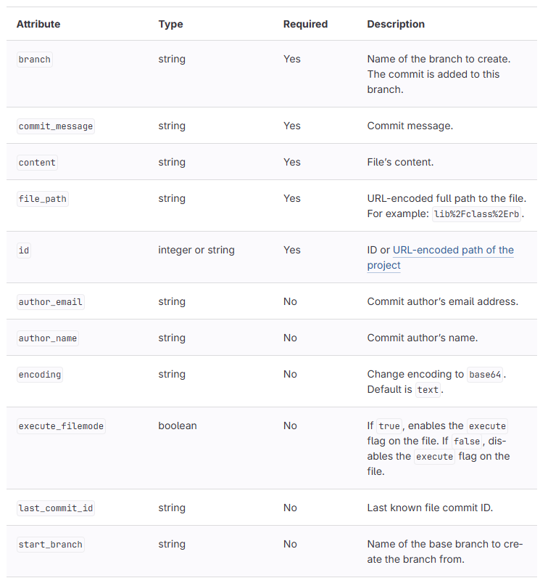

List repository tree request
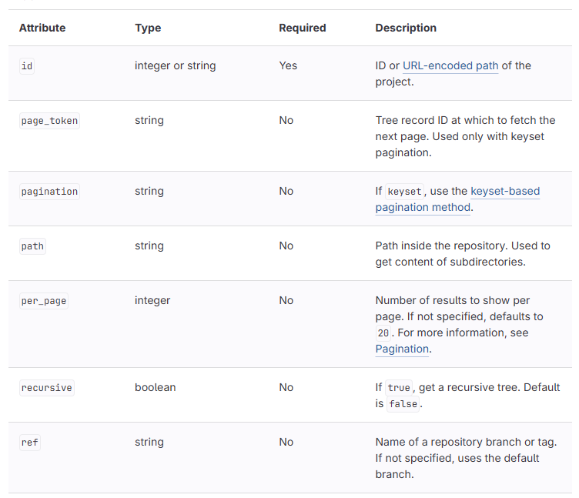

List repository commits request
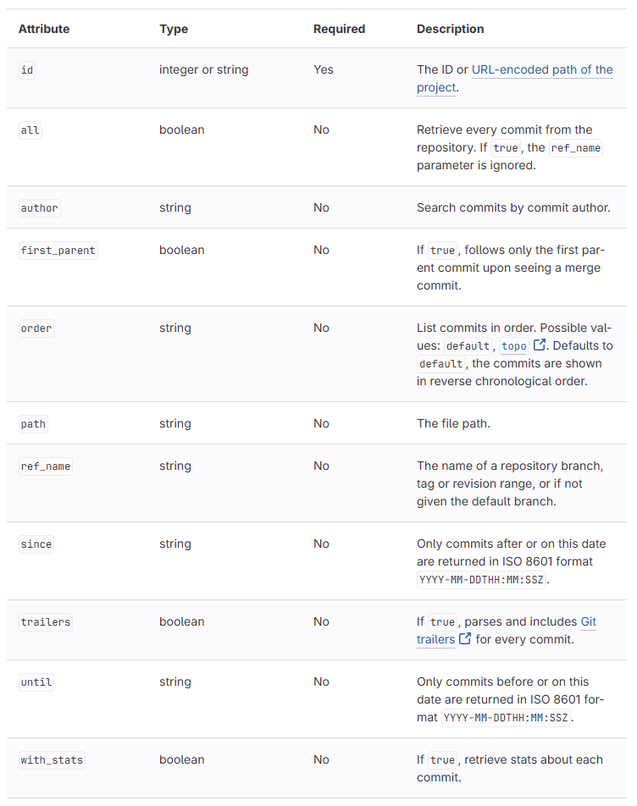

Retrieve a commit request
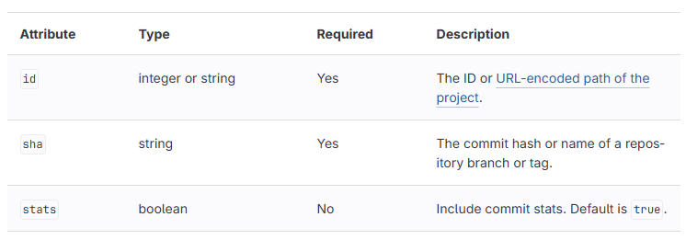

Retrieve the current user request
Does not take any parameters beyond the personal access token.

Retrieve a test report for a pipeline request
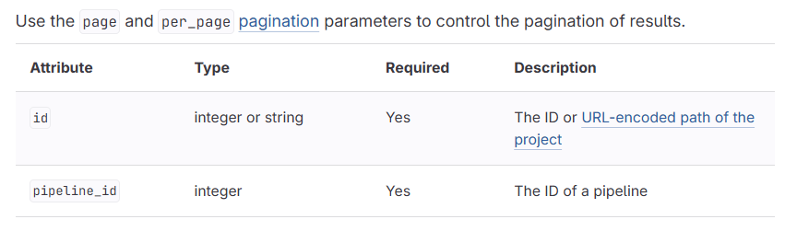

Create issue request
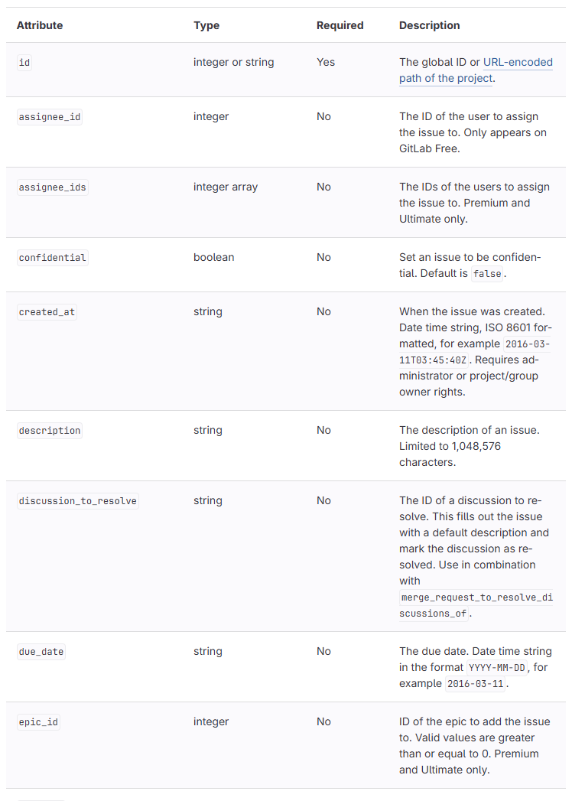
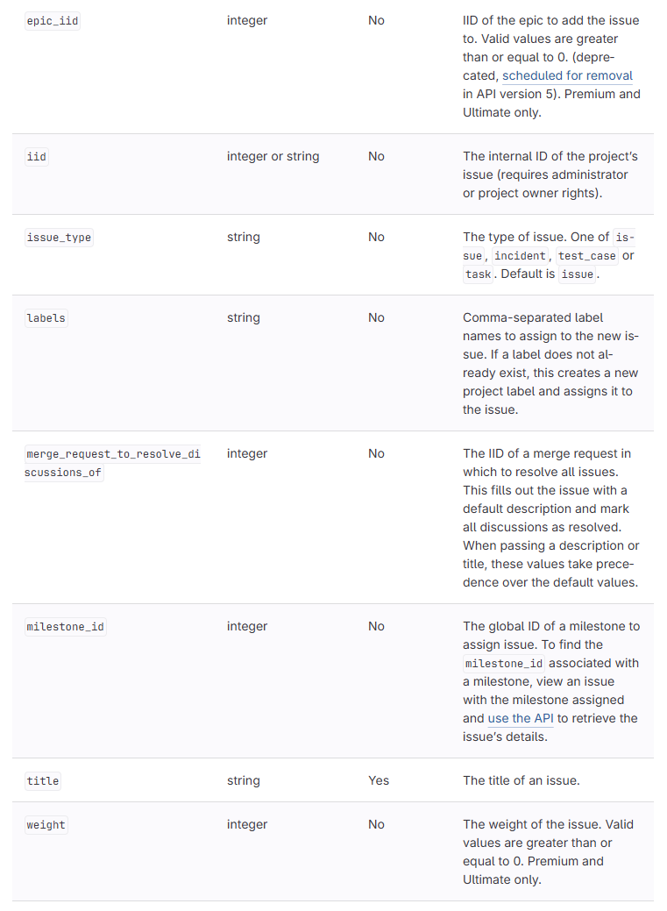

Create a commit request
Note: this request is not used in any of the games code but it is included here as it allows users to perform multiple requests at once.
