Learning Journey Assistant
System Architecture
Refined architecture based on the current implementation

1. Architecture Overview
The Learning Journey Assistant uses a layered architecture separating the user interface, backend services, data storage, Moodle integration, and mastery calculation. The current implementation uses Next.js/React with TypeScript for the frontend and Flask with Python for the REST API. Flask-SQLAlchemy provides database access and SQLite is used as the development database.
Student, subject, assessment, learning outcome, rubric feedback, and mastery data are processed by the backend. A deterministic mastery calculator currently produces a 0-100 mastery score for each learning outcome. Future sprints can extend this baseline with AI/NLP for feedback interpretation, weakness identification, summaries, and personalised recommendations.

2. Refined System Architecture
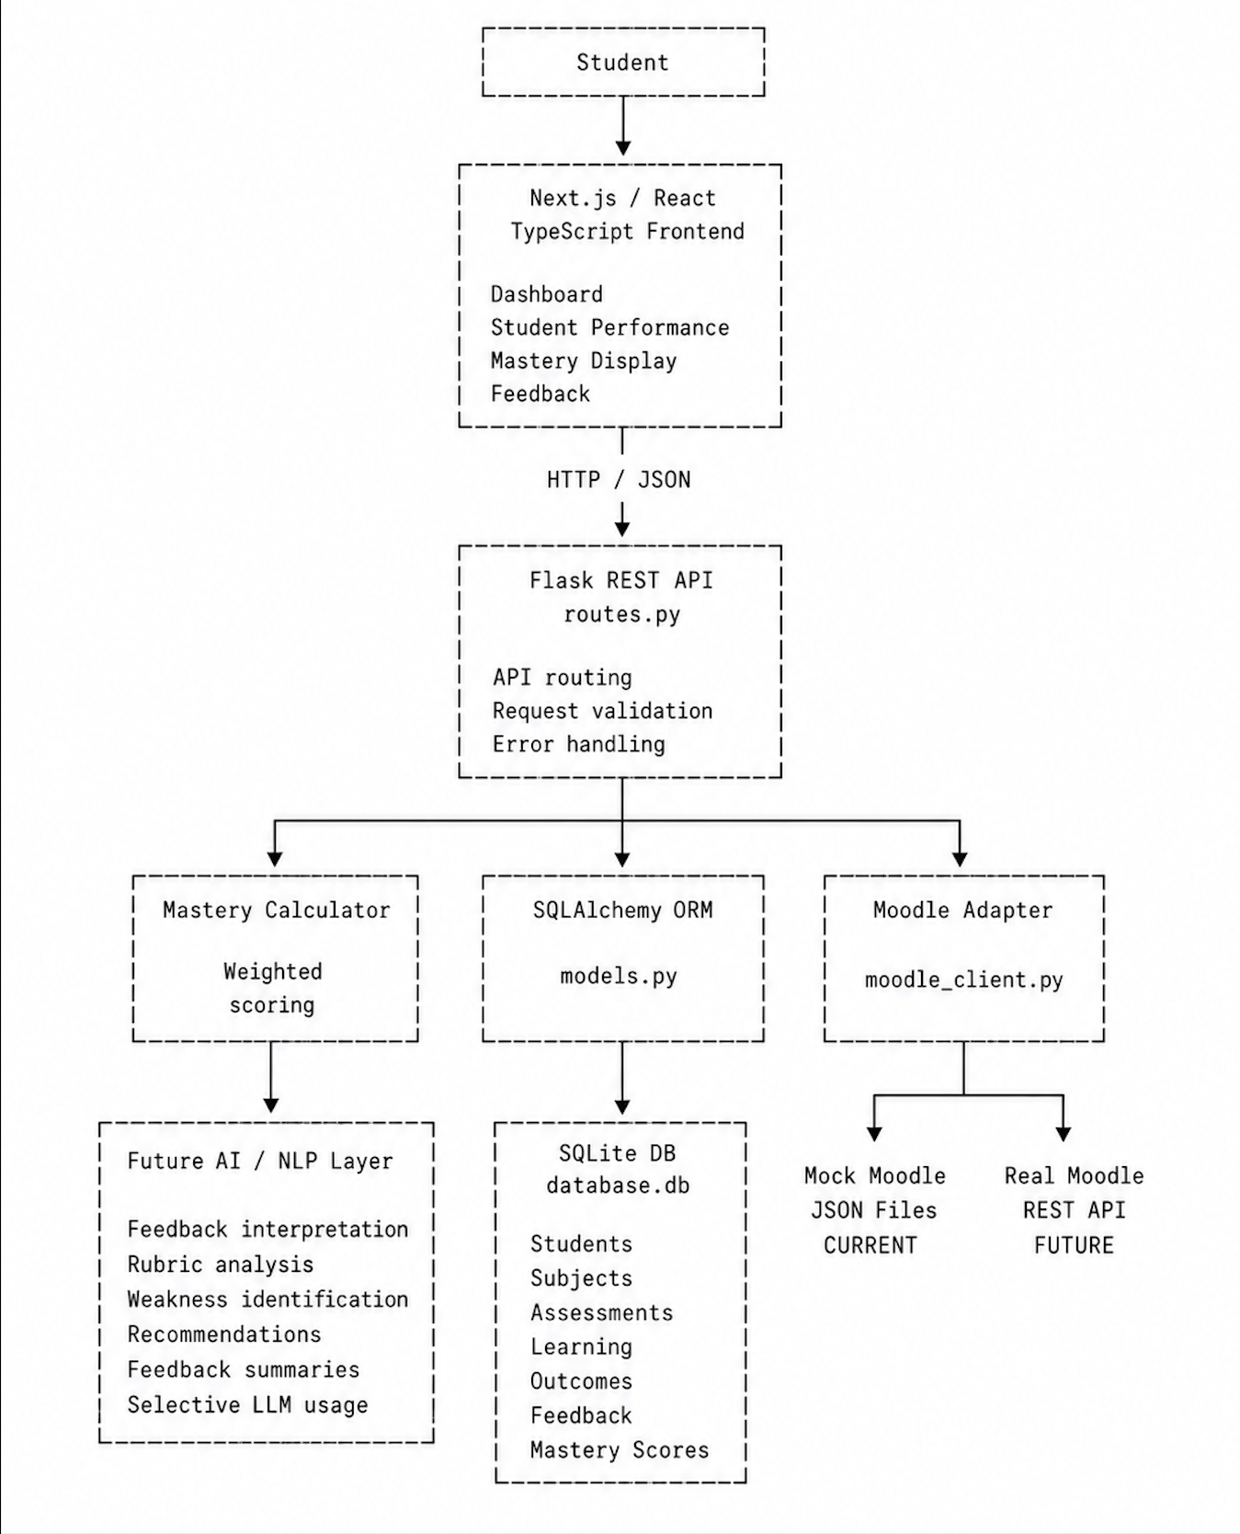

3. Frontend Layer
The frontend is implemented using Next.js, React, and TypeScript. It provides the student facing interface and communicates with the Flask backend using HTTP requests and JSON responses.
- Student profiles and subjects
- Assessment and rubric feedback
- Learning outcomes and mastery scores
- Areas requiring improvement
- Future AI-generated recommendations

4. Backend REST API
The backend is implemented using Flask. API routes are grouped under /api/... and act as the communication layer between the frontend and backend services.
- Health and system-information checks
- Student and subject retrieval
- Student rubric feedback retrieval
- Mastery score retrieval and updates
- Mastery recalculation
- Moodle data access
The API includes a mastery endpoint used by the frontend to retrieve current learning-outcome scores and a POST endpoint that can receive mastery scores produced by the AI layer.

5. Database Layer
Flask-SQLAlchemy is used as the ORM. The current development database is SQLite (backend/database.db). Six core entities model the learning data flow:
- Student - student ID, name, email and enrolment information.
- Subject - university subject details.
- LearningOutcome - skills or knowledge associated with a subject.
- Assessment - assignments and assessments within a subject.
- RubricFeedback - tutor comments and rubric scores mapped to students, assessments and learning outcomes.
- MasteryScore - the current 0-100 mastery score for each student and learning outcome.

6. Mastery Calculation Service
The current mastery calculation is deterministic rather than AI-based. For each learning outcome, rubric feedback is ordered from newest to oldest. The newest score receives a weight of 1.0 and older scores receive a weight of 0.7. A weighted average is calculated and stored as the student's current mastery score.
This provides a transparent and explainable baseline. AI/NLP can later enhance the interpretation and recommendations without making the underlying numerical score unnecessarily opaque.

7. Moodle Integration
The Moodle integration uses an Adapter Pattern. A common MoodleClient interface defines operations for retrieving subjects, learning outcomes, students, assessments, and student feedback.
Currently, MockMoodleClient reads synthetic Moodle data from JSON files in the backend data directory. A RealMoodleClient placeholder is available for future Moodle REST API integration. Because both implement the same interface, the data source can be swapped with minimal changes to downstream services.

8. AI / NLP Layer
The planned AI/NLP layer will extend the deterministic mastery system. It can analyse textual rubric feedback alongside numerical mastery information to provide more useful learning support.
- Analyse written rubric feedback
- Identify recurring strengths and weaknesses
- Match feedback to learning outcomes and relevant concepts
- Extract important concepts and keywords
- Summarise feedback across assessments
- Generate targeted improvement recommendations
- Provide personalised study guidance
- Use lightweight/local NLP before LLM calls where practical to reduce cost and latency

9. Configuration
Backend configuration is managed through config.py. It defines the Flask secret key, SQLite database location, mock Moodle data directory, debug mode, and support for environment variables. Production secrets should be supplied through environment variables rather than committed to source code.

10. Security Considerations
- Validate incoming API data before processing or storage.
- Use environment variables or secret management for production credentials.
- Implement authentication and authorization before production deployment.
- Restrict access to individual student information.
- Validate data received from external systems such as Moodle.
- Protect Moodle API credentials.
- Disable Flask debug mode in production.
- Avoid hard-coded production secrets.
- Use HTTPS when deployed.

11. Testing
The backend includes automated tests for the API, database models, mastery calculator, and Moodle client. This supports regression testing as new features and integrations are introduced.
- test_api.py
- test_mastery_calculator.py
- test_models.py
- test_moodle_client.py

12. Current vs Future Architecture
Component | Current | Future
Frontend | Next.js / React / TypeScript | Expanded student dashboard
Backend | Flask REST API | Additional secure API services
Database | SQLite | Production database if required
ORM | SQLAlchemy | Retained where suitable
Moodle | Mock JSON Moodle client | Real Moodle REST API
Mastery | Deterministic weighted calculation | Enhanced scoring if validated
AI/NLP | Planned | Feedback analysis and recommendations
Security | Validation and environment configuration | Authentication, authorization and production hardening

13. Sprint 2 Architecture Refinement
During Sprint 1, the architecture was primarily a high-level representation of the proposed technology stack. During Sprint 2, it was refined to align with the team's actual implementation.
- Confirmed Flask as the current Python backend framework.
- Confirmed Next.js/React with TypeScript as the frontend.
- Identified SQLAlchemy as the ORM and SQLite as the current development database.
- Separated mastery calculation into a dedicated backend service.
- Defined Moodle integration using an Adapter Pattern.
- Distinguished current mock Moodle integration from future real Moodle integration.
- Defined the integration point for the future AI/NLP component.
- Included configuration, security, and automated testing as supporting architecture concerns.
This refined architecture provides a clearer foundation for future development while keeping the current implementation modular, testable, and extensible.

