
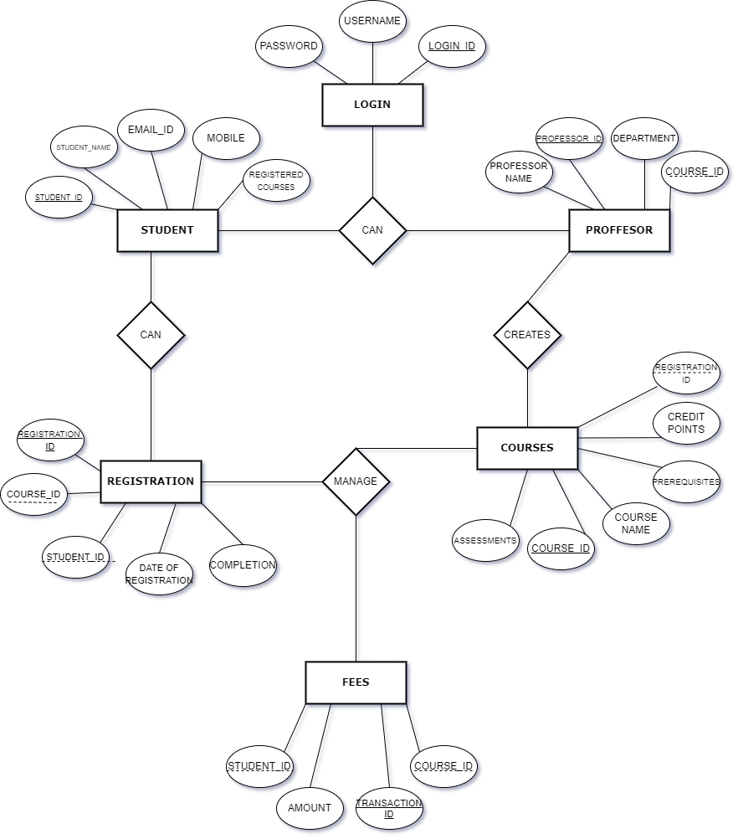
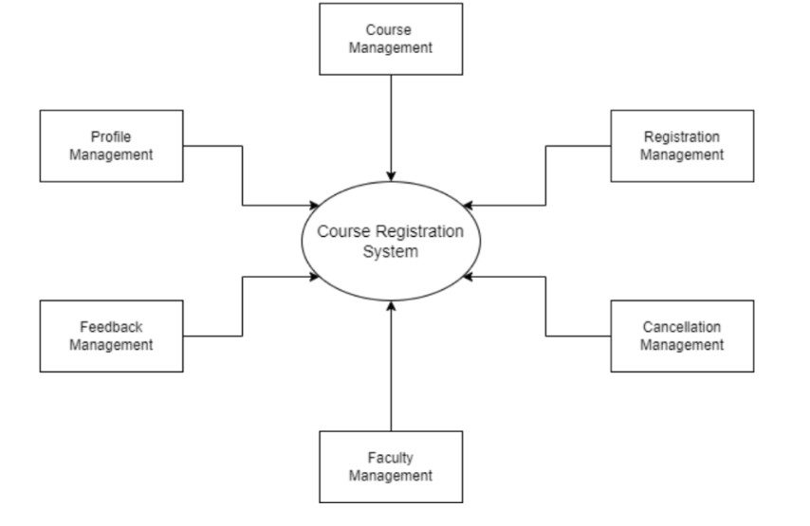
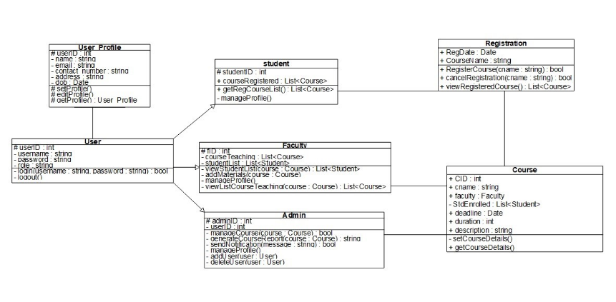
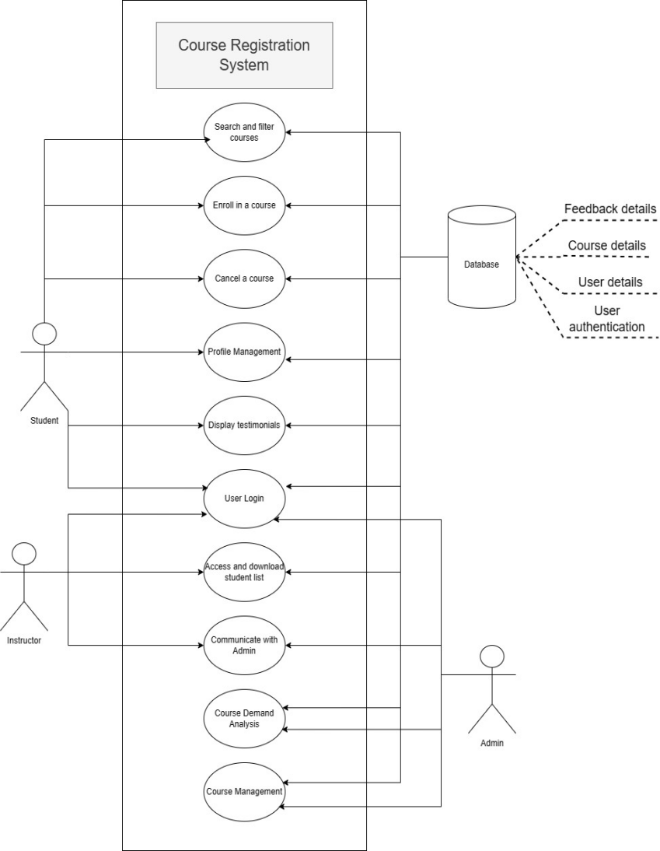
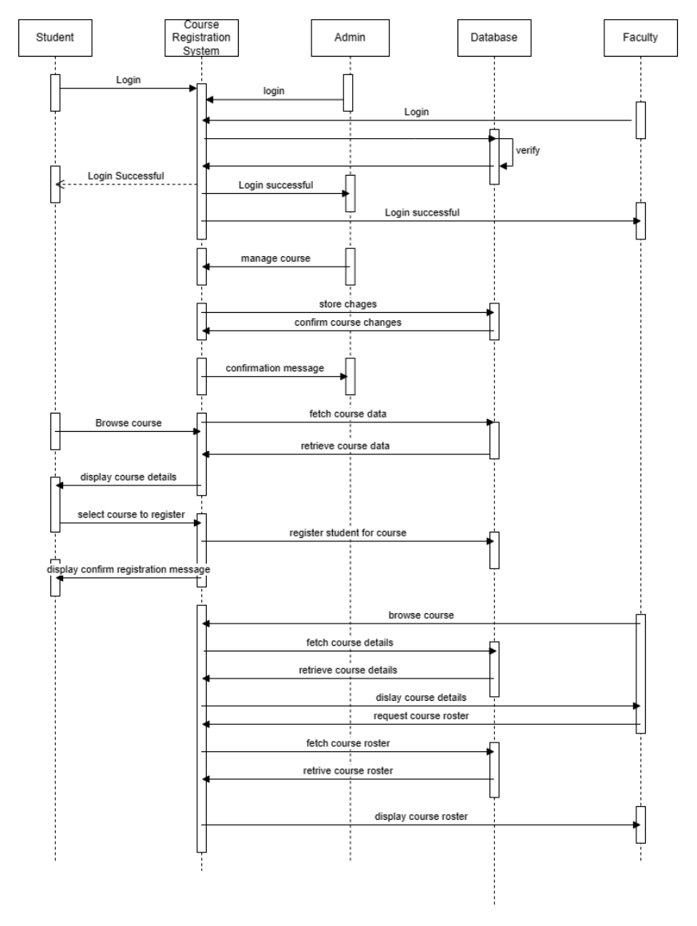
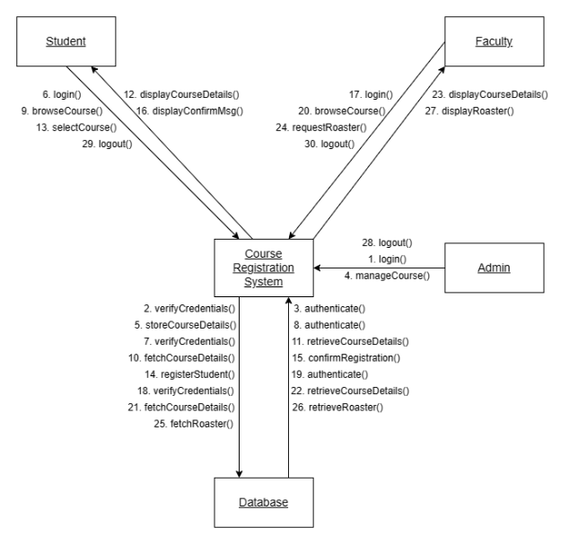
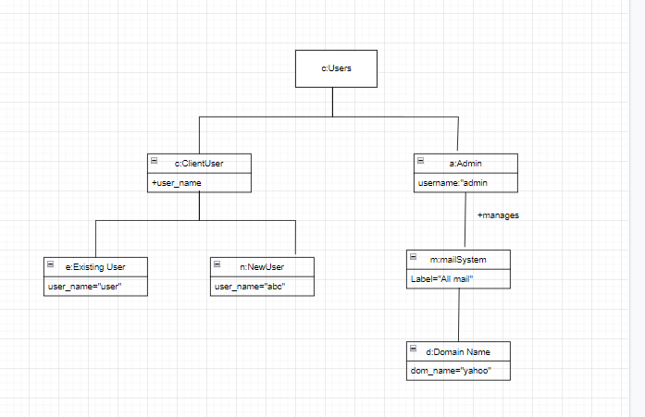
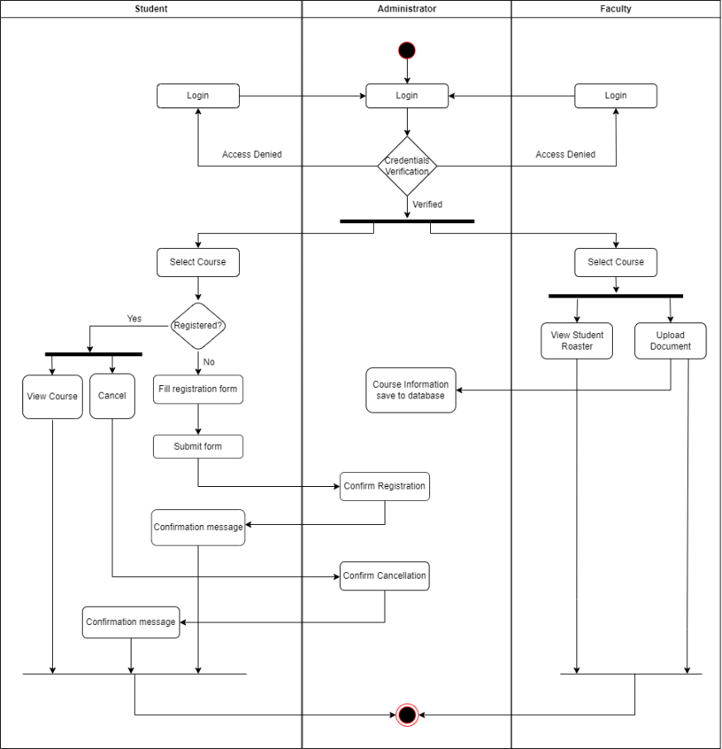
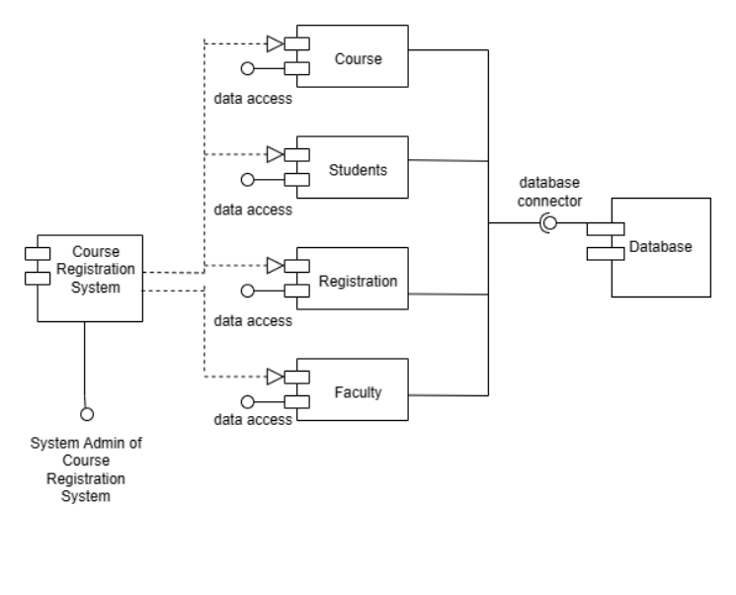
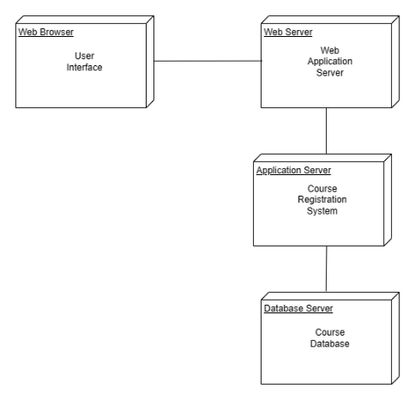
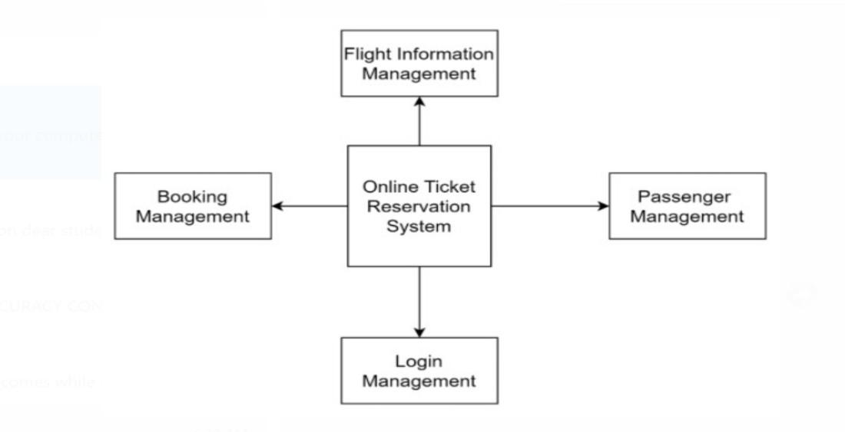
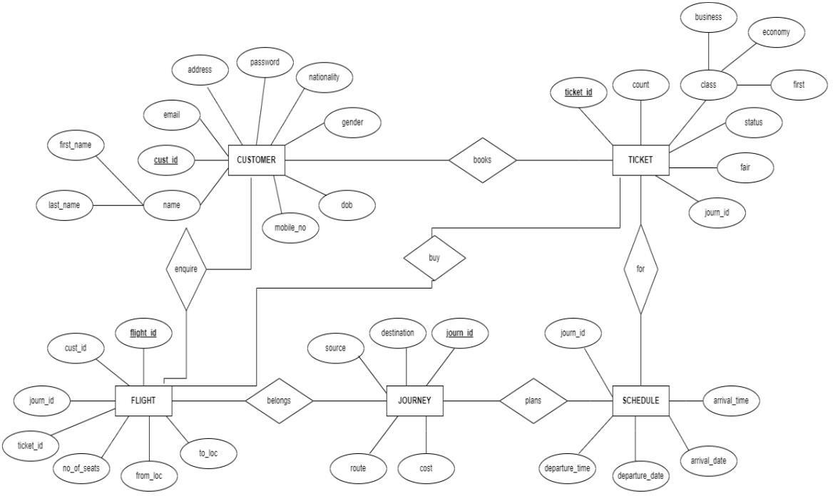
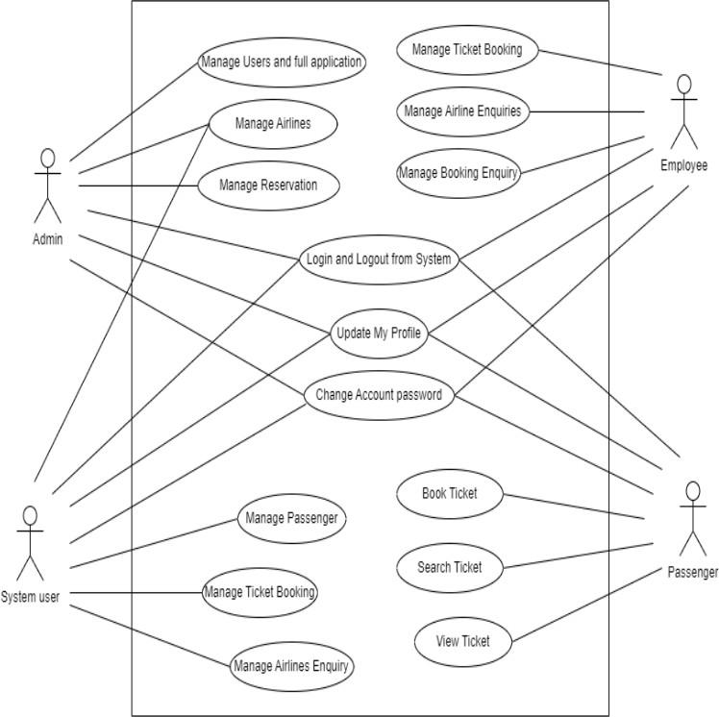
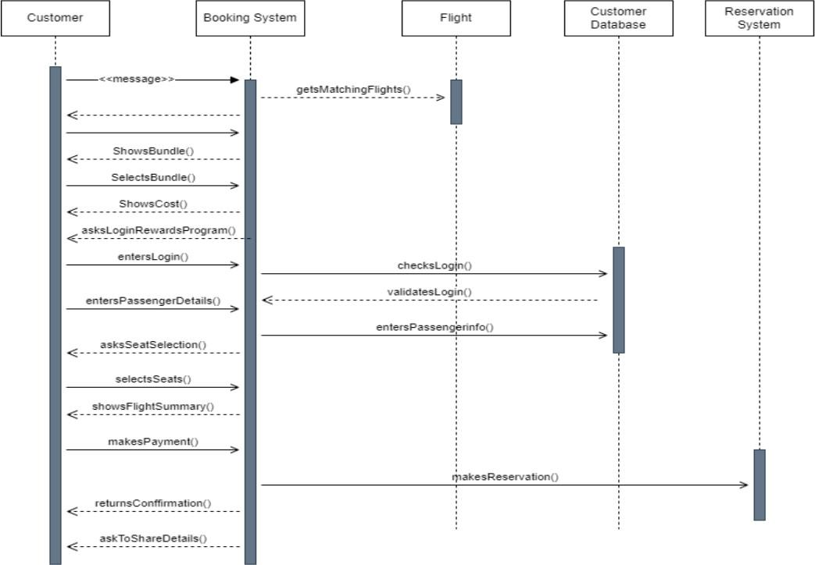
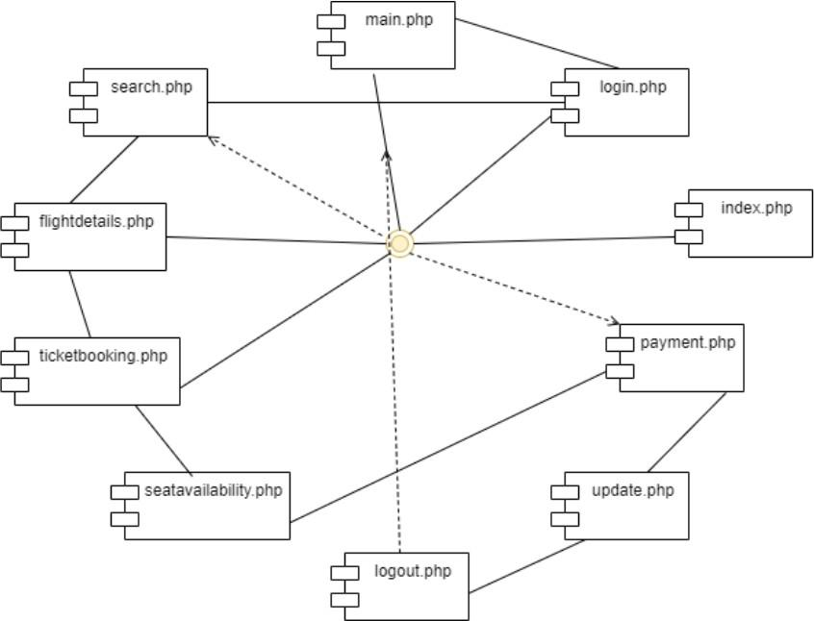
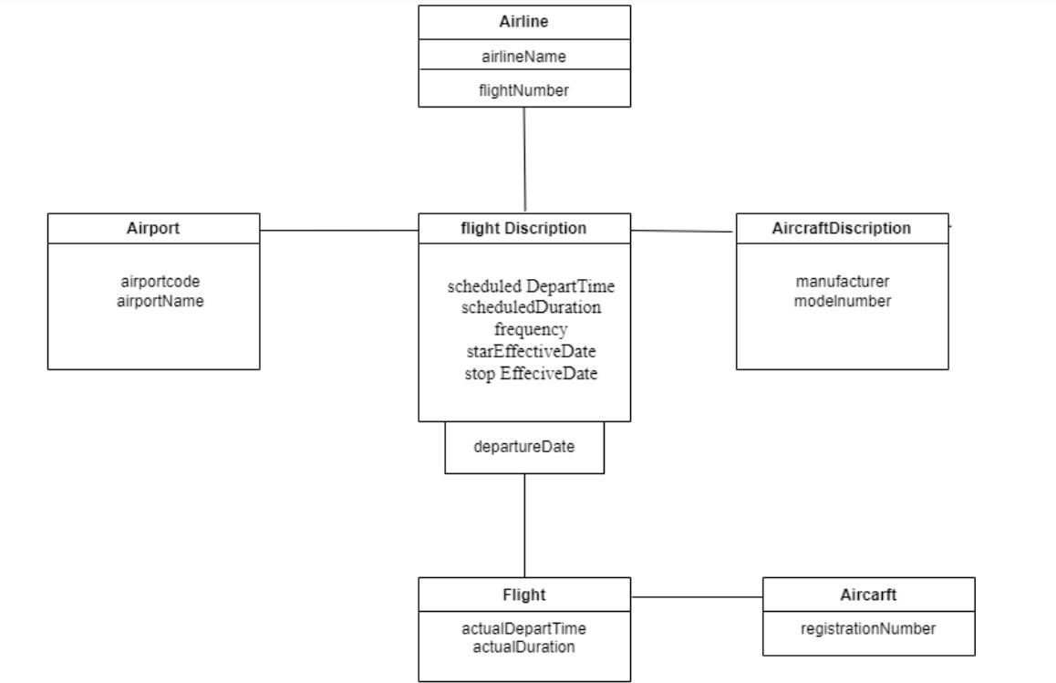
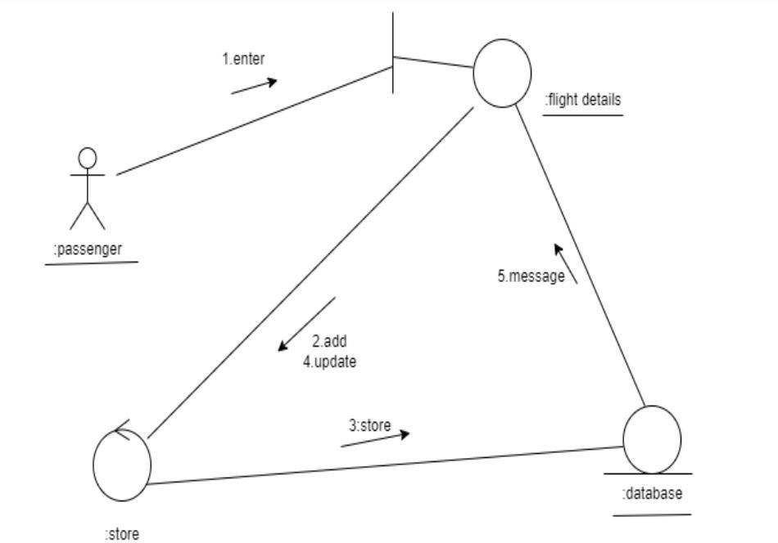
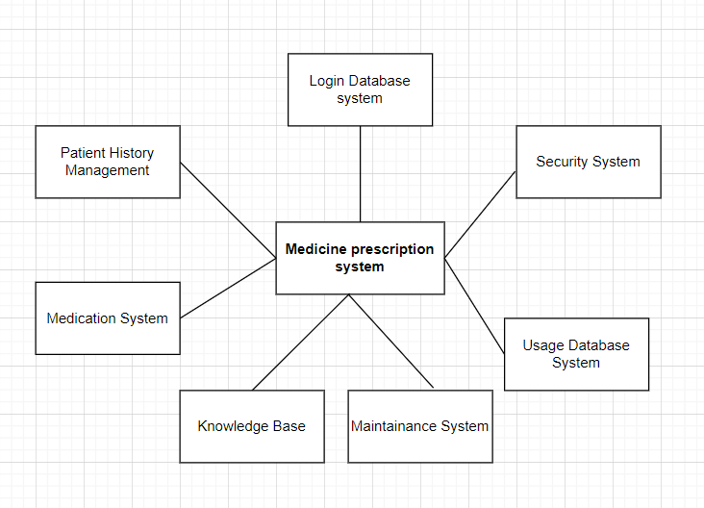
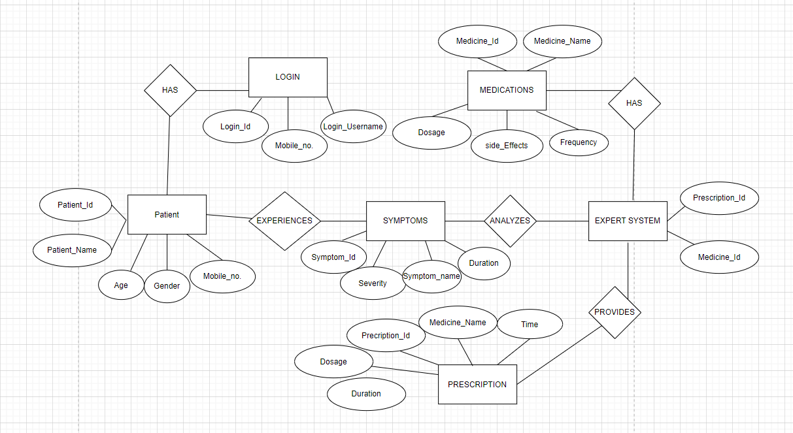
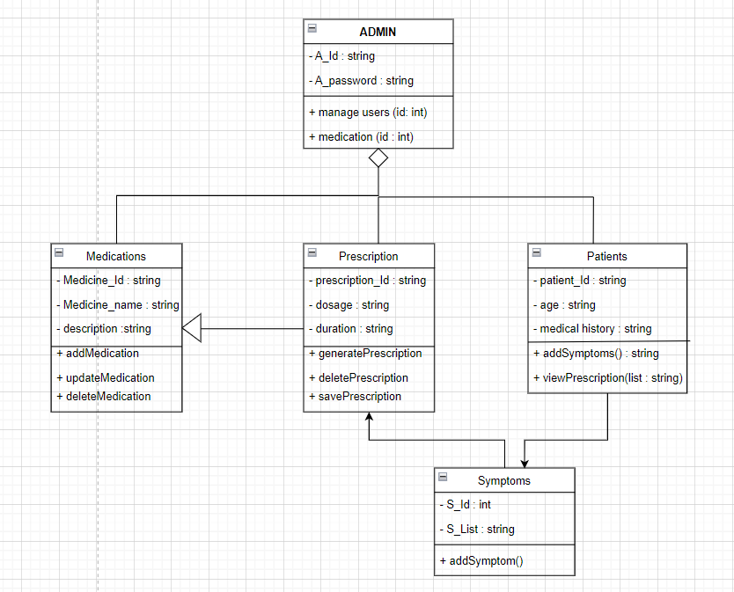
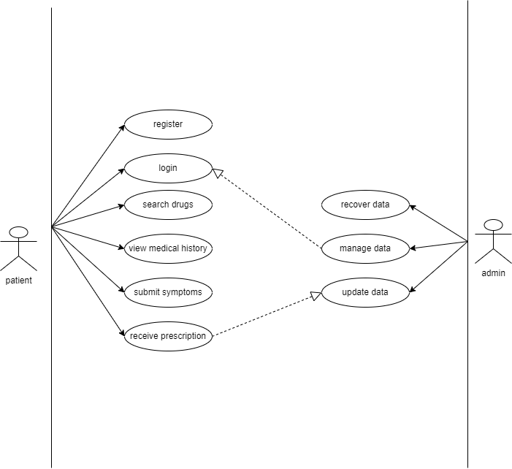
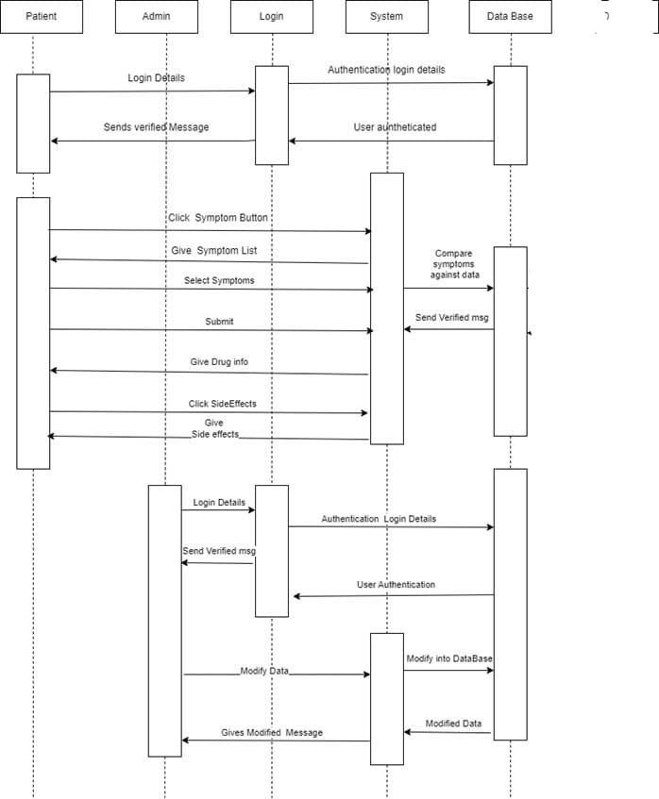
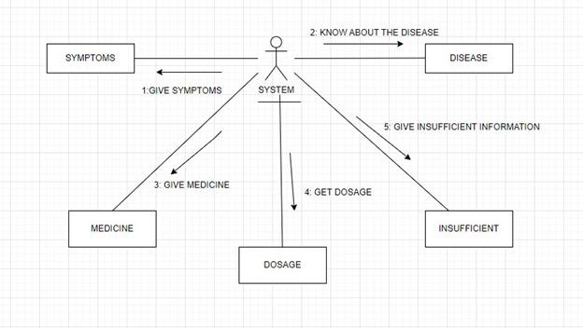
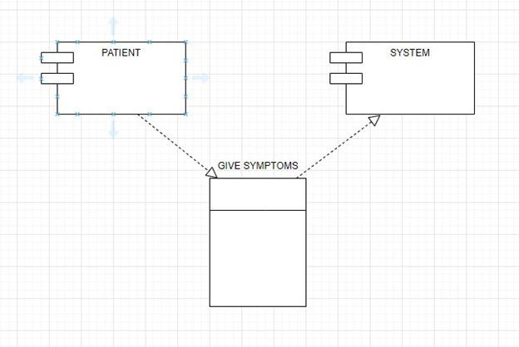
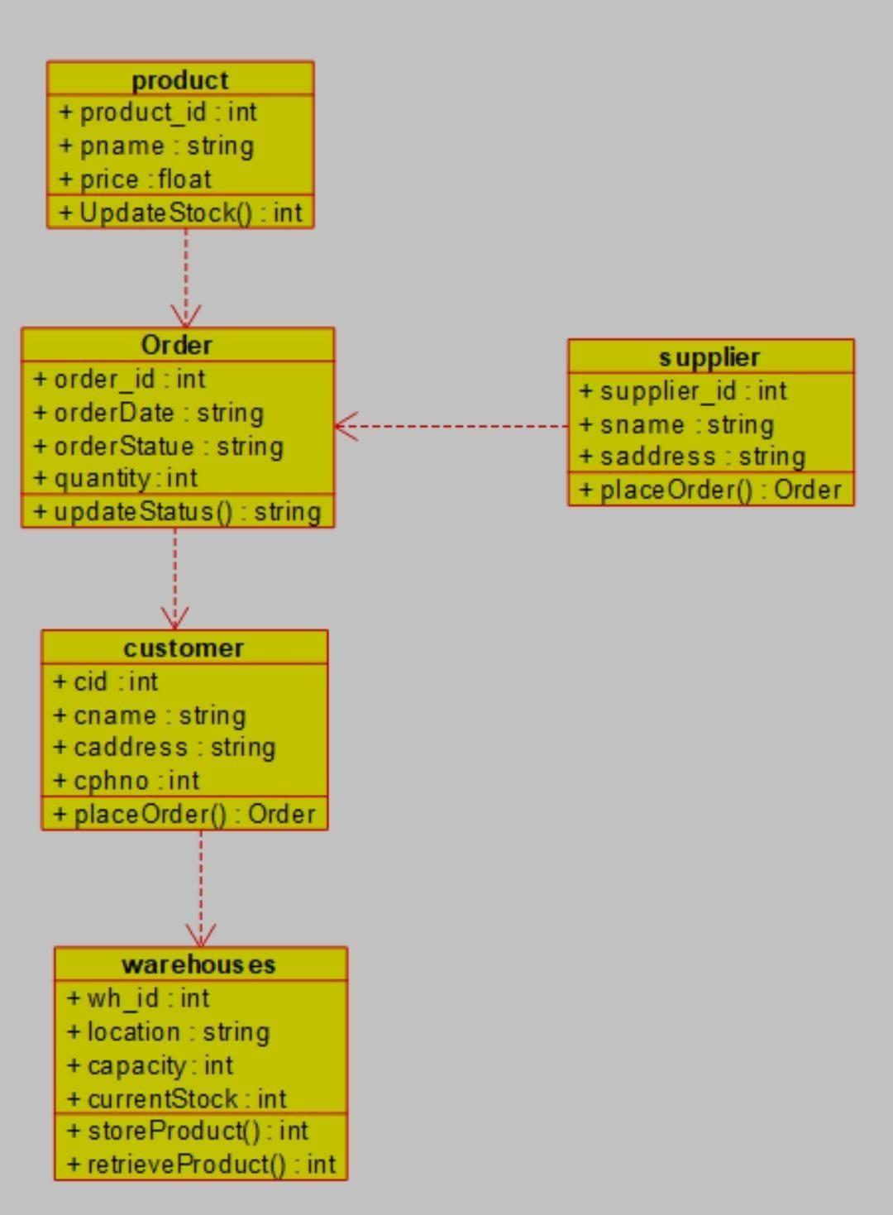
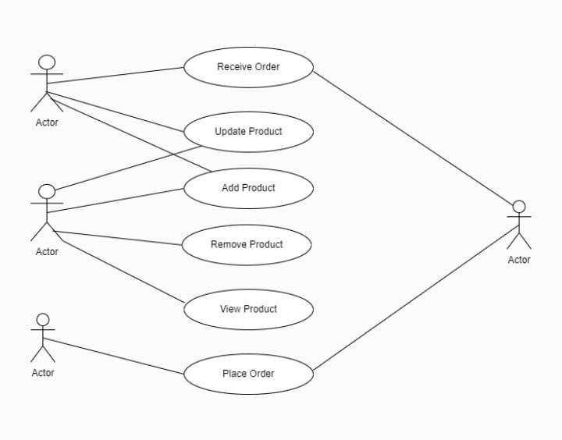
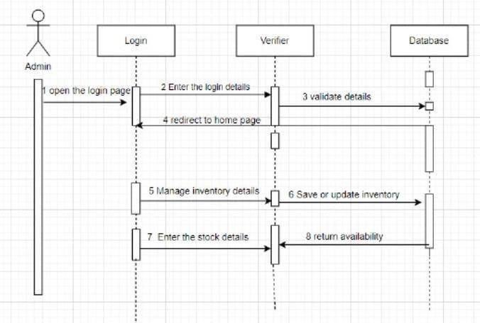
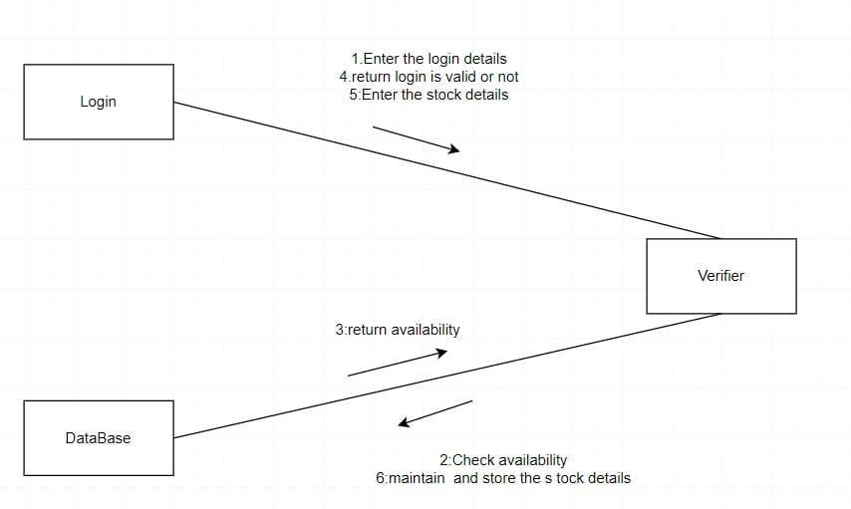
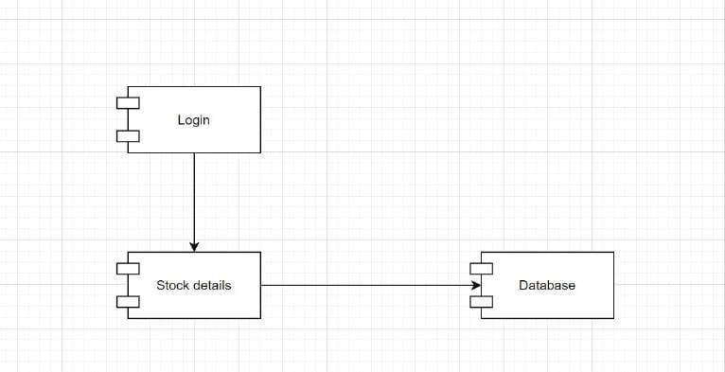
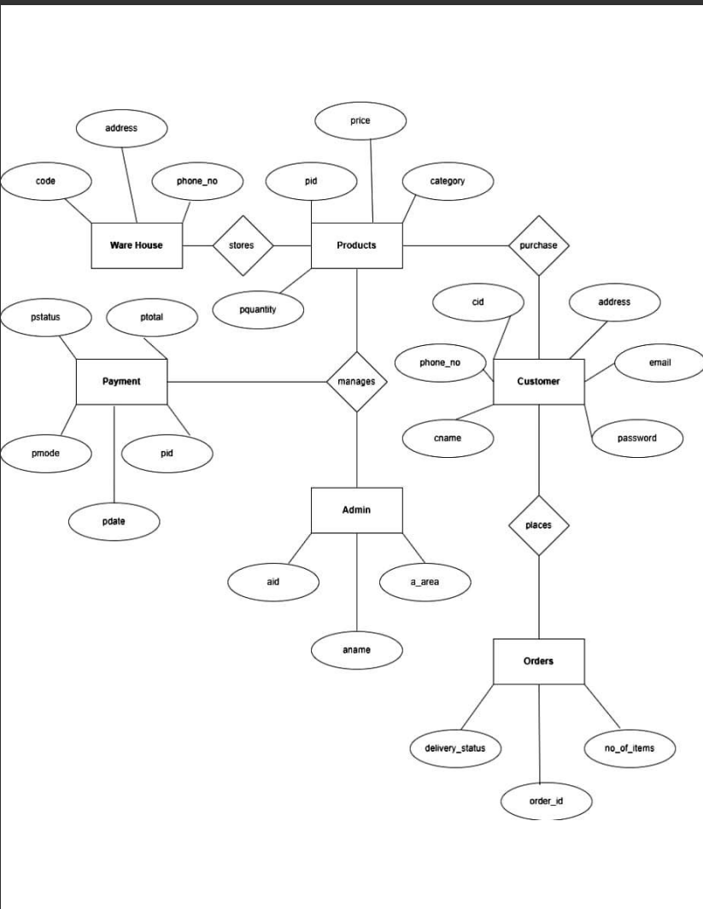
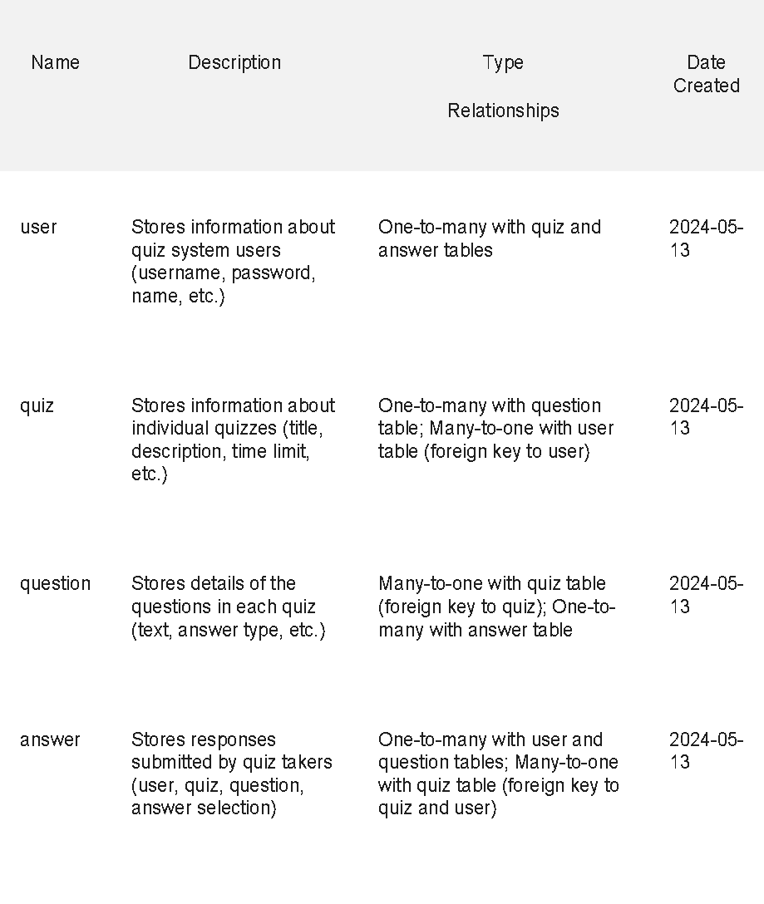
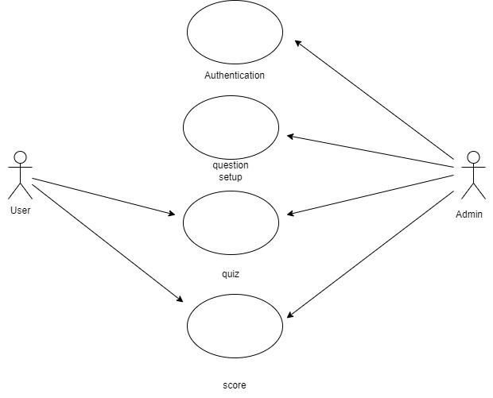
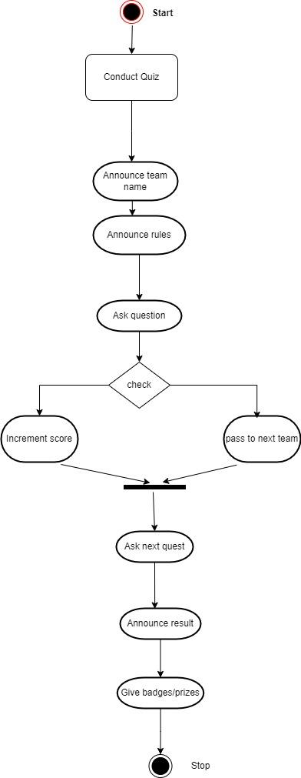
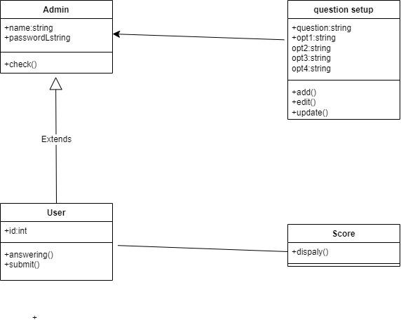
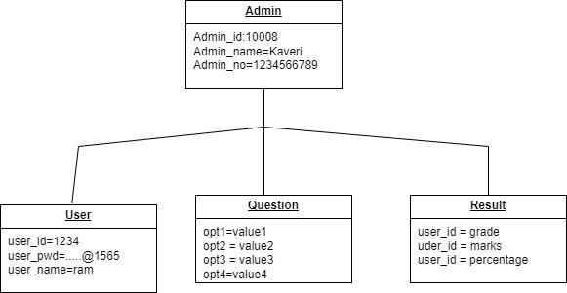
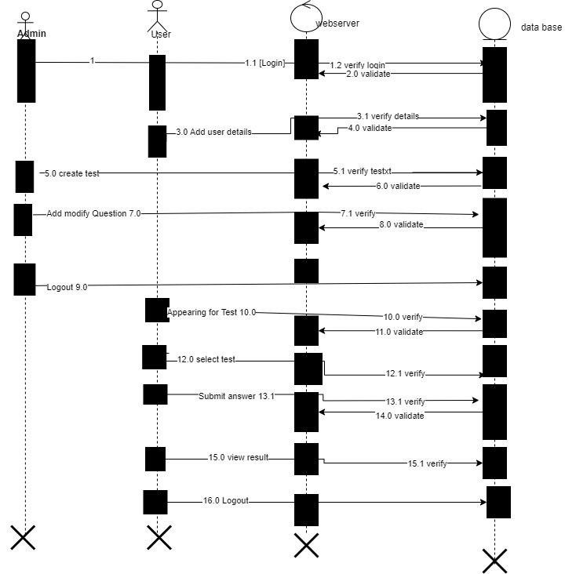
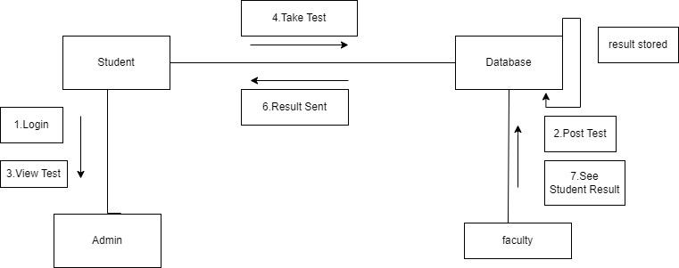
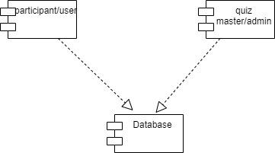
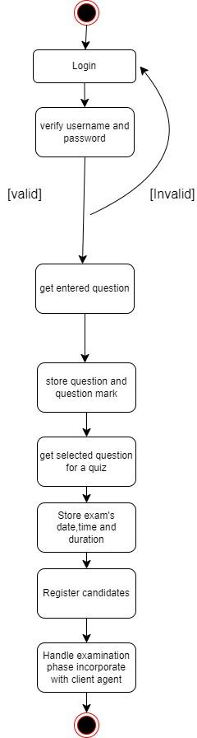
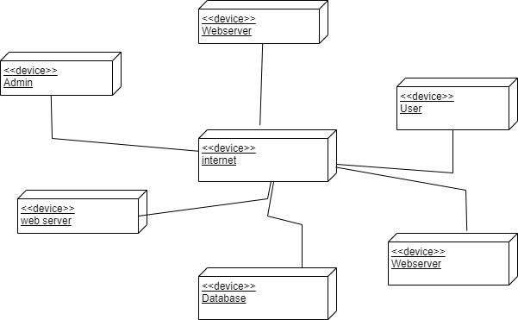

Department of Information Technology

SOFTWARE ENGINEERING LAB

1. COURSE REGISTRATION SYSTEM
2.1.1. PROBLEM ANALYSIS AND PROJECT PLANNING
2.2.1.1 Problem Statement
The course registration system will allow students to register for a particular course based on their choice.
This system also provides information about the offered course such as professor, department and duration to help students to make informed decisions.The proposed system aims to automate the process and provide tools such as course searching, selection and registration.
2.1.1.2 Project Scope
The proposed system involves student and faculty login to the system which is accessible through web platforms ensuring user friendly experience while maintaining data security and consistency. The system provides the list of courses available and allow student to register to the course they are interested. The system allows faculty to see the courses and list of students assigned to them. The system provides tools for administrator to maintain the course and student details. The system helps students to gather information about particular course like the course duration and the deadline to register.
2.1.1.3 General Objective
- The system allows the users to register for desired courses by viewing course details like prerequisites,faculty etc.
2.1.1.4 Specific Objectives
- When a student first uses the application he/she will have to sign up and create an account.
- Students who already have an account login to the systems.
- Students can view all the course details.
- Each course is specified with faculty,duration,prerequisites,exam type etc.
- Students can opt for desired course.
- They can make payment for the specified course once registration form filling is completed.
- A confirmation is received by students once the registration process is completed.
- Students can open the course on a daily basis and attend scheduled or self-paced features as opted.
- Short assessments should be conducted after each lectures to make sure the students are attentive.
- Students can also access the doubts and discussion feature to clear their doubts from the mentor.
- Students will also be recommended courses based on their previous preferences and standard.
- Students can provide rating after course completion.
- Admin can edit,archive,add or remove courses and course details.
- Admin will also know who opted which course.
- Course attendance will also be provided with a course completion certificate.This certificate can only be attained when atleast 90% of the lectures are played and all the assessments and assignments are attempted with a pass score.
1.1.2. SOFTWARE REQUIREMENTS SPECIFICATION
1.1.2.1. INTRODUCTION
This document specifies the requirements for course registration form. These requirements are grouped by their stakeholders along with the functional and non-functional requirements.
1.1.2.2. STAKEHOLDERS
S | Student
A | Administrator
F | Faculty

1.1.2.3. GENERAL REQUIREMENTS
- The system shall allow only authorized users and ensure only role-based specific action are performed by the authorized users.
- The system shall provide a user friendly and engaging interface that easy to navigate and understand.
- The system shall provide information about each course,such as course name,no of registrations,faculty details,reference material.
- The system shall allow admin to notify students and faculty regarding the cancelled classes due to technical error,and any other related information.
- The system shall ensure the user date is protected and sensitive course information is secured .
- The system shall ensure that the performance is not degraded due to high number of registrations,and it shall be handle large number of users.

1.1.2.4 FUNCTIONAL AND NON FUNCTIONAL REQUIREMENTS
1.1.2.4.1Requirements for stakeholder-1 [student]
R1 | Course searching and browsing | The system shall allow user to search for a course and filter the data according to the necessity of the user.
R2 | Enrollment and Cancellation | The system shall allow user to enroll for the interested course and cancel the course which they are not interested in.
R3 | Profile Management | The system shall allow the user to update their information like contact details,educational details etc.
R4 | Logout functionality | The system shall allow the students to be able to securely logout off their  accounts when they have completed their tasks.
R5 | Testimonials | The system shall provide testimonial feature to give feedback and receive  response towards the course.

NON FUNCTIONAL REQUIREMENTS
ACCESSIBILITY
R6 | The system shall create content that is accessible, usable and readable for all people including readers with disabilities.
R7 | The system shall have high accessibility.
PRIVACY
R8 | The system shall protect the user privacy policy.
R9 | The system shall not allow the viewing of other email accounts.
SECURITY
R10 | The system may not grant access until the user creates a strong password,i.e, a strong password must contain a certain number of characters and a capital letter.
R11 | The system shall be secure
INTEROPERABILITY
R12 | The system should allow sending/receiving emails to/from different types of email clients, i.e , the system would be able to send an email using Gmail to someone’s yahoo account.
AVAILABILITY
R13 | The system shall not allow downtime except during a server problem.
R14 | The system shall have to higher its availability of the course.
USER-FRIENDLINESS
R14 | The system shall have a single login to access all content.
R15 | The system shall be user-friendly.
R16 | The system shall provide easy navigation.
1.1.2.4.2. Requirements for stakeholder-2 [Admin]
Functional Requirements:
R17 | Analysis tools | The system shall provide administrator features to analyze the responses of thestudent and get idea of the demanding course.
R18 | Course Management | The system shall allow Admin to manage the course details like faculty assigned,course duration, etc.

NON-FUNCTIONAL REQUIREMENTS
USER-FRIENDLINESS
R19 | The system shall provide user friendly environment.
R20 | The system shall provide easy navigation
R21 | The system shall have single login to have all access control
PRIVACY
R22 | The system shall provide the user privacy policy
R23 | The system shall not allow viewing from the unregistered emails
AVAILABILITY
R24 | The system shall have high availability
R25 | The system shall not have unexpected downtime.
SECURITY
R26 | The system shall be highly secured
R27 | The system may lock an account to protect the user’s information from the hackers.

Requirements for stakeholder-3 [Faculty]
Functional Requirements:
R28 | Course Roster | The system shall allow instructor to access and download a complete list ofstudents enrolled in their courses.
R29 | Communication with Administrators | The system shall provide means to communicate with administrator for anyissues related to the course registration system through mail.

NON-FUNCTIONAL REQUIREMENTS
USER-FRIENDLINESS
R30 | The system shall provide user friendly environment.
R31 | The system shall provide easy navigation
R32 | The system shall have single login to have all access control
PRIVACY
R33 | The system shall provide the user privacy policy
R34 | The system shall not allow viewing from the unregistered emails
AVAILABILITY
R35 | The system shall have high availability
R36 | The system shall not have unexpected downtime.
SECURITY
R37 | The system shall be highly secured
R38 | The system may lock an account to protect the user’s information from the hackers.

SRS INDEX

1. INTRODUCTION
1.1. Purpose
1.2. Scope
1.3. Definitions and abbreviations
1.4. Reference
1.5. Overview
2. SPECIFIC REQUIREMENTS
2.1. Function requirements
2.2. External interface requirements
2.3. Performance requirements
2.4. Design constraints
2.5. Software system attributes
3. FEASIBILITY STUDY
4. ER DIAGRAM
4.1 Data Dictionary

5. CONTEXT DIAGRAM
6. UML DIAGRAMS

- INTRODUCTION
This document specifies the requirements for the course registration form. These requirements are grouped by their stakeholders along with the functional and non-functional requirements.
1.1 PURPOSE
The purpose of this document is to present a detailed description of the course registration form. It will explain the requirements and features of the system, The constraints under which it must operate and how the system will react. This document is intended for both the stake holders and users of the system.
1.2 SCOPE
The proposed system involves student and faculty login to the system which is accessible through web platforms ensuring user friendly experience while maintaining data security and consistency. The system provides the list of courses available and allow student to register to the course they are interested. The system allows faculty to see the courses and list of students assigned to them. The system provides tools for administrator to maintain the course and student details. The system helps students to gather information about particular course like the course duration and the deadline to register.
1.3DEFINITIONS AND ABBREVIATIONS
Administrators | A | The administrator has access to all the modifications and updates of the database.
Students | S | They are people who register for the courses
Faculty | F | They are people who are teaching the courses

1.4 REFERENCES
http://njpas.com.ng/wp-content/uploads/2024/05/2.NJPAS-23-B08.pdf
https://www.researchgate.net/profile/Md-Kabir-79/publication/360118139_Web_Based_Student_Registration_and_Exam_Form_Fill-up_Management_System_for_Educational_Institute/links/6262e89c8e6d637bd1f5122a/Web-Based-Student-Registration-and-Exam-Form-Fill-up-Management-System-for-Educational-Institute.pdf
1.5 OVERVIEW
- "Implementation of an Effective Course Registration Credit Unit Monitoring System":

Summary
Authors: Prof. Godwin A. Otu, Stephen E. Iheagwara, Fredrick I. Okonkwo, Suleiman A. Usman, Modupe S. Oyebanji
Publication: Nigerian Journal of Pure and Applied Science, Volume 37, Issue 1, 2024
The paper presents an automated system for monitoring course registration and credit units, aiming to address inefficiencies in manual processes that consume time and resources. It focuses on automating the calculation of credit units to ensure accuracy. Developed using Java, the system includes a user-friendly credit unit calculator that functions offline. Benefits include streamlined registration processes, time savings, and increased accuracy. Overall, the system offers a significant improvement over manual methods, showcasing the practical application of automation in educational administrative processes.
b) "Web Based Student Registration and Exam Form Fill-up Management System for Educational Institute,"

Summary
Authors: Md. Tofail Ahmed, Md. Humaun Kabir, Sujit Roy
Publication: International Journal of Information Engineering and Electronic Business, April 2022
The paper introduces a web-based application developed to streamline student registration and exam form fill-up processes in educational institutes. Traditional manual systems are prone to errors and time-consuming. The objective is to develop an integrated web-based system that automates these processes, ensuring efficiency and accuracy. The system supports multiple user roles and functions, such as online submission of forms, approval processes, and fee payment. It employs web programming languages and technologies, including MySQL for the database, to ensure data integrity and security. Implementation involves creating web forms, processing approvals, and integrating payment gateways, with provisions for data backup. Overall, the system offers significant benefits in reducing time and effort, minimizing errors, and enhancing operational efficiency in academic administrative tasks.

2.SPECIFIC REQUIREMENTS
2.1 FUNCTIONAL REQUIREMENTS
- Course searching and browsing: The system shall allow user to search for a course and filter the data according to the necessity of the user.
- Enrollment and Cancellation: The system shall allow user to enroll for the interested course and cancel the course which they are not interested in.
- Profile Management: The system shall allow the user to update their information like contact details,educational details etc.
- Logout functionality: The system shall allow the students to be able to securely logout off their accounts when they have completed their tasks.
- Testimonials :The system shall provide testimonial feature to give feedback and receive response towards the course.

2.2 EXTERNAL INTERFACE REQUIREMENTS
- The system can be used either with mouse or keypad implementation.
- The system must have a single login to access all content.
- The system uses SQL database to store the records of all users.
- The system must have access to the internet.
2.3 PERFORMANCE REQUIREMENTS
- The system shall provide easy navigation.
- The system shall create content that is easily accessible, usable and readable for all people including readers with disabilities.
- The system should be able to support multiple users at a time.
- The system may lock an account to protect user’s information from hackers, after certain number of invalid login attempts.
2.4 DESIGN CONSTRAINTS
- The system disables automatic opening of messages.
- The system can run on those devices which has access to internet.
- The system can run on both Android and iOS devices.
2.5 SOFTWARE SYSTEM ATTRIBUTES
The quality of the system is maintained in a way so that it can be very user-friendly to every user. The software quality attributes are:
- Compatible
- Reliable
- Accurate
- Fast
- Secure
3.FEASIBILITY STUDY
3.1 TECHNICAL FEASIBILTY
Evaluate hardware, software, scalability, security, and integration capabilities to ensure the system can handle user load and functionality requirements.

3.2 LEGAL FEASIBILITY
Ensure compliance with data protection laws, address intellectual property concerns, and implement secure payment processing methods to mitigate legal risks.
3.3 ECONOMIC FEASIBILTY
Assess development, operational costs, and potential revenue streams to determine the project's financial viability and return on investment.
3.4 OPERATIONAL FEASIBILITY
Evaluate user requirements, system usability, training needs, and support requirements to ensure smooth system operation and user satisfaction.
3.5 SCHEDULING FEASBILITY
Develop a realistic project timeline, allocate resources effectively, and implement risk management strategies to ensure timely delivery and project success

4. E-R DIAGRAM

4.1 DATA DICTIONARY ENTRIES
Name | Description | Type | Date
User | The person who works with the system | entity | 18/03/24
User_name | The name of the user of that system | attribute | 18/03/24
Manages | A one-to-one relationship between student and faculty | relationship | 18/03/24
Domain_name | The internet designation for the course which maybe a private site,company or organisation | entity | 18/03/24
User_password | The string of characters that allows access to the system | attribute | 18/03/24
Roles | The function or position of a person | entity | 18/03/24
Login | A permission that lets to use email  student interface | entity | 18/03/24
Role_name | Name of the role of a user | attribute | 18/03/24
User_mobile | Mobile number of the user for logging into the system | attribute | 18/03/24
User_address | Address of the student who register for the course. | attribute | 18/03/24
Permission | Authorization that is given to use the administrator. | entity | 18/03/24
has | A one-to-one relationship between both student and facutly and roles and permission | relationship | 18/03/24
Per_name | Name of the kind of course given to access to the student | attribute | 18/03/24
Role_id | A unique number that is auto generated by the system for different student for different course | attribute | 18/03/24
Mailbox_name | Username of the recipient on the email server or destination domain | entity | 18/03/24
User_id | A unique number for the student that is auto generated by the system | attribute | 18/03/24
Per_role_id | A unique permission number that is set for various courses | attribute | 18/03/24
User_email | Email id of the student of the interface to get access to the system | attribute | 18/03/24
Login_username | The name that uniquely identifies someone on the system | attribute | 18/03/24
Per_id | A unique number that is generated by the system for various permissions | attribute | 18/03/24

5.CONTEXT DIAGRAM

6. UML DIAGRAMS

6.1Class diagram

6.2.Use case diagram-

6.3. Sequence diagram

6.4.Collaboration diagram

6.5. Object diagram

6.6. Activity diagram

6.7. Component diagram

6.8. Deployment diagram

7. FORWARD ENGINEERING
/**
* Class Email_System_Controller
*/
public class Email_System_Controller extends fileController, sendEmail, fileSystem, fileController, sendEmail, fileSystem, readEmail, LoginHandler {
//
// Fields
//
//
// Constructors
//
public Email_System_Controller () { };
//
// Methods
//
//
// Accessor methods
//
//
// Other methods
//
/**
*/
public void registerNewUser()
{
}
/**
*/
public void authentication()
{
}
/**
*/
public void sendtoExistingUser()
{
}
/**
*/
public void sendAttachment()
{
}
/**
*/
public void forwardMail()
{
}
/**
*/
public void viewMail()
{
}
/**
*/
public void delete()
{
}
/**
*/
public void changeFont()
{
}
}
/**
* Class fileSystem
*/
public class fileSystem {
//
// Fields
//
//
// Constructors
//
public fileSystem () { };
//
// Methods
//
//
// Accessor methods
//
//
// Other methods
//
/**
*/
public void getPassword()
{
}
/**
*/
public void storeMails()
{
}
/**
*/
public void storeAttachment()
{
}
/**
*/
public void getMails()
{
}
/**
*/
public void getAttachment()
{
}
/**
*/
public void new_operation()
{
}
}
/**
* Class Email_System_Controller
*/
public class Email_System_Controller extends fileController, sendEmail, fileSystem, fileController, sendEmail, fileSystem, readEmail, LoginHandler {
//
// Fields
//
//
// Constructors
//
public Email_System_Controller () { };
//
// Methods
//
//
// Accessor methods
//
//
// Other methods
//
/**
*/
public void registerNewUser()
{
}
/**
*/
public void authentication()
{
}
/**
*/
public void sendtoExistingUser()
{
}
/**
*/
public void sendAttachment()
{
}
/**
*/
public void forwardMail()
{
}
/**
*/
public void viewMail()
{
}
/**
*/
public void delete()
{
}
/**
*/
public void changeFont()
{
}
}
/**
* Class Email_System_Controller
*/
public class Email_System_Controller extends fileController, sendEmail, fileSystem, fileController, sendEmail, fileSystem, readEmail, LoginHandler {
//
// Fields
//
//
// Constructors
//
public Email_System_Controller () { };
//
// Methods
//
//
// Accessor methods
//
//
// Other methods
//
/**
*/
public void registerNewUser()
{
}
/**
*/
public void authentication()
{
}
/**
*/
public void sendtoExistingUser()
{
}
/**
*/
public void sendAttachment()
{
}
/**
*/
public void forwardMail()
{
}
/**
*/
public void viewMail()
{
}
/**
*/
public void delete()
{
}
/**
*/
public void changeFont()
{
}
}
/**
* Class fileController
*/
public class fileController {
//
// Fields
//
//
// Constructors
//
public fileController () { };
//
// Methods
//
//
// Accessor methods
//
//
// Other methods
//
/**
*/
public void changeFont()
{
}
}
/**
* Class Email_System_Controller
*/
public class Email_System_Controller extends fileController, sendEmail, fileSystem, fileController, sendEmail, fileSystem, readEmail, LoginHandler {
//
// Fields
//
//
// Constructors
//
public Email_System_Controller () { };
//
// Methods
//
//
// Accessor methods
//
//
// Other methods
//
/**
*/
public void registerNewUser()
{
}
/**
*/
public void authentication()
{
}
/**
*/
public void sendtoExistingUser()
{
}
/**
*/
public void sendAttachment()
{
}
/**
*/
public void forwardMail()
{
}
/**
*/
public void viewMail()
{
}
/**
*/
public void delete()
{
}
/**
*/
public void changeFont()
{
}
}
import java.util.*;
/**
* Class LoginHandler
*/
public class LoginHandler extends fileSystem {
//
// Fields
//
private void name;
private void userId;
private void password;
private void age;
private new_classemailAddress;
//
// Constructors
//
public LoginHandler () { };
//
// Methods
//
//
// Accessor methods
//
/**
* Set the value of name
* @param newVar the new value of name
*/
private void setName (void newVar) {
name = newVar;
}
/**
* Get the value of name
* @return the value of name
*/
private void getName () {
return name;
}
/**
* Set the value of userId
* @param newVar the new value of userId
*/
private void setUserId (void newVar) {
userId = newVar;
}
/**
* Get the value of userId
* @return the value of userId
*/
private void getUserId () {
return userId;
}
/**
* Set the value of password
* @param newVar the new value of password
*/
private void setPassword (void newVar) {
password = newVar;
}
/**
* Get the value of password
* @return the value of password
*/
private void getPassword () {
return password;
}
/**
* Set the value of age
* @param newVar the new value of age
*/
private void setAge (void newVar) {
age = newVar;
}
/**
* Get the value of age
* @return the value of age
*/
private void getAge () {
return age;
}
/**
* Set the value of emailAddress
* @param newVar the new value of emailAddress
*/
private void setEmailAddress (new_classnewVar) {
emailAddress = newVar;
}
/**
* Get the value of emailAddress
* @return the value of emailAddress
*/
private new_classgetEmailAddress () {
return emailAddress;
}
//
// Other methods
//
/**
*/
public void create()
{
}
/**
*/
public void registernewuser()
{
}
/**
*/
public void Login()
{
}
}
/**
* Class Email_System_Controller
*/
public class Email_System_Controller extends fileController, sendEmail, fileSystem, fileController, sendEmail, fileSystem, readEmail, LoginHandler {
//
// Fields
//
//
// Constructors
//
public Email_System_Controller () { };
//
// Methods
//
//
// Accessor methods
//
//
// Other methods
//
/**
*/
public void registerNewUser()
{
}
/**
*/
public void authentication()
{
}
/**
*/
public void sendtoExistingUser()
{
}
/**
*/
public void sendAttachment()
{
}
/**
*/
public void forwardMail()
{
}
/**
*/
public void viewMail()
{
}
/**
*/
public void delete()
{
}
/**
*/
public void changeFont()
{
}
}
/**
* Class readEmail
*/
public class readEmail extends fileSystem {
//
// Fields
//
private void checkMail;
private void readReply;
//
// Constructors
//
public readEmail () { };
//
// Methods
//
//
// Accessor methods
//
/**
* Set the value of checkMail
* @param newVar the new value of checkMail
*/
private void setCheckMail (void newVar) {
checkMail = newVar;
}
/**
* Get the value of checkMail
* @return the value of checkMail
*/
private void getCheckMail () {
return checkMail;
}
/**
* Set the value of readReply
* @param newVar the new value of readReply
*/
private void setReadReply (void newVar) {
readReply = newVar;
}
/**
* Get the value of readReply
* @return the value of readReply
*/
private void getReadReply () {
return readReply;
}
//
// Other methods
//
/**
*/
public void viewMail()
{
}
/**
*/
public void check()
{
}
/**
*/
public void viewAttachment()
{
}
/**
*/
public void delete()
{
}
/**
*/
public void checkMail()
{
}
}
/**
* Class Email_System_Controller
*/
public class Email_System_Controller extends fileController, sendEmail, fileSystem, fileController, sendEmail, fileSystem, readEmail, LoginHandler {
//
// Fields
//
//
// Constructors
//
public Email_System_Controller () { };
//
// Methods
//
//
// Accessor methods
//
//
// Other methods
//
/**
*/
public void registerNewUser()
{
}
/**
*/
public void authentication()
{
}
/**
*/
public void sendtoExistingUser()
{
}
/**
*/
public void sendAttachment()
{
}
/**
*/
public void forwardMail()
{
}
/**
*/
public void viewMail()
{
}
/**
*/
public void delete()
{
}
/**
*/
public void changeFont()
{
}
}
import java.util.*;
/**
* Class webserver
*/
abstract public class webserver {
//
// Fields
//
private void name;
private void userID;
//
// Constructors
//
public webserver () { };
//
// Methods
//
//
// Accessor methods
//
/**
* Set the value of name
* @param newVar the new value of name
*/
private void setName (void newVar) {
name = newVar;
}
/**
* Get the value of name
* @return the value of name
*/
private void getName () {
return name;
}
/**
* Set the value of userID
* @param newVar the new value of userID
*/
private void setUserID (void newVar) {
userID = newVar;
}
/**
* Get the value of userID
* @return the value of userID
*/
private void getUserID () {
return userID;
}
//
// Other methods
//
}
/**
* Class Email_System_Controller
*/
public class Email_System_Controller extends fileController, sendEmail, fileSystem, fileController, sendEmail, fileSystem, readEmail, LoginHandler {
//
// Fields
//

//
// Constructors
//
public Email_System_Controller () { };
//
// Methods
//
//
// Accessor methods
//
//
// Other methods
//
/**
*/
public void registerNewUser()
{
}
/**
*/
public void authentication()
{
}
/**
*/
public void sendtoExistingUser()
{
}
/**
*/
public void sendAttachment()
{
}
/**
*/
public void forwardMail()
{
}
/**
*/
public void viewMail()
{
}
/**
*/
public void delete()
{
}
/**
*/
public void changeFont()
{
}
}

/**
* Class sendEmail
*/
public class sendEmail {
//
// Fields
//
private void compose;
//
// Constructors
//
public sendEmail () { };
//
// Methods
//
//
// Accessor methods
//
/**
* Set the value of compose
* @param newVar the new value of compose
*/
private void setCompose (void newVar) {
compose = newVar;
}
/**
* Get the value of compose
* @return the value of compose
*/
private void getCompose () {
return compose;
}
//
// Other methods
//
/**
*/
public void compose()
{
}
/**
*/
public void changeFont()
{
}
/**
*/
public void forwardmail()
{
}
/**
*/
public void sendAttachment()
{
}
}

2. AIRWAYS DOMAIN

ONLINE TICKET RESEERVATION SYSTEM
2.1.1PROBLEM ANALYSIS AND PROJECT PLANNING

2.1.1.1 Problem Statement
To reserve a ticket, customers just have to select a date, the start location and the end destination, and go through the intuitive step-by-step booking process. They can review all available seats at a glance and select seats easily. As soon as the booking is completed, clients receive an electronic ticket they can print at home.

2.1.1.1Project Scope
The built-in reservation management system allows script admins to add and edit bookings, and delete bookings in case of a cancellation. On top of that, administrators can manage clients' details and tickets. The online ticket reservation system allows you not only to accept reservations online, but to manually process bookings, too.

2.1.1.1 General Objectives
        - Streamline the process of booking tickets by creating a user-friendly and intuitive system.
        - Provide a seamless and efficient booking experience to improve customer satisfaction.
        - Reduce the time and effort required for customers to reserve tickets.
        - Ensure customers can receive and print their tickets instantly after booking.

2.1.1.2Specific Objectives
        - Implement a feature allowing customers to easily choose their desired travel date.
        - Develop an interface for customers to select their start location and end destination effortlessly.
        - Design a guided, step-by-step process that leads customers through each stage of the booking.
        - Create a system where customers can view all available seats at a glance.
        - Integrate a functionality for customers to select their preferred seats easily.
        - Set up an automated system that sends an electronic ticket to customers immediately after booking.

SOFTWARE REQUIREMENTS SPECIFICATION
2.1.1.2 INTRODUCTION
The purpose of this document is to describe the software requirements for the development of an online reservation system. The intended audience includes project managers, developers, testers and stakeholders.

2.1.1.2 STAKEHOLDERS

A | Admin
U | User
B | Boarding staff

2.1.1.2 GENERAL REQUIREMENTS
To reserve a ticket, customers need to select their travel date, starting location, and destination through a user-friendly interface. The system will guide them through an intuitive step-by-step booking process. During this process, users can easily review and select from available seats. Once the booking is confirmed, customers receive an electronic ticket that can be printed at home, ensuring a seamless and efficient reservation experience.

2.1.1.2 FUNCTIONAL AND NON FUNCTIONAL REQUIREMENTS
2.1.1.2.1 ADMIN

FUNCTIONAL REQUIREMENTS

R1 | Website helps the customers/travel agencies for ticket registration.
R2 | Only authorized person can access related details like login credentials.
R3 | Organizations upgrade their information in case of any slight changes in prices, available seats, duration.
R4 | Administrators can also have accessibility to add, delete, modify the flight information
R5 | Management stores the flight number, departure city, arrival city, departure time, arrival time, flight status, and available seats and provides access or functions to retrieve each piece of information.

NON FUNCTIONAL REQUIREMENTS SCALABILITY:
R6 | The system should handle an increase in the number of flights, customers, and transactions.
RELIABILITY:

R7 | The system should be highly reliable and available to customers 24/7.

PERFORMANCE:

R8 | The system should be able to provide real-time information and respond to customer requests.
SECURITY:

R9 | The system should ensure customer information and transactions confidentiality, integrity, and availability

INTEROPERABILITY:

R10 | The system should be able to integrate with other systems and technologies the airline uses.

USER

FUNCTIONAL REQUIREMENTS

R11 | A customer should be able to login to the system through the first page of the application and change the password after logging into the system.
R12 | No reservation before one day can be done.
R13 | See his/her current reservations on different flights along with the details.
R14 | Able to choose the seats which are available for a certain class.
R15 | Can select seats from different classes as well for the same class.
R16 | Give details about the credit card.
R17 | A message should be sent to the concerned person about the confirmation of the ticket to the specified mobile number. The login Id and password should be sent to the mentioned email address if a new account is created.

NON FUNCTIONAL REQUIREMENTS

RELIABILITY:
R18 | The capability to maintain the specified level of performance is called reliability. This application is a web based application that runs on any device that has a browser.
AVAILABILITY:

R19 | The application will be available for 99% of the time.

SECURITY:

R20 | The business logic is hidden from the users and is much safer and thus avoids unauthorised or illegal access or database corruption. Security of the user’s information is also safe as there is a login facility.
MAINTAINABILITY:

R21 | Maintenance is typically done after the software development has been completed. As the time evolves, so do the requirements and needs. It revolves around the understanding of the existing software and the effects of the change.

PORTABILITY:

R22 | Portability is the ability of the system or application that can run in various environments. As the web application is based on the java language, the application is portable.

BOARDING STAFF FUNCTIONAL REQUIREMENTS

R23 | The system shall provide secure login functionality for ticket verification staff.
R24 | Unique login credentials shall be assigned to ticket verification staff members.
R25 | Ticket verification staff shall have access to ticket verification features.
R26 | The system shall allow ticket verification staff to scan and validate passenger tickets using barcode or QR code scanning technology.

R27 | Manual ticket entry for verification shall be supported when necessary.
R28 | Passenger Information: Upon successful ticket verification, the system shall display passenger name, seat assignment, and special service requests.

NON FUNCTIONAL REQUIREMENTS PERFORMANCE:
R29 | The system shall ensure efficient ticket verification processes to prevent delays in passenger boarding. Response times for ticket verification should be minimal, even during peak check-in times.
RELIABILITY:

R30 | The system shall have high uptime and availability to support uninterrupted ticket verification operations. Data backup and recovery mechanisms should be in place to safeguard passenger data

USABILLITY:

R31 | The user interface shall be designed for ease of use by ticket verification staff. The system shall provide clear and user-friendly instructions for staff during the ticket verification process.
SECURITY:

R32 | The system shall implement robust security measures to protect passenger data during the ticket verification process. Access to the system and passenger data shall be secured through strong authentication and authorization mechanisms.

SRS INDEX
- INTRODUCTION
  - Purpose
  - Scope
  - Definitions and abbreviations
  - Reference
  - Overview

GENERAL DESCRIPTION
  - Product perspective
  - Product function summary
  - User characteristics
  - General constraints
  - Assumptions and dependencies

SPECIFIC REQUIREMENTS
  - Function requirements
  - External interface requirements
  - Performance requirements
  - Design constraints
  - Software system attributes

FEASIBILITY STUDY
- CONTEXT DIAGRAM

INTRODUCTION

  - PURPOSE
The purpose of this SRS document is to provide a detailed description of the online ticket reservation system. This document will outline the functional and non-functional requirements, describe the interfaces, and define the interactions users will have with the system.

SCOPE
The online ticket reservation system allows customers to select travel dates, start and end destinations, view available seats, and book tickets through an intuitive, step-by-step process. The system will generate an electronic ticket upon completion of the booking, which customers can print at home.

DEFINITIONS AND ABBREVIATIONS
    - SRS: Software Requirements Specification
    - UI: User Interface
    - E Ticket: Electronic Ticket

REFERENCES
https://www.researchgate.net/publication/337711626_A_Preliminary_Study_User_Interfa ce_Design_of_Online_Travel_Booking_Application
https://www.researchgate.net/publication/251943266_Security_of_electronic_ticketing

OVERVIEW
User Experience Design in Online Booking Systems: Best Practices and Case Studies
Authors: Jane Doe, John Smith
Summary: This paper explores the principles of user experience (UX) design in online booking systems, emphasizing the importance of intuitive, user-friendly interfaces. It highlights the need for step-by-step booking processes and visual aids such as seat maps that allow users to easily view and select seats. Several case studies are presented to illustrate successful implementations of these UX design principles in various industries, demonstrating how they enhance user satisfaction and streamline the booking process.
Security Enhancements in Electronic Ticketing Systems Authors: Emily Chen, Robert Johnson
Summary: This paper examines the security challenges associated with electronic ticketing systems and proposes various solutions. It covers encryption techniques and authentication protocols designed to prevent fraud and ensure the integrity of electronic tickets. The research also discusses the integration of mobile ticketing, utilizing technologies such as QRcodes and NFC for secure and convenient ticket validation. The proposed security enhancements aim to make electronic ticketing systems more robust and trustworthy.

GENERAL DESCRIPTION

  - PRODUCT PERSPECTIVE
The online ticket reservation system is a standalone web-based application designed to streamline the process of booking travel tickets. It integrates with backend systems for seat availability, payment processing, and ticket generation.

PRODUCT FUNCTION SUMMARY
- Date selection for travel
- Start and end destination selection
- Display available seats
- Step-by-step booking process
- Seat selection
- Electronic ticket generation and delivery

USER CHARACTERISTICS
- Customers: End-users who will book tickets.
- Technical skills: Basic internet and computer usage skills.
- Needs: A simple, intuitive interface for booking tickets.
- Admin/Support Staff: Users managing the backend operations.
- Technical skills: Moderate to advanced understanding of web applications and ticketing systems.
- Needs: Ability to manage bookings, handle queries, and maintain the system.

GENERAL CONSTRAINTS
- Compliance with relevant data protection regulations (e.g., GDPR).
- Compatibility with various web browsers and devices.
- Secure handling of payment information.

ASSUMPTIONS AND DEPENDENCIES
- Users have access to a stable internet connection.
- The system relies on third-party payment gateways.
- Availability of customer service for assistance.

SPECIFIC REQUIREMENTS
  - FUNCTIONAL REQUIREMENTS
- Date Selection: Users choose the travel date.
- Destination Selection: Users select the start and end destinations.
- Seat Selection: Users pick seats from available options.
- Confirmation: Users review and confirm their selections.
- Electronic Ticket Generation: The system generates an electronic ticket upon completion.
- Receipt Delivery: Clients receive the electronic ticket immediately after booking.
- Seat Availability Update: Real-time updates ensure accurate seat availability throughout the booking process.
- User-Friendly Interface: The booking process is intuitive and easy to navigate for users.

EXTERNAL INTERFACE REQUIREMENTS
- User-Friendly Web Interface.
  - Accessible across devices and browsers.
- Integration with Secure Payment Gateways.
- APIs for Integration with Other Systems.
- Automated Email Notifications.
- Customer Support Channels.

PERFORMANCE REQUIREMENTS
- Response Time: Ensure all user interactions have a response time of under 2 seconds to maintain a smooth booking process.
- Page Load Time: Web pages should load within 3 seconds to keep users engaged and prevent frustration.
- Booking Process Time: The entire booking process should take no more than 5 minutes to complete, from selecting dates to confirming the reservation.
- Seat Availability Updates: Seat availability should update in real-time, with changes reflected within 1 second to prevent double bookings.
- System Uptime: Maintain an uptime of at least 99.9% to ensure users can access the system without interruption.
- Scalability: Ensure the system can handle increasing user traffic without performance degradation, scaling horizontally as needed.
- Payment Processing Time: Process payment transactions within 5 seconds to provide a seamless checkout experience.

DESIGN CONSTRAINTS
- Ensure compliance with data protection regulations.
- Support various web browsers for consistent user experience.
- Optimize for different devices (desktop, mobile) with responsive design.

- Adhere to industry standards for secure payment processing.
- Integrate with external services for payment and email notifications.

SOFTWARE SYSTEM ATTRIBUTES
- Prioritize an intuitive interface for easy selection of dates, locations, and seats, with clear instructions and visual aids.
- Ensure all booking steps function correctly, providing accurate confirmations and electronic tickets, while handling errors gracefully.
- Guarantee fast response times for user interactions, instant seat availability updates, and completion of the booking process within a reasonable timeframe.
- Implement robust security measures to protect user data, including encryption, secure authentication, and compliance with industry standards like PCI DSS.
- Ensure compatibility across devices and browsers, with responsiveness to different screen sizes and resolutions for accessibility.

FEASIBILITY STUDY
  - TECHNICAL FEASIBILTY
In Technical Feasibility current resources both hardware software along with required technology are analysed/assessed to develop projects. This technical feasibility study reports whether there exists correct required resources and technologies which will be used for project development. Along with this, feasibility study also analyses technical skills and capabilities of the technical team, whether existing technology can be used or not, maintenance and up-gradation is easy or not for chosen technology etc.

LEGAL FEASIBILITY
The Legal Feasibility study project is analyzed from a legality point of view. This includes analyzing barriers to legal implementation of projects, data protection acts or social media laws, project certificate, license, copyright etc. Overall it can be said that a Legal Feasibility Study is to know if proposed projects conform to legal and ethical requirements.

ECONOMIC FEASIBILTY
In the Economic Feasibility study the cost and benefit of the project is analyzed. Means under this feasibility study a detailed analysis is carried out of what out of what will be the cost of the project for development which includes all required cost for final development like hardware and software resource required, design and development cost are operational cost and so on. After that it is analyzed whether the project will be beneficial in terms of financial organization or not.

OPERATIONAL FEASIBILITY
In Operational Feasibility the degree of providing service to requirements is analyzed along with how easy the product will be to operate and maintain after deployment. Along with
this other operational scores are determining usability of the product, determining suggested solutions by the software development team is acceptable or not etc.

SCHEDULE FEASIBILITY
In Schedule Feasibility Study mainly timelines/deadlines are analyzed for proposed projects which include: how many times teams will take to complete a final project which has a great impact on the organization. The purpose of a project may fail if it can't be completed on time.

CONTEXT DIAGRAM
5.2.3 E-R DIAGRAM

5.2.3.2 DATA DICTIONARY ENTRIES

Name | Description | Type | Date
Username | The name of the user of that system | attribute | 18/03/2024
Password | The string of characters that allows access to the system | attribute | 18/03/2024
First_name | Starting name of the user | attribute | 18/03/2024
Last_name | Last name of the user | attribute | 18/03/2024
Email | Email address of the user | attribute | 18/03/2024
Phoneno | Phone number of the user | attribute | 18/03/2024
customer | Details of the customer | entity | 18/03/2024
status |  | attribute | 18/03/2024
Ticket_id | Unique number of the ticket | attribute | 18/03/2024
Ticket_status | Details of the ticket reservation | entity | 18/03/2024
Payment | Payment mode and its details | relation | 18/03/2024
Flight | Details of flight | entity | 18/03/2024
Arrival_time | Entry time of flight | attribute | 18/03/2024
Departure_time | Leaving time of a flight | attribute | 18/03/2024
Flight_number | Unique number of flight on ticket | attribute | 18/03/2024
modified | Modifications need by users | relation | 18/03/2024
Administrator | Details of members who checks all flights | entity | 18/03/2024
Scheduled | Scheduled time of all flights | relation | 18/03/2024
airline | Details of airplane | Entity | 18/03/2024
Airline_name | Name of the planes | attribute | 18/03/2024

7. UML DIAGRAMS
USECASE DIAGRAM:

SEQUENCE DIAGRAM:

COMPONENT DIAGRAM:

CLASS DIAGRAM:

COLLABORATION DIAGRAM:

3. MEDICINE DOMAIN
3.1 EXPERT SYSTEM TO PRESCRIBE THE MEDICINES FOR THE GIVEN SYMPTOMS

3.1.1. PROBLEM ANALYSIS AND PROJECT PLANNING
3.1.1.1 Problem Statement
In modern healthcare, the accurate and timely prescription of medicines is crucial for effective patient care. However, healthcare systems globally face challenges such as limited access to experienced healthcare professionals and increasing patient loads. These challenges can lead to delays in treatment and incorrect prescriptions. There is a critical need for an automated, reliable, and intelligent solution that can assist patients by accurately prescribing medicines based on reported symptoms. This will ensure that patients receive timely and appropriate treatment.
3.1.1.2 Project Scope
- The scope of the project is limited to commonly prescribed drugs for general clinical illness and chronic diseases.
- The expert system takes into consideration all the symptoms, their possible side effects when used alone and with other combinations of medicines, age of the patients and the dosages to be used and precautions are provided.
- Additionally, it will incorporate security measures to protect patient data and ensure confidentiality.

3.1.1.3 General Objective
The general objective of this expert system is to enhance the efficiency, accuracy, and accessibility of medical prescriptions. The goal is to improve patient care by ensuring timely and correct treatment while reducing the burden on healthcare providers.

3.1.1.4 Specific Objectives
- The user can login and provide certain details (like age, gender) and their symptoms.
- The Expert System analyzes the symptoms and provides prescribed medicines.
- The user will be provided with the time, number of pills and dosage of pills to be used.
- Alternative medicines or previously suggested medicines will be available in history. Alerts to take medicines will be given.
- To enhance user engagement, our system introduces a chatbot which would answer all the users queries.
- In case of external symptoms videos and voice recordings can be uploaded to get the medicines.
- The diet plan would be suggested by the expert system in case of allergies.

3.1.2. SOFTWARE REQUIREMENTS SPECIFICATION
3.1.2.1. INTRODUCTION
This document specifies the requirements for the expert system to prescribe the medicines for the given symptoms. These requirements are grouped by their stakeholders along with the functional and non-functional requirements.
3.1
P | Patient
A | Admins

3.1.2.3. GENERAL REQUIREMENTS
- For the first time when the patient wants to access, he has to create a new account with a unique login-id, next time onwards he can use this login-id to login and access.
- It has an option called info, to offer services for patient facing issues.
- The patient can select language based on his choice.
- It provides privacy and security and also term options to know about user’s privacy policy and terms of services offered by the team.

3.1.2.4 FUNCTIONAL AND NON FUNCTIONAL REQUIREMENTS
3.1.2.4.1 PATIENTS
FUNCTIONAL REQUIREMENTS
R1 | The system shall allow patients to create their own account through registration.
R2 | The system shall allow the patients to upload their symptoms and basic details like age and gender.
R3 | The system shall allow the patients to view the time, number of pills and dosage of pills to be used.
R4 | The system shall allow the patients to view the side effects of various drugs.
R5 | The system shall allow the patients to upload the video and audio recording.
R6 | The system shall provide patients with a diet plan.
R7 | The system shall allow the users to select the symptoms that they might be facing to evaluate what kind of disease they are facing.

NON FUNCTIONAL REQUIREMENTS
ACCESSIBILITY
R8 | The system shall create content that is accessible, usable and readable for all people including readers with disabilities.
R9 | The system shall have high accessibility.
PRIVACY
R10 | The system shall protect the user privacy policy.
R11 | The system shall not allow the viewing of others accounts or personal information.
SECURITY
R12 | The system may not grant access until the user creates a strong password,i.e, a strong password must contain a certain number of characters and a capital letter.
R13 | The system shall be secure.
INTEROPERABILITY
R14 | The system shall allow the software interoperability on any type of device and any os and configuration.
AVAILABILITY
R15 | The system shall not allow downtime except during a server problem.
R16 | The system shall have to higher its availability of the course.
USER-FRIENDLINESS
R17 | The system shall have a single login to access all content.
R18 | The system shall be user-friendly.
R19 | The system shall provide easy navigation.
1.1.2.4.2. ADMIN
FUNCTIONAL REQUIREMENTS
R20 | The system shall allow the administrators to view the details of logged in devices.
R21 | The expert system shall provide access to the admins to modify the database and shall provide the admin, the authority to maintain the database.
R22 | The system shall allow administration to store the user details.
R23 | The system shall provide admin access to recover data in case of any failures.
R24 | The system shall provide admin access to book an appointment for patient in case of emergency.

NON-FUNCTIONAL REQUIREMENTS
USER-FRIENDLINESS
R25 | The system shall provide user friendly environment.
R26 | The system shall provide easy navigation
R27 | The system shall have single login to have all access control
PRIVACY
R28 | The system shall provide the user privacy policy
R29 | The system shall not allow viewing of other accounts or personal information.
AVAILABILITY
R30 | The system shall have high availability.
R31 | The system shall not have unexpected downtime.
SECURITY
R32 | The system shall be highly secured.
R33 | The system may lock an account to protect the user’s information from the hackers, after a certain number of invalid login countries.

SRS INDEX

1. INTRODUCTION
1.1. Purpose
1.2. Scope
1.3. Definitions and abbreviations
1.4. Reference
1.5. Overview
2. GENERAL DESCRIPTION
2.1. Product perspective
2.2. Product function summary
2.3. User characteristics
2.4. General constraints
2.5. Assumptions and dependencies
3. SPECIFIC REQUIREMENTS
3.1. Function requirements
3.2. External interface requirements
3.3. Performance requirements
3.4. Design constraints
3.5. Software system attributes
4. FEASIBILITY STUDY
5. CONTEXT DIAGRAM

- INTRODUCTION
This document specifies the requirements for the expert system to prescribe the medicines for the given symptoms. These requirements are grouped by their stakeholders along with the functional and non-functional requirements.

1.1 PURPOSE
The purpose of this document is to present a detailed description of the expert system to prescribe the medicines for the given symptoms. It will explain the requirements and features of the system, The constraints under which it must operate and how the system will react. This document is intended for both the stake holders and developers of the system.

1.2 SCOPE
This system allows the patients to enter the symptoms they are facing. It identifies and shows the patient which disease they might be suffering and gives the prescription. It allows the patients to view their histories/previously generated prescriptions.

1.3 DEFINITIONS AND ABBREVIATIONS
MPS: Medicine prescription system
UP: User Privacy
UA: Unauthorized Access
Admin | A | The admin has access to all the modifications and updates of the database.
Patients | P | They are people who want to specify symptoms and generate prescriptions..

1.4 REFERENCES
The Internet, IEEE papers and several online websites.

Research Paper 1:
Design and implementation of a medical expert system for diagnosis and prescription
Summary:
This paper proposes the Computerization of medical prescription System to improve medical services and logistic efficiency. It introduces an expert system capable of prescribing medications and diagnosing diseases based on patient symptoms. The system addresses challenges such as high costs, errors in manual process and absenteeism among medical personnel. Ultimately they aim to improve patient care and treatment outcomes. The Study highlights the importance of integrating technology into healthcare to enhance efficiency and accuracy. It discusses the benefits and challenges of expert systems. Through the integration of expert systems, the research aims to develop a knowledge based approach for providing prescriptions for given symptoms. The paper concludes with the proposal for a software
solution that online employs an Interactive mode for diagnosis and prescription, to provide real-time information and improve health care delivery.

Link: https://wjaets.com/sites/default/files/WJAETS-2021-0039.pdf

Research Paper 2:
On the Logical Foundation of a Personalized Medical Prescription System
Summary:
This paper lays down the logical foundations for a personalized Medical prescription system. Personalized Medical Prescription Ontology (PMDO) for PMDS was built and employed the description logic system. ALC was used for knowledge representation. However, The uncertain nature of medical and medicinal knowledge, some problems such as DDIs and drug disease interactions make ALC inadequate to represent a reason within a system such as PMDS. They have also provided a detailed example that shows inadequacy of ALC. Some of the features of PMDS / PMDO are that they take into consideration aspects that interfere with the appropriate safety issues of prescribing drugs, not covered by many of the available approaches. A single framework which consists of many aspects like considering caution in use, preventing contradictions, preventing drug interactions, minimizing side effects and deciding an appropriate prescription,which will reduce medical errors. The future work on the PMDS system will make it easier to choose the proper prescription with maximum effect percentage and minimum serious side effects.

Link: https://ieeexplore.ieee.org/document/8946615?denied=

1.5 OVERVIEW
This system aims to automatically prescribe medicines based on the symptoms reported by patients. This system will utilize a knowledge base of medical information, including symptoms, diseases, and corresponding medications, to make accurate prescription decisions.

2.GENERAL DESCRIPTION

2.1 PRODUCT PERSPECTIVE
The system shall provide patients with a list of symptoms for them to select their symptoms and tell what kind of medicines should be taken according to the given input.

2.2 PRODUCT FUNCTION SUMMARY
The product includes many functionalities like the following:
- The symptoms are entered by the patient.
- The system generates a prescription, with attributes like time, duration and dosage.
- Displays notifications.
- Shows the medical description of medicines prescribed.
2.3 USER CHARACTERISTICS
- It is considered that the admin is expected to be familiar with the interface of the Technical support system.
- There are various kinds of users for the product which includes the user and the admin.
- It is considered that the user should have the basic knowledge of operating the system and to have access to the internet.
2.4 GENERAL CONSTRAINTS
- The user should provide a valid email address otherwise it should throw an error.
- The system should be designed to run on various devices which have access to the internet.
2.5 ASSUMPTIONS AND DEPENDENCIES
This system can be used only if the user logs in with a correct password and user id. It needs to run the server continuously. If the server is damaged, then the whole system will collapse.

3.SPECIFIC REQUIREMENTS
3.1 FUNCTIONAL REQUIREMENTS
- The user should have a valid email id and credentials.
- The system shall allow the admin to store the user data.
- The system shall allow the user to reset the password.
- The system should make sure that the password is strong.
- The system shall allow users to view their histories.
- The system shall allow users to download/save the prescription to their device.
- The system should allow the user to select more than one symptom..
- The system shall allow the users to search for various drugs.
- The system shall allow the admin for Android and iOS devices.
- The system shall provide access to the admins to modify the database and shall provide the admin, the authority to maintain the database.

3.2 EXTERNAL INTERFACE REQUIREMENTS
- The system can be used either with mouse or keypad implementation.
- The system must have a single login to access all content.
- The system uses SQL database to store the records of all users.
- The system must have access to the internet.
3.3 PERFORMANCE REQUIREMENTS
- The system shall provide easy navigation.
- The system shall create content that is easily accessible, usable and readable for all people including readers with disabilities.
- The system should be able to support multiple users at a time.
- The system may lock an account to protect the user's information from hackers, after a certain number of invalid login attempts.
3.4 DESIGN CONSTRAINTS
- The system disables automatic opening of messages.
- The system can run on devices which have access to the internet.
- The system can run on both Android and iOS devices.
3.5 SOFTWARE SYSTEM ATTRIBUTES
The quality of the system is maintained in a way so that it can be very user-friendly to every user. The software quality attributes are:
- Compatible
- Reliable
- Accurate
- Fast
- Secure
4.FEASIBILITY STUDY
4.1 TECHNICAL FEASIBILITY
This aspect involves a careful examination of the technical requirements. It's essential to determine if the necessary hardware and software components are available and can be seamlessly integrated into the system. Compatibility with existing systems, data security, and the technical expertise needed for development are key areas of concern

4.2 LEGAL FEASIBILITY
In the legal feasibility study project is analyzed from a legality point of view. This includes analyzing barriers of legal implementation of the projects, data protection acts or social media laws, project certificates, licenses, copyrights, etc. All in all, it can be said that a legal feasibility study is the study conducted to know if proposed projects conform to legal and ethical requirements.
Some general laws that shall be applied for an expert system to prescribe medicine for given symptoms are:
a. Drug and Cosmetics Act, 1940: The Drug and Cosmetics Act, 1940, is a legal framework in India that regulates the manufacturing, sale, and distribution of drugs and cosmetics. It sets out requirements for drug quality, safety, and licensing, as well as guidelines for cosmetic products.
b. Information Technology Act, 2000: The Information Technology Act, 2000, is a law in India that addresses various aspects of electronic commerce, digital signatures, and cybercrimes. It is relevant in the context of healthcare for issues related to electronic health records (EHRs), data security, and online healthcare services.
c. Informed Consent: Informed consent is a legal and ethical principle that requires healthcare services providers to obtain permission from patients before performing medical procedures or treatments. It involves informing the patient about the treatment, its risks, alternatives, and the patient's right to refuse treatment.
d. Medical Council of India Regulations: The Medical Council of India (MCI) regulations are a set of guidelines and standards that healthcare professionals in India must adhere to. These regulations cover various aspects of medical practice, including licensing, professional conduct, ethics, and standards of care.
e. Telemedicine Practice Guidelines: The Telemedicine Practice Guidelines in India provide specific rules and protocols for healthcare providers when offering medical services remotely. These guidelines outline the procedures and standards that must be followed to ensure safe and effective telemedicine practices.

4.3 ECONOMIC FEASIBILITY
In economic feasibility study, the cost and benefit of the project is analyzed. Means under this feasibility study a detailed analysis is carried out of what will be the cost of the project for development which includes all required costs for final development like hardware and software resource requirements, design and development cost and operational cost and so on. After that it is analyzed whether the project will be beneficial in terms of finance for the organization or not.

4.4 OPERATIONAL FEASIBILITY
In operational feasibility, the degree of providing service to requirements is analyzed along with how easy the product will be to operate and maintain after deployment. Along with these other operational scopes are determining usability of product, determining suggested solution by software development team is acceptable or not

4.5 SCHEDULE FEASIBILITY
In Schedule feasibility study, the timelines/deadlines are analyzed for a proposed project which includes how much time the teams will take to complete the final project which has a great impact on the organization as the purpose of the project may fail if it can't be completed on time.

5.CONTEXT DIAGRAM

5.1 E-R DIAGRAM
5.1.1 E-R Diagram

5.1.2 DATA DICTIONARY ENTRIES
Name | Description | Type | Date
Patient | The person who uses the system | entity | 22/03/2024
Patient_name | The name of the patient of that system | attribute | 22/03/2024
Experiences | A one-to-one relationship between o  Patient and symptoms | relationship | 22/03/2024
Symptoms | The list of symptoms that the patient experiences | entity | 22/03/2024
Password | The string of characters that allows access to the system | attribute | 22/03/2024
Login | A permission that lets to use medical prescription system interface | entity | 22/03/2024
Mobile_number | Mobile number of the user for logging into the system | attribute | 22/03/2024
Age | Age of the patient who uses the medical prescription system | attribute | 22/03/2024
Gender | Gender of the patient who uses the medical prescription system | attribute | 22/03/2024
Symptom_Id | A unique number for the symptoms that is auto generated by the system | entity | 22/03/2024
Severity | A string which specifies the severity of the condition | entity | 22/03/2024
Analyzes | A one-to-one relationship between expert system and symptoms | relationship | 22/03/2024
Expert System | The system which studies the symptoms and generates a prescription | entity | 22/03/2024
has | A one-to-one relationship between both patient and login and expert system and medications | relationship | 22/03/2024
Provides | A one-to-one relationship between expert system and prescription | relationship | 22/03/2024
Prescription | The List of medications prescribed after studying the symptoms | entity | 22/03/2024
prescription_Id | A unique number for the prescription that is auto generated by the system | attribute | 22/03/2024
Dosage | A number that specifies the amount of medicine to be taken | attribute | 22/03/2024
Medications | A list of all the drugs available | entity | 22/03/2024
side_effects | The side effects of a particular drug | attribute | 22/03/2024
Medicine_name | The name that uniquely identifies someone on the system | attribute | 22/03/2024
Medication_Id | A unique number that is generated by the system for a medicine | attribute | 22/03/2024

6.UML DIAGRAMS ki
6.1 Class diagram

6.2 Use Case diagram

6.3 Sequence Diagram

6.4 Collaboration diagram

6.5 Component diagram

4. FINANCE DOMAIN

STOCK MAINTENANCE
4..1.1 PROBLEM ANALYSIS AND PROJECT PLANNING

4.1.1.1 Problem Statement
Stock management is the practice of ordering, storing, tracking, and controlling inventory. Stock management applies to every item a business uses to produce its products or services – from raw materials to finished goods. In other words, stock management covers every aspect of a business's inventory.

4.1.1.1 Project Scope
The main purpose of the Stock Maintenance System is to manage the entire details of the stock system in an automated way. The software system provides facilities for adding new item, removing item, updating the stock, calculating the turn over, sales amount, total number of stocks.

4.1.1.1 General Objective
- Maintaining sufficient stock.
- Avoid overstocking and understocking of inventory.
- Optimising product sales.
- Safety stock inventory.

4.1.1.1 Specific Objectives
- To ensure quality of goods at reasonable prices.
- To maximize profits
- To maintain a systematic record of inventory.
- To enhance overall production.
- Better customer services.

4.1.1.1 SOFTWARE REQUIREMENTS SPECIFICATION
4.1.2.1 INTRODUCTION
This document specifies the requirements for a Stock Maintenance. These requirements are grouped by their stakeholders along with the functional and non-functional requirements.
.

STAKEHOLDERS
- Suppliers and Manufacturers(Administrator)
- Investors and Shareholders
- Warehouse Managers
- Retailers
- Customers(Users)

GENERAL REQUIREMENTS
        - Regular updates and audits to maintain accurate inventory levels.
        - Considering market trends, seasonality, and promotional activities.
        - Establishing reliable relationships with suppliers.
        - Ensuring proper storage conditions to maintain product quality.
        - Keeping track of carrying costs, ordering costs, and stockout costs.

4.1.2.4 FUNCTIONAL AND NON FUNCTIONAL REQUIREMENTS
        - USER

FUNCTIONAL REQUIREMENTS

R1 | The system should allow users to add, update, and delete inventory items.
R2 | The system should provide real-time tracking of inventory levels for all  items.
R3 | The system should generate automatic reorder alerts based on predefined  reorder points.
R4 | The system should allow for the creation and management of user roles and  permissions.
R5 | The system should support adding images and documentation for each  product.

NON FUNCTIONAL REQUIREMENTS ACCESSIBILITY
R6 | The system should be able to handle large volumes of inventory data without  significant performance degradation.
R7 | The system shall have high accessibility.

PRIVACY

R8 | The system shall protect the user privacy policy.
SECURITY

R10 | The system may not grant access until the user creates a strong password,i.e, a  strong password must contain a certain number of characters and a capital letter.
R11 | The system shall be secure

USABILITY

R12 | The system should have an intuitive and user-friendly interface
R13 | The system should be available 99.9% of the time, ensuring consistent access for  users.
RELIABILITY

R14 | The system should have high availability, with minimal downtime for maintenance.
R15 | The system should include backup and disaster recovery mechanisms .
R16 | Ensure the system maintains at least 99.9% uptime for reliable user access and  minimal operational disruptions.

1.1.2.4.2. ADMINISTRATOR FUNCTIONAL REQUIREMENTS
R17 | The system should allow administrators to create, modify, and delete user  accounts.
R18 | Administrators should be able to customize fields and forms as per the  organization's requirements.
R19 | Administrators should have access to tools for monitoring system performance  and usage
R20 | Administrators should be able to perform bulk import/export of inventory data.
R21 | Administrators should be able to monitor and manage system security incidents.

NON-FUNCTIONAL REQUIREMENTS USER-FRIENDLINESS
R22 | The system shall provide a user-friendly and easy to access.
R23 | Detailed help guides for troubleshooting and feature understanding.
R24 | Personalized dashboards for quick access to frequently used tools and metrics.

PRIVACY

R25 | The system shall provide the user privacy policy
R26 | The system shall provide seamless compatibility with various browsers and  operating systems for administrative tools.
AVAILABILITY

R27 | The system shall have high availability
R28 | The system shall provide ease of updates, maintenance.

SECURITY

R29 | The system shall be highly secured
R30 | The system shall provide strong authentication methods and role-based access  control for admin access.

SRS INDEX

INTRODUCTION
  - Purpose
  - Scope
  - Definitions and abbreviations
  - Reference
  - Overview

GENERAL DESCRIPTION
  - Product perspective
  - Product function summary
  - User characteristics
  - General constraints
  - Assumptions and dependencies

SPECIFIC REQUIREMENTS
  - Function requirements
  - External interface requirements
  - Performance requirements
  - Design constraints
  - Software system attributes

FEASIBILITY 5 . ER DIAGRAM
5.1.Data Dictionary Entries

UML DIAGRAMS
  - Usecase Diagram
  - Class Diagram 6.3.Sequence Diagram
  - Component Diagram 6.6.Deployment Diagram

INTRODUCTION
This document specifies the requirements for the Stock Maintenance. These requirements are grouped by their stakeholders along with the functional and non-functional requirements.

PURPOSE
The purpose of stock maintenance is to ensure efficient inventory management to meet customer demand while minimizing costs. Key objectives include maintaining sufficient stock levels to avoid stockouts, minimizing carrying and ordering costs, and maintaining accurate inventory records. It also aims to ensure quality control, avoiding spoilage and obsolescence.

SCOPE
The main purpose of the Stock Maintenance System is to manage the entire details of the stock system in an automated way. The software system provides facilities for adding new item, removing item, updating the stock, calculating the turn over, sales amount, total number of stocks.

3 DEFINITIONS AND ABBREVIATIONS

Administrators | A | Administrator is an authorized individual responsible for overseeing and managing the system, including user permissions, system configuration, data management, and security.
Users | U | These are individuals responsible for managing  inventory operations and ensuring optimal stock levels.

  - REFERENCES JOURNAL 1
Research paper on Stock Maintenance And Print Bill :
Summary:
The paper "Stock Maintenance And Print Bill" delves into the realm of stock management and bill generation in the context of the paper production industry. It emphasizes the critical role of inventory control in meeting customer demands and ensuring operational efficiency. The study highlights the challenges faced by shopkeepers in maintaining optimal inventory levels and the need for accurate and timely bill
generation processes.The research work proposes the development of a desktop application to address these challenges and streamline inventory management tasks. By leveraging automation solutions, the application aims to facilitate the creation of backup inventory in a time-efficient and accurate manner. The study also underscores the importance of tracking inventory movements between locations and maintaining a balance between excess and insufficient stock levels.Furthermore, the PDF discusses the hardware and software requirements for implementing the proposed desktop application, including the use of Java, Netbeans, and SQLYOGULTIMATE. It also outlines the advantages of utilizing inventory management software, such as preventing shortages, production delays, and optimizing warehouse organization.

OVERVIEW
Overall, the research work provides valuable insights into the significance of efficient stock maintenance and bill generation processes for shopkeepers in the paper production industry. It underscores the importance of leveraging technology and automation to enhance inventory control, streamline operations, and ultimately improve customer satisfaction.
JOURNAL 2
Enhancing Operational Efficiency through Effective Stock Maintenance Summary:
The document titled "Enhancing Operational Efficiency through Effective Stock Maintenance" emphasizes the critical role of stock maintenance in optimizing inventory management practices for businesses. Efficient stock maintenance ensures the availability of adequate stock levels while minimizing costs, thereby enabling businesses to meet customer demand effectively. The paper discusses various strategies such as demand forecasting, setting reorder points, supplier management, and inventory turnover optimization. Additionally, it highlights the significance of technology integration, employee training, and compliance with industry standards. Ultimately, effective stock maintenance leads to improved profitability, streamlined supply chain operations, and enhanced customer satisfaction.

OVERVIEW
Overall, the document underscores the significance of prioritizing stock maintenance to drive operational efficiency, reduce costs, and enhance overall business performance.

GENERAL DESCRIPTION
Stock maintenance entails providing a user-friendly interface for efficient inventory tracking and management. It involves features such as demand forecasting, reorder point management, and supplier collaboration to ensure optimal stock levels. Additionally, robust reporting and analytics capabilities offer insights into stock performance and costs. Integration with other business systems and scalability ensure seamless operations as businesses grow. Security measures and compliance with industry standards safeguard sensitive inventory data.

PRODUCT FUNCTION SUMMARY
The product includes many functionalities like the following:
- Inventory Tracking: Efficiently track stock levels, locations, and movements in real- time.
- Reorder Point Management: Set and adjust reorder points to trigger automatic replenishment orders.
- Security and Compliance: Implement robust security measures and ensure compliance with industry regulations to protect sensitive inventory data.
- Support and Training: Provide adequate support and training resources to empower users and maximize product utilization.

USER CHARACTERISTICS
- Oversee stock levels, conduct audits, and optimize maintenance processes.
- Engage in physical handling, receiving, picking, packing, and shipping of inventory
- Manage inventory systems, ensure data integrity, and provide technical support.
- Utilize inventory data to provide accurate order updates and resolve inquiries.

GENERAL CONSTRAINTS
- Limited financial resources may restrict investments in inventory management.
- Logistics limitations impact timely stock replenishment.
- Warehouse capacity constraints affect stock storage and maintenance.

ASSUMPTIONS AND DEPENDENCIES
- Assumes relatively stable customer demand patterns without significant fluctuations.
- Assumes suppliers can consistently deliver stock according to agreed-upon terms and schedules.
- Assumes the availability of necessary infrastructure, such as warehouses and transportation, for stock handling and distribution.
- Dependency on robust inventory management systems and technological tools for efficient stock tracking and management.
- Dependency on compliance with industry regulations and standards for stock handling, storage, and reporting.

SPECIFIC REQUIREMENTS
  - FUNCTIONAL REQUIREMENTS 1.Inventory Management:
    - Add stock: The system should allow users to add stock items.
    - Update stock: The system should enable users to update the details of existing stock items.
    - Delete stock: Users should be able to remove stock items from the system.

Stock Movement:
  - Receive stock: Record incoming stock from suppliers.
  - Dispatch stock: Record outgoing stock to customers or other locations.

Order Management:
  - Create Purchase Orders: The system should allow users to create, manage, and track sales orders.
  - Order History: Maintain a history of all purchase and sales orders.

Notifications and alerts:
  - Low stock alerts
  - Order status updates

User Management:
  - User roles and permissions: Define different roles with specific permissions
.

EXTERNAL INTERFACE REQUIREMENTS
- Integration for order placement and receiving stock updates.
- Platforms for order processing and real-time stock updates.
- Integration for transaction processing.
- Management of shipments and delivery tracking.
- Recording transactions and managing inventory costs

PERFORMANCE REQUIREMENTS
- The system should be able to support multiple users simultaneously.
- The system should provide real-time updates of stock levels and transactions to ensure accurate and up-to-date information.
- The system should respond to user queries and transactions within milliseconds to ensure smooth and efficient operation.

DESIGN CONSTRAINTS
- The system can run on devices with internet access.
- The system can run on multiple platforms, including Windows, macOS, Android, and iOS devices.
- The system must be compatible with various web browsers, such as Chrome, Firefox, Safari, and Edge.
- The system should have a responsive design to ensure usability across different screen sizes and resolutions.

SOFTWARE SYSTEM ATTRIBUTES
The quality of the system is maintained in a way so that it can be very user-friendly to every user. The software quality attributes are:
- Reliable
- Accurate
- Fast
- Secure

FEASIBILITY STUDY
  - TECHNICAL FEASIBILTY
In assessing the technical feasibility of a stock maintenance system, several key considerations must be addressed to ensure its successful implementation and operation. Firstly, compatibility with existing hardware, software, and network infrastructure is paramount to facilitate seamless integration and minimize disruptions to ongoing operations.

LEGAL FEASIBILITY
In assessing the legal feasibility of implementing a stock maintenance system, careful attention must be paid to compliance with relevant laws, regulations, and contractual obligations. Ensuring adherence to regulations governing inventory management, data privacy, and consumer protection is essential to mitigate legal risks and liabilities.

ECONOMIC FEASIBILTY
involves analyzing the costs and benefits associated with its adoption. This assessment includes estimating initial investment costs, such as software acquisition, hardware infrastructure, and implementation expenses

OPERATIONAL FEASIBILITY
Assessing the operational feasibility of stock maintenance involves evaluating how well the proposed system aligns with existing processes, resources, and organizational capabilities. It entails determining if the system can be effectively integrated into the day- to-day operations of the business without significant disruption.

SCHEDULE

In evaluating the scheduling feasibility of stock maintenance, several factors must be considered to ensure efficient and effective inventory management

5. E-R DIAGRAM

5.1.DATA DICTIONARY ENTRIES

Field | Data Type | Description
ItemID | INT | Unique identifier for each item
ItemName | VARCHAR(100) | Name or description of the item
ReorderLevel | INT | Minimum quantity for reordering
UnitPrice | DECIMAL(10,2) | Price per unit of the item
SupplierID | INT | Identifier for the supplier of the  item
SupplierName | VARCHAR(100) | Name of the supplier
ContactName | VARCHAR(100) | Name of the primary contact  person
Phone | VARCHAR(100) | Contact phone number
Email | VARCHAR(100) | Contact email address
Address | VARCHAR(225) | Supplier's physical address
OrderID | INT | Unique identifier for each order
OrderDate | DATETIME | Date when the order was placed
TotalAmount | DECIMAL(10,2) | Total cost of the order
Status | VARCHAR(20) | Current status of the order
TransactionID | INT | Unique identifier for each  transaction
TransactionDate | DATETIME | Date and time of the transaction
UserID | INT | Unique identifier for each user
Username | VARCHAR(20) | User's login username
Password | VARCHAR(100) | Identifier for the user's role or  permissions level

1.Class diagram
- UML DIAGRAMS

Use case diagram-

- Sequence diagram

Collaboration diagram

- Component diagram

5.HUMAN RESOURSE MANAGEMENT :
QUIZ SYSTEM
5.1.1. PROBLEM ANALYSIS AND PROJECT PLANNING
5.1.1..1.PROBLEM STATEMENT
Quiz system is a software developed to conduct an online quiz based on the time constraints. Quiz system is accessed by entering the username and e-mail id which is added to the database. Before start of the quiz , the rules and regulations are displayed that includes description of time limit, number of questions to be answered and scoring methods. Quiz is started by displaying ten questions with four options each based on category chosen i.e General Knowledge ,Verbal Reasoning and Computer Science. If the answer is correct, score is incremented by two and no negative marks for wrong answers. If the time exceeds 10 minutes or all the questions are answered the quiz is stopped. Final score will be displayed and updated in the database with username.
5.1.1.2. PROJECT SCPOE
The scope of the quiz system project is a user friendly and interactive platform. The viewing of results of the student can be instant. It reduces the manual work. The scope is to convert traditional pen and paper based exams to online and paperless mode. This can be used in a lot of educational institutions. It can be used by a large number of students to give their exams any time as it is a web based application.

5.1.1.3.GENERAL OBJECTIVES
The objective of online quiz system is to record the details of various activities of user. It will simplifies the task and reduces the paper work. During implementation every user will be given the appropriate training to suit their specific needs. Specific support will also be provided at key points within the academic calendar. The system is very user friendly and it is anticipated that functions of the system will be accessed easily. The online quiz system provide enhanced Learning Experience, efficient Assessment, Flexibility and Convenience accommodates diverse learning styles, Objective Evaluation, Adaptive learning, Integrated with various technologies and many real-world applications like Database Management system, Networking& programming languages to create a practical application.
5.1.1.3.1 .LIMITATION OF EXISTING SYSTEM
- The existing system only provides text-based interface, which is not as user –friendly as Graphical user interface.
- Since the system is implemented in Manual, so the response is very slow.
- The transcations are executed in off-lone mode, hence on-line data capture and modification is not possible.
- Off-line reports cannot be generated due to batch mode execution.
- Implementing robust proctoring mechanism is essential to maintain exam integrity.
Hence, there is a need of reformation of the system with more advantages and flexibility. The Online quiz system eliminates most of the limitations of the existing software.

5.1.1.3.2 .PROPOSED SYSTEM
The purpose of quiz management simulator is to take offline test in an efficient manner and no time wasting for checking the paper. The main objective of offline test simulator is to efficiently evaluate the candidate thoroughly through a fully automated system that not only saves lot of time but also gives fast results.
For students they give papers according to their convenience and time and there is no need of using extra things like paper, pen etc…
5.1.1.4.SPECIFIC OBJECTIVES
Following are the specific objectives of our project “Online Quiz System”:
1.Catching two birds with one stone: This Application software is not only learning app but it will also provide its user with some fun while this quiz and provide with knowledge as well.
2.Several Topics covered: Several Topics related to particular concept and covering in this quiz, so the user can enjoy any of those topic which ever topic he/she desires to learn and answer the question related to that topic.
3.Enhancement and Entrepreneurs: There is also enhancement for the entrepreneurs in this software application which means that the user which are interested to add questions and their option related to new topics of that concept.
4.Automated Answer Evaluation: The system automatically checks answer, providing instant feedback to test takers. This efficiency reduces manual effort and accelerates the assessment process.
5.Accuracy: The online quiz system provides the quick response with very accurate information regarding the users etc. Any details or system in an accurate manner as when required.
6.User-Friendly: The software online quiz system has a very user-friendly. Thus the users will feel very easy to work on it. The software provides accuracy along with a pleasant interface. Make the present manual system more interactive, speedy and user friendly.
7.Availability: The transcation report of the system can be retried as and when required. Thus, there is no delay in the availability of any information, whatever needed, can be captured very quickly and easily.
8.Main cost: Reduce the cost of maintenance.
9.Responsive Design: Implementing a responsive design allows the system to adopt to various devise which ensures an optimal web experience for a wide range of users.
10.Comprehensive Reports and Performance Analysis: Online quiz software generates detailed performance reports for both individual students and overall classes. Educators can analyze results, identify areas for improvement, and tailor their teaching strategies.
11.Diverse Question Types: The system facilitates the inclusion of multiple question formats, such as multiple choices, true/false, short answer, and essay questions. This variety enhances assessment flexibility and caters to different learning styles.

5.1.2. SOFTWARE REQUIREMENTS SPECIFICATION
5.1.2.1. INTRODUCTION
This document specifies the requirements for an online quiz system
requirements grouped by their stakeholders along with the functional and non-functional requirements.
5.1.2.2. STAKEHOLDERS

Students/Participants: | Administrator
Instructors | Regulatory Bodies:
5.1.2.3. GENERAL REQUIREMENTS
- For the first time when the student wants to access, he has to create a new account with a unique login-id, next time onwards he can use this login-id to login and access.
- The student can select language based on his choice.
- It provides privacy and security and also term options to know about user’s privacy policy and terms of services offered by the team

5.1.2.4 FUNCTIONAL AND NON FUNCTIONAL REQUIREMENTS
5.1.2.4.1 USERFUNCTIONAL REQUIREMENTS
R1 | The user must have valid credentials to log into the system
R2 | The system shall allow the user to select multiple quizzes to take
R3 | The system shall allow the user to create and maintain a profile with personal information.
R4 | The system should provide an error message if the user attempts to start a quiz without being logged in.
R5 | The system should allow users to review their previous quiz attempts and scores.
R6 | The system should provide a notification when a new quiz is available.
R7 | The system should allow users to reset their password if they forget it.
R8 | The system should provide a timer for each quiz to track the time taken by the user.
R9 | The system should allow administrators to create, edit, and delete quizzes.
R10 | The system should display the overall score and individual question scores at the end of the quiz.
R11 | The system should disable automatic submission of quizzes without user confirmation.

NON FUNCTIONAL REQUIREMENTS
ACCESSIBILITY
R12 | The system shall create content that is accessible, usable, and readable for all people, including users with disabilities.
R13 | The system shall have high accessibility, adhering to standards such as WCAG (Web Content Accessibility Guidelines).
PRIVACY
R14 | The system shall protect the user privacy policy.
R15 | The system shall not allow the viewing of other users' quiz results or personal information without proper authorization.
SECURITY
R16 | The system shall require users to create a strong password, which must contain a minimum number of characters, including at least one capital letter, one number, and one special character..
R17 | The system shall be secure and protect against unauthorized access, data breaches, and other security threats.
INTEROPERABILITY
R18 | The system should support interoperability with various educational platforms and tools, allowing quizzes to be imported and exported in standard formats (e.g., SCORM, QTI).
AVAILABILITY
R19 | The system shall minimize downtime, ensuring high availability, except during scheduled maintenance.
R20 | The system shall aim for an availability rate of 99.9% to ensure consistent access to quizzes
USER-FRIENDLINESS

R21 | The system shall provide a single sign-on (SSO) feature for accessing all content with one set of login credentials.
R22 | The system shall be user-friendly, with an intuitive interface that requires minimal training.
R23 | The system shall provide easy navigation, with clear menus, buttons, and instructions.
1.1.2.4.2. ADMINISTRATOR
FUNCTIONAL REQUIREMENTS
R24 | The system shall allow administrators to view details of logged-in users and devices.
R25 | The system shall allow administrators to control access by functional area and user roles.
R26 | The system shall allow administrators to store and manage user details securely.
R27 | The system shall allow administrators to manage the sending and receiving of quiz-related notifications via Android and iOS devices.
R28 | The system shall provide the capability for authorized users to create unique hierarchical file structures for organizing quiz-related records.

NON-FUNCTIONAL REQUIREMENTS
USER-FRIENDLINESS
R29 | The system shall provide a user-friendly environment for administrators.
R30 | The system shall provide easy navigation for administrators, with intuitive management tools.
R31 | The system shall support single sign-on (SSO) for administrators to access all control features with one set of login credentials.
PRIVACY
R32 | The system shall enforce the user privacy policy, ensuring administrators cannot access personal information without authorization.
R33 | The system shall not allow administrators to view other users' quiz attempts or personal data without proper permissions.
AVAILABILITY
R34 | The system shall ensure high availability for administrators, with minimal downtime.
R35 | The system shall avoid unexpected downtime, ensuring reliable access for administrative tasks.
SECURITY
R36 | The system shall implement high security standards to protect administrative controls and user data.
R37 | The system may lock an administrative account after a certain number of invalid login attempts to protect against unauthorized access.

SRS INDEX
1. INTRODUCTION
1.1. Purpose
1.2. Scope
1.3. Reference
1.4. Overview
2. SPECIFIC REQUIREMENTS
2.1. Function requirements
2.2. Non- Function requirements
2.3. Design constraints
2.4. Software system attributes
2.5 Modules
3. FEASIBILITY STUDY
4.ER DIAGRAM
4.1. Data Dictionary
5.UML DIAGRAMS

1.INTRODUCTION
This document specifies the requirements for the Online Quiz System. These requirements are grouped by their stakeholders along with the functional and non-functional requirements.
1.1 PURPOSE
The purpose of this document is to present a detailed description of the Online Quiz System. It will explain the requirements and features of the system, The constraints under which it must operate and how the system will react. This document is intended for both the stake holders and developers of the system.
1.2 SCOPE

The scope of the quiz system project is a user-friendly and interactive platform. The viewing of the results of the student can be instant. It reduces the manual work. The scope is to convert traditional pen and paper-based exams to online and paperless mode. This can be used in a lot of educational institutions. It can be used by a large number of students to take their exams at any time as it is a web-based application
1.3 REFERENCES
. The study titled "Online Quizzes in a Virtual Learning Environment as a Tool for Formative Assessment"
The Internet, IEEE papers and several online websites. (Read the full article here)

Summary: Online Quizzes in a Virtual Learning Environment as a Tool for Assessment

Introduction and Theoretical Background
The landscape of higher education is evolving rapidly, driven by technological advancements and changing student expectations. Learners now have ubiquitous access to learning materials via the internet, demanding innovative teaching approaches. In this context, online assessment tools play a crucial role in supporting effective pedagogy. The study titled "Online Quizzes in a Virtual Learning Environment as a Tool for Formative Assessment"¹ investigates the impact of online Moodle quizzes on learning outcomes and student attitudes. Let’s delve into the key findings and implications.

Research Context
- The study population consisted of 204 college students enrolled in life sciences.
- A blended learning model was adopted, combining large face-to-face lectures, smaller practice sessions, and a robust Moodle learning environment.
- Assessment occurred weekly throughout the semester, using both written tests and online quizzes in Moodle.

Key Findings

1. Learning Outcomes
- Written Tests vs. Online Quizzes:
  - Both written tests and online quizzes significantly predicted the final exam grade.
  - Students’ performance on these assessments directly impacted their overall understanding and knowledge retention.
  - The integration of online quizzes into the learning process contributed to formative assessment.

2. Student Attitudes
- Positive Attitude Toward Online Quizzes:
  - Students exhibited a generally positive attitude toward online quizzes.
  - The convenience, immediate feedback, and interactive nature of online quizzes were well-received.
  - As students progressed through attempts, they improved their scores and reduced their completion time.

3. Implications for Instructional Design
- Enhancing Pedagogy:
  - The study underscores the need for instructors to embrace technology effectively.
  - Integrating online quizzes into courses can enhance student engagement and learning outcomes.
  - Educators should guide students in building comprehension and knowledge using digital tools.

4. Challenges and Considerations
- Security and Cheating Prevention:
  - Ensuring the integrity of online quizzes is essential.
  - Measures to prevent cheating and unauthorized access must be implemented.
- Scalability and Responsiveness:
  - As user participation grows, the system must handle increased traffic without compromising responsiveness.
- Accessibility Across Devices:
  - Online quizzes should be accessible across various devices and platforms to accommodate diverse student needs.
1.4 OVERVIEW
The study demonstrates that online quizzes, when thoughtfully integrated into a virtual learning environment, serve as valuable tools for formative assessment. By leveraging technology, educators can enhance instructional design and create engaging learning experiences. As higher education continues to evolve, the effective use of online assessment systems remains pivotal.

2..SPECIFIC REQUIREMENTS
2.1 FUNCTIONAL REQUIREMENTS
• User Authentication
- Users should be able to register, log in, and manage their accounts.
- Admins should have the ability to manage user accounts and roles.
- Secure password storage and retrieval mechanisms should be implemented.
• Quiz Creation and Management
- Admins should be able to create, edit, and delete quizzes.
- Quizzes should support various question types like multiple-choice, true/false, and fill-in-the-blank.
- Questions should allow for multimedia content such as images or videos.
• Quiz Taking Functionality
- Users should be able to select and take quizzes.
- Timers can be incorporated to limit quiz duration.
- Randomization of questions and answer choices to enhance fairness.
• Answer Evaluation and Scoring
- Automated grading of quiz responses based on defined correct answers.
- Calculation of final scores and provision of feedback to users.
- Ability to display correct answers post-assessment.
• Reporting and Analytics
- Generation of detailed performance reports and analytics for both users and quiz creators.
- Visual representation of data for easier understanding.
- Tracking of user progress and history for personalized recommendations.
• User Profile Management
- Users should be able to create and update their profiles with personal information.
- The system should allow users to view their quiz history and scores.
• Notifications and Alerts
- The system should notify users of new quizzes, upcoming deadlines, and quiz results.
- Admins should be notified of user activity and system issues.
•Question Bank Management
- Admins should be able to create and manage a question bank.
- The system should support categorization and tagging of questions for easy retrieval.
•Feedback and Comments
- Users should be able to leave feedback or comments on quizzes.
- Admins should be able to review and respond to user feedback.
•Accessibility and Usability
- The system should be accessible to users with disabilities, adhering to WCAG standards.
- The interface should be user-friendly and support multiple languages.

2.2 Non-Functional Requirements
- Performance
  - The system should respond quickly to user interactions.
  - Minimum acceptable response times for loading quizzes and submitting answers.
  - Scalability to handle increased user loads during peak times.
- Security
  - Implementation of encryption for sensitive data transmission.
  - Protection against unauthorized access and data breaches.
  - Compliance with data protection regulations and standards.
- Usability
  - Simple and intuitive user interface for easy navigation.
  - Clear instructions and guidance for users while taking quizzes.
  - Accessibility features for users with disabilities.
- Reliability
  - The system should be stable and available for users at all times.
  - Backup and recovery mechanisms to prevent data loss.
- Scalability
  - Ability to handle a growing number of users and quizzes.
  - Performance should not degrade with increased system usage.
  - Support for future enhancements and expansions in quiz content.

2.3 Design Constraints

Functional Constraints
- User Management
  - Secure login, role-based access control.
- Quiz Management
  - Ability to create, edit, and randomize questions.
- Scheduling
  - Set dates, times, and time limits for quizzes.
- Grading
  - Support for both automated and manual grading, with feedback mechanisms.
- Reporting
  - Generation of performance reports and analytics.

Non-Functional Constraints
- Scalability
  - Support a large number of users and efficient data handling.
- Reliability
  - Ensure high uptime with robust backup and recovery mechanisms.
- Security
  - Implement data encryption and protection against web vulnerabilities.
- Usability
  - Design an intuitive and responsive user interface.

Technical Constraints
- Technology Stack
  - Use compatible languages, frameworks, and databases.
- Integration
  - Support APIs and Single Sign-On (SSO).
- Performance
  - Ensure fast load times and efficient algorithms.
- Compliance
  - Adhere to educational standards and accessibility guidelines.

Deployment Constraints
- Hosting
  - Options for cloud-based or on-premises hosting.
- Maintenance
  - Ongoing monitoring and regular updates.
- Backup
  - Regular backups and disaster recovery plans.

2.4 Software System Attributes
The quality of the system is maintained in a way so that it can be very user-friendly to every user. The software quality attributes are:
- Compatible
- Reliable
- Accurate
- Fast
- Secure
2.5 Modules
The modules of a quiz system can be organized into various components to handle different aspects of the quiz application. Below are the key modules and functionalities that are typically included in a quiz application:
- User Authentication and Management
  - User registration and login functionality ⁶
  - User profile management
  - Role-based access control for administrators, assessors, and quiz takers
  - Password reset and security features
- Quiz Management
  - Create, edit, and delete quizzes ⁶
  - Add and manage questions for each quiz
  - Manage quiz categories and topics
  - Randomization of quiz questions and answers ⁹
- Question Types and Formats
  - Support for multiple-choice questions, true/false questions, fill-in-the-blank questions, open-ended questions, matching questions, and more ² ¹⁰
  - Options for different interactive quiz formats
- Answer Evaluation and Scoring
  - Automated assessment of answers based on predefined correct answers
  - Calculation of scores and feedback based on user responses
  - Display of correct answers and explanations post-assessment
- Quiz Taking
  - Interface for users to take quizzes ¹⁰
  - Timer functionality to track time taken for each quiz
  - Randomization of quiz questions and options
- Reporting and Analytics
  - Generation of quiz performance reports and statistics ⁹
  - Data visualization for user and quiz analytics
  - Tracking user progress and quiz history
- User Feedback and Results
  - Providing immediate feedback on user responses
  - Displaying final scores and performance summaries
  - Sharing quiz results on social media ⁹
- Mobile Responsiveness
  - Ensuring that the application is responsive and accessible on mobile devices ⁹
- Security and Privacy
  - Encryption and secure transmission of user data
  - Protection against unauthorized access and data breaches
  - Compliance with privacy regulations
- Integration and Extensibility
- Integration with external databases for data storage ⁸
- Ability to integrate with third-party APIs for additional functionalities
- Support for customization and extensibility based on specific requirements

3. Feasibility Study

3.1Technical Feasibility
Conducting a feasibility study for an online quiz system involves evaluating its viability across several dimensions. Technically, it requires a web-based platform compatible with various browsers, utilizing technologies like HTML, CSS, JavaScript, and robust backend frameworks, with a focus on scalability and security.

3.2Economic Feasibility
Economically, it involves assessing development, operational, and marketing costs against potential revenue streams such as subscriptions, pay-per-quiz models, advertisements, and sponsorships, along with break-even and ROI analyses.

3.3Legal Feasibility
Legally, it must comply with data protection laws like GDPR and CCPA, ensure no intellectual property infringements, and maintain clear terms of service and accessibility standards.

3.4Operational Feasibility
Operationally, it needs skilled personnel, adequate resources, seamless process integration, and dedicated support and maintenance teams.

3.5Scheduling Feasibility
Scheduling feasibility involves creating a realistic timeline with well-defined phases and milestones, and efficient resource allocation.

4.E-R DIAGRAM
4.1DATA DICTIONARY ENTRIE

6. UML DIAGRAMS
6.1. Use Case Diagram
- Definition: Use case diagrams give a graphic overview of the actors involved in a system and the different functions needed by those actors. They display the main processes of the system.

6.2.Activity Diagram
Activity diagrams show the workflow from a start point to the finish point detailing the many decision paths that exist in the progression of events contained in the activity.

6.2.1.Data flow:
A data flow diagram (DFD) maps out the flow of information for any process or system. It uses defined symbols like rectangles, circles and arrows, plus short text labels, to show data inputs, outputs, storage points and the routes between each destination. Data flowcharts can range from simple, even hand-drawn process overviews, to in-depth, multi-level DFDs that dig progressively deeper into how the data is handled.

6.3.Class diagram:
lass diagrams are a type of UML (Unified Modeling Language) diagram used in software engineering to visually represent the structure and relationships of classes in a system. UML is a standardized modeling language that helps in designing and documenting software systems. They are an integral part of the software development process, helping in both the design and documentation phases.

6.4.Object diagram:

6.5.Sequence diagram:

6.6.Collaboration diagram:

6.7.Component diagram :

6.8.State chart:
6.9.Deployment:

