After classifying the text, 887 data were sorted and collected for Lotte World in Busan, and rated 1 to 5 star ratings. The people who visited the Lotte World Park to enjoy it gave an average of 3.78 stars rating out of 5. Among them, 66% most honest reviewers gave 4 and 5 star ratings while 16% of visitors were not satisfied with the experience since they gave 1 and 2 star ratings.

Table 1

 | Ratings | Frequency | Percentage | Cumulative percentage
 | 1 | 88 | 9.9% | 9.9%
 | 2 | 58 | 6.5% | 16.4%
 | 3 | 151 | 17.0% | 33.4%
 | 4 | 243 | 27.4% | 60.8%
 | 5 | 347 | 39.2% | 100.0%
 | Totals | 887 | 100.0%
average score 3.78 ( std. dev. 1.3)

Table 2 shows the 70 most frequent words relating to visitors' satisfaction that were extracted and ranked by their frequencies. The most frequent word was ‘ride’ ,with the frequncy of 305, as it plays crucial role to attract people. The words ‘good’ and ‘child’ were placed in the second and third positions respectively, with a frequency of 266 and 177 , meaning the Lotte World Adventure is a good place for children. Furthermore, the fourth and fifth positions were taken by the words ‘fun’ and ‘time’, with a frequency of 161 and 157 respectively, which means the visitors had fun there.’ It is also worth to point out that the visitors mentioned the word “weekday" considerably more compared to the word “weekend”, which means people prefer to visit The Lotte World Adventure on weekdays rather than weekends.

Table 2
 | Rank | Words | Frequency | Rank | Words | Frequency
 | 1 | ride | 305 | 36 | price | 36
 | 2 | good | 266 | 37 | pass | 34
 | 3 | child | 177 | 38 | swing | 33
 | 4 | fun | 161 | 39 | smaller | 33
 | 5 | time | 157 | 40 | bit | 32
 | 6 | park | 154 | 41 | food | 32
 | 7 | many | 153 | 42 | better | 32
 | 8 | small | 134 | 43 | big | 32
 | 9 | lot | 123 | 44 | giant | 31
 | 10 | amusement | 121 | 45 | clean | 30
 | 11 | people | 119 | 46 | new | 29
 | 12 | parade | 112 | 47 | entrance | 28
 | 13 | facility | 97 | 48 | fee | 28
 | 14 | place | 94 | 49 | raincoat | 28
 | 15 | hour | 84 | 50 | roller | 28
 | 16 | adult | 79 | 51 | performance | 27
 | 17 | weekday | 76 | 52 | pity | 27
 | 18 | day | 73 | 53 | play | 27
 | 19 | minute | 67 | 54 | size | 27
 | 20 | more | 67 | 55 | weekend | 27
 | 21 | attraction | 64 | 56 | coaster | 26
 | 22 | parking | 64 | 57 | water | 26
 | 23 | much | 59 | 58 | hot | 24
 | 24 | ticket | 54 | 59 | other | 24
 | 25 | few | 54 | 60 | short | 24
 | 26 | little | 49 | 61 | suitable | 24
 | 27 | discount | 42 | 62 | staff | 23
 | 28 | thing | 42 | 63 | nice | 23
 | 29 | line | 41 | 64 | expensive | 22
 | 30 | school | 41 | 65 | great | 22
 | 31 | kid | 40 | 66 | large | 22
 | 32 | long | 40 | 67 | student | 21
 | 33 | afternoon | 39 | 68 | able | 21
 | 34 | family | 38 | 69 | first | 21
 | 35 | restaurant | 38 | 70 | narrow | 21

Table 3 evaluates the Consumer satisfaction with 5 groups of categorised Reviews, such as Attraction-and-Entertainment, Family-and-Kids, Pricing-and-Discounts, Facility-and-Services and Time-and-Visitation.

1). As from entertainment category 1, train and theme were rated low as 2 ratings while ride, swing and parade were highly satisfied by the visitors and received 4.5 and 5 stars.

2). As the family sections come, “Adult and kids' ' did not receive good ratings with 2.5 and 3 respectively, which seems there is not much to do for kids. However coming with family , it is always enjoyable with them and they also gave high ratings of 5.

3). As expected, discount and price sections were overall rated so low, no more than 3 ratings for all sections since it is not quite affordable to visit for normal people and having discounts is also rare there, therefore rated 2.

4). Service sections unexpectedly received overall less than average ratings since people are not satisfied with the staff along with complaining about the resting area giving 1 and 2 ratings respectively.

5). Visitations section received many complaints about the” time” and” day” with 1 stars ratings, meaning the place must be working night shifts as well but the people were happy from morning and weekend time shifts since they gave them 4.5 star ratings because of it.

Table 3
1. Attraction and Entertainment |  |  |  |  |  | 4. Facilities and Services:
 | Keywords | Stars | Frequencies |  |  |  | Keywords | Stars | Frequencies
 | ride | 5 | 305 |  |  |  | area | 4 | 20
 | swing | 5 | 33 |  |  |  | parking | 2 | 64
 | attraction | 3 | 64 |  |  |  | staff | 1 | 23
 | train | 2 | 16 |  |  |  | rest | 2 | 15
 | parade | 4.5 | 112 |  |  |  | raincoat | 5 | 28
 | theme | 2 | 15 |  |  |  | size | 4 | 27
 | performance | 4 | 27 |  |  |  | facility | 2.5 | 97
 | play | 3.5 | 27 |  |  |  | equipment | 4 | 17
 | roller | 4 | 28
2. Family and Kids: |  |  |  |  |  | 5. Time and Visitation:
 | Keywords | Stars | Frequencies |  |  |  | Keywords | Stars | Frequencies
 | family | 5 | 38 |  |  |  | time | 1 | 157
 | kid | 3 | 40 |  |  |  | minute | 5 | 67
 | baby | 5 | 18 |  |  |  | day | 1 | 73
 | school | 3.5 | 41 |  |  |  | hour | 1.5 | 84
 | student | 5 | 21 |  |  |  | pm | 3 | 19
 | adult | 2.5 | 79 |  |  |  | weekday | 4 | 76
 | people | 4 | 119 |  |  |  | weekend | 4.5 | 27
 |  |  |  |  |  |  | afternoon | 3.5 | 39
3. Pricing and Discounts: |  |  |  |  |  |  | morning | 4.5 | 19
 | Keywords | Stars | Frequencies |  |  |  | visit | 3 | 16
 | discount | 2 | 42
 | card | 1 | 20
 | price | 3 | 36
 | money | 2 | 15
 | fee | 1 | 28

The Descriptive Statistics for all 5 categories are presented in Table 4. It shows mean, median and Standard Deviation of each group. Customer satisfaction, which ranged from 1 to 5, had an average rating of 3.78. This suggests that most of the visitors had a satisfactory experience during their visit to Lotte World Adventure in Busan. In this regard, there are two categories with the highest and the lowest ratings which are worth mentioning. Category called “ Family and Kids” is the most effective for consumer satisfaction with the highest Mean(4), Median(4) and Standard Deviation with 1.04. We can also say that this category is the only one with the highest Minimum rating which is 2.5. On the other hand, “Pricing and Discounts” category has the poorest points of all which are Mean with 1.8, Median with 2, Standard Deviation with 0.84 and 1 minimum rating score.

Table 4

Descriptive analysis results
 | Categories | Mean | Median | Std.dev | min | max
 | Attraction and Entertainment | 3.67 | 4 | 1.15 | 2 | 5
 | Family and kids | 4 | 4 | 1.04 | 2.5 | 5
 | Pricing and discounts | 1.8 | 2 | 0.84 | 1 | 3
 | Facilities and services | 3.06 | 3.25 | 1.37 | 1 | 5
 | Time and Visitation | 3.1 | 3.25 | 1.49 | 1 | 5
 | Overall customer satisfaction | 3.78 | 4 | 1.29 | 1 | 5
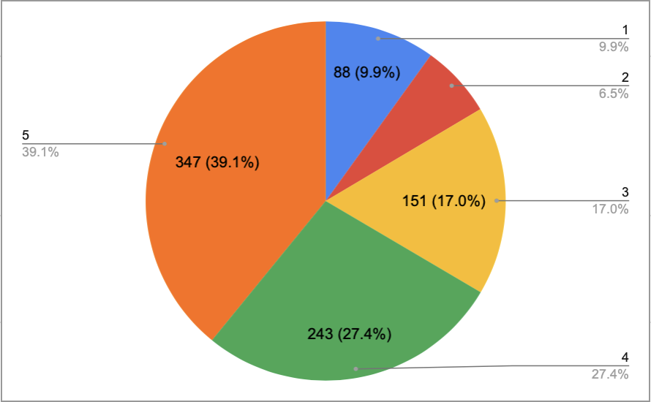

std.dv | proportions of top ratings
1.3 | 5 start | 4 star | 3 star | 2 star | 1 star
total numbers | 347 | 243 | 151 | 58 | 88
Proportions | 39.1% | 27.4% | 17.0% | 6.5% | 9.9%

The pie chart above represents the proportion of ratings which give us the perception that 5 star rating is the highest among them covering almost 40% of the pie (347 people) , meaning that most people cherish this place. 2 and 1 star ratings contribute only 6.5% and 9.9% (58 and 88 people) respectively to the chart. So, overall satisfaction of visitors is still high.

Overall
Regarding the data that we mentioned above, here are some issues which visitors are facing:

Facilities and Services:
- "Area" has the lowest star rating (2 stars) with 4 frequencies, indicating potential dissatisfaction with the overall space or layout of the park.
- "Parking" has a low rating (2 stars) with 2 frequencies, suggesting parking might be inconvenient or inadequate.
- "Staff" and "Restroom" have ratings of 1 and 2 stars respectively, highlighting potential issues with staff helpfulness or restroom cleanliness/condition.
Pricing and Discounts:
- "Price" has a rating of 3 stars, suggesting that ticket prices might be a concern for some visitors.
- "Discount" has a low rating (2 stars), implying that available discounts might not be perceived as valuable or attractive.

Potential Solutions:

Facilities and Services:
- Improve park layout or offer designated spaces for different activities to address concerns about crowded or unclear areas.
- Expand parking options or implement better parking management strategies to ease parking difficulties.
- Train staff on customer service best practices and address any underlying issues impacting their helpfulness.
- Improve restroom cleanliness, maintenance, and accessibility to address hygiene concerns.

Pricing and Discounts:
- Consider offering more ticket tiers or discounts catering to different budgets and demographics.
- Highlight the value proposition of existing discounts and make them easily accessible to potential customers.

