 

# Worksheet 3.2

## Student Name: Sarvesh Singh UID: 19BCA1314

**Branch: B.C.A Section/Group: 19BCA2ON/1**

**Semester: 5th Date of Performance: 11/14/2021 Subject Name: Web Development using PHP-Lab Subject Code: CAB 302**

1. **Aim/Overview of the practical:** Working with php loops
2. **Task to be done:** Customizing WordPress Website and perform the following : Installing WordPress themes

Themes Adding Widgets

## Syntax/Format used:

1. **Answer:**

**Downloading & Installing WordPress themes**

If you purchased a theme from a developer that operates outside of the WordPress themes directory, you need to upload it before installing. Follow these simple instructions to upload and install a theme.

1. Begin by downloading the theme’s .zip file from the source onto your local computer.
2. From your WordPress Administration area, head to Appearance > Themes and click **Add New**.

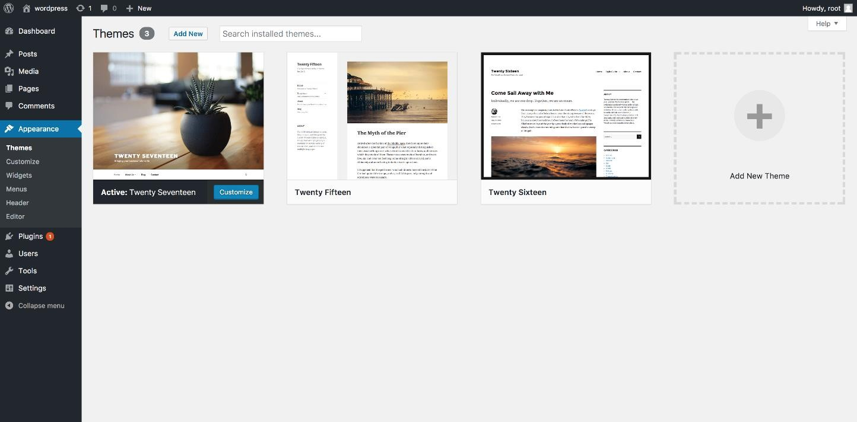

1. The Add New theme screen has a new option, **Upload Theme**.

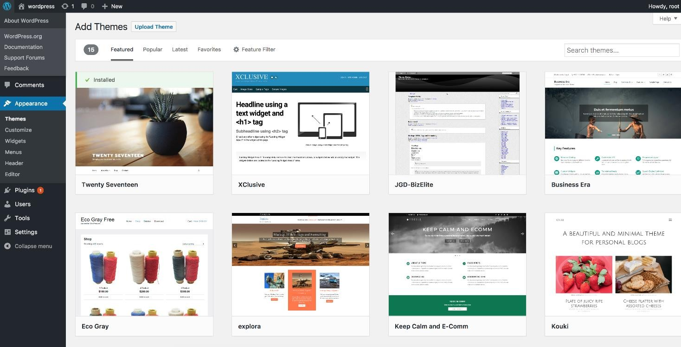

1. The theme upload form is now open, click **Choose File**, select the theme zip file on your computer and click **Install Now**.

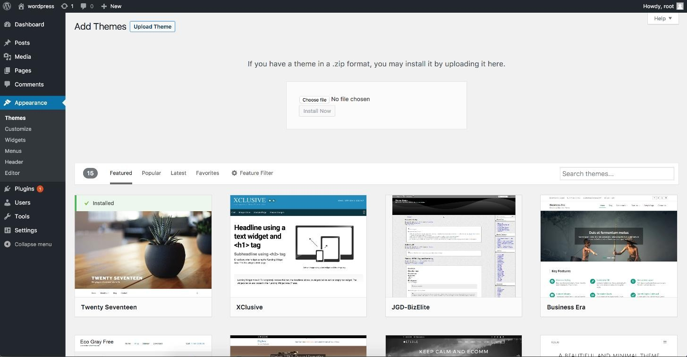

1. Once the theme is downloaded from the zip file, you can activate it from your admin. Select the Appearance tab and open the Themes directory, locate the theme and click the **Activat**e link.

# Installing WordPress Widgets

link. WordPress comes pre-packaged with a variety of Widgets. If those are insufficient for your needs you can install new ones by searching the WordPress Plugin Directory which is accessible from the WordPress Administration Plugins > Add New Screen.

# Displaying Widgets

Existing Widgets in Existing Widget Areas

Before you can add a Widget you must verify that the Theme, you’re using supports Widgets (more specifically: Widget Area). You can do so by simply navigating to the Appearance menu and looking for a sub menu titled “Widgets”.

If your Theme supports Theme Customizer then you can use the following Steps. In Theme Customizer, the live preview of changes is available.

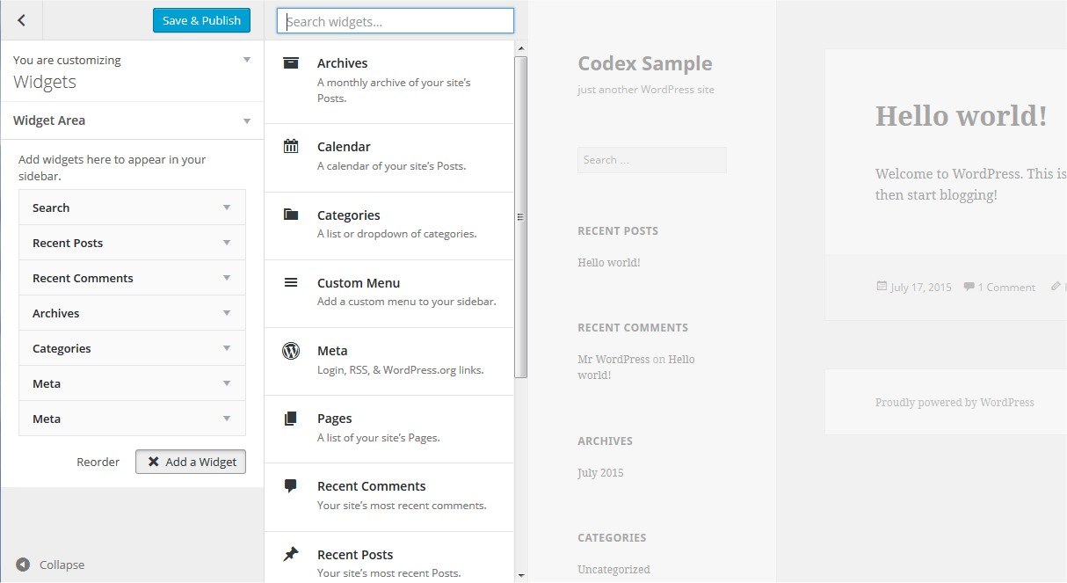

1. Go to **Appearance > Customize** in the WordPress Administration Screens.
2. Click the **Widget** menu in the Theme Customizer to access to the Widget Customize Screen.
3. Click the **down arrow** of Widget Area to list the already registered Widgets.
4. Click Add a Widget button at the bottom of sidebar. It shows the list of available widgets.
5. Click a widget you want to add. The widgets should be added in the sidebar.
6. Preview your site and you should see the content from your new Widget.
7. To arrange the Widgets within the Sidebar, drag and drop the widgets in the order you want or click Reorder link and click up arrow and down allow of each widget and click Done after the arrange operation.
8. To customize the Widget features, click the **down arrow** in the right to expand the

Widget’s interface.

1. To remove the widget, click **Remove** from Widget’s interface in above step.

If your Theme does not support Theme Customizer then you can use the following conventional steps:

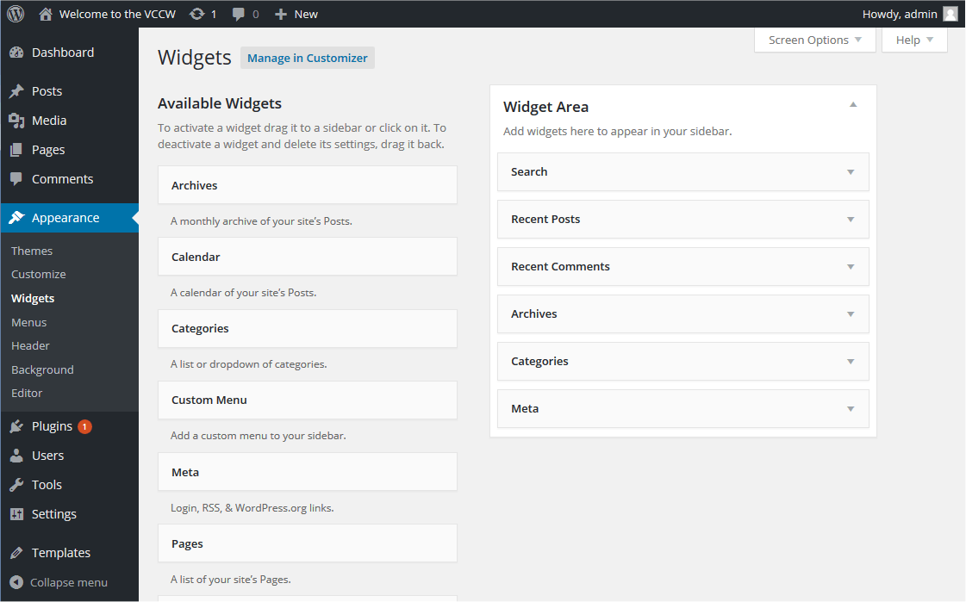

1. Go to **Appearance > Widgets** in the WordPress Administration Screens.
2. Choose a Widget and either drag it to the sidebar where you wish it to appear, or click the widget, (select a destination sidebar if your theme has more than one) and click the Add Widget button. There might be more than one sidebar option, so begin with the first one. Once in place, WordPress automatically updates the Theme.
3. Preview the site. You should find that the “default” sidebar elements are now gone and

only the new addition is visible.

1. Return to the Widgets Screen to continue adding Widgets.
2. To arrange the Widgets within the sidebar or Widget area, click and drag it into place.
3. To customize the Widget features, click the down arrow in the upper right corner to

expand the Widget’s interface.

1. To save the Widget’s customization, click Save.
2. To remove the Widget, click Delete.

If you want to remove the widget but save its setting for possible future use, just drag it into the Inactive Widgets area. You can add them back anytime from there. This is especially helpful when you switch to a theme with fewer or different widget areas.

When changing themes, there is often some variation in the number and setup of widget areas/sidebars and sometimes these conflicts make the transition a bit less smooth. If you

 

changed themes and seem to be missing widgets, scroll down on the screen to the Inactive Widgets area, where all of your widgets and their settings will have been saved.

Enabling Accessibility Mode, via Screen Options, allows you to use Add and Edit buttons instead of using drag and drop.

## Learning outcomes (What I have learnt):

* 1. **Wordpress Themes**
  2. **Working with Wordpress**
  3. **Wordpress Widgets**

**Evaluation Grid:**

|  |  |  |  |
| --- | --- | --- | --- |
| Sr. No. | Parameters | Marks Obtained | Maximum Marks |
| 1. | Demonstration/Performance/Pre  Lab Quiz |  | 5 |
| 2. | Worksheet |  | 10 |
| 3. | Post Lab Quiz |  | 5 |