[Introduction] Good day! everyone…. I am Nia Jin L Ubagan…….

[Overview] Last day, I began to observe the environmental problems near me and I got some in my mind. Philippines is a developing nation. The rapid growth has been seen in few years in urban communities, industries and other sectors. Philippines rank 70th in 106 countries on the world most polluted country in 2020.

[Topic] I feel today the environment is very unstable around us. There is a long list of environmental issue these days including Global Warming, Air pollution, water pollution, Deforestation. We can feel the change in air, water and soil, right? Toxicity is filled in everything today and caused a lot of environmental problems.

[Topic with explanation] Topic: Air and water pollution

Air Quality in Philippines has deteriorated over the years. Smoke belching vehicles and gases from factories are the culprits in contributing to air pollution. 70% of the contribution in air pollution is made by motor vehicles. I found that, approximately 1.1 million private vehicles were registered in the Philippines. Jeepney “the king of the road” is considered as most common means of transport. Jeepney and other utility vehicles represent about 40-45% of all registered vehicles nationwide. Industries contribute around of 30% in water pollution Waste water from industries are discharged untreated into rivers. Eventually, four major river system that included the historic Pasig River were declared as “Biologically Dead”. Oils wastes from petrol stations, oil depots, barges, tankers and boats have been added to the pollution loads. Pollutants which are many found that are effecting are:

* Pesticides
* Heavy Metals
* Toxic Chemicals
* Sewage

[Topic with explanation] Topic: Global warming due to emission of greenhouse gases

I feel like anything we do we emit greenhouse gases, anything can be using electricity, cooking or driving the cars. As we breathe out, we produce carbon dioxide. The more people around me will produce, the bigger amount of carbon dioxide is produced in the environment. As the gas is produced, the heat is produced which make changes in our climate. My research says more warmer the earth will go, more ice on the mountains will melt.

[Topic with explanation] Topic: Overpopulation

I personally think that overpopulation is the seed of lot of problems. Today Scarcity of food can be experienced due to the limited ability of the animals to populate fast. And some dishonest people nowadays resort to using chemicals and medications to boost and fake the growth of these animals. Overpopulation also means having more garbage to dispose which increase load more.

[Topic with explanation] Topic: Solid Waste

I found that about 35,580 tons of garbage is generated every day in our nation. On the average, each person in the country produces about 0.5kg -0.3kg of garbage every day. About 50% of solid waste are organic and biodegradable especially those churned by households consisting of kitchens or food and yard or garden wastes. Aside from the voluminous municipal solid generated, the problem of collection and disposal of these waste has become a very serious environmental issue.

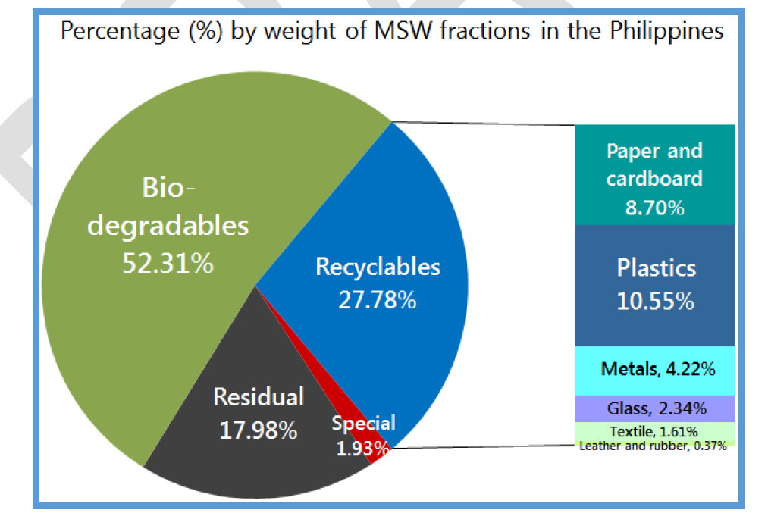

[Topic with explanation] Topic: Deforestation

Deforestation is increasing as the demand of paper is increasing. I think deforestation is also one of the most pressing problem the country is currently facing is. Forests are the vital in the conversation of soil and water. The research tells 80,000 hectares of land per year till 1978 were cleaned up. This number went up to 130,000 hectares of land between 1989 and 1995. Due to it, some region with extensive deforestation has experienced loss of lives in last few years.

[Outro]

Mark Twain well said “Every problem has a solution”. I certainly believe some new environmental laws are required to be introduced. While I was researching about problems, I got a list of solution for every problem. Today is generation of electronic cars, cars which don’t emit smoke out. The usage of electric cars should be increased. Rain water harvesting should be installed in every house. Reuse of water should be increased so water can be conserved as much as it can be. The use of plastic should be made almost to be zero. Reusable bags should be used rather then plastic bags as plastic don’t decompose easily at all. The three rules of R should be followed everywhere:

* Recycle
* Reuse
* Reduce.

[Call Of Action]

Volunteering is required. Everyday everyone needs to plant one tree. I think the education about why environment is need and why it should be protected is needed. Without environment the survival of species is not at all possible. In my believe the solution of the environmental problem is required to be implemented really soon and government should take them very seriously as “Environment is no one’s property to destroy; it’s everyone’s responsibility to protect. – Mohith Agadi”

Thank you so much.