**Conclusion/Recap**

# 1)Attacks, threats, and vulnerabilities

**It makes up 24% of the questions on the exam**

# 

# 2)Architecture and design

**It makes up 21% of the questions on the exam**

# 3)Implementation

**It makes up 25% of the questions on the exam**

# 4)Operations and incident response

**It makes up 16% of the questions on the exam**

# 5)Governance, risk and compliance

**It makes up 14% of the questions on the exam**

# 5 Tips



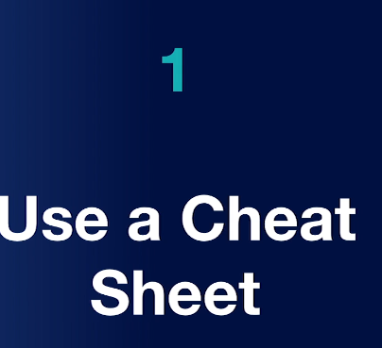

(Now actual cheating but the whiteboard provided to make notes at the first minutes of the exam)

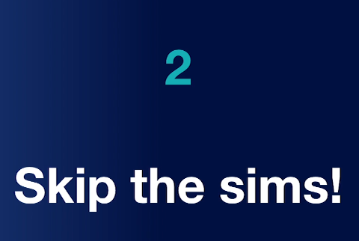

(Skip the Sims and put these at the end)



(take a guess if you have doubts. There is no negative scoring)

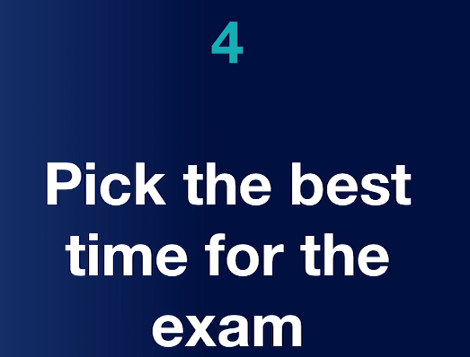

(Best it suits you)

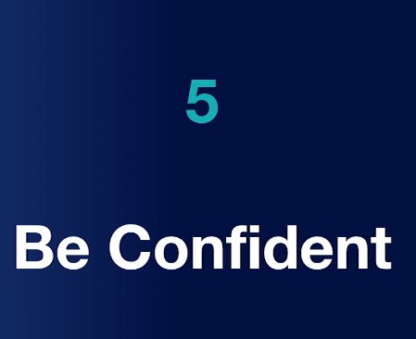

(Be confident)