programming_1

Andrew Shaw

2025-08-28

# Data creation

This step creates a random variable with half of the observations centered at 2 with standard deviation 1 and half centered at 6 with standard deviation 1/2.

## [1] 3.975581

## [1] 2.141799

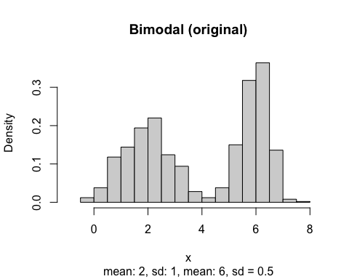

# Problem 1

What happens to the probability density function as the standard deviation of either of the peaks changes in the step 1? What happens to the SD. of X as the means change? Play around with the means and standard deviations to see.

## [1] 3.976371

## [1] 2.97653

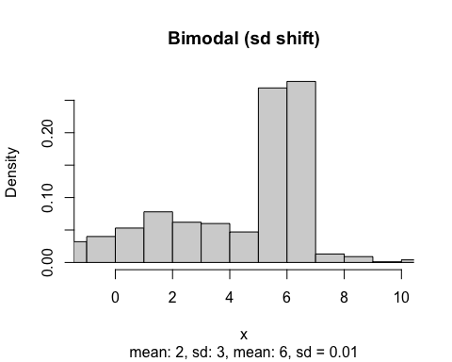

## [1] 4.5158

## [1] 3.548852

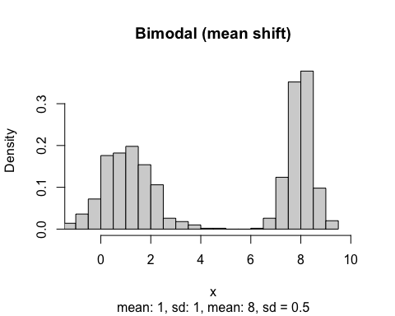

If the means get farther apart, the standard deviation begins to rise and conversely if the means begin to converge, the standard deviation shrinks. This changes the shape of the distribution so that with a larger deviation, the peaks become flatter. As the standard deviations get smaller, the means converge toward the true mean of 4 if the peaks of the distribution are 2 and 6. Regardless of how the deviations move, the mean stays around the mean of the two distributions with subtle shifts.

# Problem 2

Pictured is a bimodal distribution, make a trimodal distribution. A trimodal distribution has three peaks.

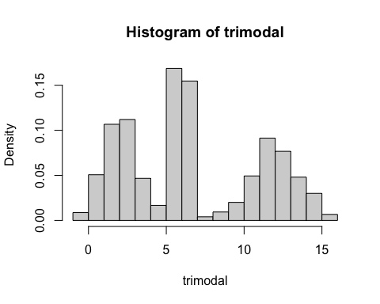

# Problem 3

Compute the correlation of x and y. What happens to the correlation of x and y as the SD of X increases?

## [1] 0.8153664

## [1] 0.9995327

As the standard deviation of x increases the correlation coefficient begins to approach 1. When the standard deviation of x is lower than the error term, e, the noise from the error term is greater than the signal from the x,y relationship pulling down the correlation coefficient.

### Monte Carlo Simulation

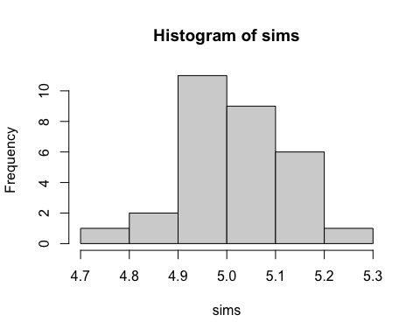

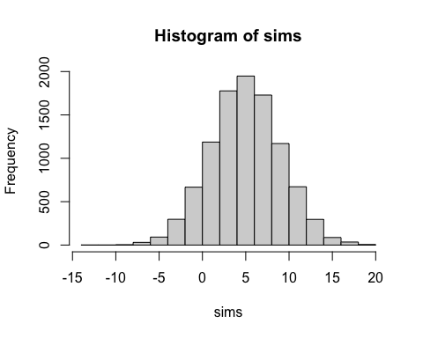

# Problem 4

What parameters effect how fast the sampling distribution becomes normal? (Hint: play with the parameters until your histogram looks normal)

Both the number of observations per sample and number of sample runs affect the shape of the distribution but in different ways. The sample size for each run really controls the convergence of the sample means to normal distribution even though the original distribution is non-normal as it’s bimodal. So even with lots of observations but few runs, the histogram looks jagged. When the runs are increased, the more sample means are taken and the normal distribution comes into focus.