(5) Extracting haematocrit, diameter, or red blood cell velocity from a linescan trajectory of a single capillary:
Three in-house developed MATLAB scripts are provided which respectively extract haematocrit, diameter and velocity traces from two-photon linescans. The trajectory of the linescan path should run down the centre of the vessel (for haematocrit and velocity readings) and also cross the vessel horizontally (for diameter reading) (see Figure 4a (left) for example path). The haematocrit script (extractLinescanHaematocrit.m) loads a binary TIF-file which is a crop of the section of the linescan path that runs down the vessel centre (by default called ‘RBCV_binary.tif’), and calculates what % of the pixels in the scan are RBCs (black) versus blood (white, background) for each requested time window (40ms by default). The diameter script (extractLinescanDiameter.m) loads a TIF-file which is a crop of the section of the linescan path that crosses the vessel horizontally (by default ‘diam.tif’) and uses a full width half maximum calculation to locate the pixels at which the fluorescent vessel changes to the dark background (note this is a simplified FWHM whereby the perpendicular line to scan along the central vessel skeleton is set as horizontal because the vessel is always vertical due to the linescan trajectory). Finally the velocity script (extractLinescanVelocity.m) loads a TIF-file which is a crop of the section of the linescan path that runs down the vessel centre (non-binarised, by default ‘RBCV.tif’), and utilises the Radon transform function supplied by Drew et al., (2010) (https://sites.esm.psu.edu/~pjd17/Drew_Lab/Resources.html) to calculate the angle of the RBCs from within the centre of the vessel and convert this into a velocity measurement over time.
Instructions:
Scan instructions: When two-photon imaging a single capillary using a linescan trajectory, the scan path should both run along the centre of the vessel for velocity and haematocrit readings (passing through RBC shadows) and cross the vessel for diameter measures (to distinguish the fluorescent vessel from the dark background) (see Figure 4 a left for example scan path, blue circle indicates path starting point, and blue arrow path direction). Note that the direction of the scan path along the centre of the vessel should follow the direction of the blood flow (i.e. away from the source arterioles in post-arteriole capillaries). A scan path which follows the direction of the blood flow will result in a velocity reading whereby the RBCs (black shadows) slant downwards from left to right (see Figure 4a linescan images in red boxes (centre and right)). If a scan has been conducted where the RBCs are travelling against the path (i.e. the shadow slants upwards from left to right), a text file should be put into the experimental directory which is titled ‘wrongWay.txt’, and the MATLAB script for extracting RBC velocity will flip the image (for a more accurate Radon transform when calculating the line angle). It is also advised that two-photon linescans are carried out at a high zoom (e.g. ~160nm per pixel) and speed (e.g. ~1500 Hz or 1.5ms per line path) for enhanced spatial and temporal accuracy when recording from very small vessels (5 μm). Linescans will typically be outputted from the recording software as TIF-files which present multiple lines per frame (see Figure 4a centre for example frame). The y-pixels (e.g. 256 pixels in Figure 4a centre) represent a single scan path per row (256 line paths). If the user scanned first along the centre of the vessel and then horizontally across, the RBC velocity image will appear on the left of the frame and the diameter image the centre/right (as per Figure 4a centre, RBCV image in red box, diameter image in green box).
Image preprocessing: To pre-process the data ready for the extraction of haematocrit, diameter and velocity traces using the MATLAB scripts provided, the TIF-file with multiple frames representing line scan paths per pixel row (e.g. Figure 4a centre) needs to unscaled (so the values are in pixels (e.g. 365 x 256 pixels) and not microns (e.g. 58.46 x 41.00 μm)) and cropped using FIJI ImageJ (see video demonstration ##). The user should draw a bounding box around the portion of the image from which RBCV can be calculated, identifiable as having slanted black lines which represent the travelling of RBCs (here in red box on left hand side of Figure 4a centre). The bounding box should contain as much of the slanted lines as possible (so that the angle can be calculated), but avoid the edges (as the signal may drop out). It is important to ensure that the bounding box encompasses the full length of the frame (i.e. the y-pixels), as this is essential for calculating the timing information of the scan path (the crop occurs in the x-pixel direction to shorten the length of the path to be only around the RBCV portion of the scan). Once the bounding box has been drawn, it is advised the user steps through the frames to check they capture as much of the vessel signal as possible. Once happy with the bounding box, if the user needs to additionally calculate the pixel size (because the outputted pixel size from the scanning software was inaccurate), they may need to measure the XY coordinates of the box (in pixels). To get the box coordinates the ‘bounding rectangle’ measurement should be requested (Analyse > Set Measurements > Tick Bounding Rectangle) and extracted (Analyse > Measure), this can then be saved into the experimental directory as a CSV file (default expected by MATLAB script: ‘Results_RBCV.csv’). The scan image can now be cropped to the size of the bounding box (Image > Crop), and should be saved into the experimental directory under a different name (MATLAB script default: ‘RBCV.tif’). The haematocrit can be calculated from this same cropped portion of the TIF-file, but should be binarised so that the % of black (RBC shadows) versus white (fluorescent background) pixels can be distinguished (to give a reading of the proportion of the blood that is made up of cells). To do this, convert the RBCV.tif cropped image to binary (Process > Binary) using the method which best represents the data (recommended: Huang). It is essential that the ‘Background’ is set as ‘Light’ so that fluorescent background pixels are given a value of 0 and dark RBC pixels a value of 255. This cropped and binarised image can now be saved into the experimental directory as a TIF-file under a different name (MATLAB default: ‘RBCV_binary.tif’) (see Figure 4a right for example RBCV TIF-files). Finally a bounding box can be drawn around the diameter portion of the scan path (see green bounding box on Figure 4a centre for example). The box should encompass the entirety of the vessel, as well as some dark background, so that a full width half maximum calculation can be used to distinguish fluorescent signal from background to calculate the vessel diameter. Note that the bounding box should not overlap with the RBCV portion of the image, as this fluorescent signal would affect the FWHM calculation (which uses fluorescence intensity). When drawing the bounding box, again make sure it encompasses the entire length of the frame (essential for timing information) and measure the XY coordinates if needed for calculating pixel size (saving as a CSV file, by default assumed to be named ‘Results_diam.csv’), before cropping and saving as a TIF-file into the experimental directory (MATLAB default: ‘diam.tif’, see Figure 4a far right for example frame from TIF-file).
Editing MATLAB script preferences for extracting haematocrit, diameter and velocity traces: Three MATLAB scripts are provided to extract haematocrit (‘extractLinescanHaematocrit.m’), diameter (‘extractLinescanDiameter.m’) and velocity (‘extractLinescanVelocity.m’) separately. All scripts will search individual experimental directories for the TIF-files saved during the previous ImageJ pre-processing stage (‘RBCV_binary.tif’, ‘diam.tif’ and ‘RBCV.tif’, respectively; although the specific name of the TIF-files can be edited in the ‘channel prefs’ at the top of each MATLAB function). The user can edit the preferences at the top of each MATLAB function to change the default settings. First, the ‘timing preferences’ require the user to specify how they wish to load the millisecond per scan path (mspline) and frames per second (fps) information. By default MATLAB will try to load an accompanying INI-file (which should also be inside the experimental directory), as outputted from the SciScan imaging software (prefs.loadINI = 1). The user can either edit this so that the mspline and fps information is inputted manually (change prefs.loadINI to = 0, and edit the prefs.mspline and prefs.fps to have numerical values rather than empty brackets); or edit the loaded file to be compatible with their outputted software calibration file (e.g. MATLAB script currently expects the calibration file to have the mspline information with the name ‘x_.ms0x2ep0x2eline’). If editing the name of the calibration file variables, the user needs to edit inside the function TIF-file loop under the ‘TIMING INFO’ section (e.g. ‘mspline = str2num(ini_file.x_.ms0x2ep0x2eline);’ and ‘fps = str2num(ini_file.x_.frames0x2ep0x2esec);’). The editable timing preferences also contain the requested window size (in milliseconds) for calculating haematocrit, diameter or velocity over. This value should be divisible by 4 (as the function loops through the linescan windows at increasing, overlapping steps of ¼ of the requested window size), and 40ms is assumed by default (as per Drew et al., 2010 recommendation). Note that the requested window size should ideally be kept the same between any traces which the user wishes to compare (e.g. for haematocrit/diameter/RBC velocity within a single vessel’s experimental directory; and across experimental groups).
The velocity and diameter MATLAB functions have an additional user editable preferences section, the ‘pixel size preferences’. If the user specified to load the calibration file in the preferences above (prefs.loadINI = 1), the pixel size can be loaded from here. The pixel size can also be inputted manually if the prefs.loadINI is set to 0, and the prefs.pxSz variable has a numerical value (rather than empty brackets). However, if the software inaccurately calculated the pixel size from the zoom, this preference can be overwritten by setting prefs.pxFlag to 1. This means that the optional subfunction ‘pixel4ls.m’ will be called to calculate the pixel size manually from the cropped image. The code is written to work with SciScan calibration settings, and so contains known zooms (‘zooms’) and corresponding pixel sizes (‘pxsz’) from this software (these default associated zooms/pixel sizes will need to be re-entered for alternative softwares). It loads the outputted calibration file (by default an INI file) and reads the zoom used for the present linescan, as well as the .coord file which contains the coordinates of the scan path (start and end pixels of cropped linescan image). It also requires the coordinates of the ‘bounding box’, which were saved as a Results_*.csv file, so that it can calculate where along the line scan path the cropped TIF file is located. Once the user has ensured the ‘pixel4ls’ function receives the scan zoom/scan path and cropped path coordinates, as well as some corresponding known zoom/pixel size combinations, the function can calculate the pixel size specific to this scan. It calculates the distance between each pixel and the next in the skeleton (in pixels) using sqrt(2) as the pixels may be diagonal instead of next to each other (due to path trajectory). The code uses the known zoom levels and associated pixel sizes to calculate the correct length of each pixel for the zoom extracted from the INI file. It then loads the bounding box CSV Results file to calculate the start and stop pixels of the cropped linescan image, and extracts the pixel present in the line.
Next, the ‘channel preferences’ can be edited to specify the names of the cropped linescan image (prefs.tifNm, by default ‘RBCV_binary.tif’ for haematocrit, ‘diam.tif’ for diameter, ‘RBCV.tif’ for velocity), and additional locomotion (prefs.locoChNm) and external screen stimulation (prefs.stimChNm) TIF-files to load. The locomotion and external stimulation channels will be given an average intensity value whose timing corresponds to the portion of the line scan path being measured.
Finally, the preferences to clean the trace (‘trace clean prefs’) can be altered. For diameter and velocity measurements the image of the section (or 40ms ‘window’) of line scan may be thresholded (if prefs.Thresh is set to 1, which by default it is not). If the user needs to threshold the image (for noisy scans where it may improve signal-to-background noise) this preference can be set to 1, and the standard deviation value used (‘prefs.imgThresh’, by default 0.5) to distinguish the fluorescent vessel from the dark background can be set (this may need to be optimised by stepping through the code and seeing what works best). Next, all three MATLAB scripts require the user to specify preferences for removing signal spikes from the trace (prefs.removeSpikes, by default set to 1, which calls the subfunction ‘RemoveSpikes.m’) and smooth the trace (prefs.doSmooth, by default set to 1, which calls the subfunction ‘smoothKnit.m’). Note that ‘prefs.removeSpikes’ is recommended, and will remove large signal shifts from the final continuous data trace (a graph will be outputted which shows the before and after), and prefs.doSmooth is recommended as the final continuous data trace will be smoothed (ignoring parts of the data trace which are filled with NaNs), and both the smoothed and unsmoothed traces will be outputted (as well as a graph which shows the before and after smooth). The ‘extractLinescanVelocity.m’ script also has a final editable preference for cleaning the data trace. The subfunction ‘findLocoEvents.m’ is called to find large noise spikes in the trace, and these are removed (and replaced with NaNs). The user can edit the distance between individual spikes detected (by default 100 frames) to alter the sensitivity of the spike removal process (if default settings are altered, this may require user to step through and optimise for their data).
Calling MATLAB scripts: The user should call the function ‘extractLinescanHaematocrit.m’ for extracting haematocrit traces from binarised TIF-files of the cropped RBCV portion of the line scan (‘RBCV_binary.tif’); the function ‘extractLinescanDiameter.m’ for extracting diameter traces from TIF-files of the cropped diameter portion of the linescan (‘diameter.tif’); and the function ‘extractLinescanVelocity.m’ for extracting velocity traces from the cropped velocity portion of the linescan (RBCV.tif’) (see Figure 4a right). Each function requires a minimum of one input, which is a folder which contains one or multiple experimental directories which have the requested TIF-file (e.g. ‘RBCV_binary.tif’, ‘diam.tif’, or ‘RBCV.tif’ inside). Once the TIF-files are loaded (and optionally the locomotion and external stimulus channels too), the data is reshaped from 3 dimensions (i.e. in frames x height x width) into 2 (i.e. line scan path bounding box pixels x time, where each row in the time dimension represents one traversal of the scan path). Each function then takes a window of time over multiple line trajectories (by default prefs.windowSz = 40 milliseconds), and continues to loop through the data by stepping along the time dimension by ¼ of the requested window size (e.g. 10 ms). Progressively stepping in ¼ of the window size creates a temporal smooth which will reduce the effect of signal loss on the final measurements (see example in progressing red line shown over blue pixels in Figure 4b, beneath blue arrow).
Extracting haematocrit: The haematocrit function finds the number of dark pixels within each sliding time window, calculating an average % of the space made up of RBCs (versus blood) (see Figure 4b left for an example binarised image from which the proportion of dark versus white pixels can be calculated along multiple overlapping windows). The haematocrit data trace is saved as ‘hct’ (see Figure 4b right for an example subsection of the data trace) and the smoothed trace as ‘hct_smooth’, the locomotion and external stimulus may be optionally extracted (averaged over the same windows to calibrate the timing) as ‘locomotion’ and ‘stim’, and the corresponding time vector (in seconds) is outputted as ‘time’ (variables saved as ‘contData_ls_hct.m’).
Extracting diameter: For each sliding time window line scan image (see Figure 4c left), the extractLinescanDiameter function finds the intensity curve per row (i.e. for each of the scan paths within the time window) (Figure 4c centre). These fluorescent intensity curves are averaged per sliding time window (e.g. for the 28 line scan paths within the 40 ms sliding window; see bold blue line on intensity plot), and the full width half maximum (see black dotted line) is calculated to see where the intensity curve crosses this (in pixels) and convert this pixel measurement to microns. The diameter (in µm) is calculated per sliding time window, as well as a time vector (in seconds), a subsection of which is plotted in Figure 4c (right). The diameter trace is saved as ‘diameter’ and smoothed trace as ‘diameter_smooth’, the locomotion and external stimulus may be optionally extracted (averaged over the same windows to calibrate the timing) as ‘locomotion’ and ‘stim’, and the corresponding time vector (in seconds) is outputted as ‘time’ (variables saved as ‘contData_ls_diam.m’).
Extracting velocity: For detailed information regarding the determination of particle velocity from space-time images refer to the Drew et al. (2010) paper from which this MATLAB script was adapted. Briefly, for each sliding time window the line scan velocity image is normalised to remove baseline intensity and inhomogeneities in illumination in space (see example blue and black image in Figure 4d left). This image (per sliding window) is then sent into the MATLAB function ‘radon.m’, which computes the Radon transform. Here, the Radon transform is the projection of the image intensity along a radial line oriented at 1:180 degrees (see Figure 4d centre). The theta line angle is calculated as the maximum variance of the outputted Radon transform values, and this is the angle which is used to form a triangle against the slope of the RBC (see Figure 4d left, green line). This line angle is used to calculate the velocity using equation 4 from Drew et al. (2010, see equation 1 below):
Vi(θmax)=ΔxΔtcot(θmax) (1)
Where Δx is calculated from the number of pixels in the bounding box and Δt from the number of seconds per sliding time window. This velocity reading is then filtered to remove exceptionally small values or large values which are greater than 3 standard deviations greater than the mean (replace with NaNs). The velocity trace (see Figure 4d right for example subsection) is saved as ‘velocity’ and smoothed trace as ‘velocity_smooth’, the locomotion and external stimulus may be optionally extracted (averaged over the same windows to calibrate the timing) as ‘locomotion’ and ‘stim’, and the corresponding time vector (in seconds) is outputted as ‘time’ (variables saved as ‘contData_ls_RBCV.m’).

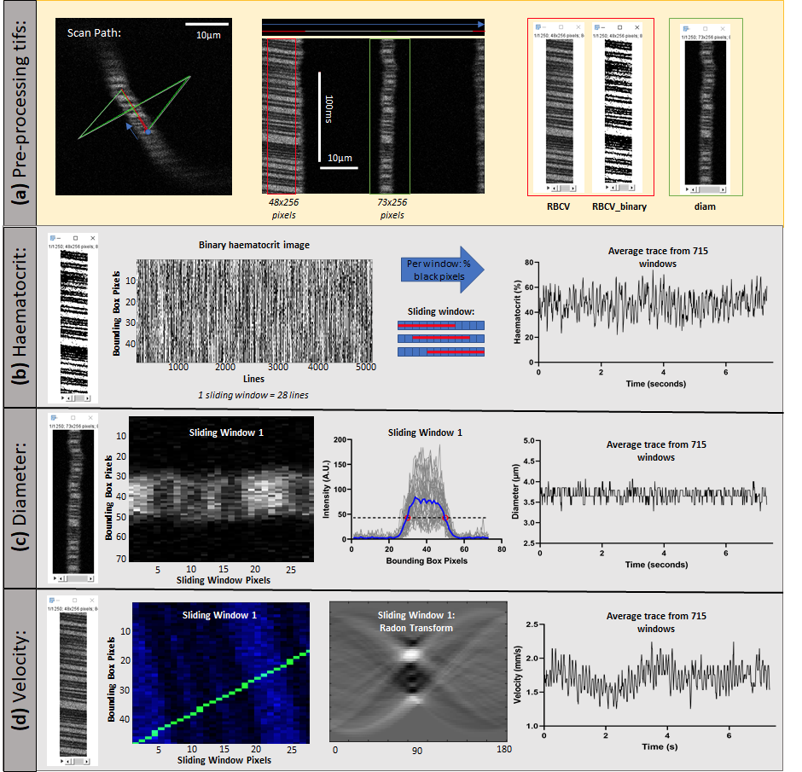

Figure 4: Analysis pipeline for extracting haematocrit, diameter or velocity from line scan recordings of single vessels.
Pre-processing steps in ImageJ are presented in the yellow box (top row) and data extraction steps using MATLAB in the grey box (rows 2-4). (a) Left: an example of the line scan trajectory drawn in the two-photon recording software which starts at the blue dot, and follows the direction of the blue arrow (direction of blood flow), running along the centre of the vessel (red line), before crossing the width of the vessel horizontally (green line). The scale bar is 10 µm. Centre: An example frame from the outputted TIF-file of the line scan trajectory shown (left). Each row of the frame represents one scan path (total 256 paths shown). The left side of the frame shows where the velocity reading would be calculated from (inside red bounding box) and the centre where the diameter would be calculated from (green bounding box). The vertical scale bar represents 100 ms and the horizontal scale bar 10 µm. Right: The cropped TIF-files needed from the centre frame for calculating red blood cell velocity (‘RBCV.tif’), haematocrit (‘RBCV_binary.tif’) and diameter (‘diam.tif’). These should be saved inside the individual experimental directory, and will be loaded by the MATLAB scripts. (b) Left: an example binarised image showing multiple line scans inside the ‘RBCV_binary.tif’ bounding box. A sliding window (default 40 ms) would be selected from this image, and the percentage of black pixels (i.e. RBCs) would be calculated. Centre: An example of how the time window progresses with an overlap of ¼ of its size for each step of looping through the line scan data. The blue squares represent individual pixels (or rows of the sliding window), and the red line shows which pixels are selected for each sliding window. Right: An example 7.5 second subsection of a haematocrit trace (here over 715 of the sliding windows). (c) Left: An example subsection of the cropped diameter section of the line scan path for the first sliding time window (here time window is 40 ms and 28 pixels). Centre: Intensity curves are plotted for all rows of the example sliding time window (28 gray traces from 1 40 ms window), and the average intensity curve across these rows displayed in blue. The full width half maximum of the average intensity curve is used as a threshold (black dotted line), and the first and last pixels where the average intensity curve crosses this threshold (red dots) are used to calculate the diameter per window (pixels converted to microns using pixel size). Right:An example 7.5 second subsection of a diameter trace (here over 715 of the sliding windows). (d) Left: An example subsection of the cropped velocity portion of the line scan path for the first sliding time window (here time window is 40 ms and 28 pixels). The image has been normalised, and background (blood) pixels can be seen in blue and RBC pixels in black. The green line shows the angle (with the maximum variance) which has been calculated across this window using a Radon transform to form a triangle against the slope of the travelling RBCs. Centre: The Radon transform shows the projection of the image intensity along a radial line between 0 and 180 degrees. The maximum variance is found across the angles of this projection to determine the slope of the line angle (green) displayed on the left image. Right: An example 7.5 second subsection of a velocity trace (here over 715 of the sliding windows).

