(3) Extracting vascular density from detailed z-stack images:

Widefield z-stack images (with multiple planes per step) of the vasculature may be taken across a brain region of interest (e.g. on a confocal or two-photon microscope) in order to capture information about the vascular density (e.g. for comparing between genotypes or brain regions of interest).
Instructions:
ImageJ plugins: The in-house macro to capture vascular density across a z-stack is written in the Beanshell language for use in ImageJ. In order for the macro to run, it requires the following packages installed into ImageJ: LIST PACKAGES (can we offer to put a copy of them somewhere for people to download)?
Image pre-processing: The tif file containing the raw z-stack images of the vasculature should be stored in its own folder. A subfolder named ‘finalStack’ should then be created inside this top image folder for each individual z-stack recording which contains one single tif file only, which is the pre-processed recording. It is advised that the vascular stack is pre-processed before running the macro in order to optimise vessel signal (as including bad frames can alter final vascular density readings), and that this optimised stack is stored as a tif file inside the ‘finalStack’ folder. Useful pre-processing steps for optimising vessel signal include removing bad frames (with lots of dark patches/low vessel signal) from the top and bottom of the stack, and adjusting the brightness/contrast (to reduce background and enhance vessel signal).
Running the macro in ImageJ: Open the macro file ‘oneStopShopBeanshell.bsh’ in ImageJ. Once you press ‘Run’ the macro will offer 3 steps: (1) Process raw images - registration, group averaging; (2) Generate preprocessed images from thresholded stacks; (3) Analyse skeleton and distance map of thresholded stacks. ImageJ will ask for the folder location and settings information once you select each step. When prompted for folder information note that you can select a top directory which contains multiple z-stack recordings, as long as each individual pre-processed z-stack tif file is stored inside its own subfolder labelled ‘finalStack’. The user settings asks for the name of the folder (inside the specified directory) which contains the z-stack tif file (automatically named ‘finalStack’), the channel the vessels are in (e.g. if you have 2 channels (green/red) specify which contains the vessels), and the method by which the images were collected (i.e. confocal or 2P; this is important for calibration and two-photon tif files will need to be accompanied by the calibration text file if the images do not contain pixel size information).
First select step 1 to register the images (i.e. remove motion artefacts), calibrate them (convert the pixels to size in microns), and average across the multiple planes captured per stack step. Once you have selected your settings and press OK, the macro will generate a tif file called ‘preprocessed’ into the ‘finalStack’ subfolder- this is a group averaged, image registered and calibrated version of your stack.
Step 2 is the most labour-intensive step, used for cleaning and thresholding your images, and this can be run once the ‘finalStack’ folder is specified which contains the ‘preprocessed.tif’ image generated in step 1. A pop-up will be displayed which contains the following options in a dropdown menu: i. Start from beginning - remove all image edits, ii. Remove ROIs, iii. Manually threshold the image, iv. Try an automated thresholding technique, v. Smooth the image, vi. Despeckle the image. The ‘Start from beginning…’ option is to be used if your cleaning and thresholding of the images has been unsuccessful and you wish to revert back to the original ‘preprocessed.tif’ file. First it may be optimal to smooth the images by selecting the ‘Smooth the image’ option, this will generate the inbuilt ImageJ ‘Image Smoothing’ pop-up where the user is asked to select smoothing technique (recommend Gaussian), whether to despeckle prior to smoothing (recommend yes), and the number of pixels to smooth by in x, y, and z (recommend x 1, y 1, and z 1). A preview will then be generated which asks the user if they’re satisfied with the smoothing process (if you select no by unticking ‘Happy with the smoothing?’ it will revert back the images to the tif file before any smoothing was applied). Another important cleaning step before thresholding the vessel versus the background is to ‘Remove ROIs’. This can be used to remove some sections from the stack (e.g. where the vessel signal is weak/non-existent or the background noise is too high) so that the final vascular density calculation does not contain volumes of black space which are influenced by noise (rather than sampling actual vascular density from brain tissue). If you select to remove some regions from the stack, a ‘ROI selection’ pop-up will be generated which says ‘Draw a ROI on preprocessed.tif to exclude from image if desired, and set the stack to the slice you want to start at’. Use the polygon or freehand sections tool from the ImageJ menu and draw a ROI over the area you wish to exclude, move the image to the frame you wish to start the ROI removal at and press OK. You will then be prompted to move the image to the end frame to stop the ROI removal. Repeat this process until all noisy / non-tissue sections of the stack are no longer included in the tissue volume (untick the selection to ‘manually remove another ROI’ when done). The preprocessed tif file has now been cleaned ready for thresholding where the image will be binarised, meaning each pixel is given one of two values which represent either white (‘vessel’) or black (‘background’) (depending if they are above or below the threshold). The pop-up with dropdown menu offers two ways of thresholding the image, either manually or automated. To manually threshold, select this option and then from the ImageJ tab you can select Image > Adjust > Threshold and adjust the scale until your black and white (thresholded) image looks like it best represents the vessel (white, value=255) and background (black, value=0). If you use an automated threshold, a 4 x 4 panel displaying 16 thresholded images (with 5 frames per threshold to scroll through) will pop-up and the user can select which (if any) of the thresholds best represents their z-stack recording (numbers start at 1 from left to right of each row proceeding from top to bottom). Once the threshold looks representative, select that you’re happy with it and the open tif file will be binarised, before 4 images are generated (Skeleton, Skeleton visualisation in 3D, Thresholded image, and EDT): ‘Thresholded image’ is the binarised image of the vessels (in white) and background (in black) that was selected by the user (manual or automated); ‘Skeleton’ is a binarised image which shows 1 pixel-thick lines (white, value=255) which have been generated down the centre of each vessel (from the binarised ‘Thresholded image’); and ‘Skel visualisation in 3D’ shows the user what the skeleton (pink) looks like overlaid on top of the non-thresholded version of the vessel stack (blue). If the generated skeleton through the centre of the vessels does not look good (e.g. in very large vessels sometimes the skeleton has lots of twists and turns in it which do not follow the vessel), then the user can untick the selection that they’re happy with the skeleton and press OK. A pop-up labelled ‘Skeleton editing’ will then be generated, which has a dropdown option that allows you to ‘Remove parts of the skeleton’. To do this, the freehand or polygon selection tool can again be used to remove ROIs from the thresholded image (selecting the start and end frames), this process can be repeated until all bad skeleton points are removed, and once the user then ticks that they’re happy with ROI removal the 4 skeleton images will be generated again, and a dropdown option to ‘Proceed with the skeleton as is’ can be selected. ImageJ will now save some relevant tif files into the ‘finalStack’ subfolder: ‘dmap.tif’, ‘masksRemoved.tif’, ‘nonthresholdedimage.tif’,’skeletonisedImage.tif, and ‘thresholdedImage.tif’. The ‘masksRemoved’ shows where the ROIs (shown in white on a black background) the user selected to remove from the image where drawn, and the ‘dmap’ is the distance map. The distance map is used to calculate the size (radius) of our vessels in the stack. The dmap is not a binarised image (like Thresholded or Skeleton), as the lighter pixels (overlying the vessels) have values which represent how far each white pixel is from its nearest black pixel (background). This means that the centre of the vessel will have a higher value than the edge of the vessel (as it is further from the tissue). The radius of the blood vessel can be calculated by overlying the skeleton and the distance map, as the dmap values at the skeleton pixels (i.e. centre of the blood vessels) show how far the centre of the vessel is from the tissue (the diameter can be calculated by multiplying this radius value by 2).
Step 3 is used to generate Microsoft Office Excel xlsx files which contain the calculated vessel radii from across the step (‘3Dcoords’, ‘AllPixels’, and ‘Branch Details’ will be added to ‘finalStack’ subfolder). To generate these, run the main macro again and select the third analysis option ‘Analyze the skeleton and distance map of thresholded stacks’. The ‘Branch Details’ file contains a number of useful columns: the ‘Skeleton Number’ and ‘Branch Number’ columns tell you which branches are connected to each other; the ‘Radius’ column has a radius value for each vessel (as calculated from the distance map and skeletons); the ‘Branch Length’ column tells us how long each vessel is (which is essential for calculating vascular density within a volume of tissue (length per volume)); ‘Euclidean Distance’ is the distance from the start to the end of the blood vessel (following the shortest ‘straight line’ path) and this may be useful for tortuosity calculations; and ‘Image Volume’ (row 1 only) is the entire volume of the brain tissue imaged, ‘Volume Removed’ (row 1 only) the volume of brain tissue removed by the user (as ROIs) during image processing, and the ‘Volume Analysed’ (row 1 only) is the volume of brain tissue leftover after ROI removal (so will be used to calculate the vascular density). To look at vascular density you want to measure the total length of the vasculature (by summing the ‘Branch Length’ column you get the total length in µm) and divide it by the entire volume of brain tissue analysed (‘Volume Analysed’, which is in µm³), to get a value in m/mm³: convert the branch length to metres by dividing the total branch length by 1000 twice, and convert the volume to mm³ by dividing the value by 1000, you can then get the density by dividing the branch length (in metres) by the volume analysed (in mm³). Note that if you only want to look at the density across the capillary bed, the radius values (diameter = radius*2) can be used to exclude vessels over a certain size; and for optional extra noise removal the ‘Branch Length’ column can also be used to exclude vessels with a length below a certain threshold (e.g. are vessels of 1 pixel long real or just noise?). An accompanying video demonstration of how to use the macro can be found on Github, and example data is provided.
Extracting vascular density or capillary spacing into MATLAB: An optional MATLAB script (‘findDensity.m’) is provided which loads the ‘Branch Details.csv’ file, removes noise, calculates the vascular density in m/mm³ (using the process described above), and then saves a matfile named ‘VascularDensity.m’ into each individual experimental directory (the ‘FinalStack’ folder). The second MATLAB script provided (‘Make3Ddistmaps.m’) uses the MATLAB and ImageJ interface (see https://uk.mathworks.com/matlabcentral/fileexchange/47545-mij-running-imagej-and-fiji-within-matlab for installation instructions) to load the 3D distance maps generated by the ‘OneStopShopBeanshell.bsh’ macro, and calculate the space in microns from each capillary to its nearest neighbouring capillary. These spacings are then separated by 7 distance percentiles across the tissue (50th, 60th, 70th, 75th, 80th, 90th, 95th), to give an average distance (µm) for the capillaries which are at each of these capillary spacing percentiles across the tissue to their neighbouring capillary. This script can be called inside an individual experimental directory or top directory containing multiple folders with 'thresholdedImage.tif' inside. Two MAT-files will be saved inside each individual experimental directory, one (‘bigdistmap.m’) with the distance map TIF in the MATLAB workspace, and the other (‘capspacing_prcentiles.m’) with the variables ‘dist_um’: the distance for every non-vessel pixel in the image to its nearest capillary (pixels overlying vessels would have a value of 0, and these are removed); and capspacing: which contains the average distance to the neighbouring capillary split by the varying percentiles across the tissue.

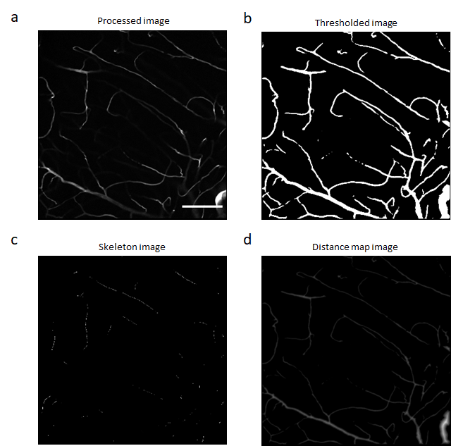

Figure 2: Images produced from widefield stacks of the vasculature to calculate vascular density and capillary spacing across the tissue.
All images provide an example of a representative frame from the outputted TIF-files of the macro. (a) The processed image, which is image registered and averaged across the grouped stack (in the event multiple pictures were taken per step in the z dimension). (b) The thresholded image, where the raw values in the processed image are binarised so that the vessel (white) has a value of 255 and the tissue (black) of 0. (c) The skeleton image, which shows the skeleton pixels that have generated down the centre of the vessels (calculated using the thresholded image). (d) The distance map, where every pixel contains an intensity value representing how far each white (vessel) pixel is from its nearest black (tissue) pixel.

