(4) Extracting vessel diameter along the vessel length and (optionally) fluorescence changes from cells surrounding the vasculature:

The in-house developed MATLAB script presented here uses a full width half maximum (FWHM) calculation to yield 2-dimensional traces of vessel diameter fluctuations over time from two-photon xy zoomed in recordings of individual vessels loaded with a fluorescent dye (where the background is dark). For optimal sensitivity to diameter changes, it is recommended that two-photon recordings of the vasculature have a minimum pixel size resolution which is sensitive enough to detect minimum vascular dilations of ~1% (e.g. 50 nm for a 5 µm vessel, 200 nm for a 20 µm vessel, etc).
Instructions:
Image preprocessing: A number of pre-processing steps should be taken to improve image quality and consistency between vessel recordings. Chiefly, the vessel (e.g. channel 1) and surrounding perivascular calcium (e.g. channel 2) recordings should be image registered to remove motion artefacts (as vessel movement would disrupt the FWHM calculation). If perivascular calcium is being extracted, it should be subject to the same registration coordinates as the vessel. Image registration can be completed using alternative software packages such as Suite2P or the FIJI distribution of ImageJ (using the ‘Template Matching’ function). Once recordings have been image registered, the calcium tif file does not require any more preprocessing (as altering light levels can affect fluorescence estimates), whereas the vessel tif file should be further processed in FIJI ImageJ to enhance the signal-to-noise ratio between the bright vasculature and dark background. Noisy recordings may be despeckled and/or median 3D filtered to smooth the image, and then the ‘Stack Contrast Adjustment’ plugin can be applied to match the overall brightness between frames (eliminating light artefacts from the data which may be distributed unevenly if visual stimulus trials were presented). Once the vessel recording has been processed, it should be saved as a tif file (script will default search for a file ending in ‘vessel.tif’) inside an individual experimental directory, which also contains the calcium tif file (code will default search for a file ending in ‘ch_1.tif’), and the corresponding (ini) file with pixel size and recording speed (Hz) information.
Running the MATLAB script to extract vessel diameter and (optionally) surrounding calcium signal: The editable sections of the code (at the top of the script) will first be detailed, and then information on how the code extracts the vessel diameter (using FWHM) and expands the search parameter to extract surrounding calcium. The description will also list all the in-house built sub-functions which are called by the script, and the main function and all sub-functions should be saved into the users MATLAB path.
- Editing user preferences- Open the MAT-file ‘xyFWHM_diam_periCa’ in MATLAB. There are user preferences which should be edited at the top of the script before running. The working directory to search for the vessel recording can be edited (variable = expDir). This should be a single experimental directory which only contains one vessel file (due to manual input being needed per recording, the script does not loop through multiple vessels). The script can be used to extract vessel diameter without surrounding perivascular calcium by changing the prefs.caCh variable to equal 0, or to extract concurrent perivascular calcium with the diameter by setting this value as 1. The name of the vessel (variable = prefs.vessChNm) and surrounding calcium (variable = prefs.caChNm) tif files can be edited (by default the code searches for a vessel file ending in ‘vessel.tif’ and a calcium file ending in ‘calcium.tif’ using the in-house developed ‘findFolders.mat’ function). The imaging speed (frames per second (fps)) and pixel size information are essential for extracting the amplitude and timing of the vascular dilations and/or calcium fluorescence changes, and so this information also needs to be inputted into the script. The code will automatically search for an ini file inside the experimental directory if the ‘prefs.pxInfoINI’ variable is set to 1, the specific name of the frames per second (variable = fps) and pixel size (variable = pxsz) contained in the ini file may need to be edited depending what software (e.g. SciScan v1.2.1) was used to extract this information (lines 96 & 98). If this resolution information is contained in a different file type (i.e. not ini), the user can either manually enter the pixel size and frames per second information into the prefs (prefs.pxInfoINI=0, prefs.pxSz = pixel size information in metres, & prefs.fps = frames per second in Hz), or loadedit the ‘findFolders’ (line 89) to search for a different file type (i.e. not an ini file). The ‘skelLineLength’ preference is used for determining the length of the skeleton line (in pixels) to step through for generating a perpendicular line for calculating the FWHM of the vessel signal against the dark background (variable = prefs.skelLineLength, 8 pixels by default). The user can also edit preferences for how many pixels to scan either side of the vessel edge (inside edge = prefs.insidePx and outside edge = prefs.outsidePx) when measuring perivascular calcium fluorescence (lines 65 & 67). The final preferences which may be optionally edited (lines 73-75) are used for thresholding the vessel signal from the background (variables = prefs.imgThresh and prefs.clean), however these have already been optimised so likely will not need changing.
- Loading the data and generating a skeleton along the vessel length (requires manual input)- the inbuilt MATLAB function ‘loadTifFileIn2Mat.m’ will load the vessel and (optionally) surrounding calcium TIF-files into the MATLAB 3D variables ‘rawVess’ and ‘rawCa’ respectively (taking the form: frames x width x height). The user will then receive a dialogue box prompting them to indicate whether the loaded vessel displayed in the image is vertical (see Fig 3b (left image) for example). Vessels which are displayed vertically will be flipped, to aid with the accuracy of the perpendicular line calculation and vessel scan along the centre skeleton. The vessel (pink) and an automatically generated example skeleton down the centre of the vessel (green) are then displayed. The automatically generated example skeleton will not be used for the perpendicular line calculation or vessel scan, but gives a good indication as to whether the signal-to-noise ratio between the vessel and background is good (as inaccurate skeleton placement indicates that background noise is high). The user will now be asked to draw the skeleton along the centre of the vessel branch of interest. It is recommended that the user traces around the edges of the vessel (rather than creates a thinner box down the middle), and closes either side of the box with a point (to stop the skeleton from forking) (see Fig 3b (centre image) for example). A figure will display the vessel with the final skeleton down the centre. The user will next be asked for manual input again, this time to define where the vessel region of interest is. This requires the user to draw a box around the vessel branch they wish to scan for diameter reading. The box should leave enough space around the vessel for diameter changes to fit within, but not include any signal from other structures (see Fig 3b (right image) for example). The information outside of the hand-drawn box will be removed for the skeleton and the vessel, so that any nearby fluorescent signal (e.g. from other vessel branches) will not affect the diameter reading of the vessel branch of interest.
- Generating a perpendicular line along the vessel skeleton and calculating diameter using FWHM of the intensity profile: The coordinates of the central skeleton will be determined, and then the code will step through sections (by default: 8 pixels long) of the skeleton (progressing 1 skeleton pixel at a time, see Fig 3c (centre) for example). Within this loop (for each section of skeleton), to smooth the connecting line between skeleton pixels, more points are added to the line and a polynomial fit is applied. If the user wishes to check the original line connecting skeleton points and the smoothed line, they can enter debug mode and manually run the plots inside the if false statement (lines 381-386). A perpendicular line is then generated for the middle of this skeleton section, which is at least twice as wide as the vessel (to scan the intensity profile between vessel and background). To generate a perpendicular line (see Fig 3c (left image) for example) the following formula is used: y = bx+c. Where x and y are the middle coordinates of the polynomial smoothed line between skeleton points, b is the slope of the normal line (-1/gradient) and c is the intercept (c = y-bx). In the rare case that the line between skeleton points is exactly vertical or exactly horizontal, a respectively perpendicular exactly horizontal or vertical line will be automatically generated (without the need for solving the above line equation). For each section of the skeleton, the coordinates of the perpendicular line will be overlaid onto the vessel image (variable = perpLine) and extracted. For the first frame of the vessel recording a video will be created and saved into the individual experimental directory, which displays the scan of the normal line along the vessel skeleton. The script next loops through each individual frame and perpendicular line (generated previously per skeleton section) and extracts the intensity profile of the fluorescent vessel (against dark background) along the calculated perpendicular line (see Fig 3c (right image) for example intensity profile along the perpendicular line). The x axis of this intensity profile represents the pixels of the tif image and the y axis the fluorescence intensity. For use as a threshold, the half maximum value of this intensity profile (black line in Figure 3c centre) is calculated by adding the minimum and maximum intensity values (i.e. min and max values on y-axis) and dividing by 2 (halfMax = (min(y)+max(y))/2). The find function is then applied to find the x coordinates of the ‘first’ and ‘last’ index points on the intensity profile to cross this half maximum threshold value (green and red dots respectively on Fig 3c centre). The difference between these first and last index points (in pixels, which represent the edges of the vessel) can be converted to microns to find the vessel diameter at that specific frame and skeleton section (by using the pixel size information previously loaded in). The diameter trace takes the form skeleton pixel number x frame number (see Fig 3e left for average (across skeleton points) diameter trace).
- Expanding the search perimeter to calculate perivascular calcium fluorescence changes (optional): For the optional additional step of calculating the calcium fluorescence of surrounding perivascular cells, the detected ‘first’ and ‘last’ x pixels (i.e. located at the vessel edges using the FWHM calculation) will be used. The search perimeter will be extended on either side of these edge coordinates (by default, 10 pixels inwards of the vessel edge and 20 pixels outward). The script indexes into the perpendicular line (variable = line_ttt) for these two expanded (default: 30 pixel) vessel edge locations (see Fig 3d centre image for example). The intensity of the calcium channel around these vessel edges is averaged across the pixels contained in the two vessel edge lines for every perpendicular line and frame (see Fig 3d right image). The 2D fluorescent calcium trace over time (see Fig 3e right) is then normalised by first subtracting the minimum fluorescent value, then dividing by the maximum fluorescent value, and finally subtracting the smoothed trace.
- Saving out plots and data: The script will finally save out some (optional) plots and data into the experimental directory specified at the top of the script (variable = expDir). The plots display the 2D traces of vessel diameter and calcium fluorescence (both raw and normalised) over time. The saved variables include: the raw vessel (variable = rawVess) and calcium (variable = rawCa) images (frames x height x width); the mask around the vessel area of interest (where outside background was removed, variable = mask); the generated skeleton (variable = skeleton) and perpendicular line (variable = lineIm); the pixel size in microns (variable = pxsz_um) and frames per second (variable = fps) information; the 2D traces of calcium fluorescence intensity over time (raw, variable = calcium; normalised variable = calcium_norm), vessel diameter changes over time (variable = cont_diam); a time vector (created using the total number of frames included and the recording speed (frame per second, fps) (time = [0:size(cont_diam,2)-1]/fps)); and the user-editable preferences (from the top of the code) will also be saved out (variable = prefs; format = structure).
Example vessel and perivascular calcium data (already pre-processed and with the preferred folder structure), and an accompanying video demonstration, are provided on Github. Note that any additional information recorded from the experimental set-up (e.g. locomotion, visual stimulation, pupil size, etc) will need to be extracted separately. The function ‘extractLocoStimCh.m’ is provided for the reader to peruse as an example script which extracts locomotion and visual stimulation information. Note that the vessel diameter and perivascular calcium data is averaged per recording frame, so the additional information (e.g. locomotion/visual stimulation, etc) also needs to be averaged in the same way to align the timing.

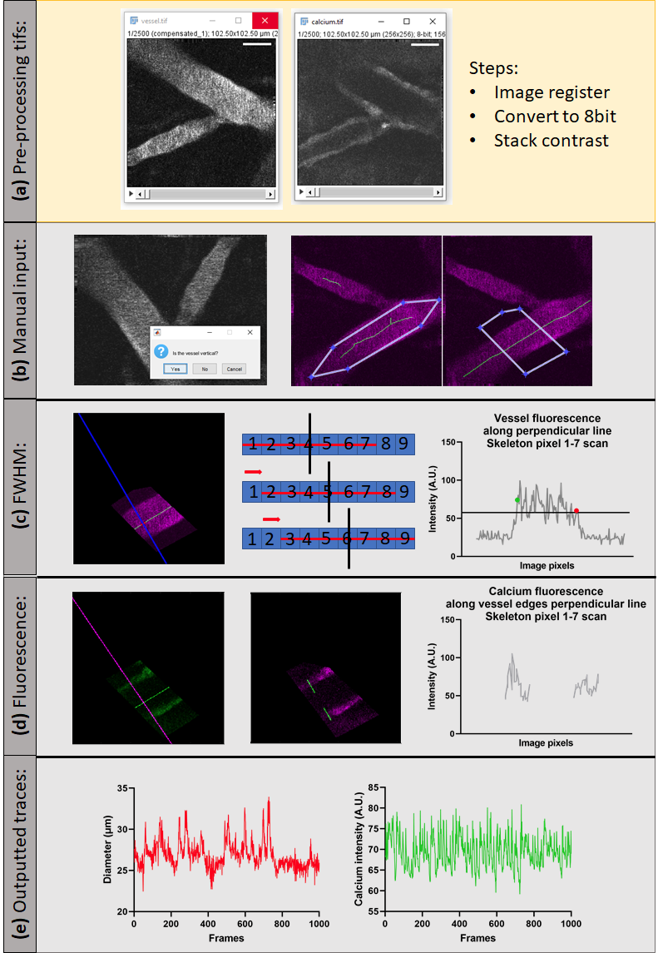

Figure 3: Analysis pipeline for full width half maximum calculation for vessel diameter and perivascular calcium.
Pre-processing steps in ImageJ are presented in the yellow box (top row) and data extraction steps using MATLAB in the grey box (rows 2-5). (a) An example frame from the pre-processed tif files for the xy vessel (left, vessel.tif) and perivascular calcium (right, calcium.tif) recordings, ready for loading into the MATLAB script for diameter and fluorescence intensity calculations. Both tif files have been image registered using the same coordinates, and converted to 8 bit images. The vessel file has also been subject to stack contrast adjustment to reduce artefacts from altering external light sources (e.g. from the presentation of a visual stimulus). (b) Examples of the steps of the MATLAB script were the user is asked for manual input. Left: the user is asked whether the vessel is vertical (as scans along the skeleton pixels are more subject to error along vertical skeleton lines). If the user answers ‘Yes’, the vessel image will be flipped (so the vessel is horizontal). Centre: Example box outline (white lines with blue connecting dots joined to a point on either edge) over the vessel (pink) area of interest, which will be used to generate the skeleton line along the centre of the vessel branch. The user should draw the skeleton box along the edges of the vessel area of interest (selecting only one branch), and the box outline should narrow to a point at either edge to avoid generating a skeleton which forks. Right: Example mask outline for highlighting the vessel area of interest. The regions outside of the hand-drawn mask will be removed from the image, so any other vessel branches in the background will not affect the fluorescence intensity scan of the skeleton perpendicular line. (c) The full width half maximum (FWHM) calculation steps from the MATLAB script used for extracting the vessel diameter. Left: an example of the perpendicular line (blue) generated to scan the vessel (pink) along a subsection of the central skeleton (skeleton shown in green, skeleton section used to generate perpendicular line highlighted in red). Centre: A schematic showing how the MATLAB script steps through the skeleton pixels to generate the perpendicular line used in the FWHM calculation. Each numbered blue box represents an individual pixel of the central skeleton, and the horizontal red line indicates which skeleton pixels have been used to generate the perpendicular line (black). The progression from the top, middle and bottom row of this schematic show how the script steps through each skeleton point one pixel at a time (as indicated by the red arrow). Right: An example intensity plot (grey) generated along the perpendicular line of one of these skeleton subsections. The black horizontal line represents the full width half maximum (FWHM) threshold (calculated by summing the minimum and maximum intensity value and dividing by 2), and the green and red dots show the first and last (respectively) pixels which exceed this FWHM threshold. The differential of the index between these first and last pixels to cross the FWHM intensity threshold is calculated and converted to microns to generate the vascular diameter for every skeleton point per every frame of the xy vessel recording. (d) The stages of the optional step of the MATLAB code used for extracting the fluorescence intensity of the calcium signal either side of the vessel edges. Left: The same perpendicular line (pink) generated from the vessel skeleton (see (c) row 3) is used to scan the calcium.tif image (green). Centre: The perpendicular line is cropped (green) to only take an intensity reading from either side of the vessel edges. The vessel edges are those detected using the FWHM calculation. Right: The fluorescence intensity profile (grey) for the cropped perpendicular line which aligns the vessel edges. This is averaged to give one intensity value per skeleton pixel for every frame. (e) Example diameter (left, red) and raw calcium fluorescence (right, green) traces averaged across all skeleton pixels for each frame of the recording.

