METHODS TO FIND OUT IP ADDRESS OF OTHER DEVICE:

1. Browse router ip address 192.168.1.1 to find out based on different routers
2. Cmd (not word good)
   1. Net view
   2. Netstat
3. Use nmap (not finishing)

Methods to log into raspberry pi cmd through ssh:

Go to putty, enter pi’s ip or just click saved session “raspberry pi”

Click OK, username “pi”, password “raspberry”.

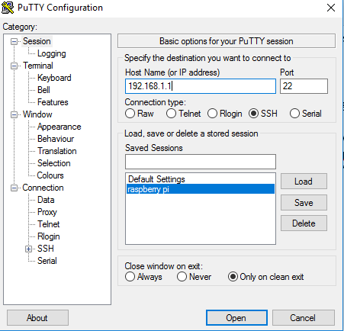

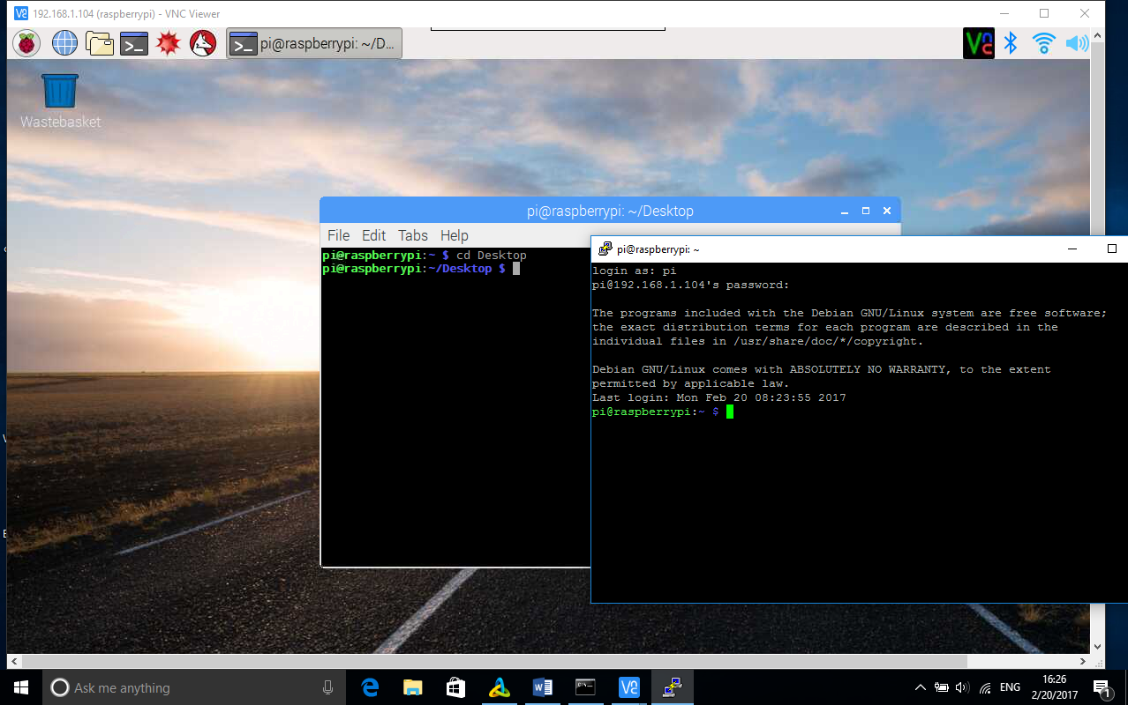

Commands

Open python file

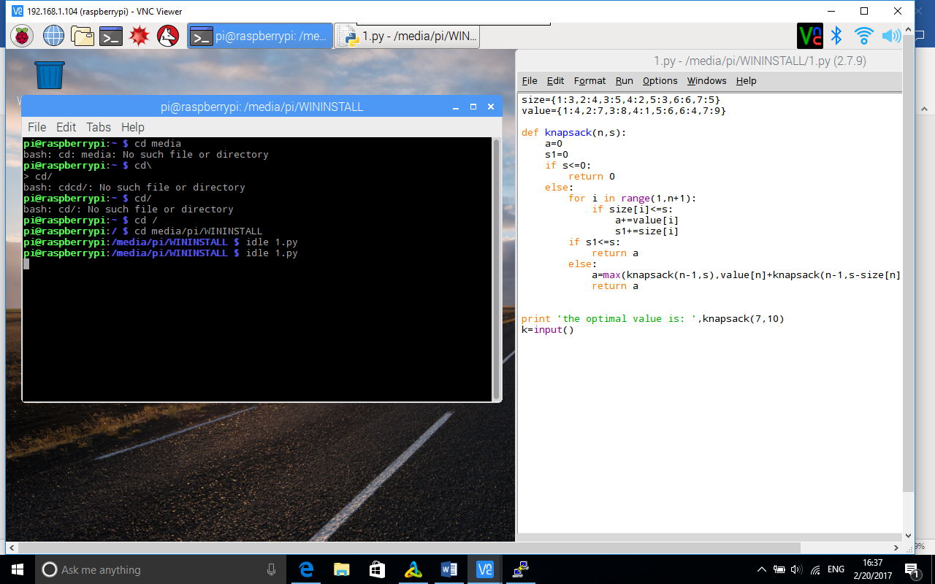

Run python file

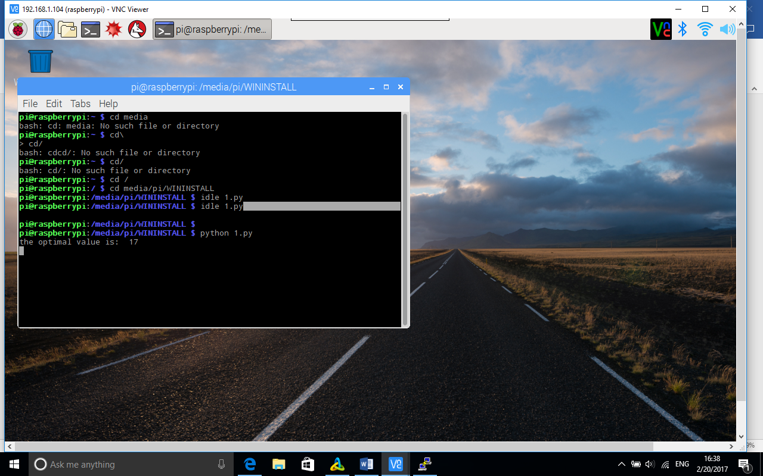

Type nano 1.py for editing

