**雅思写作批改：作文情况分析&指导**

Welcome to TONGZHUO IELTS Writing Score Improvement Channel

**学员基础信息**

**Basic**: 0.0

**Goal**: 6.5

**写作题目 & 审题思路**

1. **Question （写作题目）**

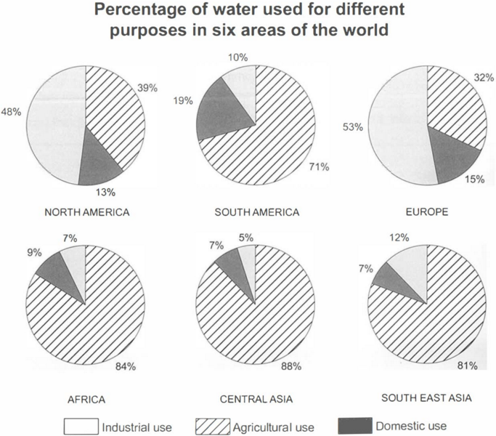

The charts below show the percentage of water used for different purposes in six areas of the world.Summarise the information by selecting and reporting the main features, and make comparisons where relevant.

1. **Topic exploring （审题思路）**

**Charts analysis table （图表题审题表）**

|  |
| --- |
| **How many charts/graphs are there in this task?**  3  **What are the types of charts/graphs?**  Pie  **Is it static or dynamic?**  Static  **What is the rubric?**  The charts below show the percentage of water used for different purposes in six areas of the world.  **Is there a unit in the chart/ table?**  yes  **What is the unit in the chart/ table?**  Percent  **Is there a title of the chart/ table?**  yes  **What is the title of the chart/ table?**  Percentage of water used for different purposes in six areas of the world  **Is there any legend in the chart?**  yes  **11.What is the legend in the chart?**  **Industrial use, agricultural use, domestic use** |

**作文批改**

**Composition Analysis （作文批改）**

Given are charts showing the amount of water consumed for various goals in six regions around the world.Overall, the percentages of water used for agricultural sectors are highest in South America, Africa, Central Asia and Southeast Asia, while the consumption of water for industrial is dominant in North America and Europe. Commencing with water used for industries, the proportion of it accounts for 48% in North America, 5% lower than that used in Europe. On the contrary, the other regions consume under 12% of water for this sector, in which that in Central Asia ranks last at 5%.With regard to the agricultural field, its usage of water is nearly the same in Africa, Central Asia, Southeast Asia, and South America with over three quarters, in which Central Asia utilizes the most for this area (88%). In comparison, those in North America and Europe are close, as both range over one-third.Concerning the water consumed for domestic purposes, South American households take up the largest volume, at 19%. The rest does not exceed 15% wherein only 7% of this is used by families in Central Asia and Southeast Asia each.

**Word count: 205**

**作文评分**

1. 了解雅思考官如何给作文评分：[可以按住CTRL键点这里了解](http://video.itongzhuo.com/03c6d3c6040c465683630a9304ec1bc7/9900328d2c824744bdb24a3d6617c227-702ea4d234a0e7352569e089bfa681af-fd.mp4)
2. 如果想扫掉关于作文估分的几个地雷：[可以按住CTRL键点这里了解](http://video.itongzhuo.com/6ebeca47130945b293d7f1f0d798a10b/38ea38bce2e548b996046c2174171340-09a6ffb8f74c1515a8d8ce4a94d25a80-fd.mp4)

**具体评分：**

|  |  |  |
| --- | --- | --- |
| **Scoring Criteria** | **Score** | **Overall Positive Assessment** |
| **Task Response** | **6** | Some main features were stated |
| **Coherence and Cohesion** | **6** | Some cohesive devices were used |
| **Lexical Resource** | **6** | Some collocations were used. |
| **Grammatical Range and Accuracy** | **6** | A mix sentence patterns were noted. |
| **Overall Band Score** | **6** | **Competent User** |

**提升建议 ( Suggestions )**

TR ( Task Response )

|  |
| --- |
| **WEAK POINT 1:** you wrote most figures not allowed in task 1.  **MY ADVICE:** In task 1, both static and dynamic tasks, we should not write all numbers. Your goal is to choose only the important ones. **Proper grouping of data will help you be consistent with your comparisons and avoid listing or missing all numbers**. This way, you will have relevant comparisons which are required in task 1.  Here’s a checklist for A STATIC TASK:   1. **Key points to write in this task:** 2. Highest data for agriculture: 88% 3. Highest data for industry: 52% and 48% 4. Highest data for domestic: 19% 5. Group similarities:  * over 70% in four regions * lower than 15% for industrial use in four regions * lower than 10% for domestic use  1. **Relevant comparisons**    * + 1. **By region**  * Developed region vs. developing region (agriculture) * Developed region vs. developing region (industry) * Developed region vs. developing region (domestic)   + - 1. **By purpose**   **Comparison one**   * developing region (agriculture vs. industry vs. domestic: choose relevant numbers only)   **Comparison two**   * developed region (agriculture vs. industry vs. domestic: choose relevant numbers only)   **by rank**  highest in all regions (agriculture, industry, domestic)   * lowest in all regions developed region (agriculture vs. industry vs. domestic: choose relevant numbers only)   **You can check the structures in CC below.**  **POSITIVE RESULT OF THE CHANGE:**  Clearer and complete summary of key features.    **WEAK POINT 2: The overview paragraph can be improved .**  **MY ADVICE:**   1. **Solution for the overview of multiple charts/  a chart with many data in a static task–**Pick 2 of the most obvious features from each graph and limit yourself to writing about these things and these things only. Don’t worry about leaving information out; the examiner will be actually looking for your ability to leave insignificant information out because this shows that you are summarising and only reporting the main features. We normally highlight the highest and lowest.     **POSITIVE RESULT OF THE CHANGE:** Having an overview paragraph cannot guarantee that you can get an automatic score of 7. Consider these things:   * 5 in TA= this has NO/poor/wrong overview * 6 in TA= this has an overview with 1 correct summary or 1 that needs improvement * 7 in TA= good and accurate overview; the general trends and main features were highlighted. There is an error but it’s a mere grammar or word slip.   So if you wish to get 6 or higher in TA, then have a good and stronger overview. |

CC ( Coherence and Cohesion )

|  |
| --- |
| **WEAK POINT 1.** Proper grouping of data may be improved to create a more relevant comparison  **MY ADVICE:**   1. In Task 1, you should group the data well. ***to make a logical division of data, group the bullet points and place them in each body according to their rank/trend and make relevant comparisons. In other words, don’t write all information in one paragraph.     BODY1: **two developed nations (North America and Europe):**  = show the highest ranks for these two  = group the data for agriculture (over 30%, under 40%, over one-third…)  BODY 2: **four developing nations**  **=** group figure for agriculture (over three quarters, over 70%, ranged around 80%, more or less 80%....)  = group their lowest rates (not exceeding 12%, no surpassing 15%, ranging around 10% more or less  = emphasize highest rank (88%)    **Other grouping**  Group/body 1: (highest vs. lowest)- agriculture vs. domestic  Group/body 2: (second highest)- industry  or  group 1: two highest  group 2: one lowest  or  BODY1: agriculture (highest): compare developing and developed countries.  BODY 2: industrial and domestic (lower): compare developing and developed countries.  **POSITIVE RESULT OF THE CHANGE:** better summary and grouping of data |

LR ( Lexical Resource )

|  |
| --- |
| **WEAK POINT 1:** Problems in word choices and repetitions  **MY ADVICE:**  LEXICAL RANGE and GRAMMAR RANGE can be improved if you show variations in the languages you use. You can combine these tips in 1 essay:  a. **Precision and use of proper Synonyms**: these are words with similar meaning.  WATER USE (noun): *water consumption, consumption of water, use of water, water consumed/used, usage of water*  USE (verb)- use, use up, consume, utilize, take up, exhaust  b. **Word families** – use of same word but with different forms  = use = uses, usage, using  = consume = consumes, consumption, consuming  c. **Collocations** – combining right words together  **\*for percentages:**figure for, rate of, data for, statistics of, proportion of, percentage of,… or pronouns (that of/that in). *amount of can be used for this depending on the topic *Number of cannot be used for percentages since numbers refer to the exact figure.    **POSITIVE RESULT OF THE CHANGE:** This can help improve your grammar and lexical range since examiners will see your effort that you thought about these words and not just copied them. |

GRA ( Grammatical Range and Accuracy )

|  |
| --- |
| **WEAK POINT 1:** You can work on phrases used to describe data.  **MY ADVICE:**  Make sure to vary your structures when describing figures; give yourself time to edit your work during the test, so you can rephrase those repeated structures. LR, GRA, CC are language criteria, so you need to impress the examiners by using languages to describe numbers.  For figures, you can use diverse languages such as the following which are relevant in task 1.   * + **Make use of prepositions effectively in describing figures:** * Use to when describing what happened to the number. * Use by when describing the amount of change or gap between two numbers.   + OF can also be used to show the amount of change or gap . It comes with a noun form: a decline of 10%.   + **use OF and BY for negative data too. * Use with to give the idea of 'having' the number. Follow with + noun + -ing + figure   + *With the figure rising to 20%* * Use at to add the number in the end of a sentence.   **You can use the following phrases for data:**   * Prepositions: *in, at, with, to*, *by* * Clauses: which was 10% * Phrases: accounting for, comprising 20% * Other synonyms for account for: Constitute, comprise, consist of, take up, contain, cover, represent, occupy, made up, etc.   **You can state numbers to begin a sentence:**   * **% + of + subject of the data**  + verb * **There are/were % of + subject of the data** who/which + verb   **POSITIVE RESULT OF THE CHANGE:**  It’s not enough to use complex sentences. What you need is variety of sentence patterns since your language ability is being checked here. If this is achieved and have less or no grammar errors, you can get not lower than 7 in GRA. |

**附：原文 ( Original Composition )**

Given are charts showing what percentages of water consumed for various goals in six ares around the world.Overall, it is clear that the percentages of water used for agricultural are highest in South America, Africa, Central Asia and South East Asia, while that of the consumption for domestic use are the lowest in North America, Europe and Aouth East Asia, with South America, Africa and Central Asia use the least industrial water.Commencing with water used for industries, the consumption of it is 48%in Nouth America, a little lower than that used in Europe, at 53%. South East Asia used it for 12%, equaling that consumed in Africa and Central Asia together, at 7% and 5% separately. Ranked last is 10% in South America.With regard to agricultural-used water, usage of it nearly the same in Africa, Central Asia and South East Asia, at 84%, 88% and 81%, while that in South America is 71%, whereas that in North America and Europe are close, at 39% and 32%.Concerning water consumed for domestic purpose, North America, South America and Europe used 13%, 19% and 15% of it respectively, as opposed to 9%, 7% and 7% consumed in Africa, Central Asia and South East Asia.