CS-5500

CRN- 12787

Advanced Operating System

Project – 2

SCHEDULING ALGORITHMS

Shawana Erum Hadagalli

700733073

1. First- Come First-Served (FCFS) Scheduling:

|  |  |  |
| --- | --- | --- |
| **Process** | **Burst Time** | **Arrival Time** |
| 1 | 5 | 0 |
| 2 | 3 | 1 |
| 3 | 8 | 2 |
| 4 | 6 | 3 |

Output Screenshot:

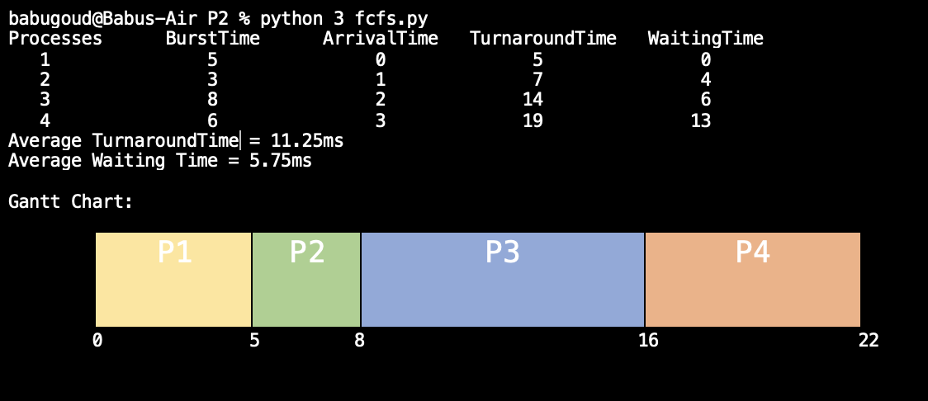

1. Shortest Job First (SJF) Scheduling:

|  |  |  |
| --- | --- | --- |
| **Process** | **Burst Time** | **Arrival Time** |
| 1 | 21 | 1 |
| 2 | 3 | 2 |
| 3 | 6 | 3 |
| 4 | 2 | 4 |

Output Screenshot:

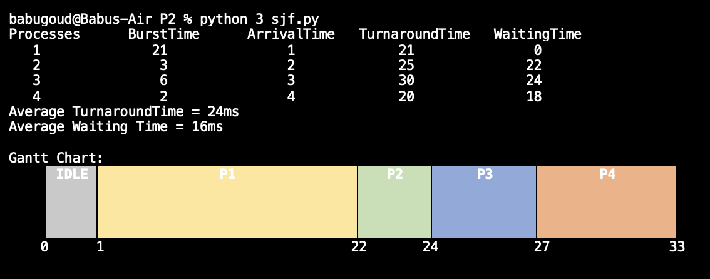

1. Round-Robin (RR) Scheduling:

|  |  |  |
| --- | --- | --- |
| **Process** | **Burst Time** | **Arrival Time** |
| 1 | 5 | 0 |
| 2 | 4 | 1 |
| 3 | 2 | 2 |
| 4 | 1 | 3 |

Output Screenshot:

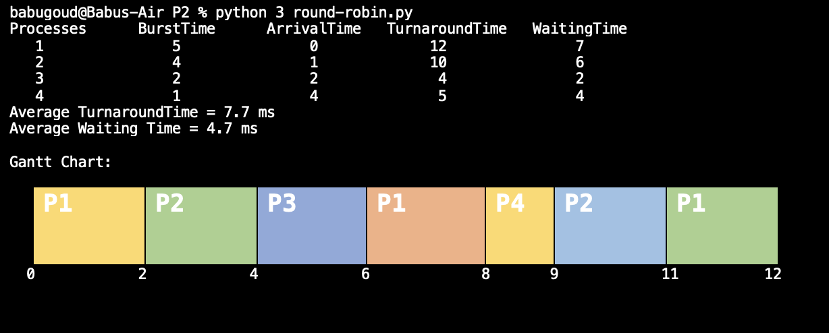

1. Round-Robin (RR) Scheduling with Priority:

|  |  |  |
| --- | --- | --- |
| **Process** | **Burst Time** | **Priority** |
| 1 | 5 | 0 |
| 2 | 4 | 1 |
| 3 | 2 | 2 |
| 4 | 1 | 3 |