# Unit testing

Create a class extends testCase

Create a test method , annotate with @Test

Add assert (Control + space for continuation)

Add an interface object element annotate with @Inject

Add a service object

In the method create a new service object

Import mackito.* classes

Call mock(interface.class)

Add when(interface.method) thenReturn(object);

Call the service using the mocked object created

Add asserEquals oe other asserts

Add verify calls

Run as unit test

# GitHub

Main > settings > collaborators > team owners > add a user

Main > create a branch > click clone URL

IDE > import > from Git > clone URL > uncheck master

Team > commit > add comment > commit and push

In git compare and pull request > add comments

Send pull request > merge pull request

jQuery Ui and jQuery plugins

text format

# ClassNotFoundException ConfigureListener :

Add Jsf 2.2 mohara library

## Bulma

Use scrimba for coding

Basic page: <section class = “section”>

<div class=container”>

<h1 class=”title”>

<p class=”Subtitle”>

Hero page <section class=”hero is-.. has-… “>

<div class=”hero-body”>

<div class=”container”>

<figure class=”image…”>

<img src=”…”

Bulma columns: <section class=”section”>

<div class=”container”>

<div class=”columns”>

<div class=”column”>

<div class=”notification”> // gives padding

Is-primary add green background

Is-info add blue background

Adding icons: <article class=”media”

<figure class=”media-left”>

<span class=”icon has-text-success”>

<i class=”fa fac-check…”>

<div class=”media-content”>

Can refactor and use <article class=”media notification is-info”>

Doing a Blog:

<section class=”section”>

<div class=”container”>

<nav class=”breadcrumb”>

<ul>

<li class=”is-active”>

Add .grid class .grid {

Display: grid;

…

}

.grid * { // anything inside a grid

Grid-column: md;

}

Class=”buttons”

Menu <aside>

Button is-link

Sections add gaps

Columns are grid 12 system

Class box will add a box good for debugging

For tiles start with left to right and then top to bottom

Image and a text:

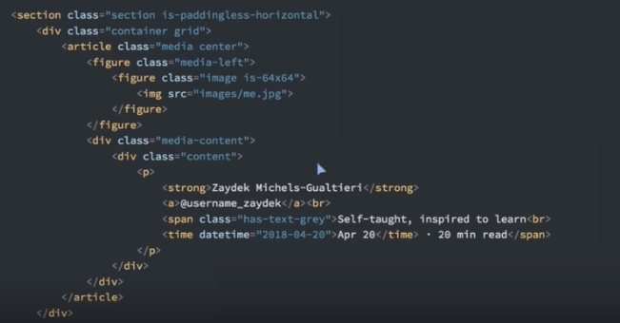

Title and subtitle:

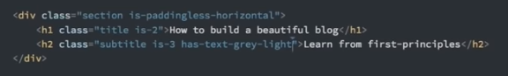

Adding columns of images

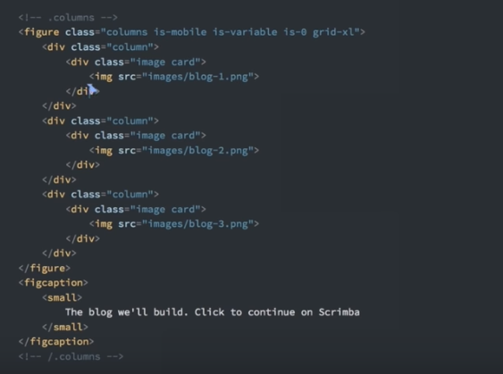

Article content:

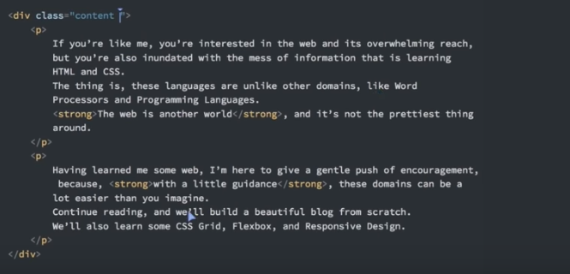

Custom css

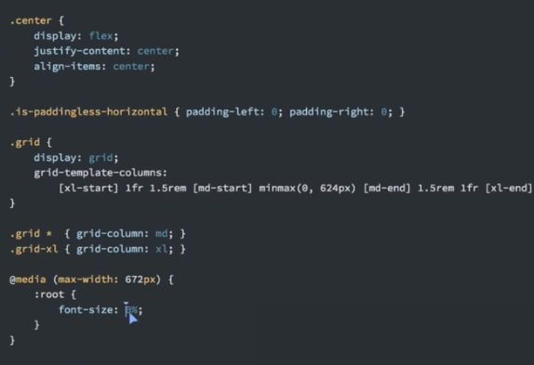

Launch page

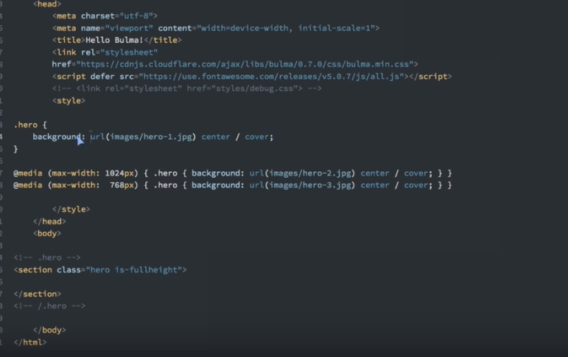

Helper.css

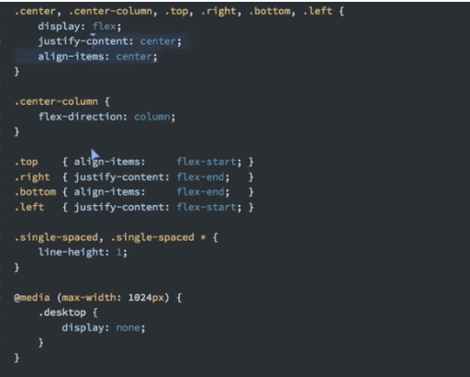

Navbar at the top

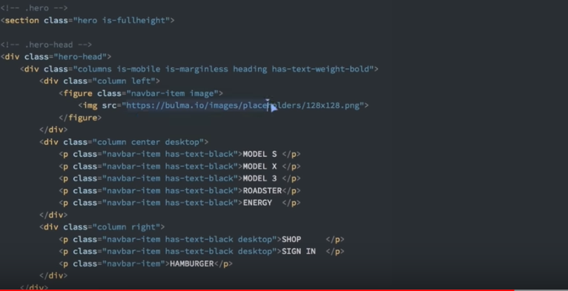

Using overlay

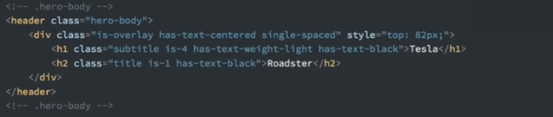

Footer

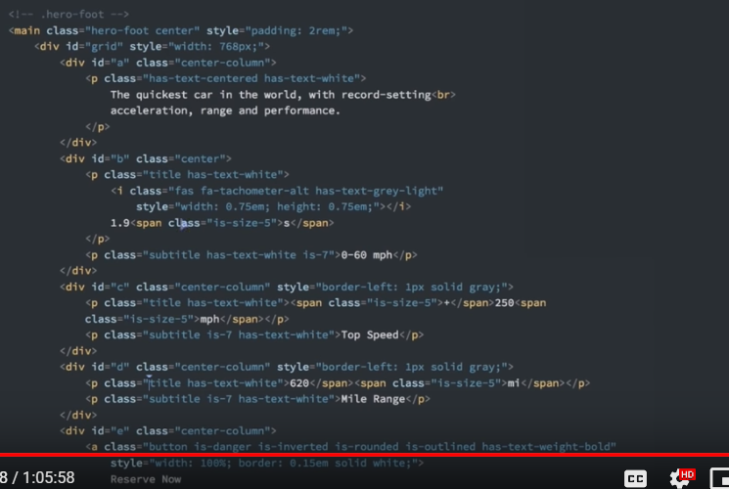

Grid css

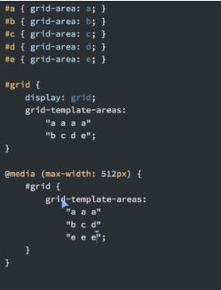

Bulma modifies <hn

tags

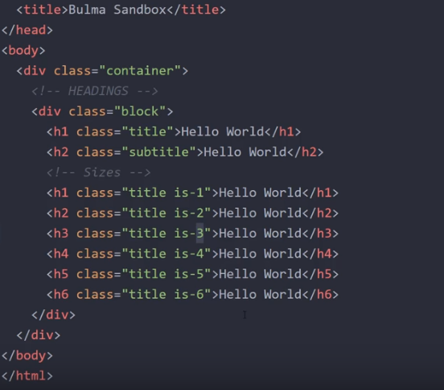

Content. Bulma removes padding for <p

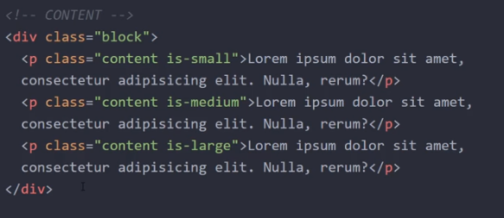

Buttons

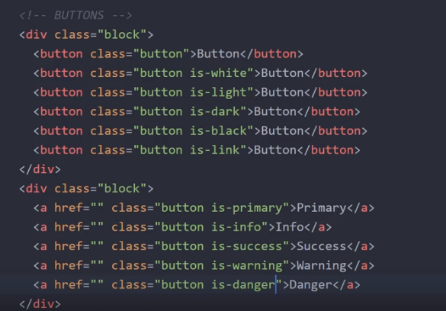

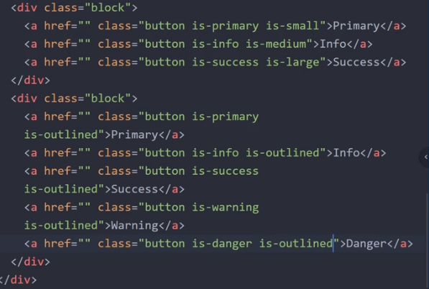

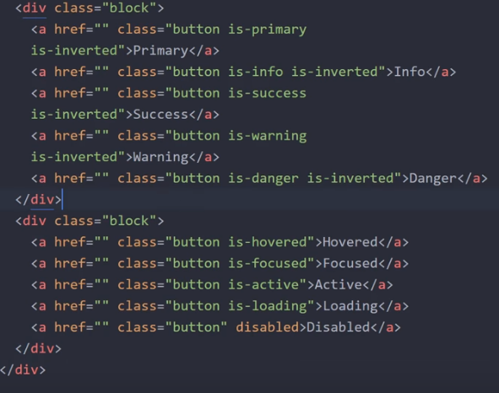

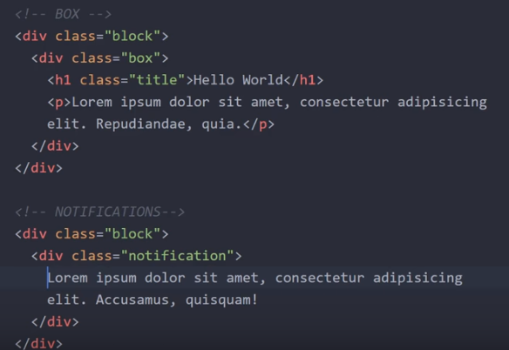

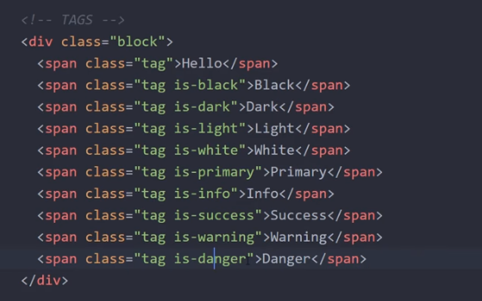

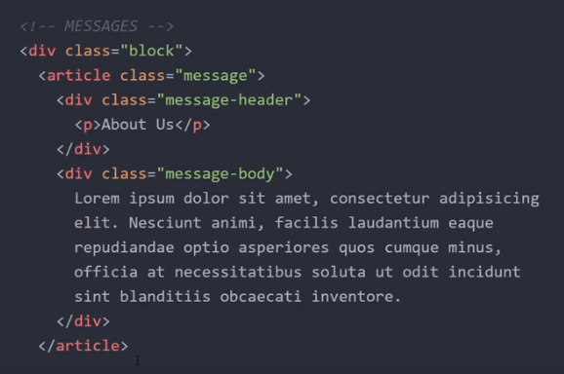

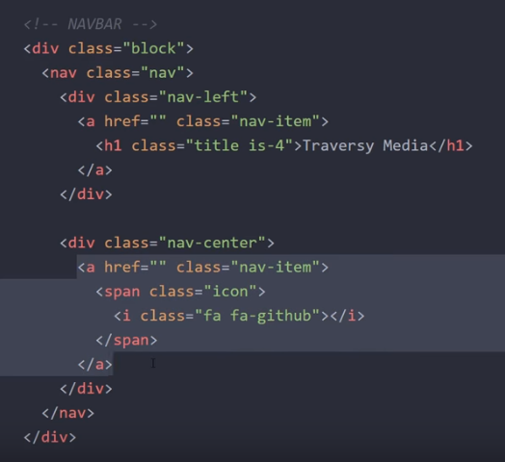

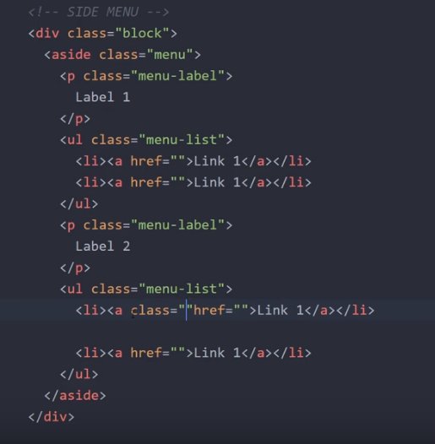

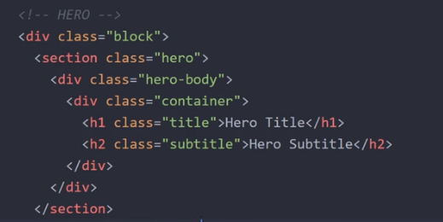

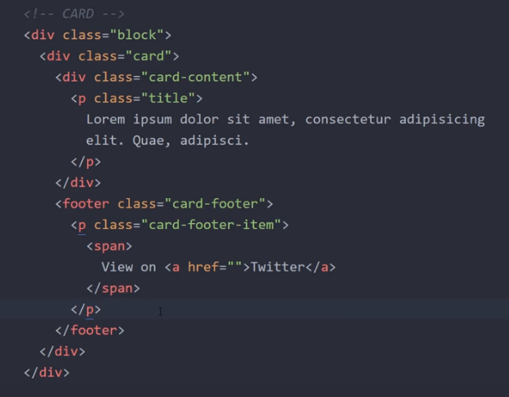

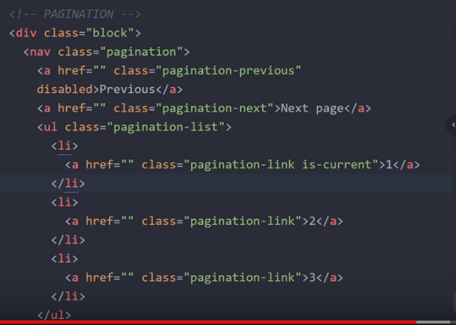

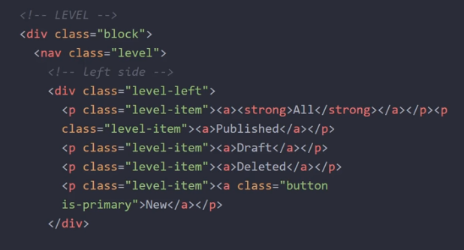

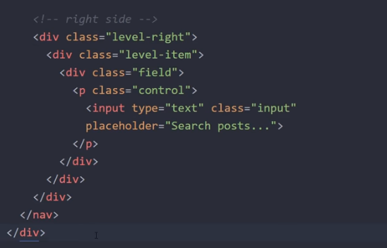

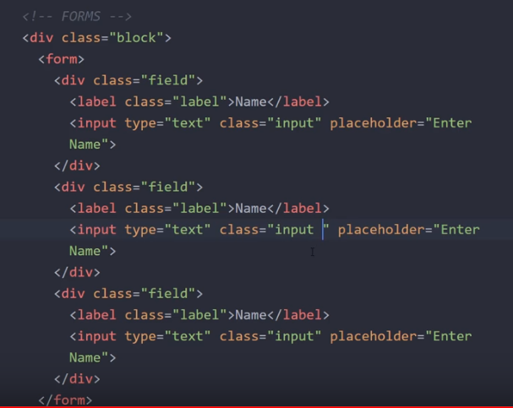

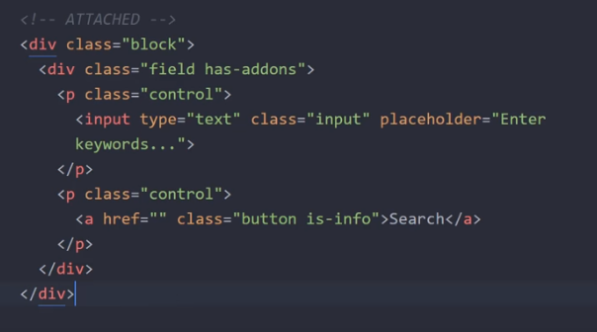

Class=”table” add “is-striped” ( optional)

