**Hands-on Assignment 5**

**Due Date: See web**

Use Q-learning to create a program that can play Tic-Tac-Toe with a human player.

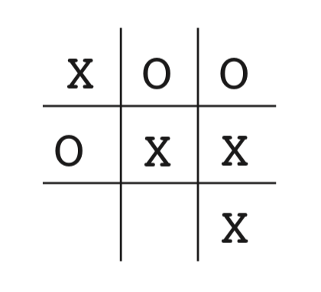

You are not required to implement the game with GUI. Simply “printing” the board after each play is enough for this assignment. As for the evaluation, human should not be able to win the learned agent. The agent should be able to win the human (if a human player makes mistake) or draw every time.

Either the agent or the human player can make the first move, so include this feature as an option in your code. After each play, the board game should be printed. When the game finishes, the program should print which player won the game, or draw if the game was a tie.

Please include Readme file that illustrates how to run the program and how to play with the agent. Submit the code, Readme, and the checkpoint for the agent (so that training is not necessary for grading). The files should be submitted via Canvas in a zip file.

Let the instructor know if you would like to share your solution to other students.