**Week5**

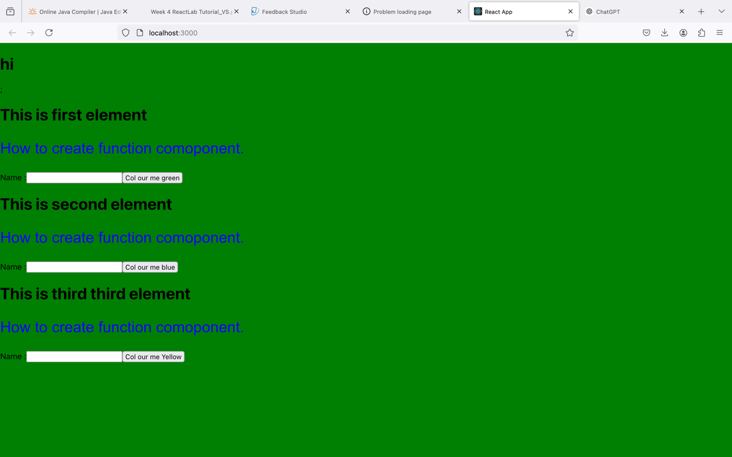

**What do you understand by React component and what command do you use to create a React component with or without property?**

* **React Component:**
  + A React component is a reusable, self-contained piece of UI. It can be a class component (using ES6 classes) or a functional component (using functions).
  + Components may accept input (called **props**) and return React elements to be rendered to the DOM.
* **Command to Create a React Component:**
  + **Without Property:**

function MyComponent() {

return <div>Hello, world!</div>;

}

With Property:

function MyComponent(props) {

return <div>Hello, {props.name}!</div>;

}

**What command will you use to render the newly created component named as MyReact?**

* You render the MyReact component using the ReactDOM.render method in the main index.js file:

import React from 'react';

import ReactDOM from 'react-dom';

import MyReact from './MyReact';

ReactDOM.render(<MyReact />, document.getElementById('root'));

Suppose the MyReact Component has a property heading, write down the code that could be used to render the MyReact Component, and pass the message to the property heading as "this is my first element".

function MyReact(props) {

return <h1>{props.heading}</h1>;

}

// Rendering the component

ReactDOM.render(

<MyReact heading="this is my first element" />,

document.getElementById('root')

);

Observe this code and answer the questions below:

<AppColor heading="This is first element" lbl="Name :" color="green"/>

#### **a. What is the name of the React Component?**

* The name of the React component is AppColor.

#### **b. How many properties does this component use?**

* This component uses three properties: heading, lbl, and color.

### ****Code for**** GreetingElementwithProp****:****

Given this code:

function GreetingElementwithProp(props) {

return (

<div className="App">

<h1>Welcome, {props.studentname}</h1>

</div>

);

}

export default ??????;

To correctly export this function, replace ?????? with the name of the function:

export default GreetingElementwithProp;

### ****Function to add two properties and display the sum on button click:****

#### Code:

function AddNumbers(props) {

const handleClick = () => {

alert(props.num1 + props.num2);

};

return (

<div>

<button value={props.color} onClick={handleClick}>

Click me to add numbers

</button>

</div>

);

}

Example of rendering this component:

ReactDOM.render(

<AddNumbers num1={5} num2={10} />,

document.getElementById('root')

);

This code takes num1 and num2 as props, adds them when the button is clicked, and displays the sum using an alert.