**Leadership Development Plan: Moving Forward**

Scott Hawkins

Washington State University

EM_522 Leading People and Organizations

Dr. Kay Bachman

15 April 2022

**Leadership Vision**

***Vision Statement:*** *Develop leadership experience and knowledge and use that to lead an effective team in the software industry.*

An important question to ask each individual is what direction they are heading in and what it will look like when they reach there – whether it’s one month from the present moment or 20 years later — and what effects they desire to occur. This question is fundamental for professional and personal development, simply because it outlines an objective; with that objective made clear, goals can then be made which will track the progress of that individual along their path to success. Unfortunately, I find it to be a question rarely asked from one person to another; I myself am only asked it once every six months for my current job, and before that, this sort of question was only asked in the onboarding interview. Therefore, I think this a question that an individual should ask themselves repeatedly. Perhaps even once a day. This is because it is essential to have a sharp vision of the future, which – as stated before – will help elucidate for the individual the next step they need to take in order to make that vision a reality. Of course, to refrain or to ignore or even to forget to ask this question will surely make one’s vision of the future less and less defined as if it were their eyesight itself degenerating.

However, to anticipate and plan for the future, one needs to understand where they are at the present moment. I took the Q12 questions exam from *First, Break all the Rules*, and recorded the results below.

Scale of 1 to 5, Strongly Disagree to Strongly Agree

Q1. I know what is expected of me at work. 3

Q2. I have the materials and equipment I need to do my work right. 5

Q3. At work, I have the opportunity to do what I do best every day. 4

Q4. In the last seven days, I have received recognition or praise for doing good work. 3

Q5. My supervisor, or someone at work, seems to care about me as a person. 3

Q6. There is someone at work who encourages my development. 4

Q7. At work, my opinions seem to count. 5

Q8. The mission or purpose of my company makes me feel my job is important. 5

Q9. My associates or fellow employees are committed to doing quality work. 4

Q10. I have a best friend at work. 2

Q11. In the last six months, someone at work has talked to me about my progress. 4

Q12. This last year, I have had opportunities at work to learn and grow. 4

While this exam shows I have a good position overall, there are areas that need improvement, especially for the first 6 questions—described in the book as the most fundamental. Going forward, I should ask myself these questions periodically; they will help me keep in mind not just where I am, but will also grant me insight into how others are thinking as well as the health of the organization overall.

Considering all this, one of the best ways to keep one’s vision of the future remain intact is to list it down, which I’ve done below. Yet it is also worth considering that one’s vision will almost certainly change over time, so this will be a table worth revisiting every time I open this plan to type something new.

|  |  |
| --- | --- |
| Vision Objectives | |
| Timeline | **Leadership Vision** |
| 6 months | * I will have finished this course and gained personal insight into being a more effective leader |
| 1 year | * I will have passed all prerequisite courses to become certified as a leader in the United States Reserve forces |
| 5 years | * I will have completed my Master’s Degree and utilize the experience to bring expertise into the software industry. * I will have started on my second degree to further enhance my knowledge. * I will shift from linguistics into the software industry and learn the fundamentals to progress my career |
| 10 years | * I will have completed my second degree and gained sufficient knowledge in the target industry to move into middle management if I so choose |
| 25 years | * I will be in a position to consider partially retiring or work in a leadership or consultant position, providing guidance, vision, and expertise to the young workforce. |

**Leadership Mission**

***Mission statement:*** *Continue the development process. Observe success, correct mistakes, learn and grow, do what’s right even if it’s more difficult.*

A good leader needs to dedicate themselves to a good mission.

As a contractor, the avenues available to situate myself within the leadership domain are limited, but I am looking beyond the horizon. If I adequately prepare myself, once I shift industries and become a software engineer, I will not only have plenty of opportunities to develop my leadership skills, but many supervisory roles which I can explore and learn from. For the here and now, though, it is best to soak up as much information as I can from the sources available, that is, my current supervisors and my professors themselves are oftentimes prime examples of leadership. Observations should be made, notes jotted down, and lessons pondered over. With those lessons taught, I also need to apply them in practice, otherwise the knowledge might just go to waste—I can dip my toe in the water by employing such skills one weekend a month, when my Army Reserves unit meets. On top of that, it is also important for me to exercise my core values (discussed later).

Looking forward, though, the mission will unquestionably be dedicated to the software and technology industry. This is a tightly-knitted industry with expert teams that run tandem with one another, and each team requires leadership not just to run independently to achieve its individual objectives, but in sync with the other teams too so that the final product can be assembled together simultaneously. Keeping this in mind, it is therefore necessary to take what I know and what I will learn over these next several years, compile it, and apply it once I’ve become embedded in that industry.

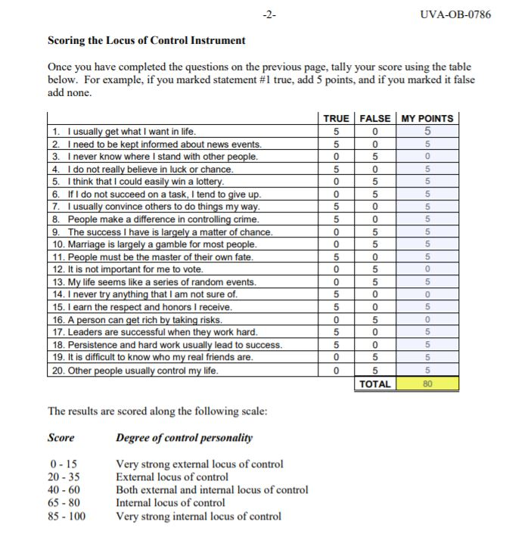

The examination above reveals that I am a strong believer in the power the individual wields. As long as I strive for it, I can make a difference; most importantly, I can make a difference for others and the organizations that I value. It may be too difficult to anticipate the effects that I will have, but listing those that I desire to have will help orient my focus.

Desired Effects on Teammates:

Increase cohesion;

Add to an atmosphere of open-mindedness;

Inspire a need to give back to community and environment.

Desired Effects on Organization:

Increase value;

Increase sustainability;

Inspire a need to give back to community and environment.

**Leadership Values**

**When it comes to values, I often reflect on those the Army taught me:**

**These are all significant values and I can declare without a moment’s hesitation that I apply them to every leadership role I have taken and will apply them to every role I aim to take in the future.**

**While perseverance and endurance may be more related to an individual’s performance than that of a leader’s, it is no less important to consider that a leader must always be looking to grow themselves too. Nobody is perfect and there is always more distance to cover. So, just because I land a decent job and am put in charge of a great team, that doesn’t mean I can just stop looking for ways to improve myself. What needs to be said, though, is it is key to assess where I am regarding these values.**

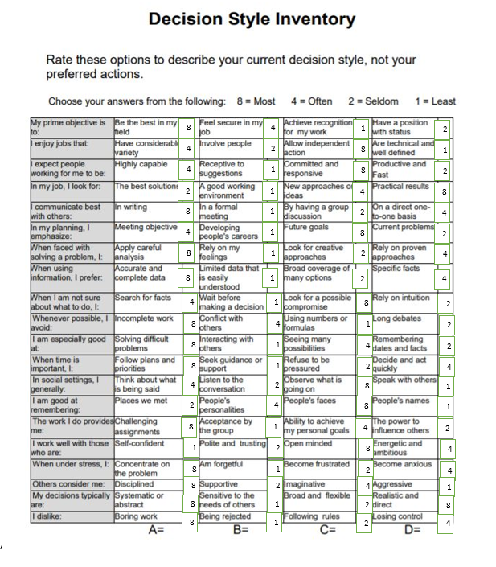

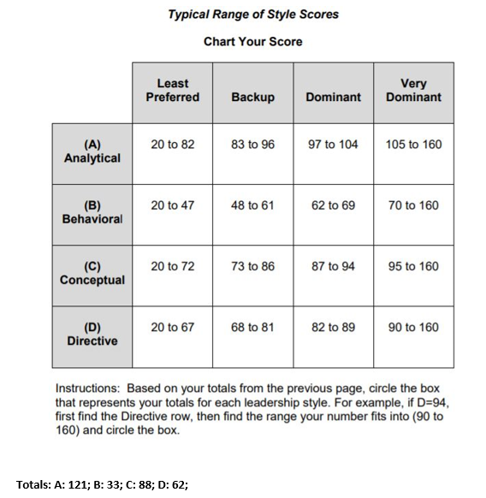

**This decision styles assessment lines up with the values of endurance and perseverance. As can be seen, I am an analytical and conceptual person; the descriptions for the items I selected indicate that oftentimes I will choose the more labor-intensive solution if it is to yield the most desirable result.**

**Continuing on, empathy and respect, I believe, are intricately linked. Every person should be treated with these two values, and adopting one without the other will not yield as nearly a powerful result as when both are used together. Not only do these values lift up other people, though, they also help ground the individual employing them. These values temper egotism and foster the seed within the mind that everyone is flesh and blood, just as yourself.**

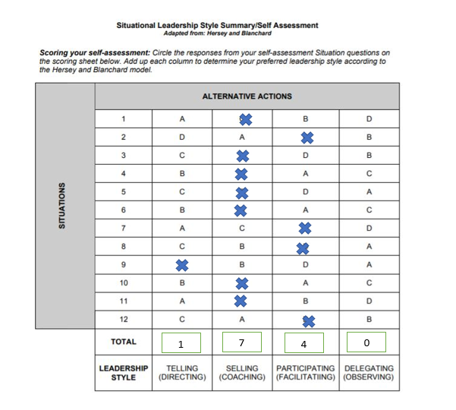

**The above assessment shows that I am most interested in hearing and helping my teammates. There certainly are occasions where orders must be direct or niceties must be cut short (in emergencies, for example), but those instances are the rare exception.**

**No value more defines my time in the Army than integrity, though. This is a value I aim to keep throughout the rest of my life, and I will ensure its continued presence as I develop into a leader. Integrity isn’t just about doing the right thing, but admitting wrongs and figuring out the course to correct them.**

**Lastly, courage is a mark of every good leader. Not just used to lead the charge, but also to challenge the consensus, offer an idea in the face of silence, and take a step back even when the pressure is mounting. There are many different forms of courage, and all of them very much belong in the best leaders. Currently I can think of no greater example of this than Volodymyr Zelensky, the president of Ukraine, who I wrote about in Journal 7. As I pointed out there, despite him being offered safety and security with a ride out of Ukraine, Zelensky has remained in his country in the face of unimaginable terror. Throughout bombardments and targeted assassination attempts, he has stood his ground against a world power, and in doing so has created a global movement.**

**Leadership Growth Objectives**

Now the question remains: how to actually plot my leadership development?

I very much doubt it will be a linear path from point A to point B. Likewise, I doubt that it will be all forward progress without a mistake in sight. A solid plan will account for this; it will define objectives, list the points to meet them, give a timeline, allow room for modification, and provide rewards for meeting objectives. However, it will avoid penalties for failure, as failure is not only expected, but it should be viewed as a valuable learning tool. What matters is one thing: moving forward.

So, combining my mission statement – that is, to develop leadership experience and apply it – with the previously mentioned values of perseverance, endurance, integrity, empathy, respect, and courage, I’ve assembled a rough plan.

**Growth Objective 1: Complete Education**

Definition: Get all of my training and education done for switching over to the software industry

Plot point: Complete EM 522

Plot point: Complete Master’s Degree

Plot point: Use GI bill to obtain secondary degree

Plot point: Complete company-offered training program

Purpose: Acquire the technical and interpersonal knowledge as well as hard and soft-skills necessary to be not only a productive team member in the software industry, but a leader as well.

Managing-self aspect: self-development

Managing others aspect: utilize personal insight development to engage with others

Managing organization aspect: add value to organization through education

Core values: Perseverance, endurance, integrity

Reward for completion: Purchase a new car

**Growth Objective 2: Rise to Senior Operative or Supervisory Position**

Definition: After obtaining work in the software industry, gain the necessary experience and influence to climb the company ladder

Plot point: Enter the software industry

Plot point: Learn the tradecraft to a proficient level

Plot point: Earn promotion to enter senior-level position

Purpose: It is necessary to take time to learn the fundamentals and skills in the software industry, but to also be on the lookout for opportunities as well. Utilizing what I have learned over the course of several years, I will make an effective leader.

Managing-self aspect: learn and practice industrial standards

Managing others aspect: use standards as a baseline for development of others

Managing organization aspect: enhance standards to benefit industry

Core values: Perseverance, endurance, integrity, empathy, respect, courage

Reward for completion: Long vacation/sight-seeing tour with intention to gain new insight and perspective of the world

**Growth Objective 3: Reach Fully Independent Position**

Definition: Reach complete financial independence and achieve seniority in position

Plot point: Pay off all debts and have financial accounts at appropriate level

Plot point: Earn promotion to senior level management

Purpose: At this level, it’s important to be in a position free of ties to any company due to finances instead of passion for the job and its people. If appropriate, the position should allow extra time off or I can choose another route to offer my leadership experience, i.e. work as a consultant or start my own company.

Managing-self aspect: refine skills and teach

Managing others aspect: create new opportunities for others

Managing organization aspect: create an organization or space within an organization that practices core values

Core values: Endurance, integrity, empathy, respect

Reward for completion: Purchase vacation home

**SWOT Analysis**

A SWOT analysis is an exercise meant to have one identify their strengths and weaknesses (preferably with some outside perspective too), which then helps to identify both the opportunities and threats in their anticipated field of work.

|  |  |
| --- | --- |
| Strengths:   * Linguistics * Cryptography * Network analysis * Military values and mentality * Computer Science degree * Artistry/Writing * Strategic and abstract thinking * Attention to detail * Learning * Problem solver | Weaknesses:   * Interpersonal relationships * Negotiation tactics * Enthusiasm |
| Opportunities:   * Software field is always expanding * Software jobs are flexible * Take classes to enhance development of relationships/negotiation techniques * Current company offers courses * Positions open for leadership in linguistics * Use understanding of AI to develop software for linguistics | **Threats:**   * AI replaces need for linguistics * Linguistics is a niche industry * Cryptography & cybersecurity increases in complexity * Software field is competitive in hiring * Industries searching for leadership experience |

**Development Opportunities**

As described in the SWOT analysis matrix, there are multiple development opportunities. At the moment, the software field is expanding dramatically, which includes flexible positions and schedules—something useful to keep in mind not just for the self but for others too—a fact that is corroborated by many publications. Supplementing this, I do plan on reaching out to my company and starting on the software engineering pipeline they offer, and I can use my unique experiences as a linguist to think of innovative solutions in the programming field for the problems that linguists face.

I do face the fact that there should be an initiative to try to mitigate some weaknesses I am aware of, such as taking professional courses to enhance work-based relationships. Looking for opportunities to explore this option could take place both at work and outside it.

**Analysis**

An effective analysis is needed to tie everything together. Strengths, weaknesses, opportunities, and threats all need their due attention. The primary reason for this work is to uncover what I’ve learned about myself so far as a leader, which, in turn, has influenced my mission, vision, and objectives.

**Strengths**

Some of the strengths I listed in the SWOT analysis were directly tied to my current occupation--that is linguistics, cryptography, and networks analysis—precisely because I have unique experience in that field. Outside of where I work, these could be considered a ‘niche’ industry skillset, but I would say that what’s make them valuable, because so few people are exposed to it. Add to that the other skills I’ve acquired from my career in the military, to include strategic thinking and attention to detail, along with those that I’ve practiced through higher education, such as a passion for learning, and I think there are a lot of strengths to explore. These described strengths line up with the StrengthsFinder exam that I took through the Gallup website, the results of which I have listed below:

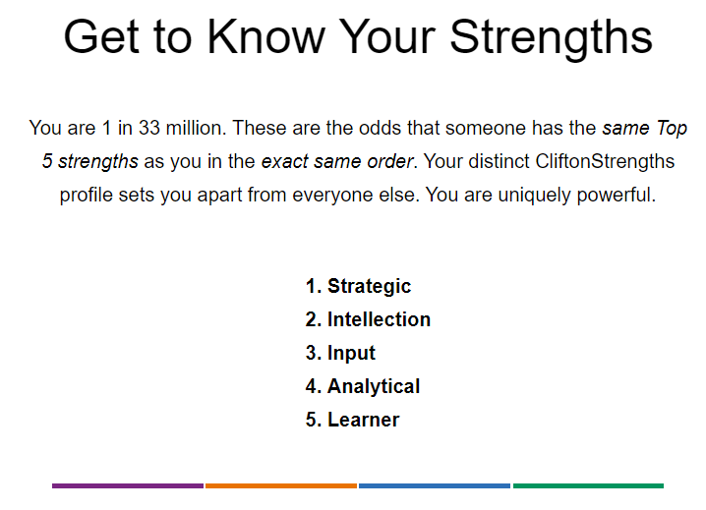

It’s important to view how these strengths are best utilized in context. I think strategic and analytical thinking is something sought after by both organizations and team environments. Another exam that I took that helped me further understand where my strengths lay was the Conflict Management style exam, which I listed the result below, along with the associated description of my style.

Total Points Tallied

|  |  |
| --- | --- |
| Controller | 20 |
| Compromiser | 29 |
| Collaborator | 46 |
| Accommodator | 13 |
| Avoider | 12 |

Ordered by Strength:

* Collaborator
* Compromiser
* Controller
* Accommodator
* Avoider

**OWL – Collaborating – I win, you win**

Owls highly value their own goals and relationships. They view conflict as a problem to be solved and to seek solution that achieves bother goals and the goals of the other person. Owls see conflicts as a means of improving relationships by reducing tensions between two persons. They try to begin a discussion that identifies the conflict as a problem. By seeking solutions that satisfy both themselves and the other person, owls maintain the relationship. Owls are not satisfied until a solution is found that achieves their goals and the other person’s goals. They are not satisfied until the tensions and negative feelings have been fully resolved.

This discovery led me to include ‘problem solver’ in the strengths section, because, as I see it, an ineffective ‘solution’ to a problem may very well lead to more problems down the line. Which means, in a sense, it’s not a solution at all. It’s still a problem to be solved, and I intend to solve it, which benefits everybody involved: myself, my teammates, and the organization as a whole.

**Weaknesses**

Sometimes it’s hard to be critical of oneself. Sometimes. Sometimes it’s very easy—especially when comparing oneself to others. But here, I found it to be a little harder, and I think I did condense my weaknesses down into just three categories, because those are the ones that most stand out to me.

For one, I listed interpersonal relationships. It’s not that I have trouble with having them or building them, it’s just maintaining them—it’s work, it’s energy used, it’s time used. And I feel like the expenditure just isn’t worth it at this point. However, when I am in a supervisory position, having good working relationships with your team members is essential to build trust and with that comes performance. So, finding the time to maintain those interpersonal relationships—whereby negotiation tactics do come into play (for instance, if a teammate asks for a raise, and the budget isn’t there for it)—is something I will need to focus on as I progress in my career.

I also listed consistency and enthusiasm. There’s not really a test to take to confirm it, or much by way of examples to prove it. I’m just not an enthusiastic person. I’m also aware that this also has a dampening effect on others, but perhaps it could be improved if others were less boring. But in all seriousness, I think finding a career field that I am passionate about will have a positive effect in regard to that.

**Threts**

On the opposite side of opportunities are threats to the norms established. Of course, it should be kept in mind when assessing threats that they appear not only in the current environment, but also in the envisioned future as well, and both had better be prepared for. To make it clear, though, I am not referring to existential threats—such as nuclear annihilation or high cholesterol—but threats in the field. According to numerous articles, AI is destined to conquer language. Although this isn’t a near-term possibility, the advances are ramping up; that too applies to cryptography and cybersecurity. In addition, the software field in general is competitive because it offers high salaries among other amenities.

These things do represent distinct threats, but if anticipated and acted upon, they can be turned into opportunities instead.

**Opportunities**

Now, understanding the opportunities available to you also means understanding yourself. Taking the 16 Personalities Quiz, for which I’ve listed the results below, helped me to zero in on where I might be most attuned.

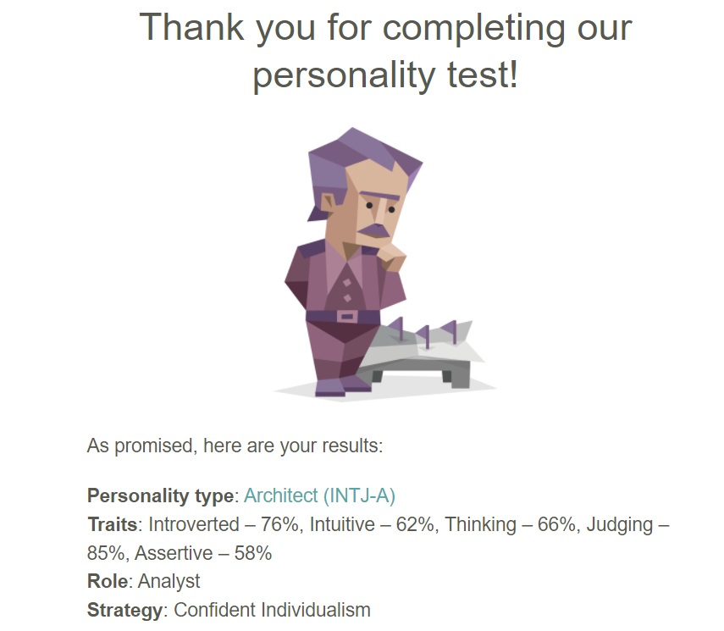

As the Architect description implied, I would be very well suited for engineering, more specifically software engineering (because the physical type would cater toward more extroverted personalities, I’m guessing). So, I would say that my choice of career is a good step forward. Other opportunities I can take are inextricably linked to the field of work I’m in now; for instance, I can use my experience in linguistics to help design language-oriented software, or even translation software, of which there is a growing demand for as the cultures of the world continues to become more interconnected.

Taking these opportunities and utilizing them fully would make me an important cog in an organization, which benefits teammates in turn. It also nicely synthesizes with my mission and vision, as long as I stay true to those statements and incorporate my values as I carry out my objectives.

**Post-EM_522 Development**

As EM 522 wraps up, it is important to review the progress I have made so far and the distance I have yet to cover. The training course has offered insight into many subjects and has greatly helped in making me aware of skills in leadership that are critical to shape and enhance. Below is a brief overview of those skills identified as personal strengths and weaknesses, whether derived through personal judgement or assessments:

* Task-related— Giving input (strength), collaboration in task management (strength in some areas, weakness in others), attention to detail (strength).
* People-related— Communication (weakness), interpersonal relationship building (weakness), empathy (strength), coaching and mentoring (strength).
* Change-related— Strategy and analysis (strength), innovation (strength).

Of course, there are always ways to improve oneself, and learning new things and new ways to do them is an irrefutable part of life. So, there’s no reason to avoid it! However, in light of this, it is important to see where you’re heading so that you can avoid retreading the same ground. Taking into account what I’ve listed above, this course has made it clear that to become a better supervisor, I need to pay particular attention to my people-related skills. With this in mind, it would make sense to redefine my plan of action in order to incorporate a focus on this crucial skillset.

**Plan of Action**

**Part 1: Complete Education**

* **Plot point:** Complete EM 522
  + **Development point:** identify skills that need to be developed (interpersonal/people-related)
* **Plot point:** Complete Master’s Degree
  + **Development point:** learn communicative and interpersonal relationship skills through team projects
* **Plot point:** Obtain secondary degree
  + **Development point:** in addition to learning communicative and interpersonal relationship skills through team projects, select a degree program which challenges current weaknesses (for example, Bachelor’s in Communication) or capitalizes on strengths (strategy and analysis)
* **Plot point:** Complete company-offered training program
  + **Development point:** increase change-related capabilities, work with coworkers also in the pipeline program to develop better communicative skills

**Part 2: Career change**

* **Plot point:** Enter the software industry
  + **Development point:** emphasize skill strengths (task-related, people-related, and skill-related) to gain entry
* **Plot point:** Learn the tradecraft to a proficient level
  + **Development point:** look for opportunities (training programs, etc.) to upgrade people-related skills
* **Plot point:** Earn promotion to enter senior-level position
  + **Development point:** practice coaching and mentoring as well as empathy while honing people-related skillset weaknesses to iron out any remaining wrinkles

**Part 3: Reach Fully Independent Position**

* **Plot point:** pay off all debts and have financial accounts at appropriate level
  + **Development point:** eliminate stress and concerns so that all focus can be given to employees
* **Plot point:** earn promotion to senior level management
  + **Development point:** utilize all the interpersonal skills learned to bring servant-type leadership to the organization and help employees achieve their goals.

**References**

SWOT Analysis:

* Taylor, B. (2020, Jun 18). Personal Swot Analysis and setting Smart Goals. Published via Youtube. From <https://www.youtube.com/watch?v=2DjU4PrS-Mg>

Personalities and strengths assessments:

* 2022. NERIS Analytics Limited. From https://www.16personalities.com
* 2022. Gallup. From <https://www.gallup.com/cliftonstrengths.com>

Additional assessments:

* Internal Locus of Control assessment. 2003. University of Virginia Darden School of Business.
* Conflict management Styles assessment. University of Maryland.
* Situational Leadership Style assessment. Adapted from the works of Hersey and Blanchard.

Mission/vision statement:

* Destiny’s Odyssey. From https://destinysodyssey.com/the-odyssey/vision-statement/mission-statement-vs-vision-statement/#:~:text=When%20it%20comes%20to%20personal,statement%20and%20vision%20statement%20interchangeably.&text=While%20a%20mission%20statement%20describes,picture%20yourself%20in%20the%20future.

Further Research:

* Certo, Samuel C., (2022). Supervision: Concepts and Skill-Building. McGraw Hill.
* Nicholas, John M. and Steyn, Herman (2021). Project Management for Engineering, Business, and Technology. Routledge.
* Gallup (2016). First, Break all the Rules. Gallup Press.
* Taplin, S. (2020, Jan 20). The Future of Software Development in 2022 and Beyond. Entrepreneur. From <https://www.entrepreneur.com/article/403829>
* McFadden, C. (2020, Aug 06). 11 of the Latest Trends in Software Engineering. Interesting Engineering. From https://interestingengineering.com/11-of-the-latest-trends-in-software-engineering
* Romero, A. (2021, May 30). Ai won't master human language anytime soon. Medium. Retrieved March 14, 2022, from https://towardsdatascience.com/ai-wont-master-human-language-anytime-soon-3e7e3561f943

**Academic Integrity Statement**

I commit myself to Washington State University's high standards to uphold academic honesty and scholarly values as established by the WSU's Standards of Conduct. I affirm that I have not given or received any unauthorized assistance on this assignment/examination, that the work product presented here is the work of the author(s) [myself or all team members listed], and that all materials from other sources (including books, articles, Internet, or other media), whether quoted or paraphrased, have been properly cited.

Scott Hawkins

**Typing my name above serves as my signature**