Single Flow Graph Program report

# Problem Statement :

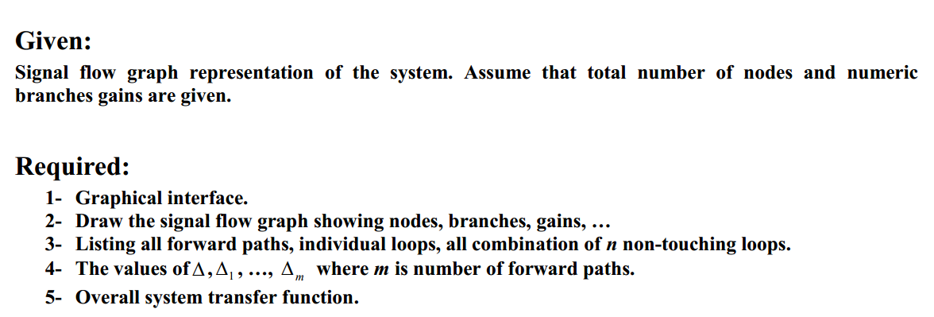

# Main Features of the program :

*The User can draw the Graph with the Graphical interface , Add Node , Delete Node and Add edge between two Nodes , While clicking Calculate button , the program ask the user to enter the start and the end Node he want to calculate the Over-All transfer function for and print out All Forward Paths , All Loops , All information for each Delta and the Over-All Transfer function .*

# Data Structure :

*Representing the graph as adjacency Matrix with an interface to build it taking the total # of Nodes and have a method to add an edge between two nodes with its weight .Using ArrayLists and arrays in the main Algorithms to save Paths and Loops and so on .*

# Main Modules :

*Designing our program as* ***MVC Model*** *with tree main packages :*

1. *Model Packages: which contain our Algorithms classes used to solve the problem .*
2. *View Package : Having the Classes which have the responsibility to show the Graphical interface and give the user the opportunity to draw this graph freely .*
3. *Control Package : which is responsible to merge the first two packages , taking the Graph from the GUI and build an Graph from the Graph Interface and push it to Model package with the given start and end points to return the results .*

# Algorithms Used :

*Using a Depth-First Search with a Back Track property to find all forward paths from the start given node to the end given node.*

*For loops we try to find all possible forward and backward paths between two nodes and merge all combinations between them and remove the duplicates if found .*

*For Non-touched loops for each Delta , we first find all combinations of 2 Non touched loops , if found then we try 3 non-touched Loops and storing all of that in an Array List , and check if the size of the Array List is increased then go again an find from a given index to find the Next combinations of Non-touched if found and so on .*

**Second:**

***User manual:***

1. Creating a node:

To create a node select "node" button then place the node in a valid place (far away from any other node)

Steps:

* 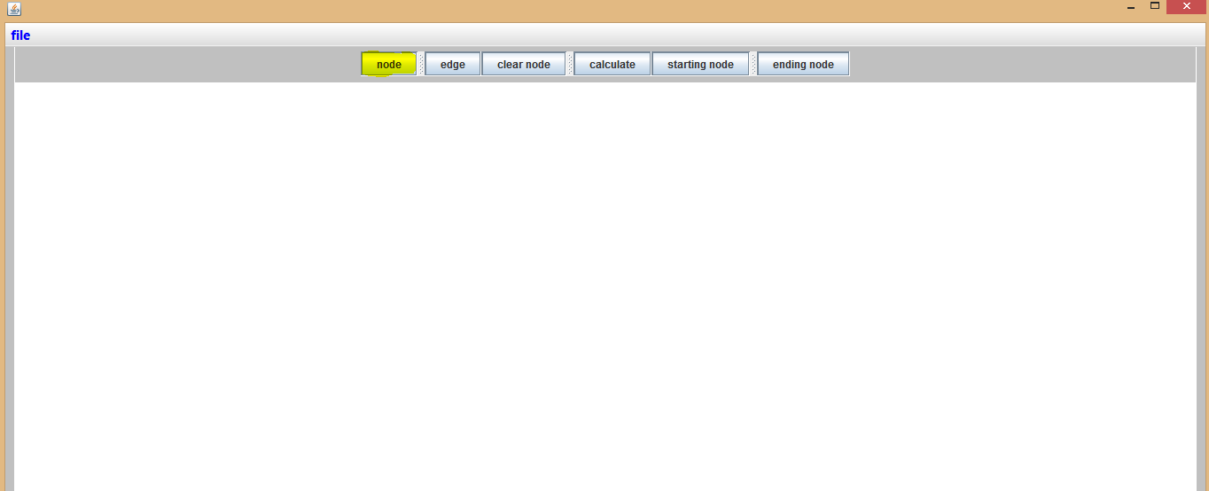
* Select a suitable location for the node:

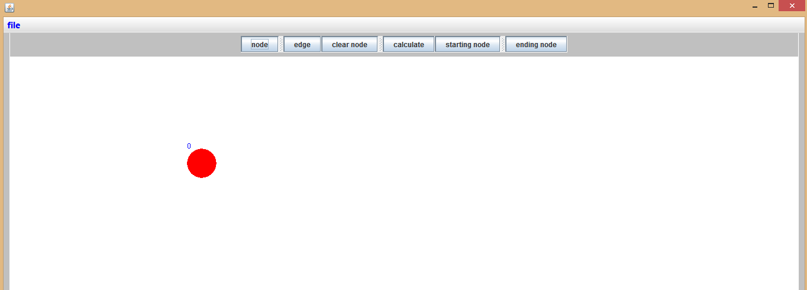

1. To construct an edge :

* Select the "edge" button

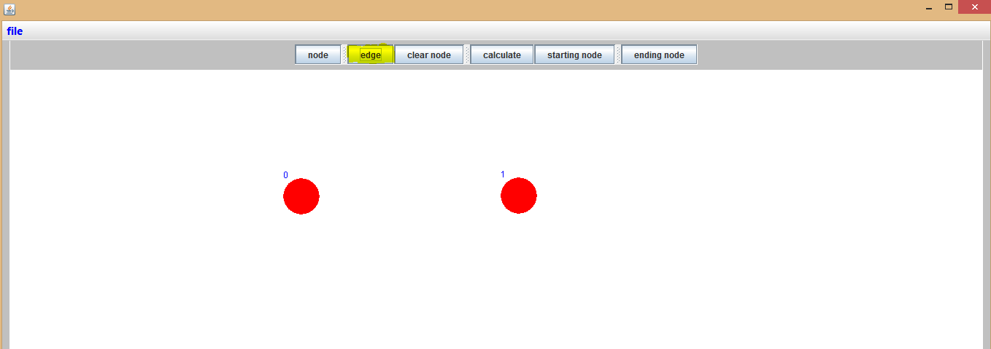

* Select the first node
* Select the second node
* Select a control point (it's preferred to select a point between the 2 nodes either upper , lower or between the to nodes )
* Select the weight of the edge

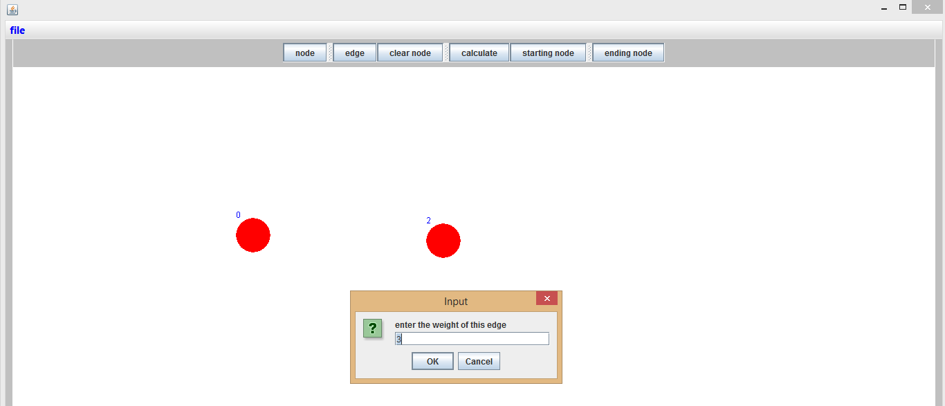

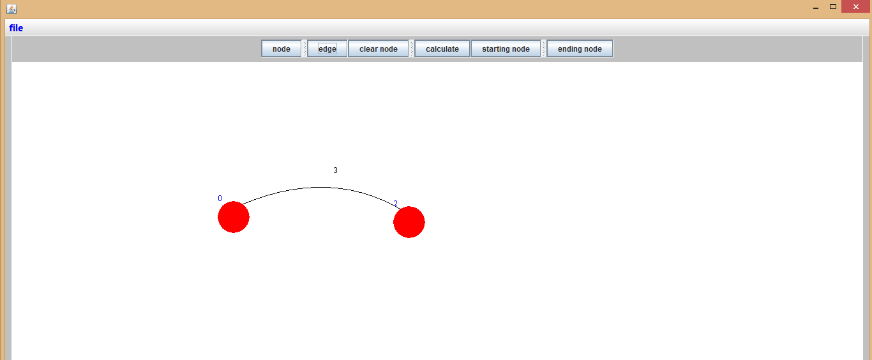

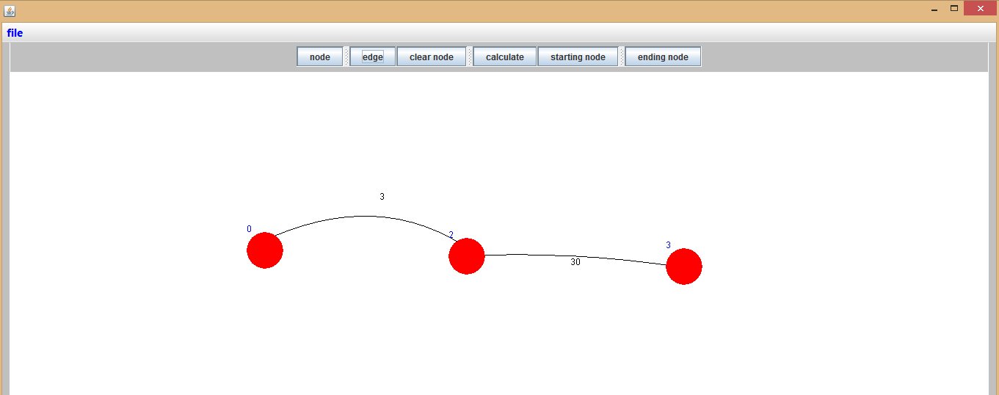

1. Clear a node:

* Select the "clear node" button:

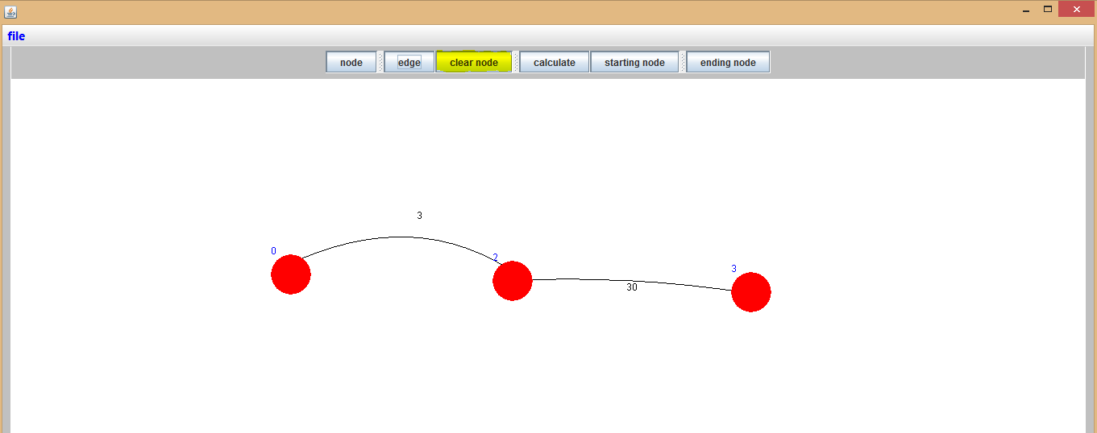

* Select a node to delete(let's delete node 3 ):

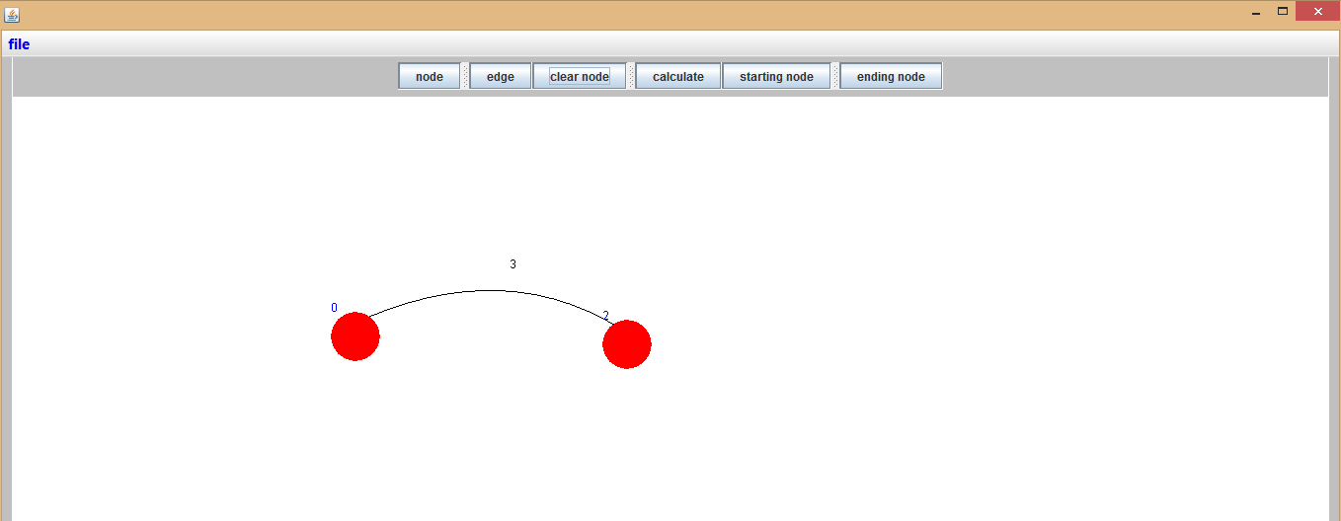

1. Select a new window:

* Select file menu(drop down menu):

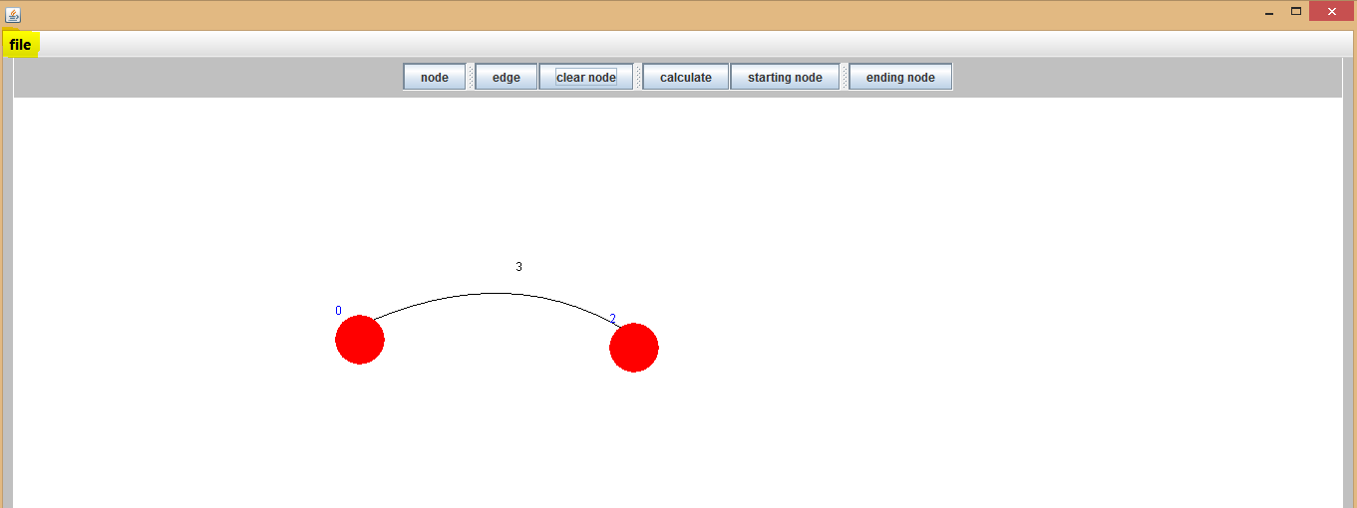

* Select new window :

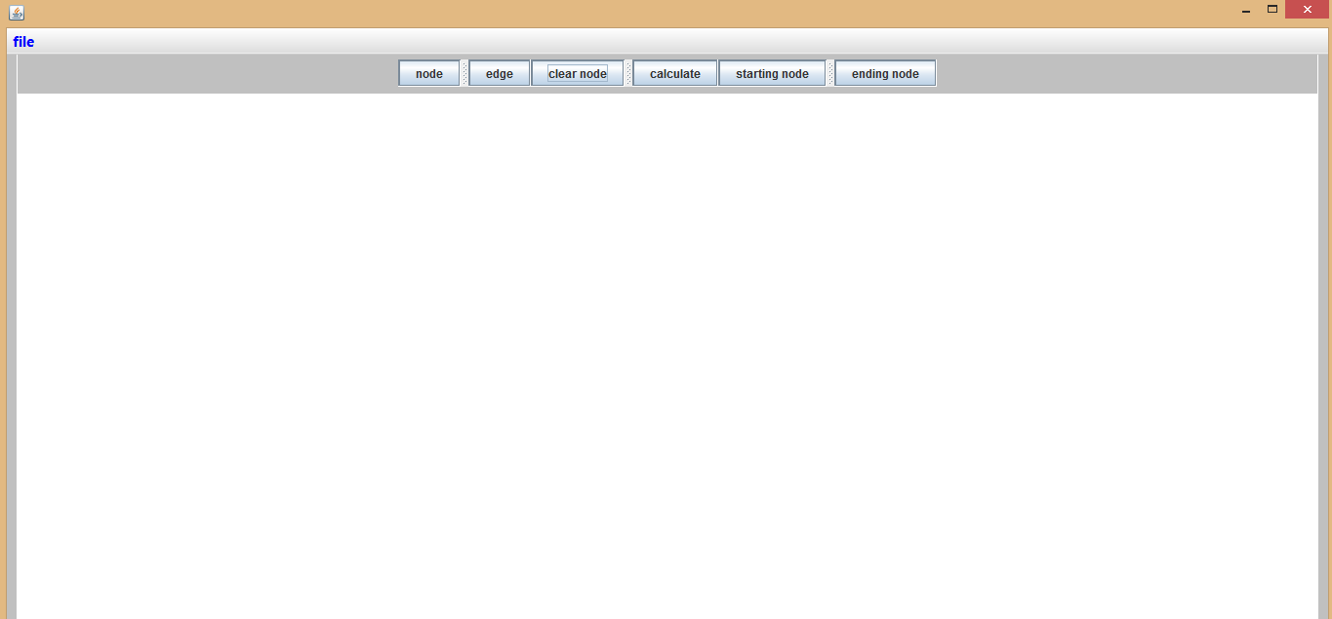

1. Calculation:

* After drawing the single flow graph click the "calculate" button:

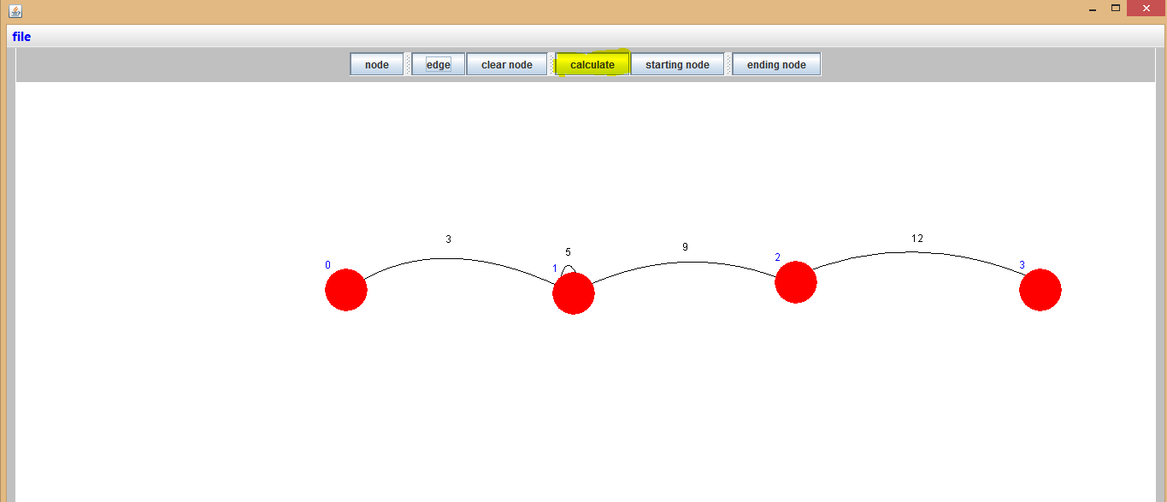

* Enter the number of the source node and the sink node

Note: (validation is applied on the entered values)

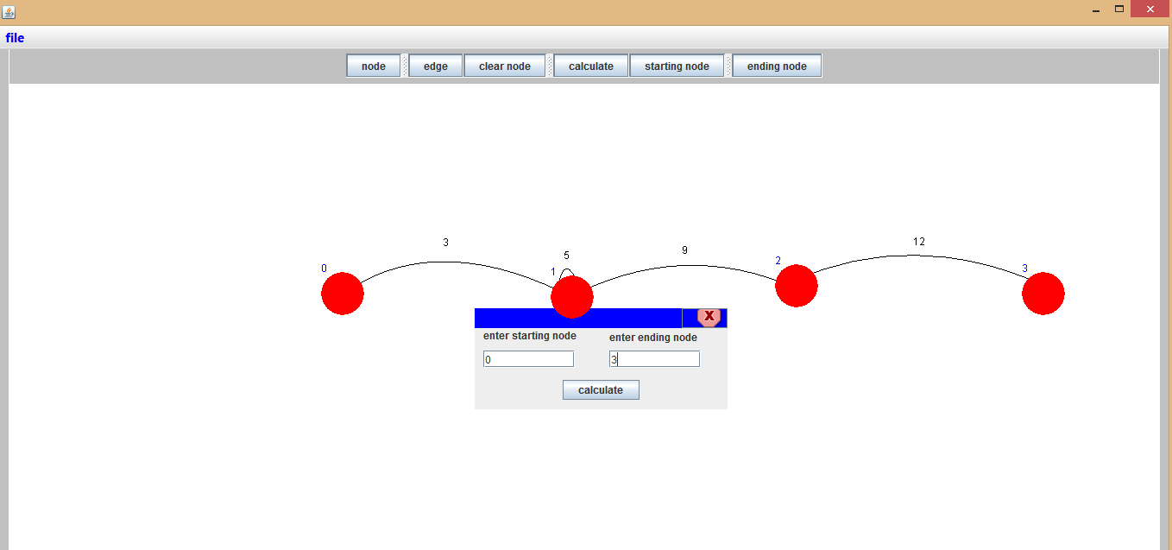

* Click the "calculate" button

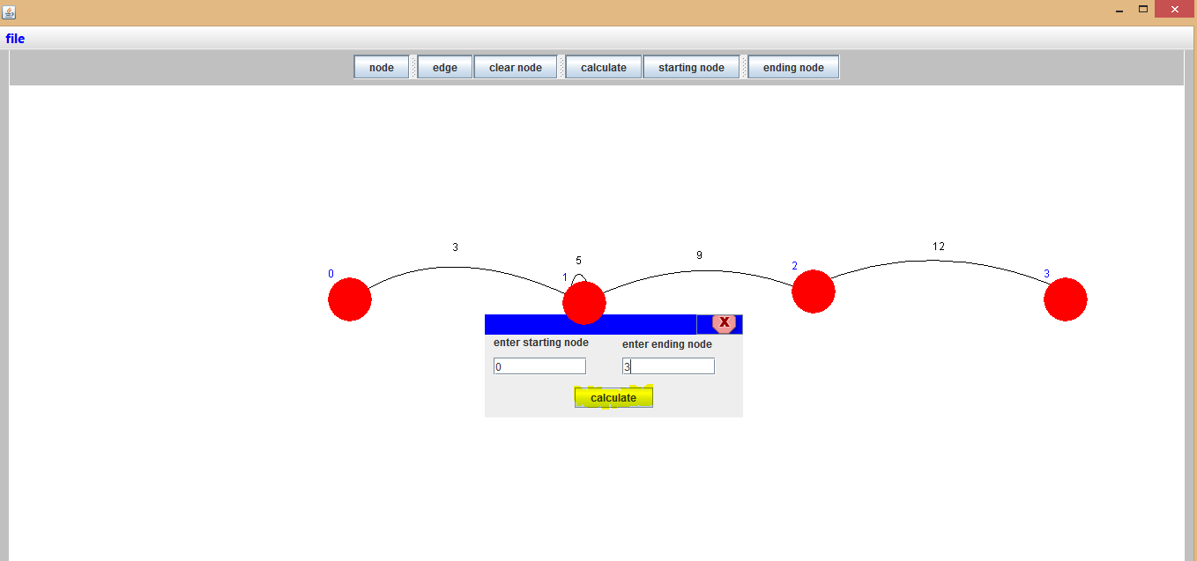

* Get the answer:

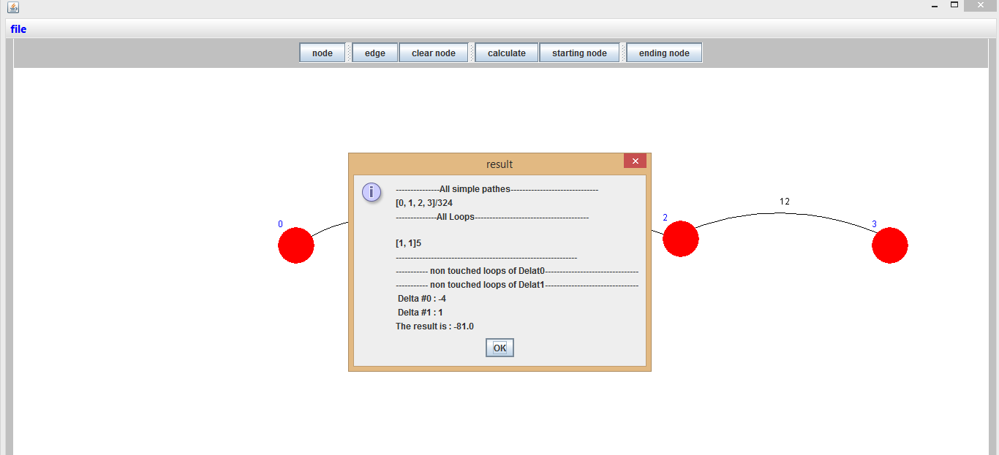

**Hints:**

1. To draw a self-loop:

* Select the node (recommended a point far away from the center)
* Select the node again(recommended a point far away from the center but o the other side)
* Select the value of the edge

1. to control the height of the edge select a higher or lower point(the control point)

(The third point)

Sample runs:

